**DAILY ONLINE ACTIVITIES SUMMARY**

|  |  |  |  |  |  |  |  |  |
| --- | --- | --- | --- | --- | --- | --- | --- | --- |
| **Date:** | **1/06/2020** | | | | | **Name:** | **MAHEK SABHA** | |
| **Sem & Sec** | **VI ,A sec** | | | | | **USN:** | **4AL17CS051** | |
| **Online Test Summary** | | | | | | | | |
| **Subject** | | **CNSC-2** | | | | | | |
| **Max. Marks** | | **60** | | **Score** | | | **48** | |
| **Certification Course Summary** | | | | | | | | |
| **Course** | **Step into Robotic Process Automation(RPA)** | | | | | | | |
| **Certificate Provider** | | | **GUVI** | | **Duration** | | | **3 hrs** |
| **Coding Challenges** | | | | | | | | |
| **Problem Statement:**  **1. Python Program to remove duplicate elements from a list**  **2. Write a Java Program to left rotate the elements of an array**  **3. Given an array of positive integers. Write a C Program to find the leaders in the array.** | | | | | | | | |
| **Status: completed** | | | | | | | | |
| **Uploaded the report in Github** | | | | | **Yes** | | | |
| **If yes Repository name** | | | | | <https://github.com/maheksa1234/Daily-Status> | | | |
| **Uploaded the report in slack** | | | | | **Yes** | | | |

**Online Test Details:**

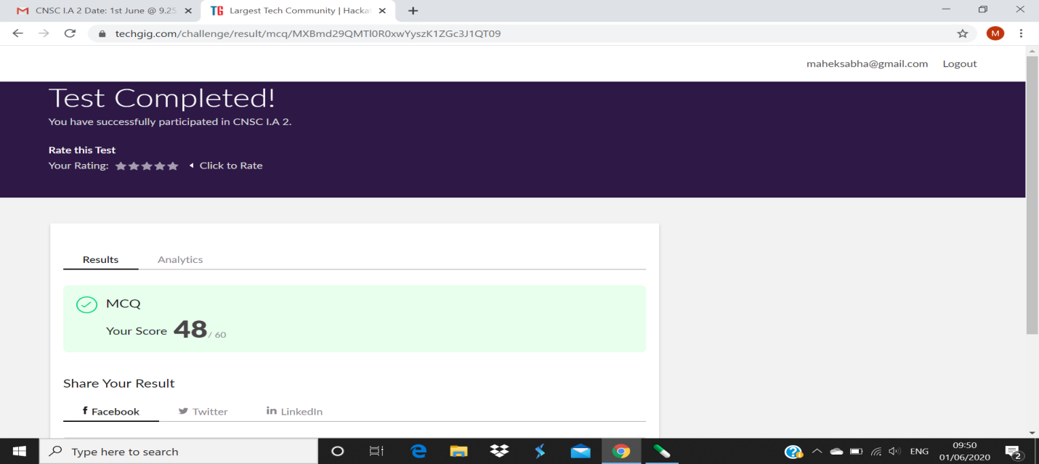

**Certification Course Details:**

Robotic Process Automation(RPA):

• Completed “RPA” course.

• Obtained the certificate for the same.

Refer GitHub account for Detailed information:

<https://github.com/maheksa1234/Daily-Status>



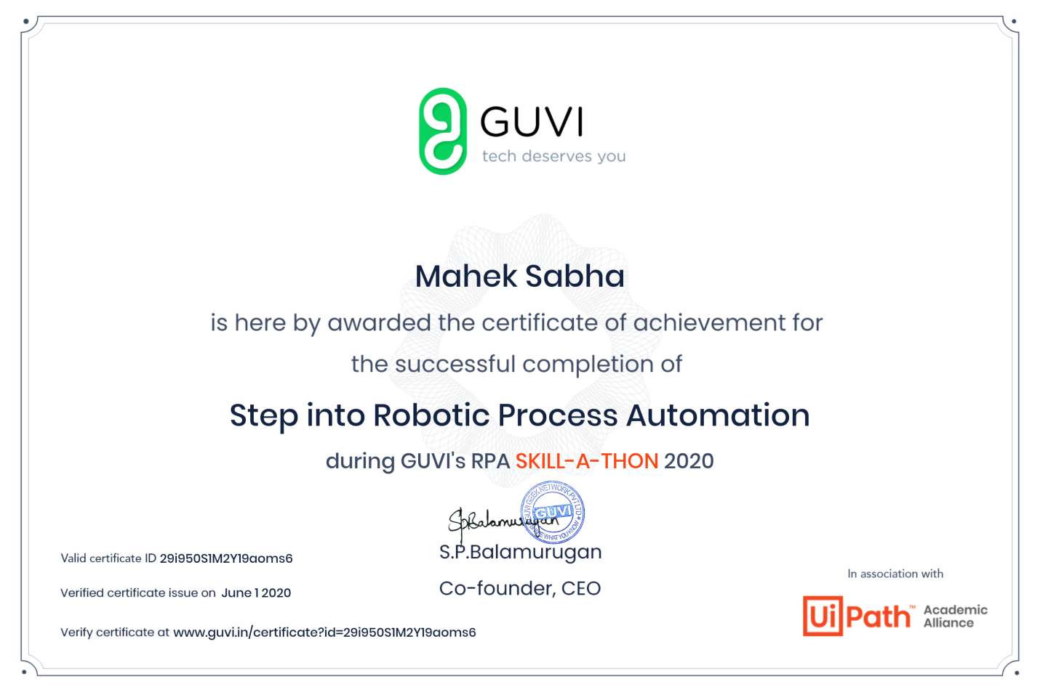

**Coding Challenges Details:**

<https://github.com/maheksa1234/Daily-Status/tree/master/Online%20Coding/June-1-6-2020>

The same report is also available in :

<https://github.com/maheksa1234/Daily-Status/tree/master/Online%20Coding>