**DAILY ONLINE ACTIVITIES SUMMARY**

|  |  |  |  |  |  |  |  |  |
| --- | --- | --- | --- | --- | --- | --- | --- | --- |
| **Date:** | **26/05/2020** | | | | | **Name:** | **MAHEK SABHA** | |
| **Sem & Sec** | **VI ,A sec** | | | | | **USN:** | **4AL17CS051** | |
| **Online Test Summary** | | | | | | | | |
| **Subject** | | **CGV-2** | | | | | | |
| **Max. Marks** | | **30** | | **Score** | | | **22** | |
| **Certification Course Summary** | | | | | | | | |
| **Course** | **MACHINE LEARNING WITH PYTHON** | | | | | | | |
| **Certificate Provider** | | | **Saeed Aghabozorgi** | | **Duration** | | | **6hrs** |
| **Coding Challenges** | | | | | | | | |
| **Problem Statement:**  1. This is a Python Program to read a number n and print and compute the series “1+2+…+n=”.  2. Python Program to Count the Number of Digits in a Number  3. Python Program to Check if a Number is a Palindrome  4. Python Program to Print all Integers that Aren’t Divisible by Either 2 or 3 and Lie between 1 and 50  5. Given an array A of size N where the array elements contain values from 1 to N with duplicates, the task is to find total number of subarrays which start and end with the same element  6. Write a program in C to print all permutations of a given string using pointers | | | | | | | | |
| **Status:completed** | | | | | | | | |
| **Uploaded the report in Github** | | | | | **Yes** | | | |
| **If yes Repository name** | | | | | <https://github.com/maheksa1234/Daily-Status> | | | |
| **Uploaded the report in slack** | | | | | **Yes** | | | |

**Online Test Details:**

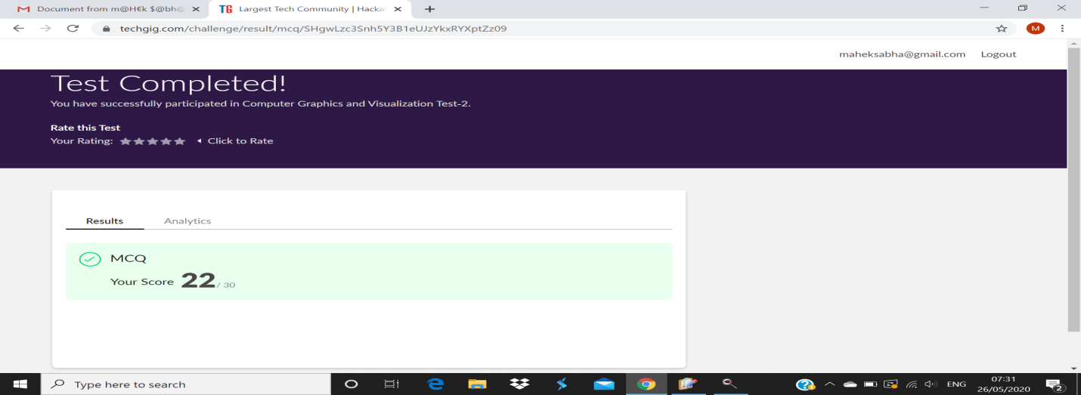

**Certification Course Details:**

Refer GitHub account for Detailed information:

<https://github.com/maheksa1234/Daily-Status/tree/master/Certification%20Course>

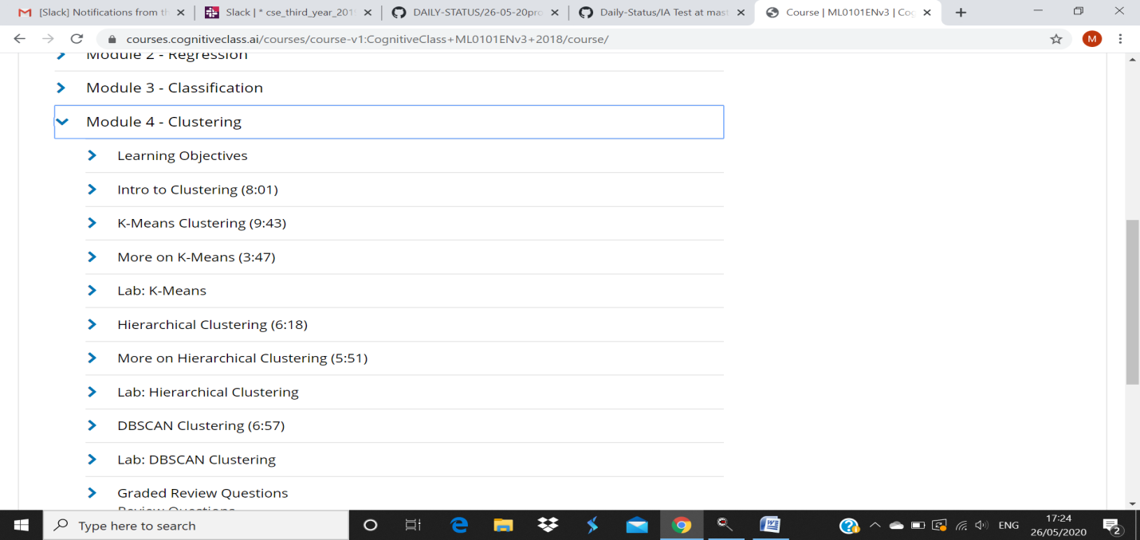

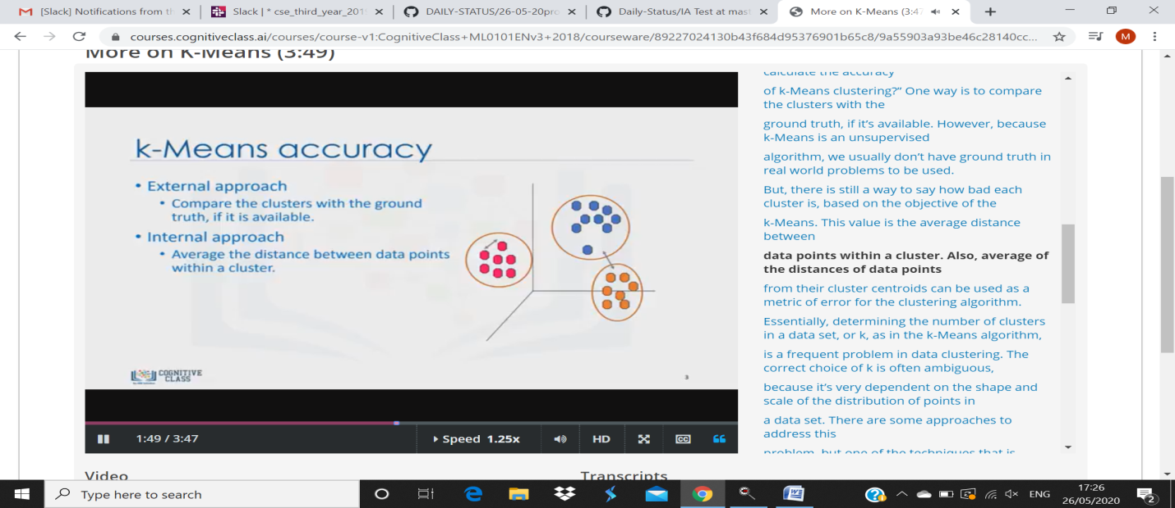

**Coding Challenges Details:**

<https://github.com/maheksa1234/Daily-Status/tree/master/Online%20Coding/26-5-2020>

The same report is also available in :

<https://github.com/maheksa1234/Daily-Status/tree/master/Online%20Coding>