**DAILY ONLINE ACTIVITIES SUMMARY**

|  |  |  |  |  |  |  |  |  |
| --- | --- | --- | --- | --- | --- | --- | --- | --- |
| **Date:** | **27/05/2020** | | | | | **Name:** | **MAHEK SABHA** | |
| **Sem & Sec** | **VI ,A sec** | | | | | **USN:** | **4AL17CS051** | |
| **Online Test Summary** | | | | | | | | |
| **Subject** | | **SSCD-2** | | | | | | |
| **Max. Marks** | | **30** | | **Score** | | | **15** | |
| **Certification Course Summary** | | | | | | | | |
| **Course** | **MACHINE LEARNING WITH PYTHON** | | | | | | | |
| **Certificate Provider** | | | **Saeed Aghabozorgi** | | **Duration** | | | **4hrs** |
| **Coding Challenges** | | | | | | | | |
| **Problem Statement:**  1. Given an array arr[] of the positive integers of size N, the task is to find the largest element on the left side of each index which is smaller than the element present at that index. Note: If no such element is found then print -1.  2. Write a Java program to implement Binary Tree using the Linked List  3. Write a C Program to sort an array of integers in ascending order and display the sorted array and Number of passes performed for sorting | | | | | | | | |
| **Status:completed** | | | | | | | | |
| **Uploaded the report in Github** | | | | | **Yes** | | | |
| **If yes Repository name** | | | | | <https://github.com/maheksa1234/Daily-Status> | | | |
| **Uploaded the report in slack** | | | | | **Yes** | | | |

**Online Test Details:**

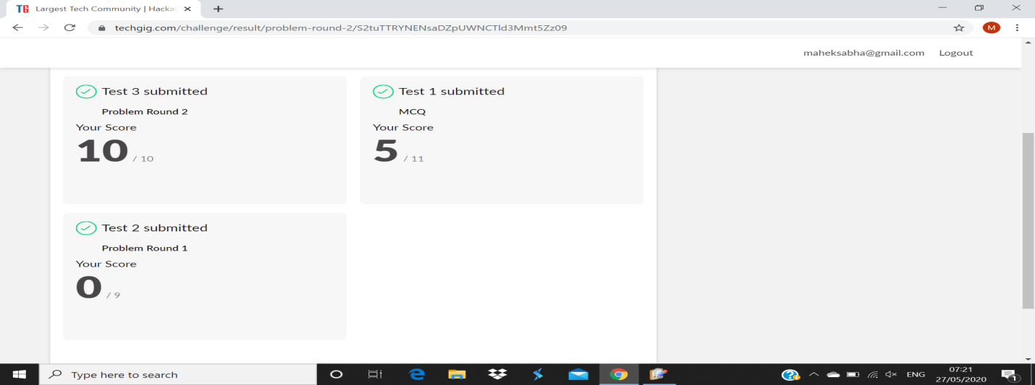

**Certification Course Details:**

Refer GitHub account for Detailed information:

<https://github.com/maheksa1234/Daily-Status/tree/master/Certification%20Course>

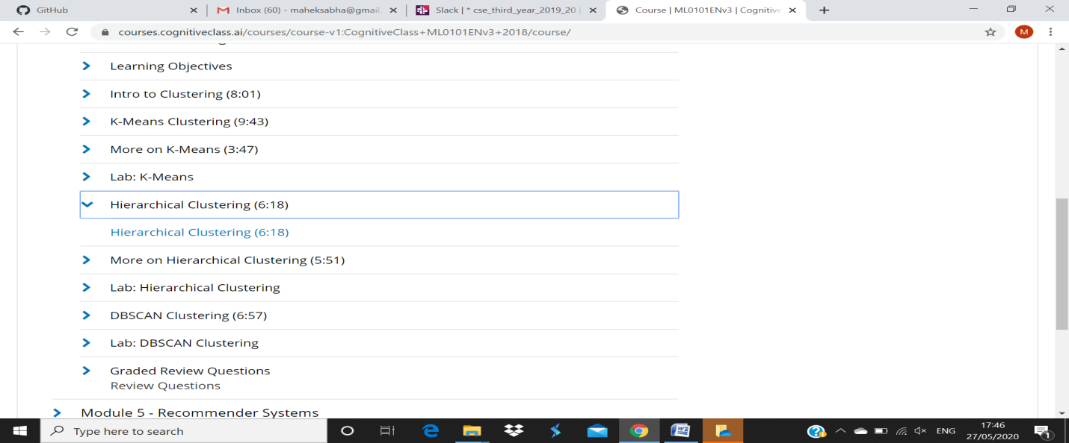

**Module 4: hierarchical clustering –**

**DBSCAN clustering**

The maximum distance between two samples for one to be considered as in the neighborhood of the other. This is not a maximum bound on the distances of points within a cluster. This is the most important DBSCAN parameter to choose appropriately for your data set and distance function.

**Coding Challenges Details:**

<https://github.com/maheksa1234/Daily-Status/tree/master/Online%20Coding/27-5-2020>

The same report is also available in :

<https://github.com/maheksa1234/Daily-Status/tree/master/Online%20Coding>