**DAILY ONLINE ACTIVITIES SUMMARY**

|  |  |  |  |  |  |  |  |  |
| --- | --- | --- | --- | --- | --- | --- | --- | --- |
| **Date:** | **28/05/2020** | | | | | **Name:** | **MAHEK SABHA** | |
| **Sem & Sec** | **VI ,A sec** | | | | | **USN:** | **4AL17CS051** | |
| **Online Test Summary** | | | | | | | | |
| **Subject** | | **OS-2** | | | | | | |
| **Max. Marks** | | **30** | | **Score** | | | **22** | |
| **Certification Course Summary** | | | | | | | | |
| **Course** | **MACHINE LEARNING WITH PYTHON** | | | | | | | |
| **Certificate Provider** | | | **Saeed Aghabozorgi** | | **Duration** | | | **3hrs** |
| **Coding Challenges** | | | | | | | | |
| **Problem Statement:**  1.Python program to find digital root of a number.  2. Write a function that accepts a string consisting entering of brackets ({}) and returns whether it is balanced.  3. write jsp code to display today’s date and time using expression tag  4. write jsp script to determine how many times the visitor has loaded the page  5. Given an array arr[] of size N and an integer K. The task is to find the last remaining element in the array after reducing the array. | | | | | | | | |
| **Status: completed** | | | | | | | | |
| **Uploaded the report in Github** | | | | | **Yes** | | | |
| **If yes Repository name** | | | | | <https://github.com/maheksa1234/Daily-Status> | | | |
| **Uploaded the report in slack** | | | | | **Yes** | | | |

**Online Test Details:**

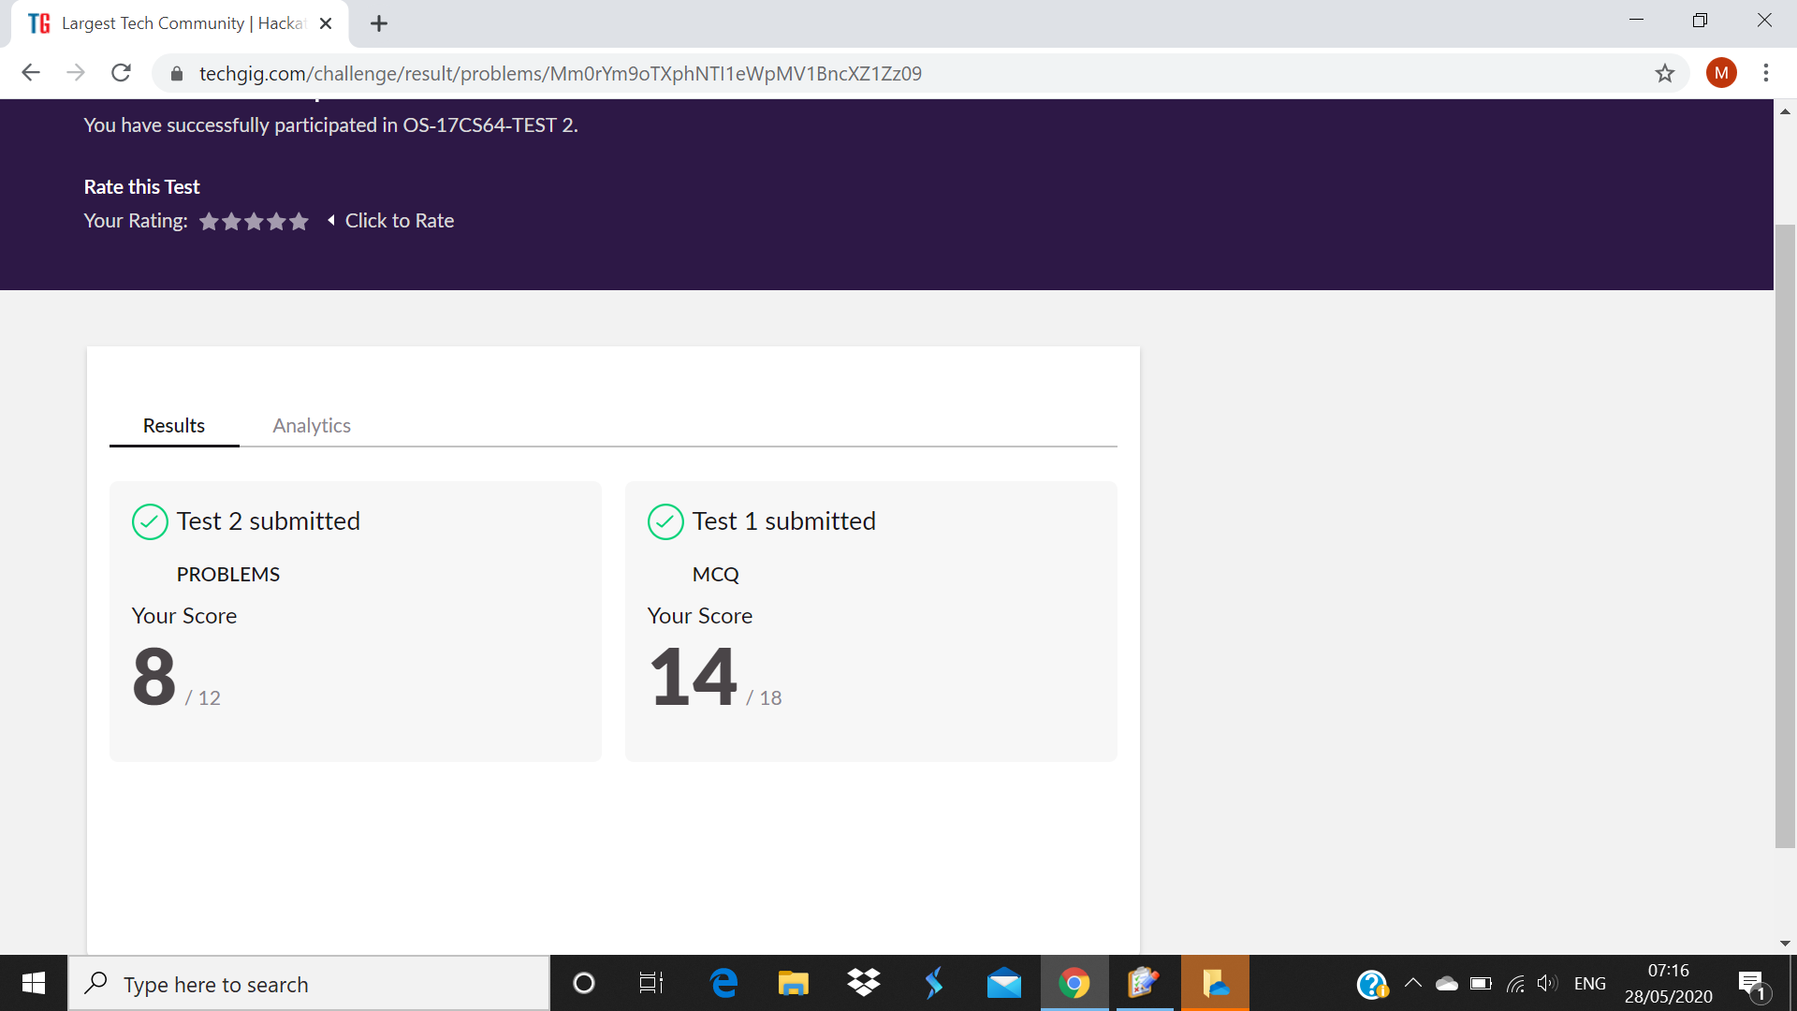

**Certification Course Details:**

Refer GitHub account for Detailed information:

<https://github.com/maheksa1234/Daily-Status/tree/master/Certification%20Course>

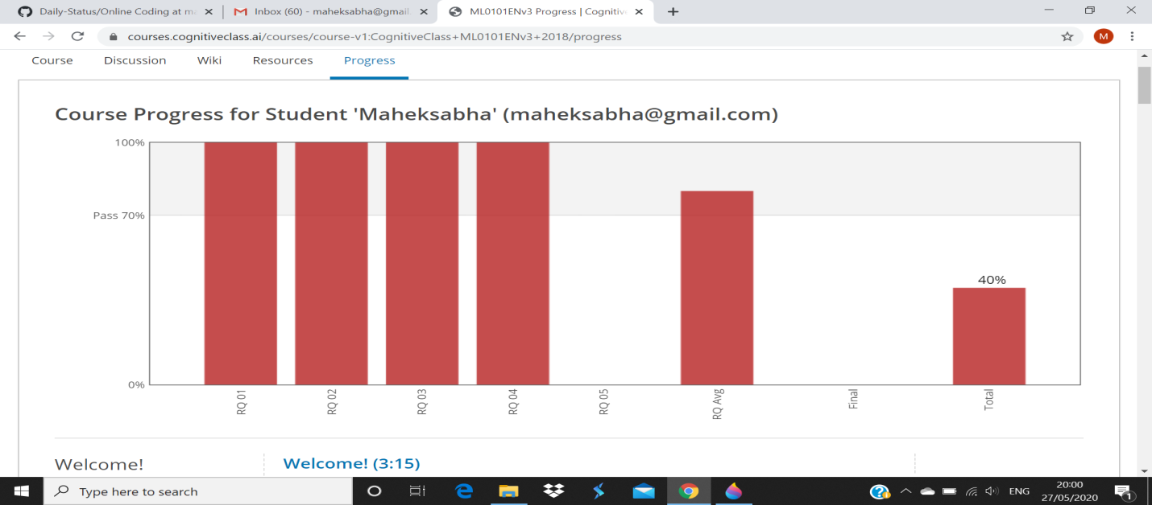

**Coding Challenges Details:**

<https://github.com/maheksa1234/Daily-Status/tree/master/Online%20Coding/28-5-2020>

The same report is also available in :

<https://github.com/maheksa1234/Daily-Status/tree/master/Online%20Coding>