**DAILY ONLINE ACTIVITIES SUMMARY**

|  |  |  |  |  |  |  |  |  |
| --- | --- | --- | --- | --- | --- | --- | --- | --- |
| **Date:** | **29/05/2020** | | | | | **Name:** | **MAHEK SABHA** | |
| **Sem & Sec** | **VI ,A sec** | | | | | **USN:** | **4AL17CS051** | |
| **Online Test Summary** | | | | | | | | |
| **Subject** | | **OR-2** | | | | | | |
| **Max. Marks** | | **30** | | **Score** | | | **30** | |
| **Certification Course Summary** | | | | | | | | |
| **Course** | **MACHINE LEARNING WITH PYTHON** | | | | | | | |
| **Certificate Provider** | | | **Saeed Aghabozorgi** | | **Duration** | | | **2 hrs** |
| **Coding Challenges** | | | | | | | | |
| **Problem Statement:**  **1. Write a python program to calculate the number of lowercase and uppercase letters in a string.**  **2. given these 3 strings write a function that detects whether str3 is a valid shuffle of str1 and str2.**  **3.write a c program to solve a system of linear congruences by applying the Chinese Remainder Theorem.**  **4.Write a Java Program to check whether the given number is Armstrong number or not. 5. Write a Java Program to find longest substring without repeating characters in a string.** | | | | | | | | |
| **Status: completed** | | | | | | | | |
| **Uploaded the report in Github** | | | | | **Yes** | | | |
| **If yes Repository name** | | | | | <https://github.com/maheksa1234/Daily-Status> | | | |
| **Uploaded the report in slack** | | | | | **Yes** | | | |

**Online Test Details:**

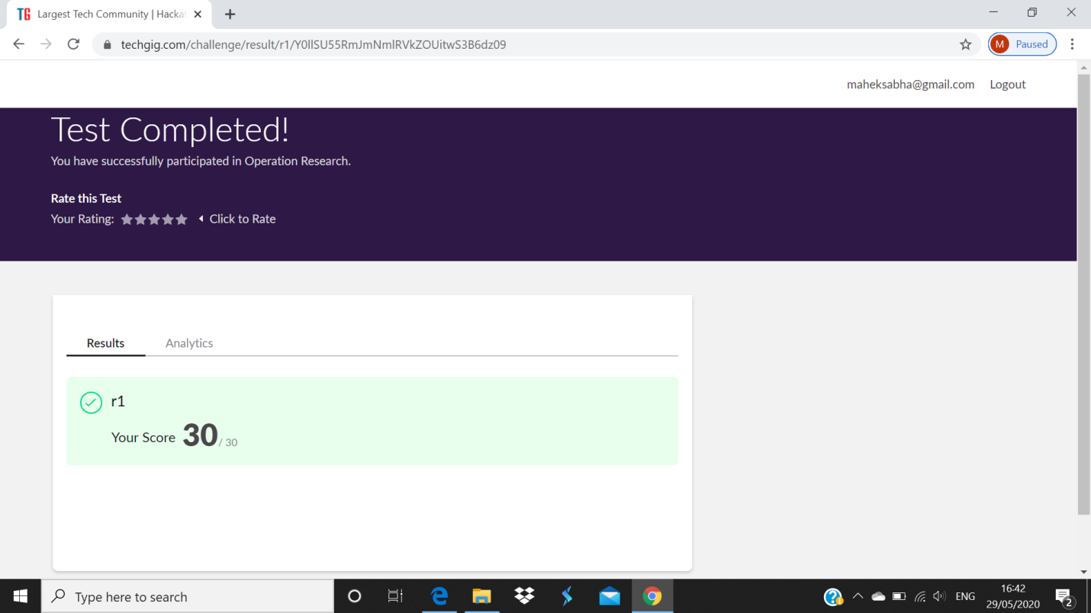

**Certification Course Details:**

Refer GitHub account for Detailed information:

<https://github.com/maheksa1234/Daily-Status>

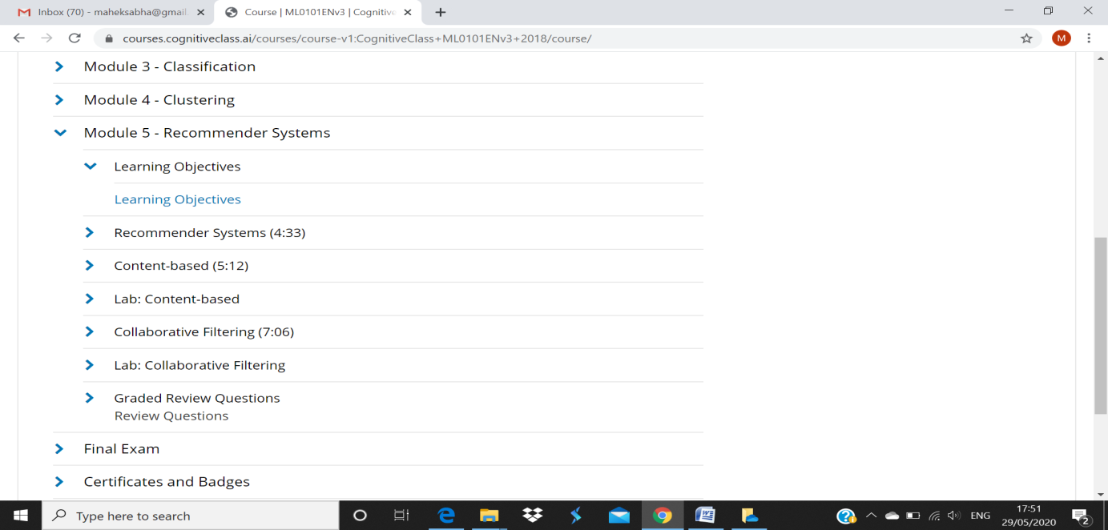

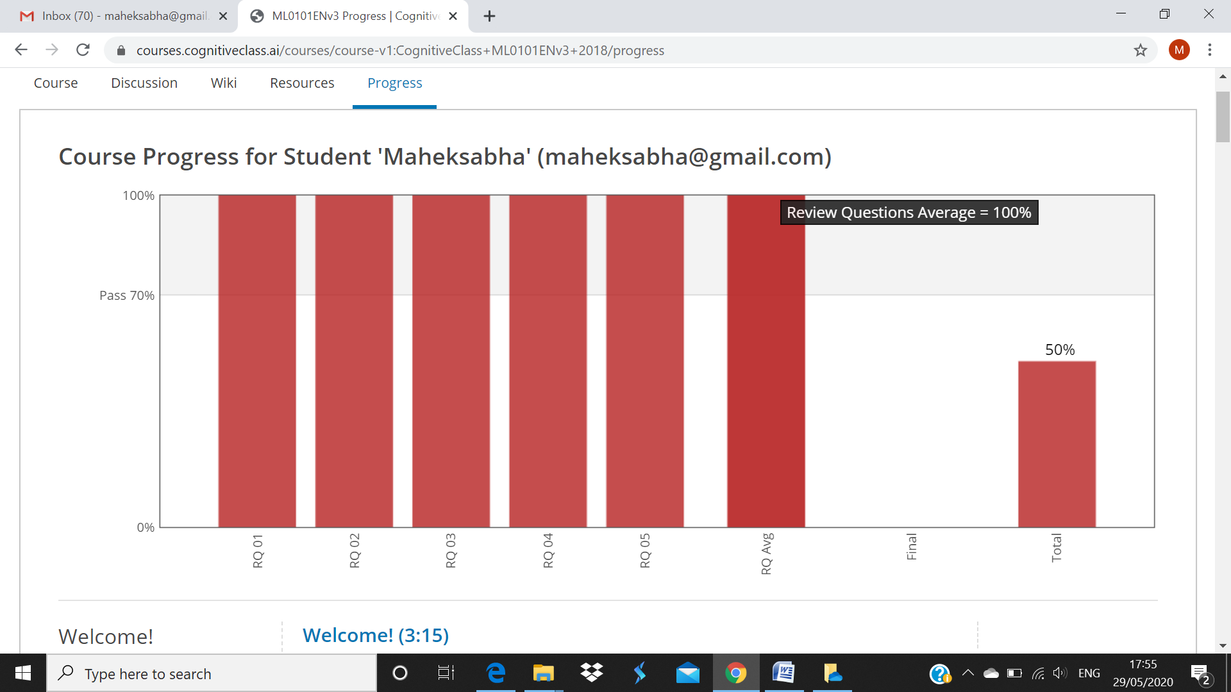

I solved the review question on module 5 and above screenshot is the progress of 5th module .

**Coding Challenges Details:**

<https://github.com/maheksa1234/Daily-Status/tree/master/Online%20Coding/29-5-2020>

The same report is also available in :

<https://github.com/maheksa1234/Daily-Status/tree/master/Online%20Coding>