**DAILY ONLINE ACTIVITIES SUMMARY**

|  |  |  |  |  |  |  |  |  |
| --- | --- | --- | --- | --- | --- | --- | --- | --- |
| **Date:** | **31/05/2020** | | | | | **Name:** | **MAHEK SABHA** | |
| **Sem & Sec** | **VI ,A sec** | | | | | **USN:** | **4AL17CS051** | |
| **Online Test Summary** | | | | | | | | |
| **Subject** | |  | | | | | | |
| **Max. Marks** | |  | | **Score** | | |  | |
| **Certification Course Summary** | | | | | | | | |
| **Course** | **GOOGLE DIGITAL UNLOCKED** | | | | | | | |
| **Certificate Provider** | | | **FICCI** | | **Duration** | | | **20 hrs** |
| **Coding Challenges** | | | | | | | | |
| **Problem Statement:**  1. Write a c program to convert decimal number to binary.  2. Write a c program to print alphabet triangle.  3. Write a python program to print the multiplication table of number. | | | | | | | | |
| **Status:completed** | | | | | | | | |
| **Uploaded the report in Github** | | | | | **Yes** | | | |
| **If yes Repository name** | | | | | <https://github.com/maheksa1234/Daily-Status> | | | |
| **Uploaded the report in slack** | | | | | **Yes** | | | |

**Online Test Details:**

**Certification Course Details:**

Refer GitHub account for Detailed information:

<https://github.com/maheksa1234/Daily-Status>

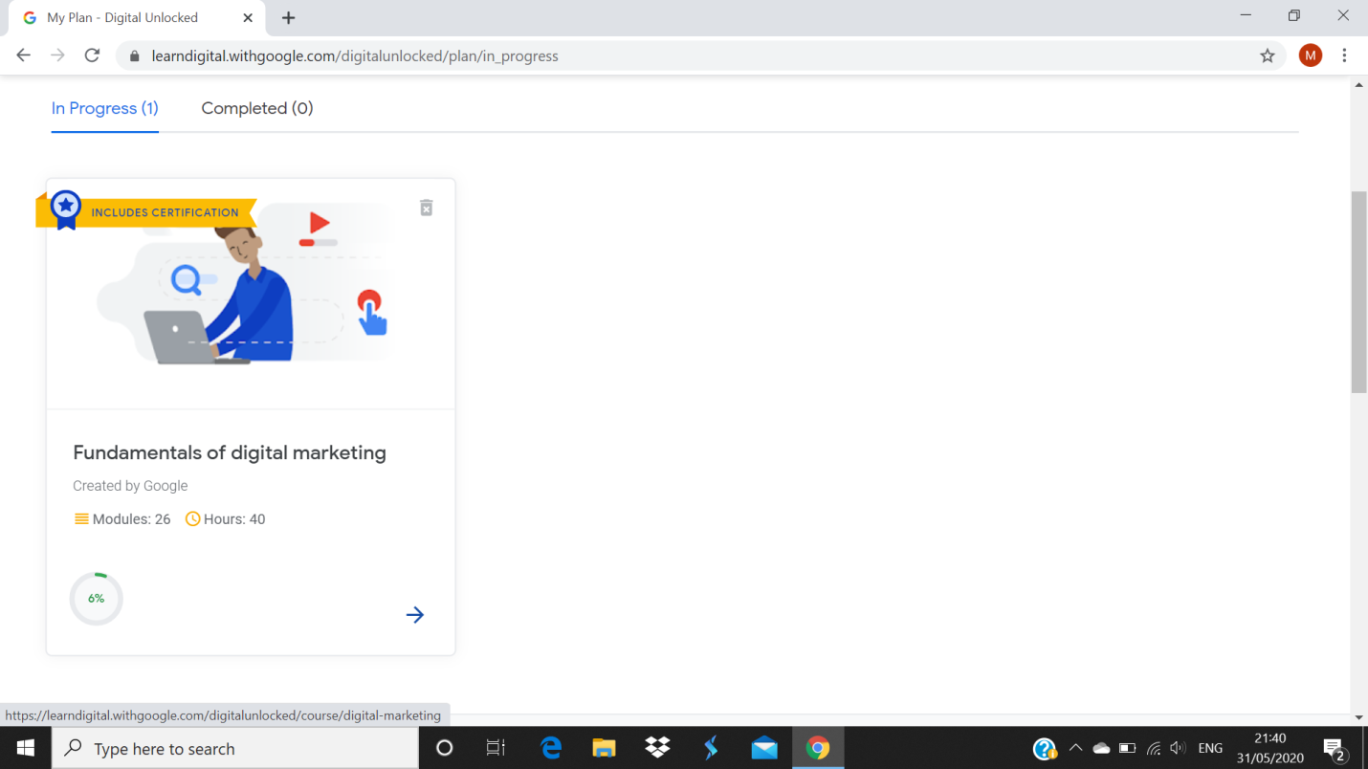

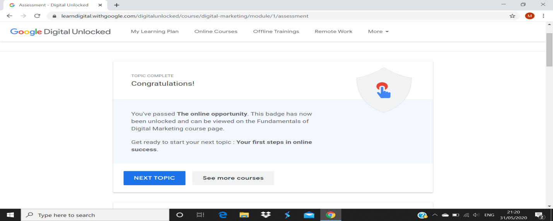

**Coding Challenges Details:**

<https://github.com/maheksa1234/Daily-Status/tree/master/Online%20Coding/31-5-2020>

The same report is also available in :

<https://github.com/maheksa1234/Daily-Status/tree/master/Online%20Coding>