**DAILY ONLINE ACTIVITIES SUMMARY**

|  |  |  |  |  |  |  |  |  |
| --- | --- | --- | --- | --- | --- | --- | --- | --- |
| **Date:** | **08/07/2020** | | | | | **Name:** | **MAHEK SABHA** | |
| **Sem & Sec** | **VI & A sec** | | | | | **USN:** | **4AL17CS051** | |
| **Online Test Summary** | | | | | | | | |
| **Subject** | | **Cloud and Infrastructure Management** | | | | | | |
| **Max. Marks** | | **-** | | **Score** | | | **-** | |
| **Course Summary** | | | | | | | | |
| **Course** | **Blockchain Basics** | | | | | | | |
| **Certificate Provider** | | | **-** | | **Duration** | | | **-** |
| **Coding Challenges** | | | | | | | | |
| **Problem Statement:**  **1.Write a python program for find sum of odd factors of a number.**     |  |  | | --- | --- | |  |  |  |  |  | | --- | --- | |  |  | | | | | | | | | |
| **Status: completed** | | | | | | | | |
| **Uploaded the report in Github** | | | | | **Yes** | | | |
| **If yes Repository name** | | | | | <https://github.com/maheksa1234/Daily-Status> | | | |
| **Uploaded the report in slack** | | | | | **Yes** | | | |

**Cloud and Infrastructure Management:**

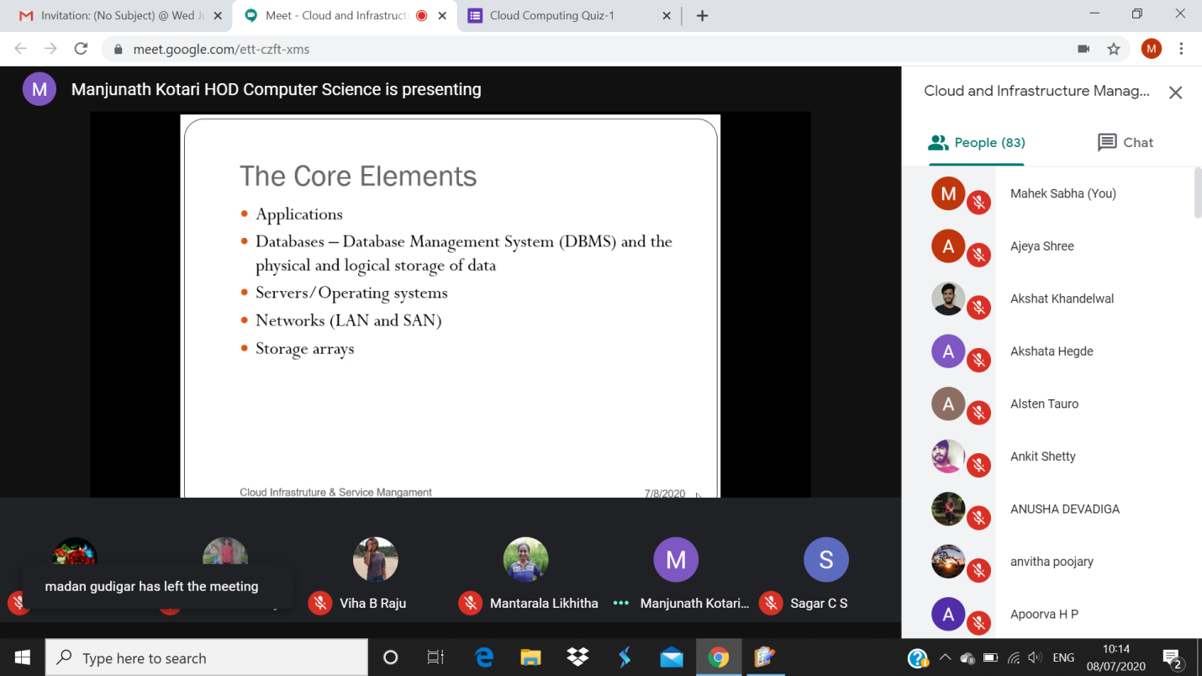

**Quiz snapshots:**

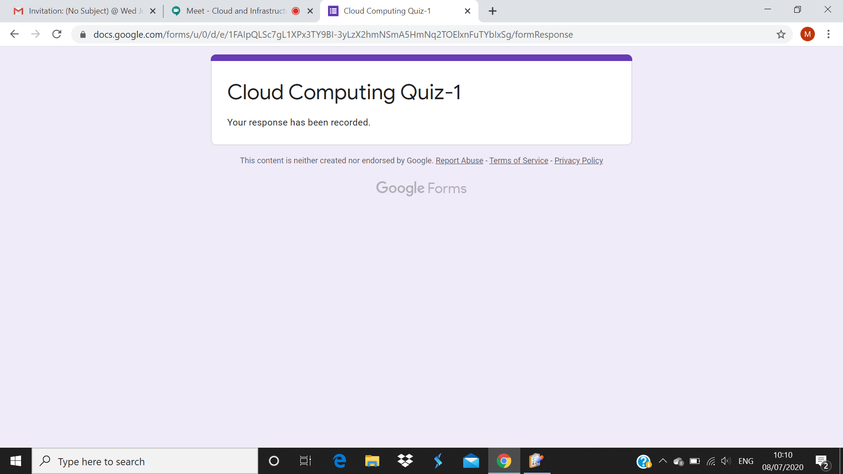

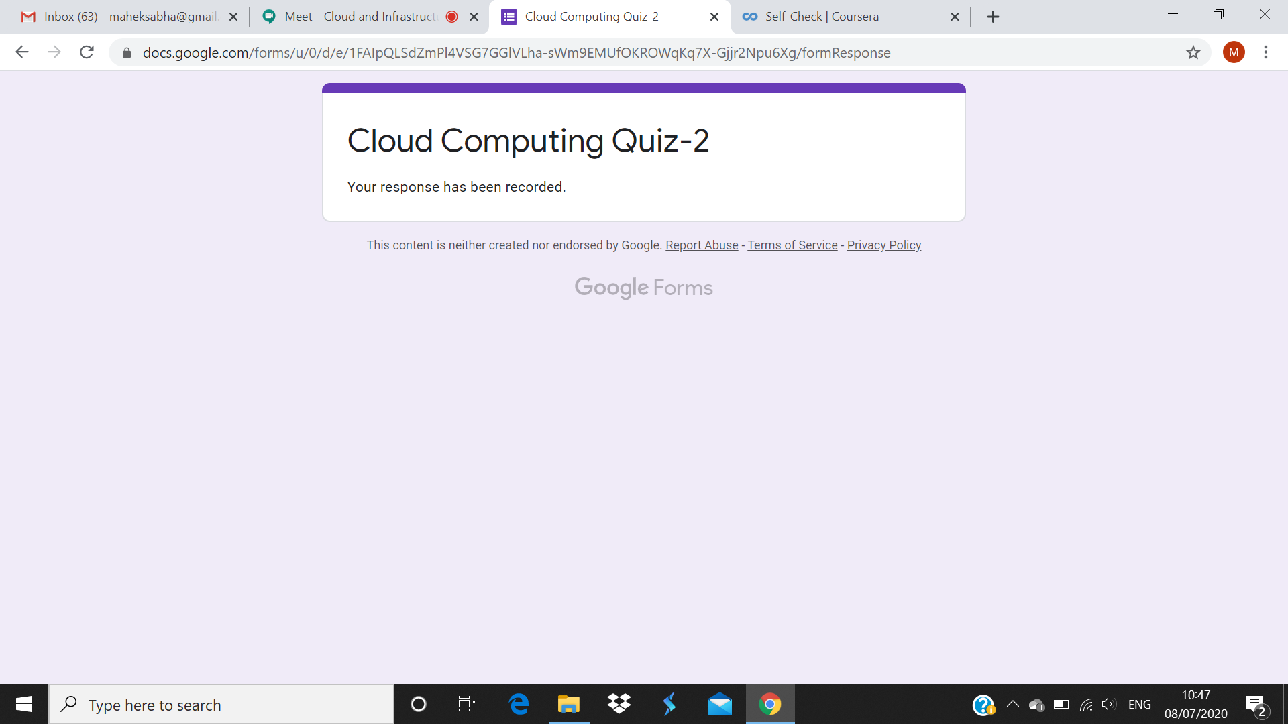

**Blockchain Basics:**

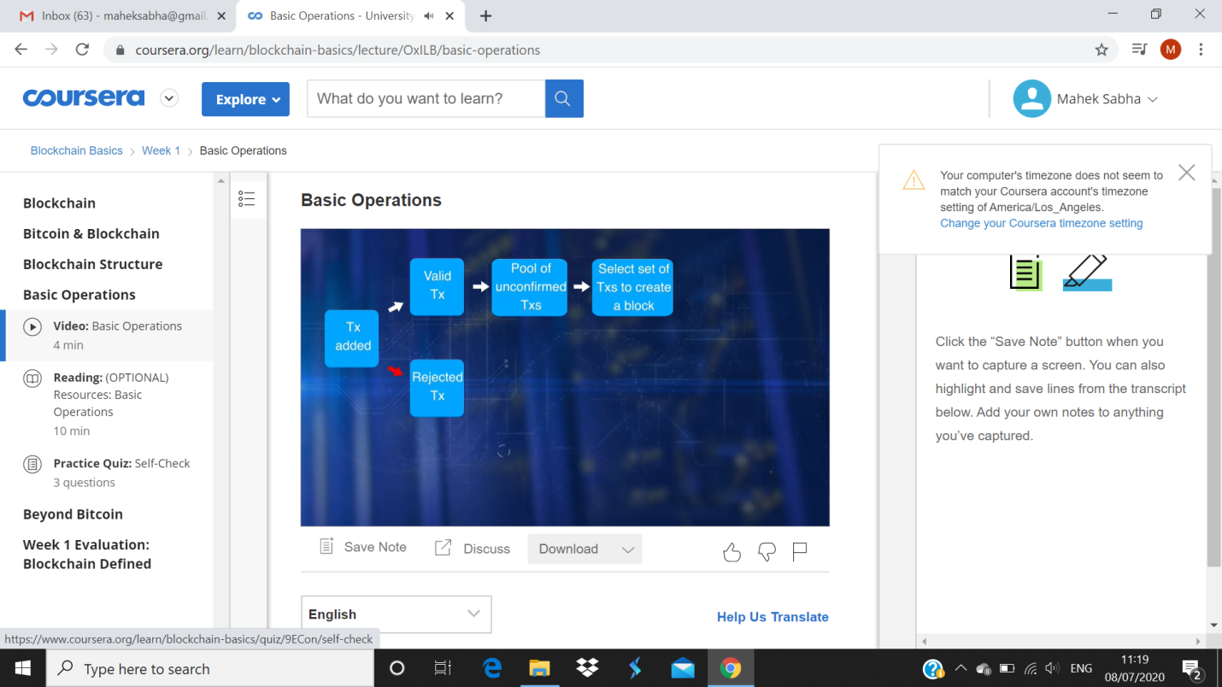

**Test snapshot:**

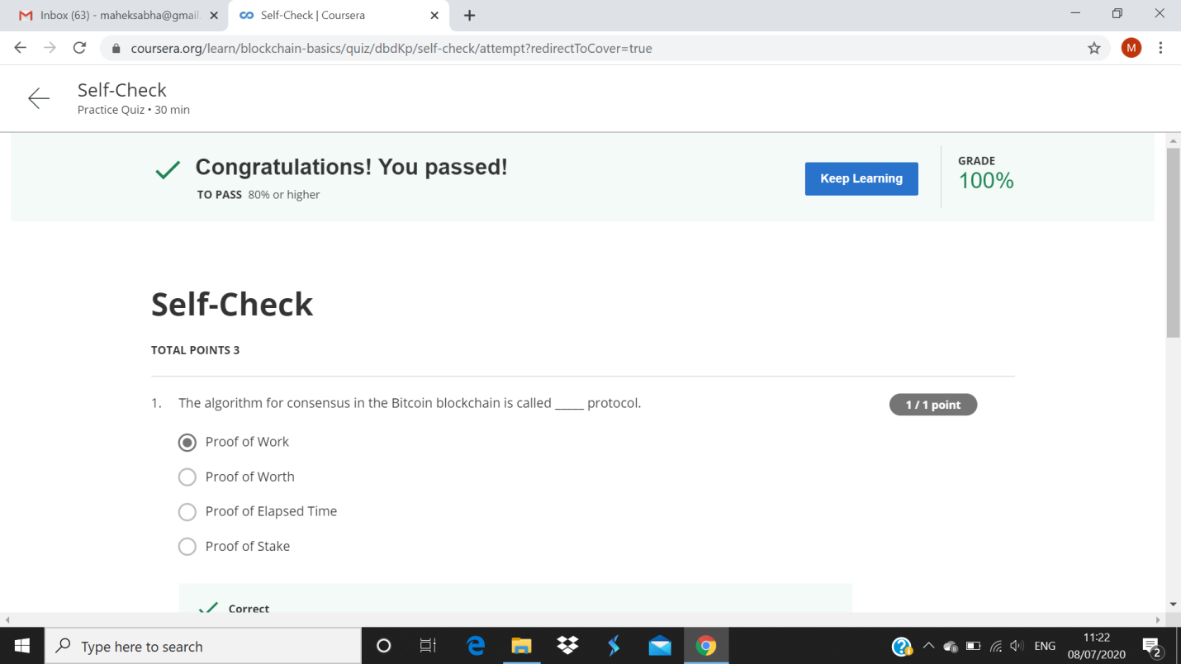

**Coding Challenges Details:**

<https://github.com/maheksa1234/Daily-Status/tree/master/Online%20Coding/July-8-7-2020>

The same report is also available in :

<https://github.com/maheksa1234/Daily-Status/tree/master/Online%20Coding>