**DAILY ONLINE ACTIVITIES SUMMARY**

|  |  |  |  |  |  |  |  |  |
| --- | --- | --- | --- | --- | --- | --- | --- | --- |
| **Date:** | **10/06/2020** | | | | | **Name:** | **MAHEK SABHA** | |
| **Sem & Sec** | **VI & A sec** | | | | | **USN:** | **4AL17CS051** | |
| **Online Test Summary** | | | | | | | | |
| **Subject** | | **SSCD-4** | | | | | | |
| **Max. Marks** | | **30** | | **Score** | | | **28** | |
| **Certification Course Summary** | | | | | | | | |
| **Course** | Cognitiveclass: **Python for Data Science** | | | | | | | |
| **Certificate Provider** | | | **IBM** | | **Duration** | | | **4 hrs** |
| **Coding Challenges** | | | | | | | | |
| **Problem Statement:**   1. Write a C Program to print the sum of boundary elements of a matrix 2. Write a Java program to find the maximum and minimum value node from a circular linked list 3. Python Program to check whether a given number is a fibonacci number or not | | | | | | | | |
| **Status: completed** | | | | | | | | |
| **Uploaded the report in Github** | | | | | **Yes** | | | |
| **If yes Repository name** | | | | | <https://github.com/maheksa1234/Daily-Status> | | | |
| **Uploaded the report in slack** | | | | | **Yes** | | | |

**Online Test Details:**

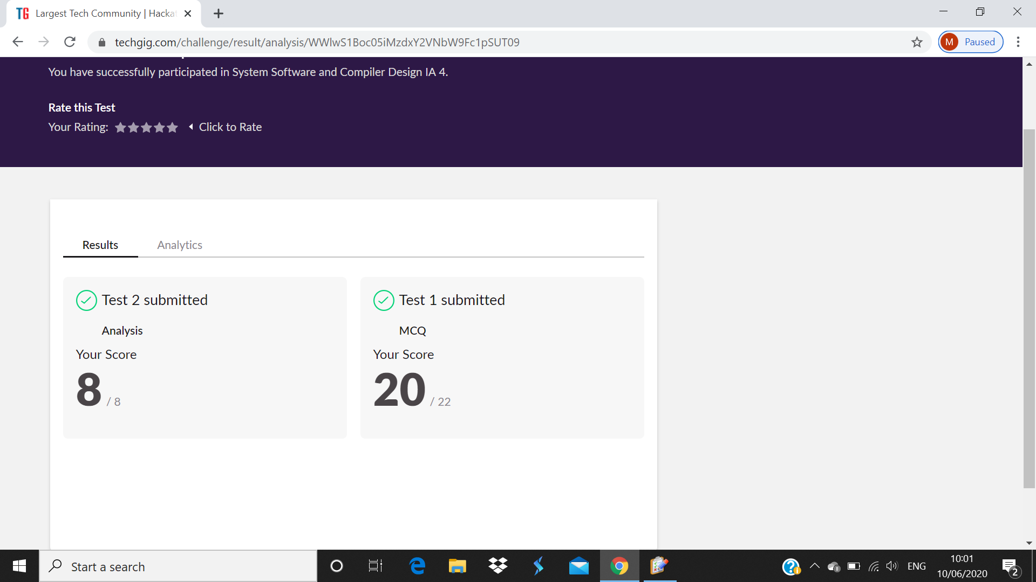

**Certification Course Details:**

Refer GitHub account for Detailed information:

<https://github.com/maheksa1234/Daily-Status>

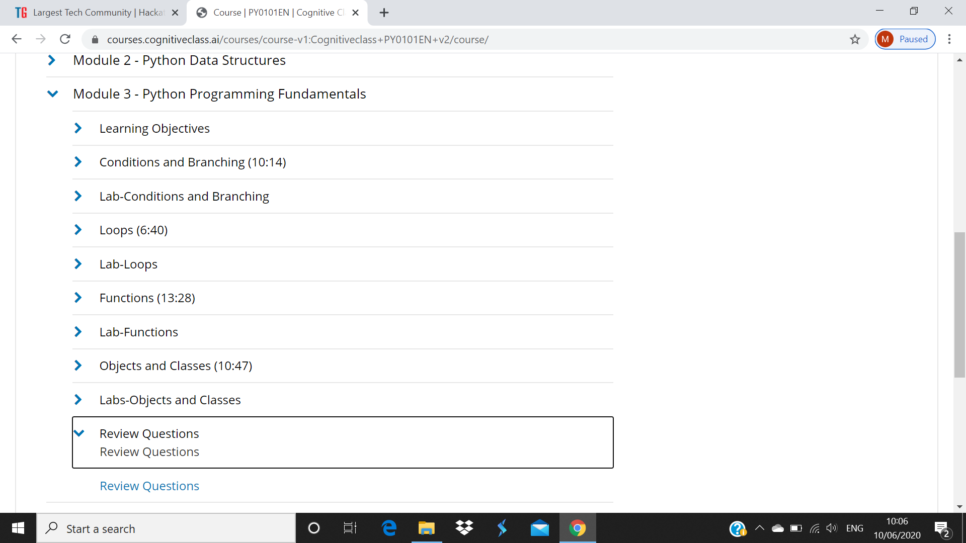

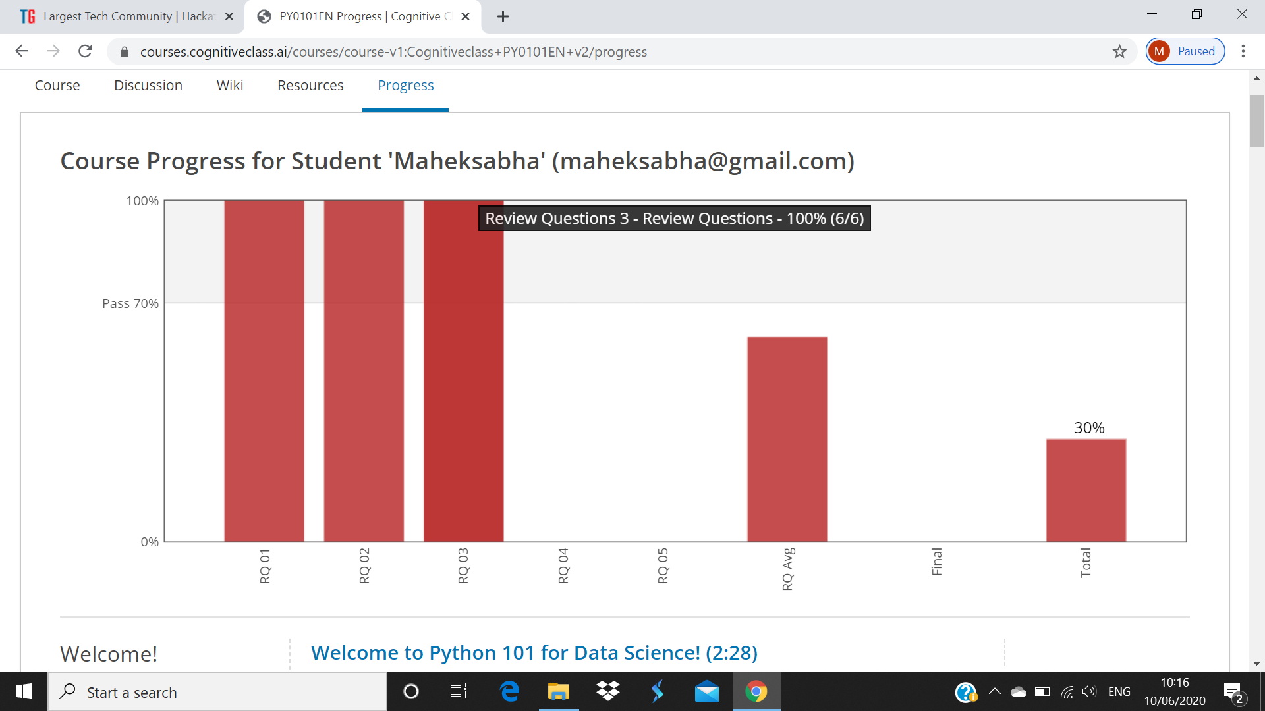

I solved the review question on module 3 and above screenshot is the progress of 3rd module .

**Coding Challenges Details:**

<https://github.com/maheksa1234/Daily-Status/tree/master/Online%20Coding/June-10-6-2020>

The same report is also available in :

<https://github.com/maheksa1234/Daily-Status/tree/master/Online%20Coding>