**DAILY ONLINE ACTIVITIES SUMMARY**

|  |  |  |  |  |  |  |  |  |
| --- | --- | --- | --- | --- | --- | --- | --- | --- |
| **Date:** | **15/06/2020** | | | | | **Name:** | **MAHEK SABHA** | |
| **Sem & Sec** | **VI & A sec** | | | | | **USN:** | **4AL17CS051** | |
| **Pre placement training Summary** | | | | | | | | |
| **Pre placement training** | | **9:00 am to 11:00 am - Programming in C**  **11:00 am to 1:00pm - Applications of python in DA and ML** | | | | | | |
| **Max. Marks** | | **-** | | **Score** | | | **-** | |
| **Certification Course Summary** | | | | | | | | |
| **Course** | 1.Cognitiveclass: **Python for Data Science**  2.Workshop exercise solving | | | | | | | |
| **Certificate Provider** | | | **IBM** | | **Duration** | | | **1hrs** |
| **Coding Challenges** | | | | | | | | |
| **Problem Statement:**   1. Write a Java Program to Find the Middle Node of a Linked list in a Single-pass   2.Write a C program to count distinct elements in an array.   |  |  | | --- | --- | |  |  |  |  |  | | --- | --- | |  |  | | | | | | | | | |
| **Status: completed** | | | | | | | | |
| **Uploaded the report in Github** | | | | | **Yes** | | | |
| **If yes Repository name** | | | | | <https://github.com/maheksa1234/Daily-Status> | | | |
| **Uploaded the report in slack** | | | | | **Yes** | | | |

**Quiz Snapshots:**

**Programming in C Quiz**

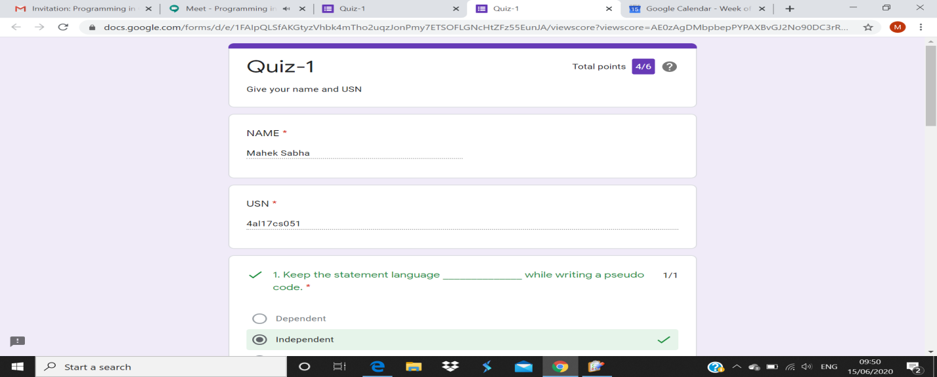

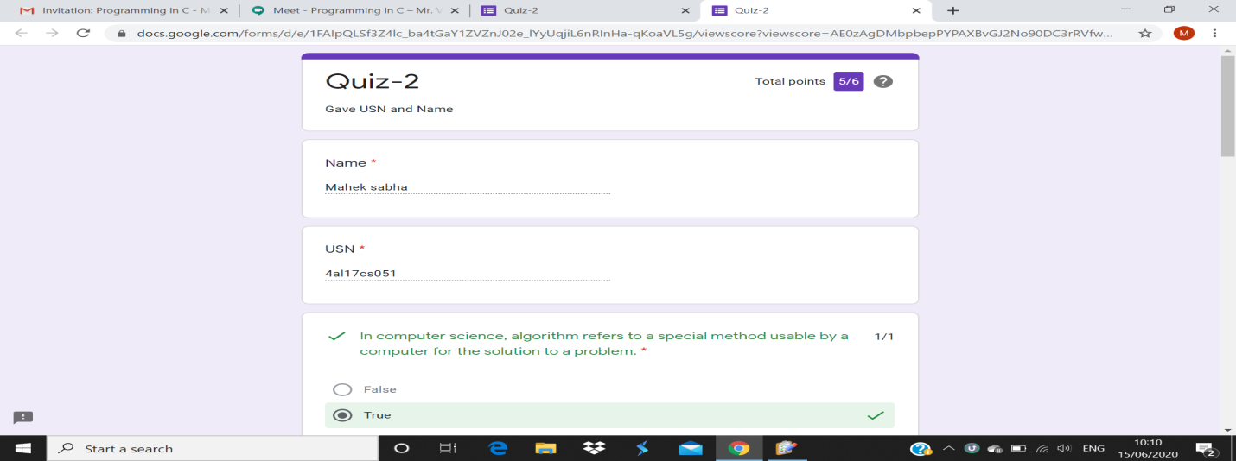 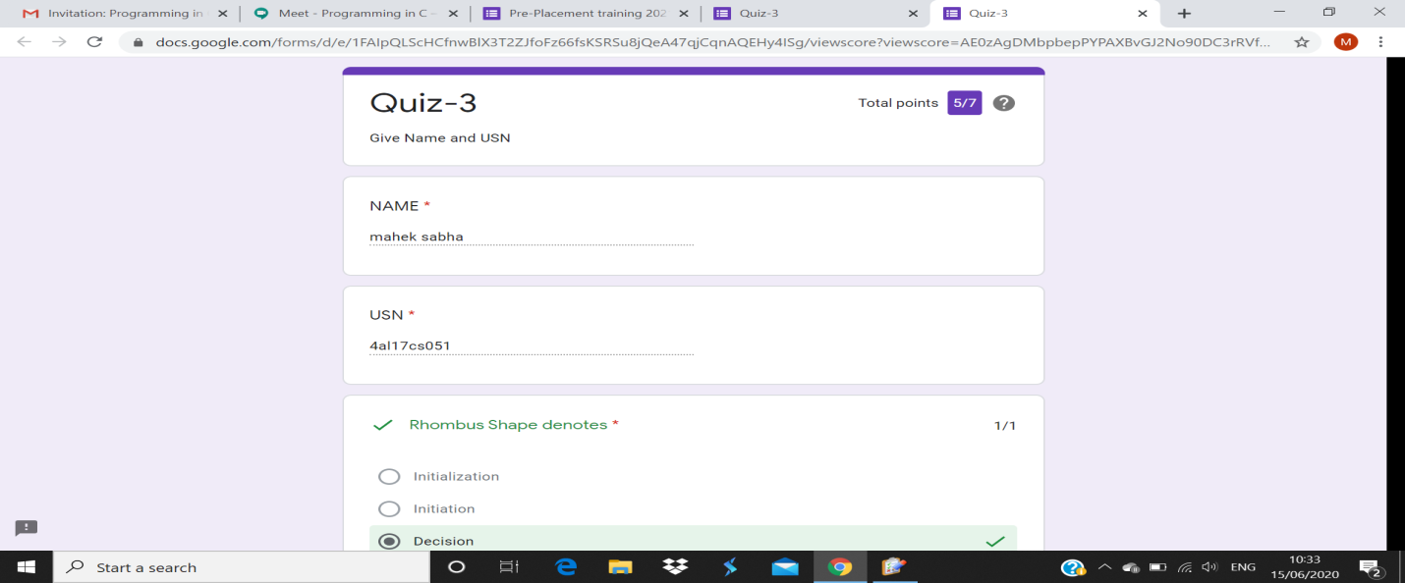

**Python workshop quiz**

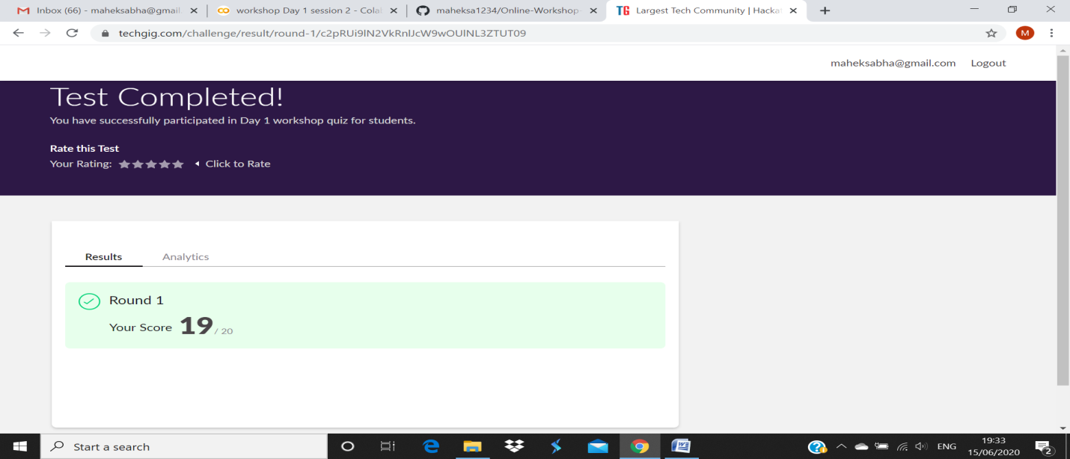

Refer the github link for example programs and exercise programs: <https://github.com/maheksa1234/Online-Workshop-Applications-of-Python-programming>

**Certification Course Details:**

Refer GitHub account for Detailed information:

<https://github.com/maheksa1234/Daily-Status>

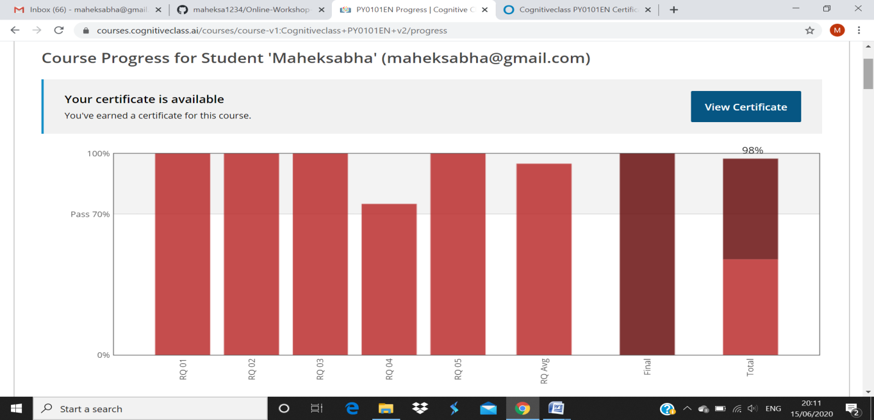

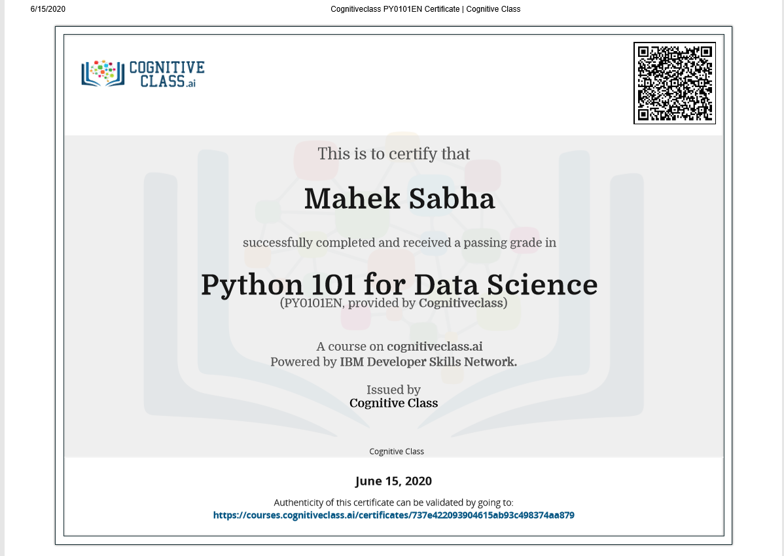

**Coding Challenges Details:**

<https://github.com/maheksa1234/Daily-Status/tree/master/Online%20Coding/June-15-6-2020>

The same report is also available in :

<https://github.com/maheksa1234/Daily-Status/tree/master/Online%20Coding>