**DAILY ONLINE ACTIVITIES SUMMARY**

|  |  |  |  |  |  |  |  |  |
| --- | --- | --- | --- | --- | --- | --- | --- | --- |
| **Date:** | **19/06/2020** | | | | | **Name:** | **MAHEK SABHA** | |
| **Sem & Sec** | **VI & A sec** | | | | | **USN:** | **4AL17CS051** | |
| **Pre placement training Summary** | | | | | | | | |
| **Pre placement training** | | **Programming in C &**  **Applications of python in DA and ML** | | | | | | |
| **Max. Marks** | | **-** | | **Score** | | | **-** | |
| **Course Summary** | | | | | | | | |
| **Course** | Workshop exercise solving | | | | | | | |
| **Certificate Provider** | | | **-** | | **Duration** | | | **-** |
| **Coding Challenges** | | | | | | | | |
| **Problem Statement:**   1. Write a C Program to rotate a Matrix by 90 Degree in Clockwise or Anticlockwise Direction 2. swap 2 numbers using pointers 3. Write a Java program to create a doubly linked list of n nodes and display it in reverse order      |  |  | | --- | --- | |  |  |  |  |  | | --- | --- | |  |  | | | | | | | | | |
| **Status: completed** | | | | | | | | |
| **Uploaded the report in Github** | | | | | **Yes** | | | |
| **If yes Repository name** | | | | | <https://github.com/maheksa1234/Daily-Status> | | | |
| **Uploaded the report in slack** | | | | | **Yes** | | | |

**Programming in C**

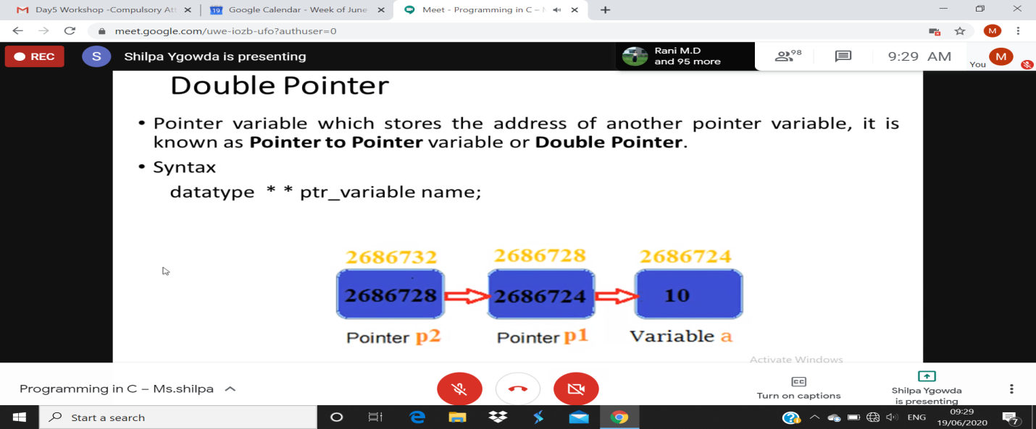

**Quiz Snapshots:**

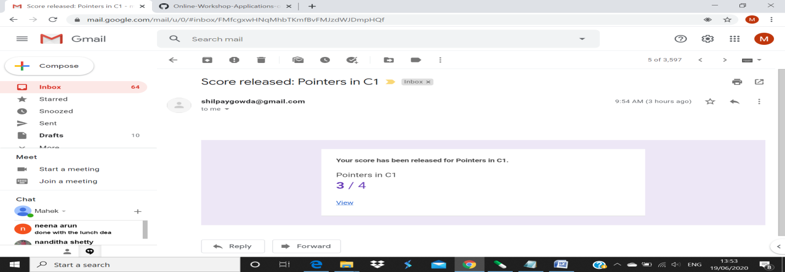

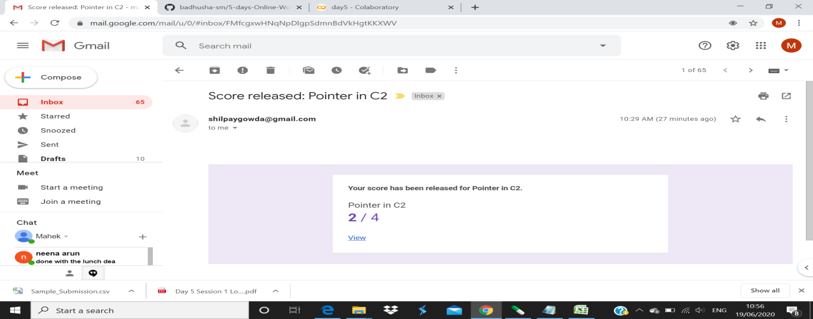

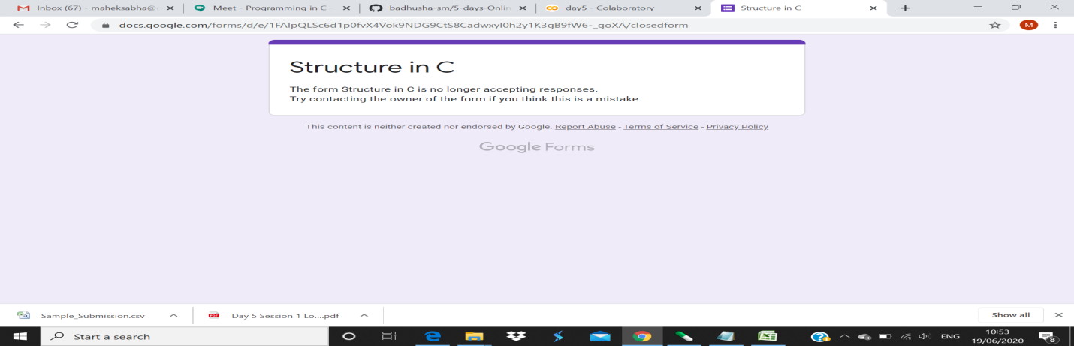

**Applications of python in DA and ML**

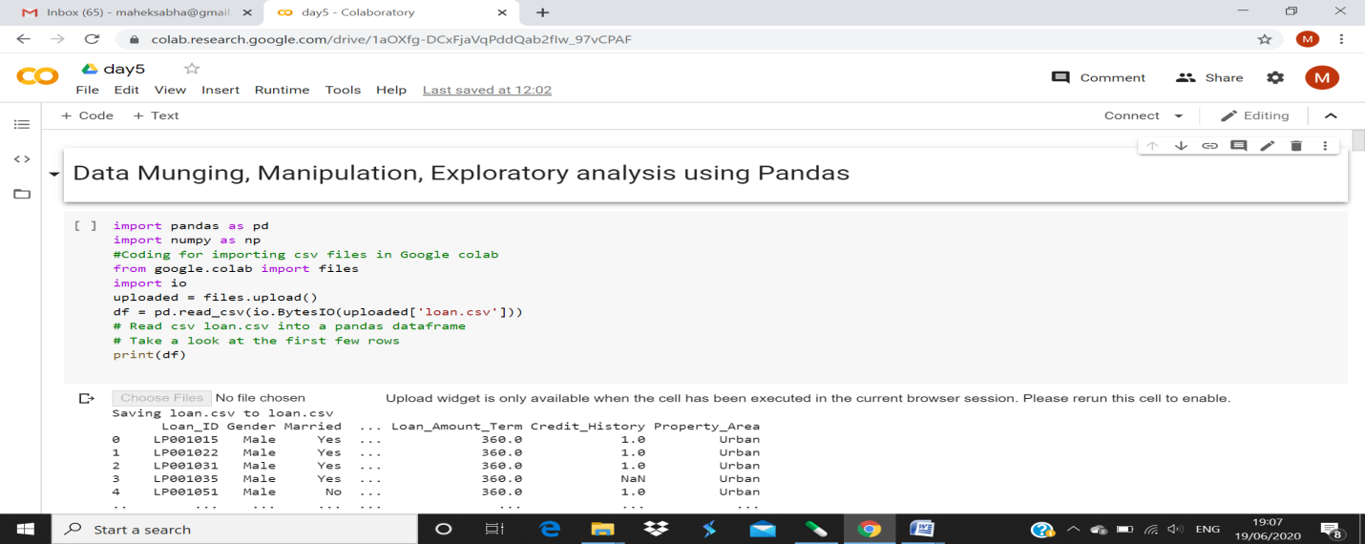

**Refer the github link for example programs and exercise programs:**

<https://github.com/maheksa1234/Online-Workshop-Applications-of-Python-programming>

**Coding Challenges Details:**

<https://github.com/maheksa1234/Daily-Status/tree/master/Online%20Coding/June-19-6-2020>

The same report is also available in :

<https://github.com/maheksa1234/Daily-Status/tree/master/Online%20Coding>