**DAILY ONLINE ACTIVITIES SUMMARY**

|  |  |  |  |  |  |  |  |  |
| --- | --- | --- | --- | --- | --- | --- | --- | --- |
| **Date:** | **23/06/2020** | | | | | **Name:** | **MAHEK SABHA** | |
| **Sem & Sec** | **VI & A sec** | | | | | **USN:** | **4AL17CS051** | |
| **Pre placement training Summary** | | | | | | | | |
| **Pre placement training**  **Online Test** | | **Java and J2EE , Data Structure with C**  **PAP assignment test-4** | | | | | | |
| **Max. Marks** | | **PAP-20**  **JAVA-10** | | **Score** | | | **18**  **9** | |
| **Course Summary** | | | | | | | | |
| **Course** | Placement training | | | | | | | |
| **Certificate Provider** | | | **-** | | **Duration** | | | **-** |
| **Coding Challenges** | | | | | | | | |
| **Problem Statement:**  **1.Write a C Program to Sort a stack using a temporary stack**  **2.Write a Java Program to traverse a binary tree using PreOrder traversal without recursion.**     |  |  | | --- | --- | |  |  |  |  |  | | --- | --- | |  |  | | | | | | | | | |
| **Status: completed** | | | | | | | | |
| **Uploaded the report in Github** | | | | | **Yes** | | | |
| **If yes Repository name** | | | | | <https://github.com/maheksa1234/Daily-Status> | | | |
| **Uploaded the report in slack** | | | | | **Yes** | | | |

**Java and J2EE (session 1)**

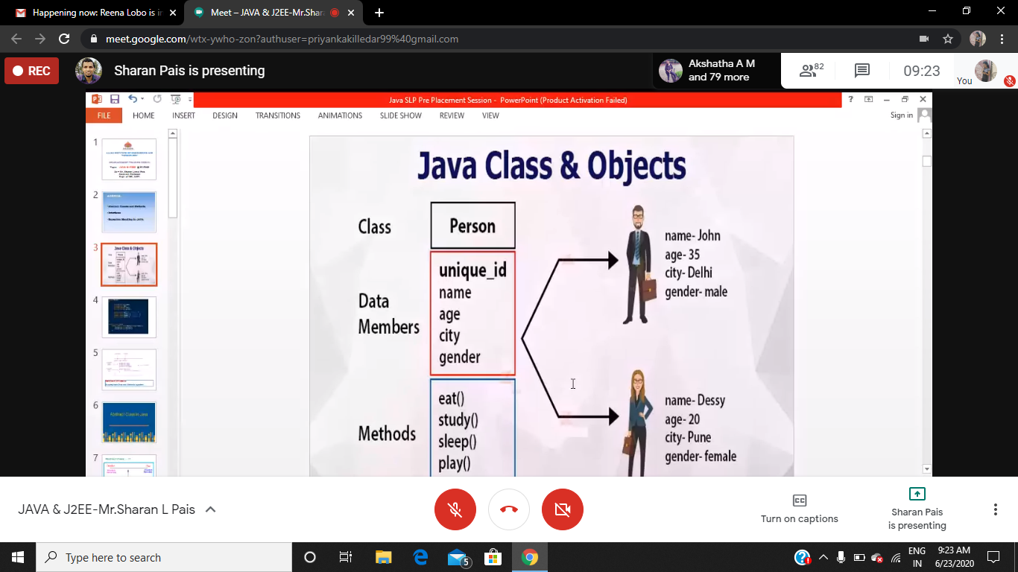

**Quiz Snapshots:**

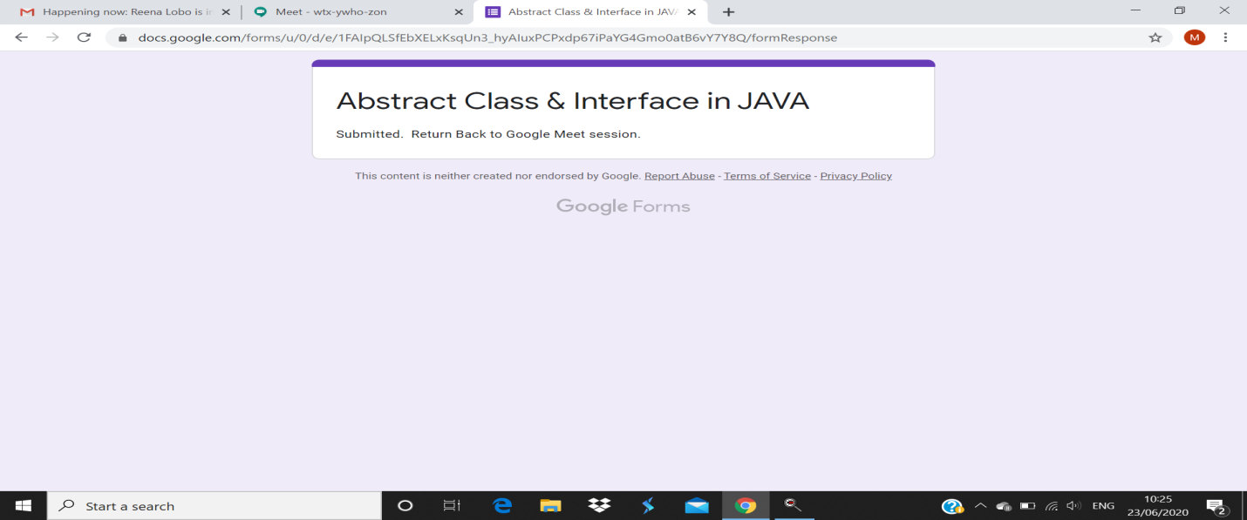

**Data Structures with C (session 2)**

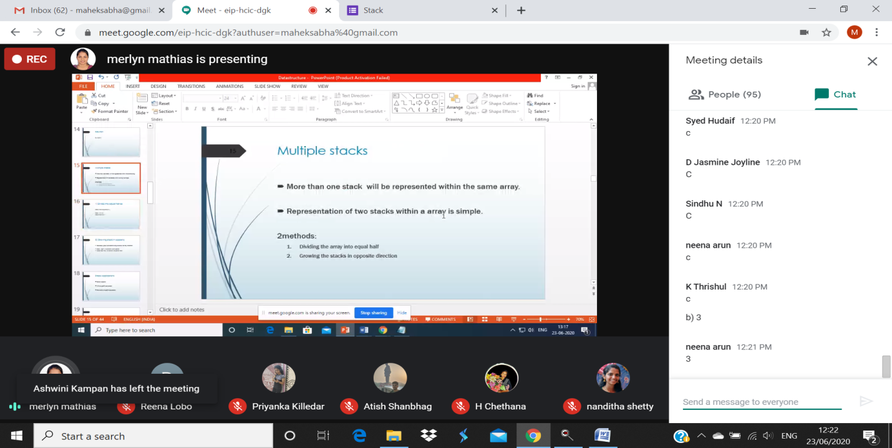

**Quiz Snapshots:**

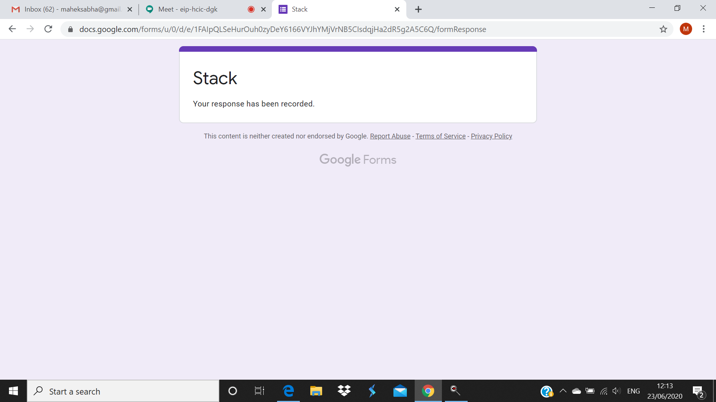

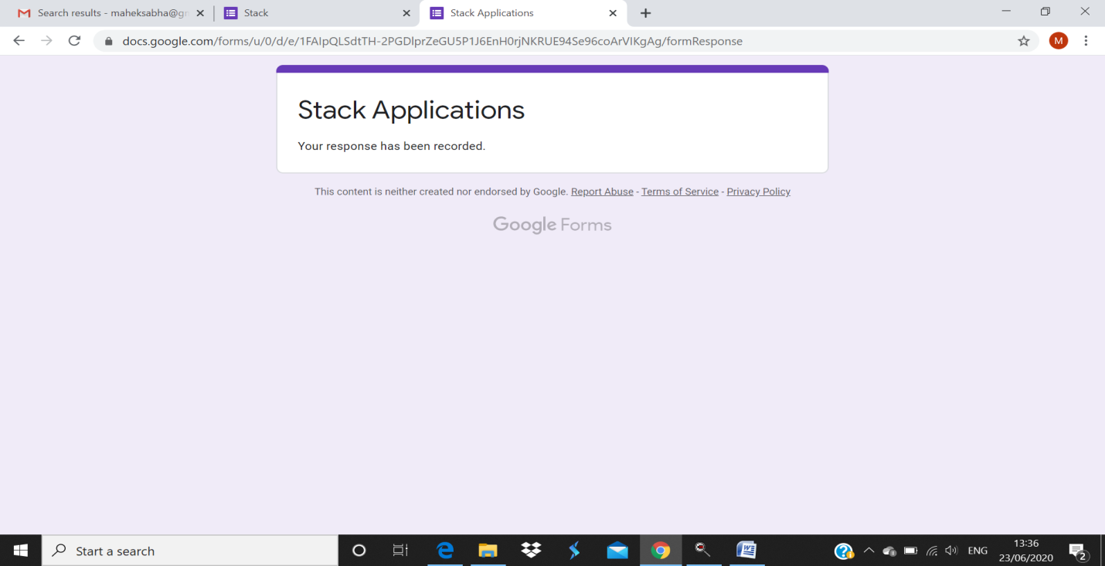

**JAVA preplacement test**

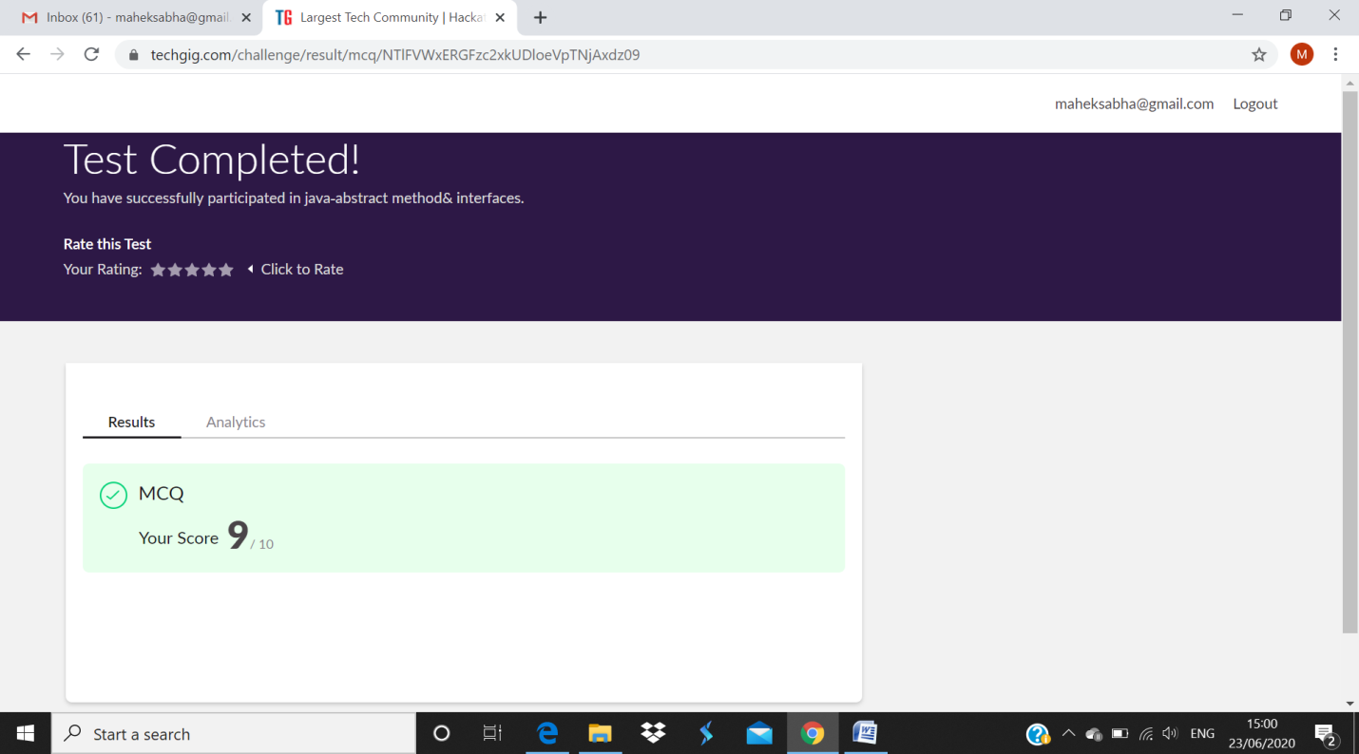

**PAP assignment test-4**

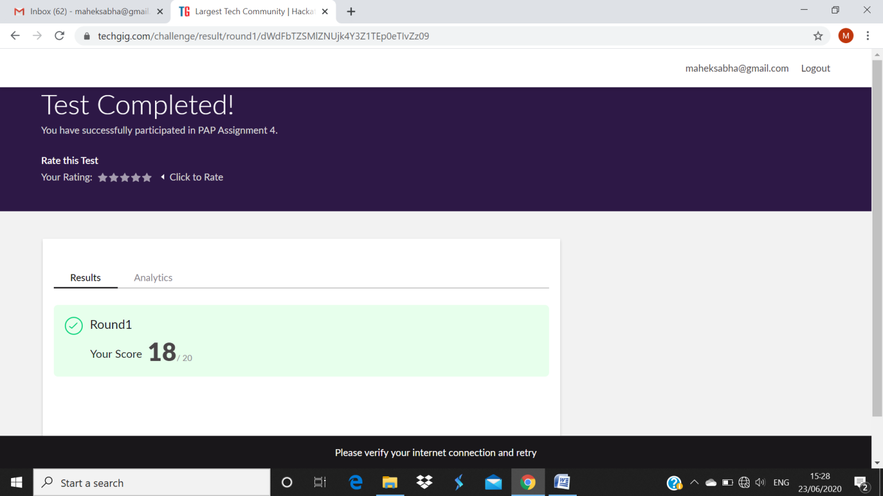

**Coding Challenges Details:**

<https://github.com/maheksa1234/Daily-Status/tree/master/Online%20Coding/June-23-6-2020>

The same report is also available in :

<https://github.com/maheksa1234/Daily-Status/tree/master/Online%20Coding>