**DAILY ONLINE ACTIVITIES SUMMARY**

|  |  |  |  |  |  |  |  |  |
| --- | --- | --- | --- | --- | --- | --- | --- | --- |
| **Date:** | **5/06/2020** | | | | | **Name:** | **MAHEK SABHA** | |
| **Sem & Sec** | **VI & A sec** | | | | | **USN:** | **4AL17CS051** | |
| **Online Test Summary** | | | | | | | | |
| **Subject** | | **OR-3**  **PAP assignment 2** | | | | | | |
| **Max. Marks** | | **0R-30**  **PAP-20** | | **Score** | | | **OR-30**  **PAP-13** | |
| **Certification Course Summary** | | | | | | | | |
| **Course** | Cognitiveclass: **Python for Data Science** | | | | | | | |
| **Certificate Provider** | | | **IBM** | | **Duration** | | | **10 hrs** |
| **Coding Challenges** | | | | | | | | |
| **Problem Statement:**  **1.** Write a Java program to implement Circular Linked List Using Array And Class  2. Python program to square each odd number in the list | | | | | | | | |
| **Status: completed** | | | | | | | | |
| **Uploaded the report in Github** | | | | | **Yes** | | | |
| **If yes Repository name** | | | | | <https://github.com/maheksa1234/Daily-Status> | | | |
| **Uploaded the report in slack** | | | | | **Yes** | | | |

**Online Test Details:**

**OR-test 3**

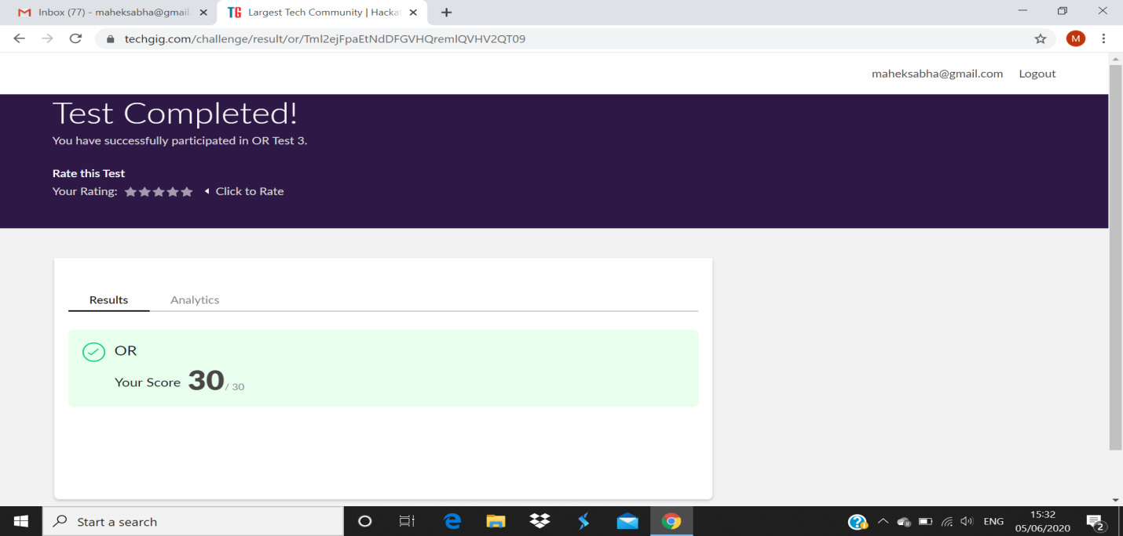

**PAP assignment2**

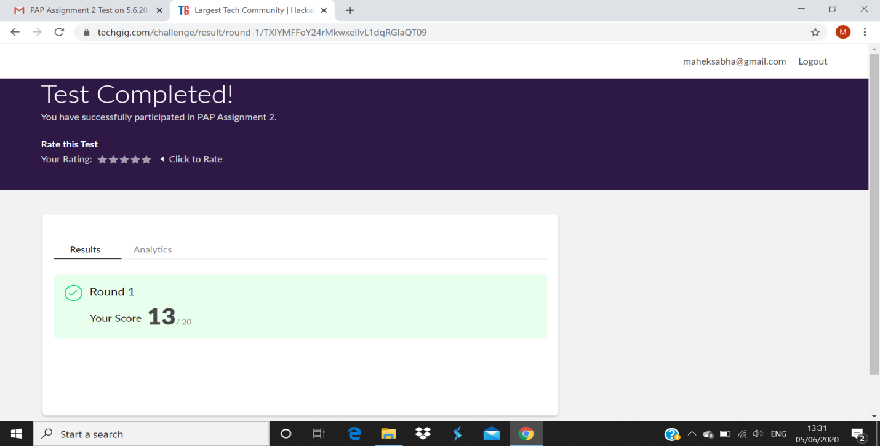

**Certification Course Details:**

Refer GitHub account for Detailed information:

<https://github.com/maheksa1234/Daily-Status>

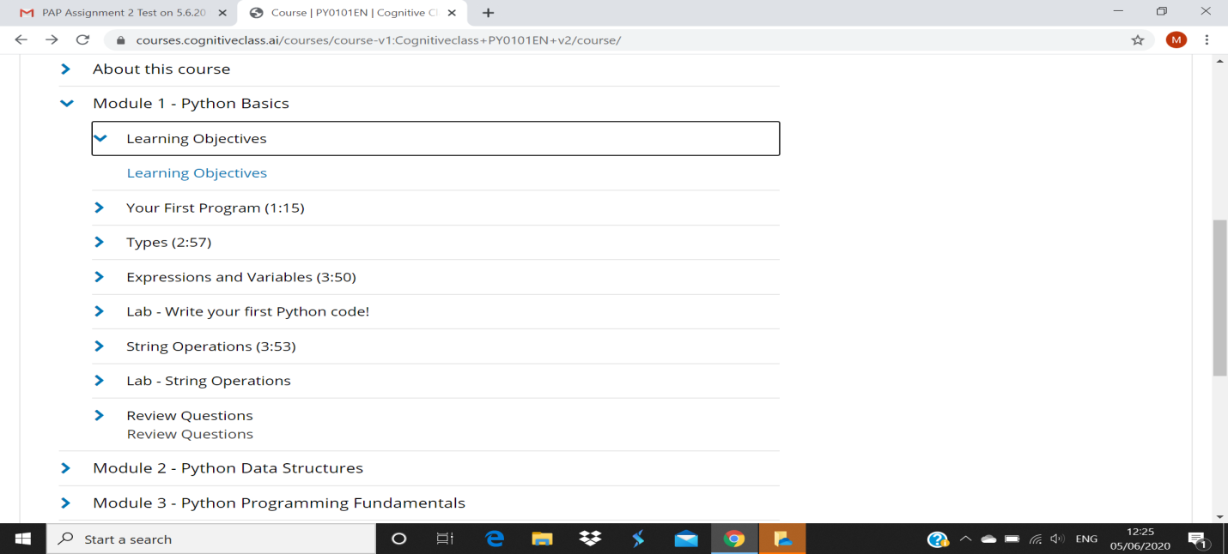

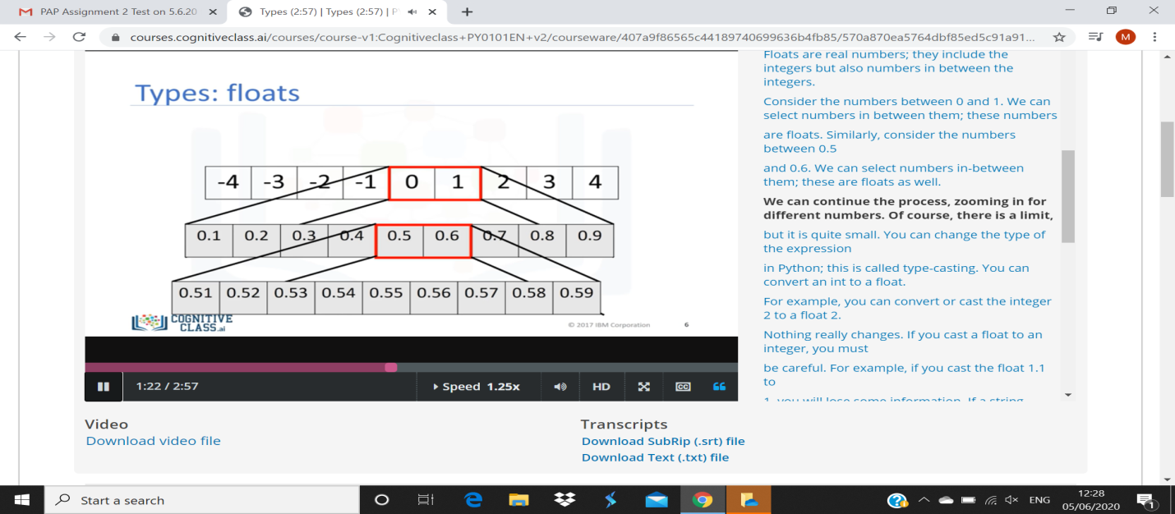

**Coding Challenges Details:**

<https://github.com/maheksa1234/Daily-Status/tree/master/Online%20Coding/June-5-6-2020>

The same report is also available in :

<https://github.com/maheksa1234/Daily-Status/tree/master/Online%20Coding>