Predicting Hit Songs Using Machine Learning
UE24CS352A - Machine Learning | Mini-Project Report

1. Problem Statement
This mini-project predicts whether a song belongs to the hit class or the non-hit class using machine learning. The output is binary: 1 means hit and 0 means non-hit. The central question is whether audio-related information can help a model identify patterns that are common in popular songs.
The project is inspired by the Stanford CS229 report "Predicting Hit Songs Using Repeated Chorus", which asks whether the repeated chorus (the "hook") of a song is what makes it popular. Because the dataset used in that paper is not publicly available, we implemented the same classification workflow on an openly available labelled dataset.

2. Dataset and Project Scope
We used the Spotify Hit Predictor dataset (file dataset-of-10s.csv), which contains 6,398 labelled songs from the 2010s. It is perfectly balanced: 3,199 hits and 3,199 non-hits. A song is labelled a hit (1) if it appeared on the Billboard Hot 100 and non-hit (0) otherwise.
Each song is described by 15 numeric features:
- Audio descriptors: danceability, energy, loudness, speechiness, acousticness, instrumentalness, liveness, valence, tempo.
- Structural attributes: duration_ms, key, mode, time_signature, chorus_hit (estimated start time of the first chorus) and sections (number of sections).
The text identifiers (track, artist, uri) were dropped, so the models learn from audio and structure information only, not from artist names.
Raw-audio pipeline. Following the paper, we also built a separate pipeline (extract_features.py) that detects a repeated 15-second chorus with PyChorus (falling back to the middle 15 seconds when no chorus is found) and extracts 11 Librosa feature groups (chroma, MFCC, RMS, spectral and tonal features). Each is summarised with 7 statistics (min, mean, median, max, standard deviation, skewness, kurtosis), giving 518 numbers per song. This pipeline was tested separately; all results below come from the 6,398-song dataset.

3. Methodology
Stage | What happens
Preparation | Dropped identifier columns; features standardised with StandardScaler inside a pipeline (no data leakage).
Split | 75% training (4,798 songs) / 25% testing (1,600 songs), stratified so both classes stay balanced.
Tuning | 5-fold stratified cross-validation with grid search over hyperparameters for every model, scored on F1.
Selection | The model with the highest cross-validated F1 was chosen as the final model and saved with joblib.
Analysis | Confusion matrix and permutation feature importance on the held-out test set.

3.1 Models compared
Eight models were compared, as in the reference paper: Logistic Regression, Linear Discriminant Analysis (LDA), Linear SVM, RBF SVM, Polynomial SVM, Random Forest, Gradient Boosting and a Neural Network (MLP). Regularisation was used throughout (for example C for the SVMs and logistic regression, shrinkage for LDA, tree depth and leaf size for the forests, and weight decay with early stopping for the MLP).

3.2 Evaluation metrics
Metric | Meaning
Accuracy | Overall percentage of songs classified correctly.
Precision | Of the songs predicted to be hits, the fraction that were really hits.
Recall | Of all real hits, the fraction the model found.
F1-score | Harmonic mean of precision and recall; balances the two.

4. Results
Random Forest achieved the highest cross-validated F1 (0.8514) and was selected as the final model. Table 1 and Figure 1 compare all eight models on the held-out test set.
Table 1. Cross-validated F1 and test-set metrics for all models (best model highlighted).
Model | CV F1 | Accuracy | Precision | Recall | Test F1
Random Forest | 0.8514 | 0.8481 | 0.8227 | 0.8875 | 0.8539
Gradient Boosting | 0.8472 | 0.8400 | 0.8148 | 0.8800 | 0.8462
Neural Network / MLP | 0.8366 | 0.8219 | 0.7864 | 0.8838 | 0.8323
RBF SVM | 0.8349 | 0.8106 | 0.7613 | 0.9050 | 0.8270
Logistic Regression | 0.8241 | 0.7969 | 0.7519 | 0.8862 | 0.8135
Linear SVM | 0.8225 | 0.7906 | 0.7332 | 0.9138 | 0.8136
LDA | 0.8185 | 0.7725 | 0.7088 | 0.9250 | 0.8026
Polynomial SVM | 0.8146 | 0.7981 | 0.7416 | 0.9150 | 0.8193

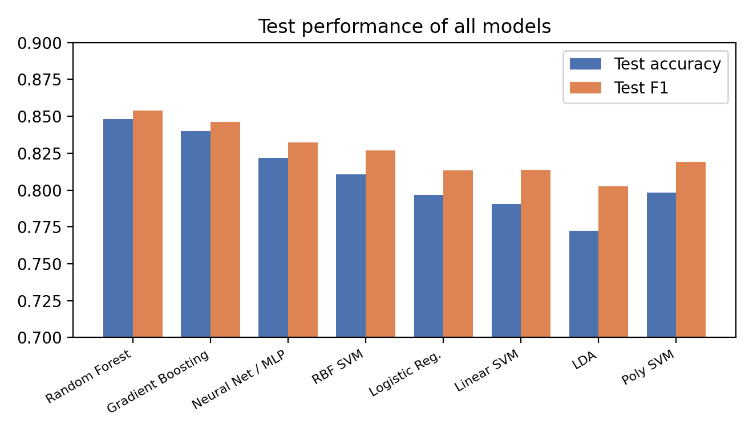
Figure 1. Test accuracy and F1-score of all eight models.
Final model: Random Forest. It reached a test accuracy of 84.81% and a test F1-score of 0.8539, i.e. it classified roughly 85 out of every 100 unseen songs correctly. Gradient Boosting was a close second (84.00% accuracy), while the ensemble methods clearly outperformed the linear models (LR, LDA, Linear SVM at 77-80%). This suggests the relationship between audio features and hit status is non-linear.
No overfitting. The cross-validated F1 (0.8514) and test F1 (0.8539) are almost identical, so the model generalises well to unseen songs.

5. Error Analysis

5.1 Confusion matrix
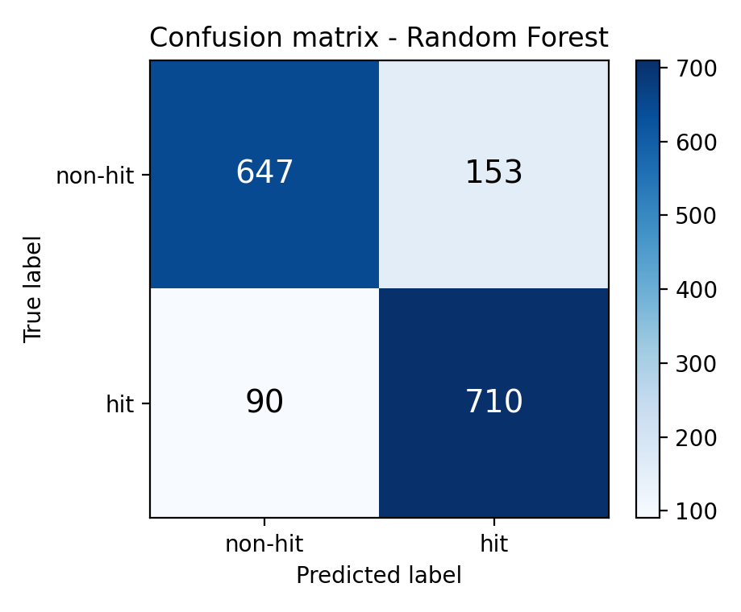
Figure 2. Confusion matrix of the Random Forest on the 1,600 test songs.
Class | Precision | Recall | F1-score | Support
non-hit (0) | 0.8779 | 0.8087 | 0.8419 | 800
hit (1) | 0.8227 | 0.8875 | 0.8539 | 800

Of the 800 real hits, 710 were found (recall 88.75%) and 90 were missed. Of the 800 non-hits, 647 were correctly rejected, but 153 were wrongly predicted as hits. The model therefore makes more false positives (153) than false negatives (90): it is slightly optimistic and tends to over-predict hits. Its precision on non-hits (87.8%) is higher than on hits (82.3%), meaning a "non-hit" prediction is more trustworthy than a "hit" prediction.

5.2 Feature importance
Permutation importance measures how much the F1-score drops on the test set when one feature's values are randomly shuffled. A larger drop means the model relies more on that feature.
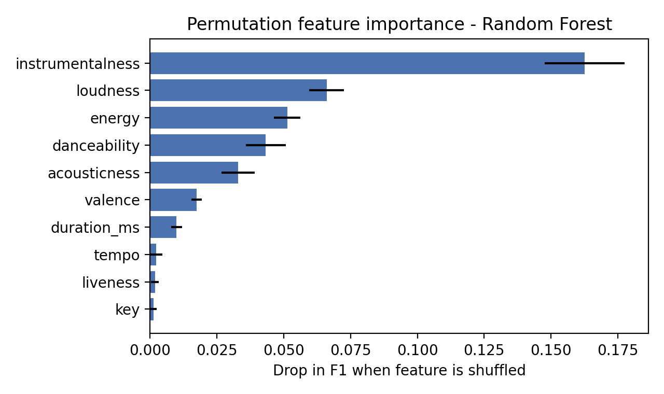
Figure 3. Top 10 features by permutation importance (mean drop in F1, with standard deviation).
- instrumentalness is by far the most influential feature (drop of 0.163 in F1), about 2.5 times the next feature. Songs with vocals are far more likely to chart than instrumental tracks.
- loudness (0.066), energy (0.051) and danceability (0.043) come next, which matches the intuition that modern hits tend to be loud, energetic and danceable.
- acousticness (0.033) and valence (0.017) contribute moderately.
- tempo, liveness and key have almost no effect (below 0.003), so these carry little information about popularity.
Unlike the reference paper, whose permutation importances were all very small (the top feature at about 0.02) because chorus-only features gave a weak signal, here a handful of features dominate. This explains why our model scores much higher.

6. Implementation
File | Purpose
src/train_models.py | Trains all eight models with 5-fold CV grid search, compares results, saves the best model and results.csv.
src/predict.py | Loads the saved model and outputs 1 = hit or 0 = non-hit for new songs.
src/analyze.py | Produces the classification report, confusion matrix and permutation feature importance.
extract_features.py | Raw-audio pipeline: finds the 15 s chorus and extracts 518 Librosa-based features.

7. Discussion and Comparison with the Paper
The CS229 paper used only audio features from a 15-second chorus and obtained modest results: its best model (a neural network) reached about 58% test accuracy, only slightly better than random guessing. Our model reaches about 85%. The two numbers should not be compared directly, because the experiments differ in important ways:
- Our features are Spotify-style descriptors of the whole song (including instrumentalness, loudness and energy), not 518 low-level spectral statistics from the chorus alone.
- The dataset is larger (6,398 songs against 554) and cleanly labelled and balanced.
- The paper's non-hits came from the same artists and albums as the hits, which makes the task much harder. In our dataset, the hit and non-hit songs are not matched by artist, so artist-level characteristics such as production style may leak into features such as loudness and instrumentalness.
Even so, the results support the paper's broader conclusion in one respect: audio information alone contains a real, learnable signal about which songs become popular.

8. Conclusion
This project built a complete hit/non-hit classification workflow: data preparation, training and tuning of eight models with cross-validation, model selection, saved-model prediction, and error analysis. Random Forest was the best model with 84.81% test accuracy, 0.8539 F1-score and 88.75% recall, and its test performance closely matched its cross-validated performance, showing it did not overfit. Instrumentalness, loudness, energy and danceability were the most important features.
Limitations. A song can become popular for many reasons beyond audio, such as artist fame, marketing, social media and release timing; none of these are captured here. The model also over-predicts hits slightly (153 false positives), and the dataset covers only the 2010s, so results may not transfer to other eras.
Future work. Add non-audio factors (artist popularity, release date, social-media signals), train on the chorus-level features from the raw-audio pipeline using a larger audio collection, and try deeper models such as convolutional neural networks on spectrograms.

References
[1] E. Liu. "Predicting Hit Songs Using Repeated Chorus." CS229 Milestone Report, Stanford University, Spring 2021.
[2] Spotify Hit Predictor Dataset (1960-2019), Kaggle. Billboard Hot-100 labels with Spotify audio features.

