**Introduction to Web Application flow**

Any web application you use has three critical components:

* **The front-end**: It is the user interface that a user interacts with. Also known as the client side. In our case we have used HTML, CSS and JAVASCRIPT to create the frontend.
* **The back-end**: It is the behind-the-scenes functionality that is not visible to the user but is responsible for the smooth functioning of the website. Also known as the server side. It is used to create the RestFul APIs that the frontend would call through http and send/receive data in JSON format. In our case we have used Python to create the backend.
* **The database**: It stores a large amount of information in an efficient and structured way. Python code would save data in database and also get data through sql queries and then send the data back to frontend. In out case we have used MySql for the database.

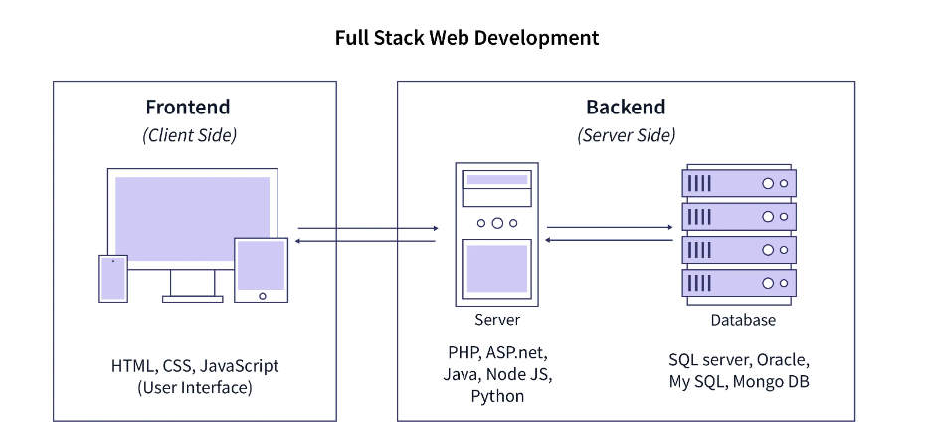



* **Section of code where the frontend makes http call to the backend API.**

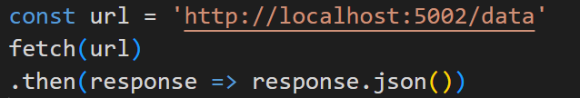

* **Section of code showing how the backend connects to MySql database.**

