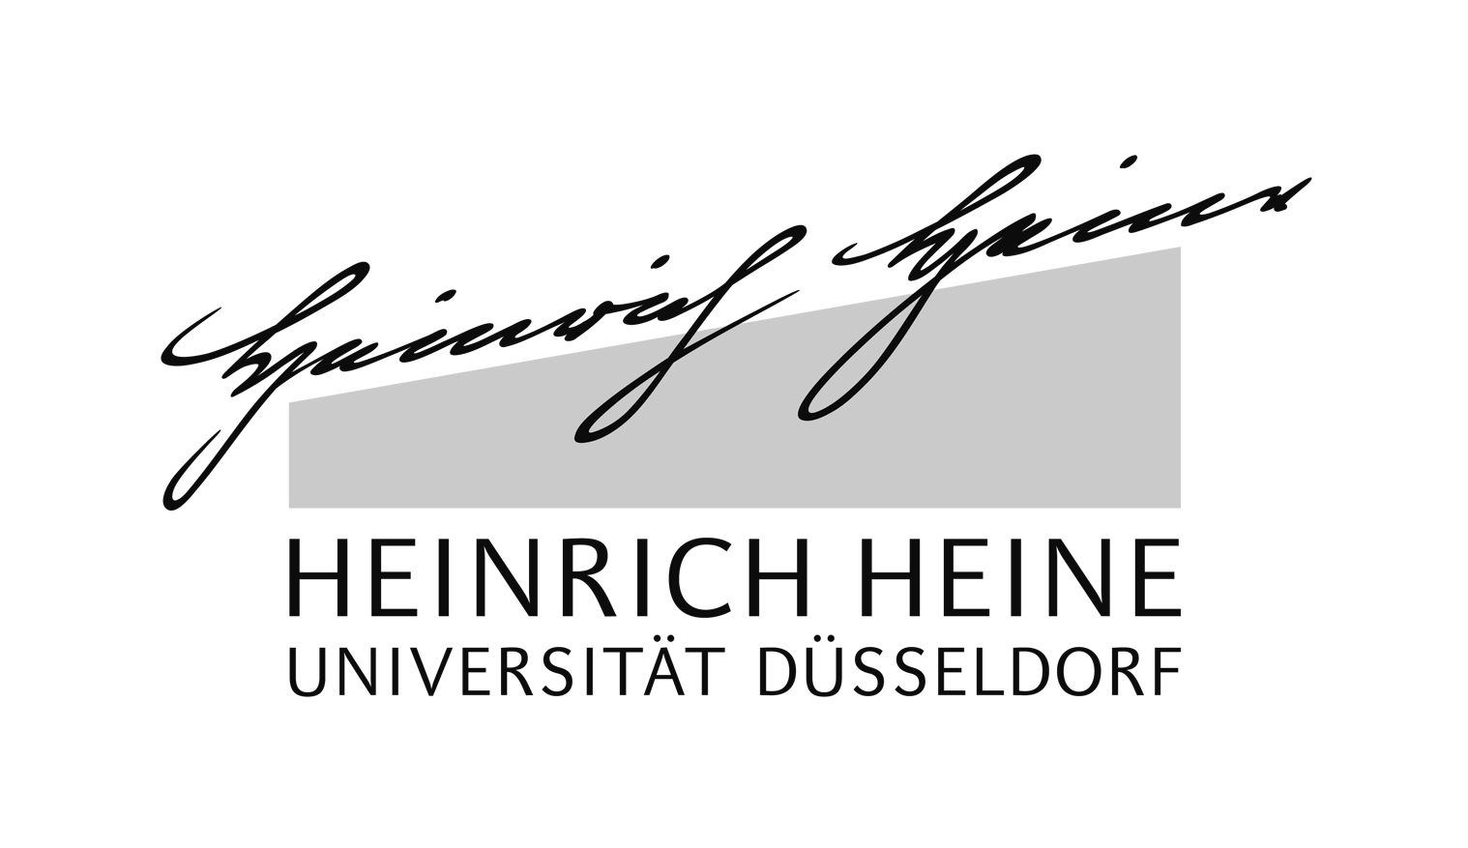

Term Paper

|  |
| --- |
| **The Warrior Stabs the Goat: Creating a Dothraki Resource Grammar with Grammatical Framework** |

**Maria Henkel**

2008709 • maria.henkel@hhu.de

**Benno Kuckuck**

000000 • benno.kuckuck@hhu.de

October 17th, 2016

|  |  |
| --- | --- |
| **Lecturers:** | Yulia Zinova, Rainer Osswald |
| **Course:** | Introduction to "Grammatical Framework"  SS 2016 |

# Contents

Contents I

List of Figures II

List of Tables II

1. Introduction 1

2. Methods 1

2.1 Planning and Execution of the Project 1

2.2 Project Structure 1

2.3 Problems and Solutions 1

3. Results 1

4. Discussion 1

4.1 Limitations 1

4.2 Outlook 1

4.3 Conclusion 1

Appendix 2

Source Code 2

References 2

Eidesstattliche Erklärung 3

## List of Figures

**Es konnten keine Einträge für ein Abbildungsverzeichnis gefunden werden.**

## List of Tables

**Es konnten keine Einträge für ein Abbildungsverzeichnis gefunden werden.**

**

“That woman which will stink has

stinked behind that tree.”

GF Run-Time System, 2016

## Introduction

Grammatical Framework (GF) is a functional programming language, created in 1998 (<https://en.wikipedia.org/wiki/Grammatical_Framework>) and designed to write natural language grammars. Since GF is “working from a language-independent representation of meaning” (Wikipedia) it can be used to translate between languages or even generate and parse text in different languages at the same time. Its own standard library, the GF Resource Grammar Library, covers more than 38 different languages(http://www.grammaticalframework.org/lib/doc/status.html) – although many of them are not yet complete – and is still growing. In 2010, it already consisted of more than 500,000 lines of code (GF BOOK). As Grammatical Framework is an open-source project, and still under development, everyone is invited to use it or even help further develop it. For example, by adding languages to the library, which is the aim of the project described in this paper.

Our goal is to write a GF resource grammar for the Dothraki language and eventually be able to add it to the GF Resource Grammar Library.

The Dothraki language is a constructed language, developed by the language creator and writer David J. Peterson (http://www.artoflanguageinvention.com/). Peterson created it

Git hub https://github.com/GrammaticalFramework

Since .. language… a complicated and lengthy task,

, about this project, structure of this paper.

## Methods

### Planning and Execution of the Project

### Project Structure

### Problems and Solutions

## Results

Text.

## Discussion

### Limitations

### Outlook

### Conclusion

## Appendix

### Source Code

The complete source code can be viewed and downloaded on GitHub:

<https://github.com/mahen2/dothraki_gf>

### References

Ranta, A. (2011). *Grammatical Framework: Programming with Multilingual Grammars.* Stanford: CSLI Publications.

Peterson, D. J. (2014). *Living Language Dothraki: A Conversational Language Course Based on the Hit Original HBO Series Game of Thrones*. New York: Living Language.

## Eidesstattliche Erklärung

Hiermit erklären wir, dass wir die vorliegende Arbeit selbständig verfasst und keine anderen als die angegebenen Quellen benutzt haben.

Die Stellen der Arbeit sowie evtl. beigefügte Zeichnungen, Skizzen, graphische Darstellungen, die anderen Werken dem Wortlaut oder dem Sinn nach entnommen sind, haben wir unter Angabe der Quellen kenntlich gemacht.

(Ort, Datum) (Unterschrift) (Unterschrift)