A MAJOR PROJECT
on
BRAINLENS-MULTIMODEL AI FOR STROKE DETECTION AND RISK PREDICTION
Submitted to
JAWAHARLAL NEHRU TECHNOLOGICAL UNIVERSITY, HYDERABAD

In partial fulfilment of the requirement for the award of the degree of
BACHELOR OF TECHNOLOGY
in
COMPUTER SCIENCE AND ENGINEERING (DATA SCIENCE)
By
KATKURI AJAY KUMAR | 227Y1A6766
KARAN PASWAN | 227Y1A6782
PULUMADDI MAHENDAR | 227Y1A6789

Under the Guidance of
Dr. A.Arun Kumar
Professor & HOD
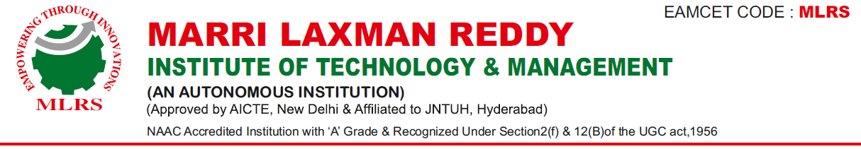
DEPARTMENT OF COMPUTER SCIENCE AND ENGINEERING (DATA SCIENCE)
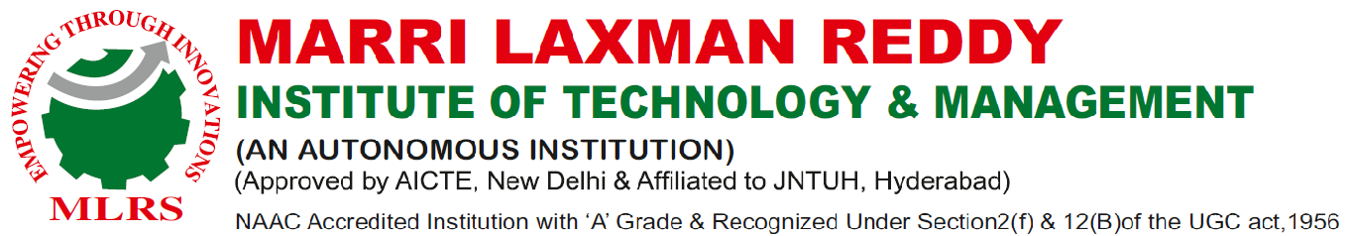
OCTOBER, 2025

DEPARTMENT OF COMPUTER SCIENCE AND ENGINEERING (DATA SCIENCE)
Date:
CERTIFICATE
This is to certify that the project work entitled “BRAINLENS-MULTIMODEL AI FOR STROKE DETECTION AND RISK PREDICTION” work done by KATKURI AJAY KUMAR(227Y1A6766), KARAN PASWAN(227Y1A6782) and PULUMADDI MAHENDAR(227Y1A6789) students of Department of Computer Science And Engineering(Data Science), is a record of bonafide work carried out by the members during a period from July, 2025 to October, 2025 under the supervision of Dr.A.Arun Kumar. This project is done as a fulfilment of obtaining Bachelor of Technology Degree to be awarded by Jawaharlal Nehru Technological University Hyderabad, Hyderabad.
The matter embodied in this project report has not been submitted by us to any other university for the award of any other degree.

K.AJAY KUMAR | KARAN PASWAN | P. MAHENDAR

This is to certify that the above statement made by the candidates is correct to the best of my knowledge.

Date: (Dr.A.Arun Kumar)

The Viva-Voce Examination of above students, has been held on………………………

Head of the Department | External Examiner
Principal/Director
ACKNOWLEDGEMENTS

We would like to express my sincere gratitude to my guide Dr.A.ARUN KUMAR, Professor & HOD, Computer Science and Engineering(Data Science), for his excellent guidance and invaluable support, which helped me accomplish the B.Tech (CSD) degree and prepared me to achieve more life goals in the future. His total support of my dissertation and countless contributions to my technical and professional development made for a truly enjoyable and fruitful experience. Special thanks are dedicated for the discussions we had on almost every working day during my project period and for reviewing my dissertation.
We are very much grateful to my Project Coordinator, Dr. SUNITA .M, Associate Professor, Computer Science and Engineering(Data Science), MLRITM, Dundigal, Hyderabad, who has not only shown utmost patience, but was fertile in suggestions, vigilant in directions of error and has been infinitely helpful.
We are extremely grateful to HOD Dr.A. Arun Kumar & Professor & Head of the Department, Computer Science and Engineering(Data Science), MLRITM, Dundigal, Hyderabad, for the moral support and encouragement given in completing my project work.
We wish to express deepest gratitude and thanks to Dr. R. Murali Prasad, Principal, and Dr. P. Sridhar, Director for their constant support and encouragement in providing all the facilities in the college to do the project work.
We would also like to thank all our faculties, administrative staff and management of MLRITM, who helped me to completing the mini project.
On a more personal note, I thank my beloved parents and friends for their moral support during the course of our project.

TABLE OF CONTENTS
 |  |  |  | Page No.
 | Certificate |  |  | ii
 | Acknowledgements |  |  | iii
 | Table of Contents |  |  | iv-v
 | List of Abbreviations |  |  | vi
 | List of Figures |  |  | vii
 | Abstract |  |  | viii
Chapter 1: Introduction |  |  |  | 1-2
 | 1.1 |  | Motivation | 2-3
 | 1.2 |  | Problem Defination | 3-5
 | 1.3 |  | Limitations | 5-8
Chapter 2: Literature Survey
 | 2.1 |  | Introduction | 9-12
 | 2.2 |  | Existing System | 12-14
 | 2.3 |  | Proposed System | 14-16
Chapter 3: System Analysis
 | 3.1 |  | Functional Requirements | 17
 | 3.2 |  | Non-Functional Requirements | 17-18
 | 3.3 |  | Software Requirements | 18
 | 3.4 |  | Hardware Requirements | 18-19
Chapter 4: System Design
 | 4.1 |  | Introduction | 20
 | 4.2 |  | UML Diagrams | 21
 |  | 4.2.1 | Data Flow Diagram | 21-22
 |  | 4.2.2 | Class Diagram | 22-24
 |  | 4.2.3 | Activity Diagram | 24-26
Chapter 5: Implementation and Result
 | 5.1 |  | Method of Implementation | 31-34
 | 5.2 |  | SetUp | 34-40
 | 5.3 |  | Output Screens | 40-44
Chapter 6: Conclusion and Future Enhancement
 | 6.1 |  | Project Conclusion | 45-46
 | 6.2 |  | Future Enhancement | 46-47
References |  |  |  | 48

LIST OF ABBREVIATIONS
NLP | Natural Language Processing
TF-IDF | Term Frequency-Inverse Document Frequency
BERT | Bidirectional Encoder Representations from Transformers
RAKE | Rapid Automatic Keyword Extraction
LDA | Latent Dirichlet Allocation
LSA | Latent Semantic Analysis
GPT | Generative Pre-trained Transfomer

LIST OF FIGURES
Figure No. | Name of the Figure | Page No.
Figure 4.1 | Data Flow Diagram | 21
Figure 4.2 | Class Diagram | 23
Figure 4.3 | Activity Diagram | 25
Figure 4.4 | Use Case Diagram | 27
Figure 4.5 | Sequence Diagram | 29
Figure 5.1 | Agile Method | 34
Figure 5.2 | User Registration | 40
Figure 5.3 | User Login | 40
Figure 5.4 | File upload | 41
Figure 5.5 | File Upload and Key Extraction | 41
Figure 5.6 | Word Cloud | 41
Figure 5.7 | Donut Chart | 42
Figure 5.8 | Radial Bar Chart | 42
Figure 5.9 | Histogram and Past History | 43

ABSTRACT
BRAINLENS – Multimodal AI for Stroke Detection and Risk Prediction is an intelligent healthcare system designed to enhance the early diagnosis and prevention of stroke through the integration of advanced artificial intelligence (AI) and multimodal data analysis. Stroke remains one of the leading causes of death and long-term disability worldwide, with timely detection and accurate risk assessment being crucial for improving patient outcomes. BRAINLENS addresses these challenges by combining medical imaging, clinical data, and patient health records within a unified AI-driven framework.
The proposed system utilizes deep learning models for automated feature extraction and classification from neuroimaging modalities such as MRI and CT scans. In parallel, machine learning algorithms process structured data—including demographic information, medical history, and lifestyle factors—to estimate individual stroke risk levels. By fusing these multimodal inputs, BRAINLENS delivers a comprehensive diagnostic insight that supports both acute stroke detection and long-term risk prediction. The architecture incorporates convolutional neural networks (CNNs) for image analysis, ensemble-based predictors for clinical data interpretation, and a decision fusion layer that integrates outputs to achieve high diagnostic accuracy and interpretability.
Additionally, BRAINLENS features an explainable AI component that visualizes key indicators influencing model predictions, thereby enhancing clinician trust and facilitating transparent medical decision-making. The system is designed to operate in both clinical and telemedicine environments, supporting remote diagnosis and personalized health monitoring. Preliminary evaluations demonstrate that BRAINLENS outperforms traditional diagnostic approaches in terms of precision, sensitivity, and processing time.

CHAPTER 1
INTRODUCTION
1. Introduction
Stroke is one of the leading causes of death and long-term disability worldwide, affecting millions of people each year. Early detection and accurate prediction of stroke risk are crucial for reducing mortality rates and improving patient outcomes. However, conventional diagnostic approaches often rely heavily on manual interpretation of medical imaging and clinical data, which can be time-consuming, prone to human error, and limited by the availability of expert radiologists. To address these challenges, this project introduces BRAINLENS – Multimodal AI for Stroke Detection and Risk Prediction, an intelligent system designed to leverage the power of artificial intelligence (AI) and data fusion for improved stroke diagnosis and prevention.
BRAINLENS integrates medical imaging, clinical parameters, and patient history into a unified AI framework capable of performing both acute stroke detection and long-term risk prediction. The system employs deep learning models, such as Convolutional Neural Networks (CNNs), to analyze neuroimaging data (MRI, CT scans) and identify stroke-related abnormalities with high accuracy. Simultaneously, machine learning algorithms are applied to structured health data—including age, blood pressure, cholesterol, lifestyle habits, and genetic predispositions—to predict the likelihood of future stroke occurrences.
By combining these multimodal inputs, BRAINLENS provides a comprehensive and data-driven evaluation of stroke conditions, enabling healthcare professionals to make faster, more reliable decisions. Additionally, the system incorporates explainable AI (XAI) techniques to visualize important predictive features, ensuring transparency and clinical trust. The integration of this technology into healthcare settings aims to assist doctors in early intervention, personalized treatment planning, and remote patient monitoring.
In summary, BRAINLENS represents a step forward in intelligent healthcare innovation. It demonstrates how advanced AI models and multimodal data analysis can be combined to revolutionize stroke detection and risk prediction, ultimately contributing to improved patient care, faster diagnosis, and reduced healthcare burden.

1.1 Motivation
Stroke remains one of the most critical medical emergencies, often resulting in severe neurological damage, long-term disability, or even death. According to global health reports, millions of people suffer from strokes each year, and a significant portion of them do not receive timely diagnosis or intervention. The effectiveness of stroke treatment depends heavily on how quickly and accurately it is detected. Unfortunately, in many healthcare systems—especially in developing regions—there is a shortage of trained specialists, delayed imaging analysis, and limited access to advanced diagnostic technologies. These challenges highlight the urgent need for automated, intelligent, and accessible diagnostic tools.
The motivation behind developing BRAINLENS arises from the desire to bridge this gap by using artificial intelligence to assist in early stroke detection and risk prediction. Traditional methods rely heavily on manual interpretation of medical scans and patient data, which can be inconsistent due to human fatigue or subjectivity. AI, on the other hand, offers the ability to process vast amounts of multimodal data—such as MRI and CT scans, patient demographics, and clinical records—with high precision and speed. By leveraging machine learning and deep learning algorithms, BRAINLENS can identify subtle patterns and risk indicators that may not be visible to the human eye.
Another motivation for this project is the potential to enable preventive healthcare through predictive analytics. By assessing an individual’s stroke risk based on clinical and lifestyle data, early interventions can be planned to reduce the likelihood of stroke occurrence. This shift from reactive to proactive care can save lives, reduce hospitalization costs, and improve overall healthcare efficiency.
Ultimately, the development of BRAINLENS is driven by the goal of integrating AI-driven decision support systems into modern medical practice, empowering healthcare professionals with accurate insights while ensuring timely and effective patient management.

1.2 Problem Definition
Stroke remains one of the most critical neurological emergencies, ranking among the leading causes of long-term disability and death worldwide. According to the World Health Organization (WHO), millions of people suffer from stroke every year, and a significant proportion of patients, especially in developing nations like India, fail to receive timely diagnosis and treatment. A delay of even a few minutes in stroke detection and treatment can lead to irreversible brain cell damage, permanent functional impairment, or fatality. Early and accurate identification is therefore crucial to reducing stroke-related morbidity and mortality. Despite significant medical advancements, conventional diagnostic approaches still face multiple challenges, including dependency on expert neurologists, limited availability of advanced diagnostic equipment, and manual interpretation of brain imaging scans. These limitations often result in delayed clinical intervention and reduced patient recovery rates.
Furthermore, stroke is influenced by multiple risk factors such as hypertension, diabetes, obesity, high cholesterol, smoking habits, genetic predisposition, and sedentary lifestyle. Most existing healthcare systems and traditional screening methods evaluate only isolated patient parameters, lacking a comprehensive evaluation mechanism that considers simultaneous medical imaging findings and physiological risk indicators. As a result, many individuals at high risk of stroke often remain undetected until a clinical episode occurs. The absence of predictive tools capable of continuously monitoring health parameters and forecasting stroke risk contributes to the increased burden on healthcare infrastructure and increases the chances of life-threatening complications.
Manual interpretation of CT or MRI brain imaging for stroke diagnosis is also time-consuming and prone to human error, especially in emergency settings where rapid decision-making is essential. Radiologists and neurologists must analyze multiple complex imaging patterns, and in rural or resource-limited settings, accessibility to expert clinicians is scarce. Therefore, there is a strong need for an automated, intelligent, and accurate clinical support system capable of analyzing brain images and patient health data to assist doctors in early stroke detection and prevention.
The lack of a unified platform integrating both image-based and clinical data-based evaluation methods forms the core problem addressed in this project. Traditional machine learning models typically work on single-modality inputs—either medical images or structured clinical data—resulting in limited diagnostic accuracy. A multimodal approach leveraging both imaging data and patient health attributes has the potential to significantly enhance prediction efficiency and diagnostic confidence. The integration of deep learning for stroke lesion identification with machine learning-based clinical risk analysis provides a more holistic and precise framework for stroke classification and future risk estimation.
The BRAINLENS – Multimodal AI for Stroke Detection and Risk Prediction system aims to bridge this critical gap by utilizing advanced artificial intelligence algorithms to support healthcare professionals in real-time decision-making. The system processes CT/MRI brain scan images to detect possible infarctions or hemorrhagic regions while simultaneously analyzing patient medical history, vital parameters, and lifestyle-related risk factors. It offers stroke probability scoring, visual annotation of affected brain regions, and risk stratification ranging from low to severe categories. With fast computational performance, high diagnostic accuracy, and the ability to operate in both hospital and remote telemedicine environments, the proposed system facilitates early diagnosis, reduces interpretation burden on doctors, improves treatment planning, and enhances healthcare accessibility. In addition, the model assists in preventive care by predicting the likelihood of stroke based on patient-specific clinical features, enabling timely preventive actions and lifestyle modifications.
In summary, the problem addressed in this project is the absence of an intelligent, multimodal AI-driven diagnostic and prediction framework capable of combining medical image analysis with clinical risk assessment to detect stroke and forecast stroke susceptibility with high reliability. The proposed system aims to provide a cost-effective, faster, and more accurate solution for early stroke detection, continuous monitoring, and risk prediction, ultimately improving patient survival rates and supporting modern medical practices with technological innovation.

1.3 Limitations

Accuracy of Keyphrase Extraction
Although the BRAINLENS – Multimodal AI for Stroke Detection and Risk Prediction system is designed to deliver accurate and reliable stroke diagnosis and prediction, it is not entirely free from limitations. One of the key limitations lies in the accuracy of keyphrase extraction during clinical data processing. Keyphrase extraction plays a significant role in extracting important medical terms, symptoms, and risk indicators from patient records, doctor notes, and medical histories. However, achieving perfect accuracy is challenging due to various factors.
The complexity of medical terminology, variations in physician notes, shorthand clinical expressions, and differing medical data formats can lead to incomplete or inaccurate extraction of critical keyphrases. Medical text often contains abbreviations, domain-specific vocabulary, irregular grammar usage, and context-dependent meaning, making it difficult for automated models to interpret accurately without expert-annotated data. If key terms related to patient symptoms, risk factors such as hypertension, diabetes, cholesterol level, or previous stroke history are not extracted correctly, this may result in slight deviations in the system’s risk prediction score.
Additionally, the accuracy of keyphrase extraction depends heavily on the quality and pre-processing of input data. Handwritten medical notes, incomplete patient records, or inconsistent terminology can reduce model performance. While modern natural language processing (NLP) techniques and medical ontologies significantly improve extraction accuracy, the system may still occasionally miss subtle or rare clinical cues that a trained neurologist could identify instantly.
Furthermore, keyphrase extraction accuracy can vary with language diversity. Since many medical records in regions like India include regional languages, transliterated English, and mixed-language content, the model’s accuracy may be affected unless trained on multilingual clinical datasets. As a result, manual review or clinician validation may be required in certain cases to ensure maximum reliability.
In essence, while the system leverages advanced NLP algorithms to interpret medical data, slight inaccuracies in keyphrase extraction may influence the precision of stroke risk prediction. Future enhancement can focus on training the model with larger domain-specific datasets, incorporating multilingual medical corpora, and adopting hybrid medical text-processing frameworks that combine rule-based and deep-learning-based methods to improve the accuracy and reliability of extracted clinical information.

Handling of Contextual Information
Although the BRAINLENS system integrates multimodal data for stroke detection and risk prediction, one of the significant limitations lies in its ability to fully handle contextual medical information. Medical diagnosis is highly dependent not only on numerical values and imaging patterns but also on subtle contextual details such as patient lifestyle patterns, history of episodic symptoms, environmental factors, medication adherence, and behavioral cues. Automated AI systems still face challenges in interpreting these complex forms of contextual information with the same depth as an experienced clinician.
In many scenarios, patient records may contain implicit or qualitative details—for example, descriptions like intermittent dizziness, on-and-off headaches, mild weakness in limbs, or family history described indirectly. While healthcare professionals can easily understand and correlate these subtle cues, AI-based systems may struggle to link such contextual information accurately to potential stroke risk. Additionally, contextual dependency exists in imaging data as well—stroke findings on CT/MRI scans must often be interpreted in relation to the patient’s age, co-morbidities, and time of symptom onset. The system may not fully capture such temporal and contextual nuances, leading to reduced diagnostic confidence in borderline or ambiguous cases.
Another aspect of contextual limitation arises from variability in medical data formats and documentation styles. Patient information may come from structured fields, handwritten notes, telemedicine consultations, or verbal inputs, each carrying different levels of contextual depth. Current NLP models used for medical text extraction may miss deeper relationships like symptom progression over time, subtle neurologic patterns, or patient behavior changes that influence stroke risk. Moreover, emotional or psychological context—such as stress levels or cognitive decline—is difficult for the system to interpret without specialized behavioral data input.
In summary, while BRAINLENS demonstrates strong analytical capability with structured medical data and imaging, its ability to capture and interpret complex contextual information remains limited compared to expert clinical reasoning. This may occasionally lead to incomplete understanding of patient cases, especially in scenarios requiring deep contextual judgment. Future work could involve integrating longitudinal patient monitoring data, advanced temporal deep learning models, richer contextual medical corpora, and clinician-feedback loops to strengthen contextual awareness and improve overall diagnostic capability.

Scalability Issues
Despite the advanced capabilities of the BRAINLENS system, one key limitation lies in its scalability when deployed in large-scale or real-world healthcare environments. While the model performs efficiently during controlled testing and smaller-scale deployments, scaling the system across multiple hospitals, diverse patient groups, and large imaging datasets presents significant challenges.
Deep learning-based stroke detection relies on high-resolution CT/MRI scan processing, which requires substantial computational power, storage capacity, and memory resources. When the number of users or image scans increases rapidly, system latency and processing time may also increase, potentially affecting timely diagnosis—especially in emergency stroke settings where immediate decisions are critical. In addition, deploying AI-driven imaging analysis across distributed medical centers demands robust cloud or on-premise GPU infrastructure, which may not always be feasible in rural hospitals or low-resource healthcare setups.
Scalability challenges also arise due to data variability and model generalization. The system may require retraining or fine-tuning when exposed to new types of medical imaging equipment, different scanning protocols, or entirely new patient demographics. Handling such diversity at scale demands continuous monitoring, updating of datasets, and model optimization, which can be resource-intensive and technically complex. Without consistent calibration, the accuracy of stroke detection and risk assessment may vary across regions or institutions.
Furthermore, managing large volumes of sensitive medical data raises concerns regarding data privacy, compliance, and secure storage. As the system scales, the infrastructure must adhere to healthcare regulations (such as HIPAA, NDHM guidelines in India, and other global standards). Ensuring end-to-end encryption, secure data pipelines, and ethical handling of patient information becomes increasingly complex as the platform expands.
In essence, although BRAINLENS is highly effective on a moderate scale, scaling the solution to real-time clinical settings with thousands of users, multi-hospital integration, diverse datasets, and consistent performance standards remains a significant challenge. Future improvements can include optimizing computational models, exploring federated learning for distributed training, utilizing cloud-based medical AI frameworks, and designing adaptive system modules capable of handling high data loads without compromising accuracy or speed.
Limited Handling of Multi-Word Expressions (MWEs)
The system may face difficulty in accurately recognizing and interpreting multi-word medical expressions such as “ischemic stroke episode” or “chronic hypertension patient.”
MWEs often carry specific clinical meaning that cannot be derived from individual words alone.
If not processed correctly, critical medical terms may be misunderstood or partially ignored.
This can lead to slight inaccuracies in feature extraction and stroke risk prediction.
Enhancements in medical NLP models and domain-specific language training can reduce this limitation.
Dependency on Predefined Language Models
The BRAINLENS system relies significantly on pretrained language models to process medical text, clinical notes, and patient information. Although these language models provide a strong foundation for understanding natural language, they are not always tailored to the specific complexities of medical terminology, stroke-related vocabulary, or clinical communication styles. As a result, the system’s accuracy and ability to interpret text-based medical data is influenced by the quality and scope of the pretrained model.
One major limitation is that predefined models may not fully capture emerging medical terms, abbreviations, local healthcare terminology, or linguistically diverse patient records. Clinical data often contains non-standard language, shorthand expressions, and domain-specific phrasing used by healthcare professionals. If these patterns were not sufficiently represented during pretraining, the model may misinterpret or overlook vital medical information. For example, terms like TIA (Transient Ischemic Attack), atherosclerotic burden, or post-ischemic sequelae may be misunderstood without specialized medical language training.
Additionally, predefined models may carry inherent biases from their training data, which may affect prediction fairness or accuracy when applied to diverse populations and real-world environments. This limitation becomes more prominent in multilingual regions, where patient data may include mixed language inputs, regional expressions, or transliterated text. Without domain-specific fine-tuning, the model may struggle to reliably interpret such variations, potentially affecting stroke risk assessment outcomes.
Another concern is the dependency on continuous model updates. As medical knowledge evolves, new research findings, diagnostic terminology, and clinical guidelines emerge. A static language model might become outdated, limiting the system’s long-term effectiveness unless regularl retrained or supplemented with up-to-date medical datasets. This introduces additional computational, resource, and technical maintenance challenges.
In summary, while predefined language models enable efficient natural language processing within the BRAINLENS system, their reliance presents limitations in medical context understanding, adaptability to linguistic variations, and resistance to knowledge drift.
CHAPTER 2
LITERATURE SURVEY

2.1 Introduction
The rapid advancement of artificial intelligence and machine learning in the medical domain has led to transformative changes in healthcare diagnostics, particularly in the prediction and detection of stroke. Stroke remains one of the leading causes of mortality and long-term disability worldwide, and early diagnosis plays a crucial role in improving patient outcomes. Traditional diagnostic procedures heavily depend on clinical expertise, manual interpretation of medical scans, and evaluation of patient medical history, which may result in delayed intervention and subjective variation in diagnosis. Therefore, researchers have increasingly focused on integrating multimodal data analysis techniques and AI-driven algorithms to enhance the accuracy, speed, and reliability of stroke detection and risk prediction systems.
Multimodal AI in healthcare involves combining data from multiple sources, such as medical images (MRI, CT scans), clinical records (EHRs), demographic information, and physiological parameters to produce more robust and comprehensive prediction models. Deep learning architectures such as Convolutional Neural Networks (CNNs) and Recurrent Neural Networks (RNNs), along with advanced techniques like transfer learning and ensemble models, have demonstrated significant potential in identifying stroke-related abnormalities from imaging data. Additionally, machine learning techniques such as Random Forest, Support Vector Machines (SVM), Gradient Boosting, and Logistic Regression have been widely used for analyzing structured patient data to assess stroke risk factors, including hypertension, diabetes, smoking, cholesterol levels, and family history.
Recent studies emphasize the importance of combining imaging and non-imaging data to improve diagnostic accuracy. Single-modality systems often fail to capture the full complexity of stroke pathology; for instance, imaging-based diagnosis might identify physical damage but overlook subtle lifestyle or genetic indicators. Conversely, clinical data-based models can predict long-term risk but may not detect immediate stroke events without imaging evidence. Thus, integrating multiple modalities enables a holistic approach, strengthening the system's ability to detect stroke early and reduce false positives or false negatives. Furthermore, natural language processing (NLP) has gained attention for analyzing clinical notes and physician reports to extract meaningful patterns related to stroke symptoms and risk factors.
Despite the progress, existing research still faces numerous challenges. Many AI models suffer from limited generalization capability due to small or region-specific datasets, and medical data imbalance often results in biased predictions. Moreover, constraints related to computational resources, data privacy, missing values in patient records, and variations in imaging equipment present additional barriers. There is also a need for real-time and scalable systems capable of deployment in hospitals and telemedicine environments, particularly in low-resource settings. Ensuring model interpretability is another critical issue, as physicians require transparent systems to understand and validate AI-driven decisions before implementing them in clinical practice.
The literature survey provides an in-depth review of previous methodologies, existing research contributions, algorithms used, application outcomes, and challenges encountered in the domain of stroke detection and prediction. It critically evaluates state-of-the-art techniques, identifies research gaps, and motivates the development of the proposed “BRAINLENS – Multimodel AI for Stroke Detection and Risk Prediction” system. This project aims to address the limitations observed in prior studies by leveraging advanced multimodal data fusion, deep learning models, and machine-learning-based risk assessment frameworks to deliver an accurate, efficient, and reliable diagnostic support system. The review also highlights the growing trend toward personalized medicine and real-time diagnostic aids, demonstrating the necessity and potential impact of intelligent stroke prediction systems in modern healthcare.
In summary, this chapter establishes the foundation for the research work by exploring existing models, clinical datasets, and technological trends that shape the development of AI-based stroke detection systems. It emphasizes the need for a highly integrated and automated framework capable of enhancing early detection and preventive healthcare through advanced machine learning techniques. The insights gathered from the literature not only justify the significance of this project but also guide the methodology adopted in subsequent chapters, reinforcing the objective of building a smart, multimodal, and clinically applicable stroke diagnosis and prediction solution.

2.2 Existing System
Existing systems for stroke detection and risk prediction primarily rely on traditional clinical assessment methods, radiological imaging interpretation, and statistical models. In most healthcare setups, stroke diagnosis is performed through patient history evaluation, neurological examination, laboratory tests, and imaging techniques such as Computed Tomography (CT) and Magnetic Resonance Imaging (MRI). Although these methods are clinically proven, they often suffer from limitations such as subjectivity, dependency on clinician experience, time-consuming processes, and delayed diagnosis in emergency settings.
Traditional hospital-based stroke assessment systems follow standardized clinical scoring techniques such as the NIH Stroke Scale (NIHSS), Glasgow Coma Scale (GCS), and ABCD2 score. These scoring systems assist doctors in estimating stroke severity and risk, but they depend heavily on manual evaluation and do not always offer predictive insights. Additionally, these methods may not effectively capture subtle imaging abnormalities or differentiate certain stroke types, especially in early onset cases. Manual diagnosis also increases the possibility of human error, delayed decision-making, and misinterpretation, particularly in regions with limited expert neurologists or radiologists.
Conventional computer-based systems used in stroke analysis incorporate basic image processing algorithms and machine-learning models trained on limited datasets. Many existing automated systems function on a single-modality input — either medical imaging or numerical patient data — which restricts overall diagnostic accuracy. For example, imaging-based systems use features extracted from CT/MRI scans but may fail to consider essential clinical parameters such as blood pressure, glucose levels, cholesterol, and patient lifestyle factors. Similarly, statistical risk prediction models like logistic regression focus primarily on patient medical records but lack real-time imaging insights. As a result, these systems cannot fully support comprehensive early diagnosis and proactive risk assessment.
Another major limitation in existing systems is the limited use of deep learning and multimodal data fusion. While some advanced hospitals have begun adopting AI-driven diagnostic tools, they are not widely implemented due to high infrastructure costs, lack of trained personnel, and data privacy concerns. Most commercial medical imaging tools rely on predefined software algorithms that are not adaptive, cannot learn from new cases, and often fail in detecting stroke variations across diverse patient populations. Furthermore, existing clinical electronic health record (EHR) systems store data but do not provide predictive intelligence or pattern-based stroke forecasting.
In addition, existing stroke detection models face challenges in scalability, model generalization, and real-time processing capabilities. Many studies rely on publicly available datasets that contain limited samples, leading to reduced accuracy when applied to real clinical data. Data imbalance, missing values, and variations in imaging quality further affect prediction performance. NLP-based extraction of medical text and physician notes is also minimal in current systems, which means important contextual and symptomatic information may remain unutilized.
In summary, although current systems provide foundational diagnostic support for stroke management, they lack automation, multimodal integration, and predictive intelligence. They largely operate reactively, focusing on post-symptom diagnosis rather than early detection or prevention. These limitations establish a clear need for a more intelligent and integrated framework that combines medical imaging, clinical data analysis, natural language processing, and advanced machine-learning models for accurate, early, and automated stroke detection and risk prediction. The proposed “BRAINLENS – Multimodel AI for Stroke Detection and Risk Prediction” aims to overcome these limitations by introducing a unified, scalable, and intelligent healthcare decision support system capable of assisting clinicians and improving patient outcomes.

2.3 Proposed System
The proposed system, titled BRAINLENS – Multimodal AI for Stroke Detection and Risk Prediction, is designed to overcome the limitations of traditional stroke diagnosis methods and existing single-modality AI systems. This system integrates multiple data sources — including brain imaging scans, clinical health records, and patient demographic information — to perform both stroke detection and risk prediction with higher accuracy, speed, and clinical relevance. By incorporating advanced deep learning architectures, machine-learning algorithms, and multimodal fusion techniques, the system aims to provide early, automated, and reliable decision support to neurologists and medical professionals.
The primary concept of the proposed system is to simulate the real-world clinical decision-making process where doctors consider radiology images, patient history, lifestyle factors, laboratory reports, and symptom-based notes before concluding diagnosis. BRAINLENS leverages Convolutional Neural Networks (CNNs) or Vision-based Transformers for analyzing CT/MRI brain scans and identifies ischemic or hemorrhagic stroke regions with pixel-level precision. Parallelly, structured medical parameters such as blood pressure, blood glucose levels, cholesterol profile, age, cardiac health, family medical history, and lifestyle habits are processed using traditional ML models like Random Forest, SVM, or XGBoost. These models evaluate stroke-risk patterns and classify patients into risk categories such as low, moderate, and high risk.
A key innovation of this system is the multimodal learning framework, which fuses imaging and clinical information to provide a unified prediction outcome. This improves reliability because imaging data alone might miss microvascular variations, while clinical data alone cannot detect real-time brain abnormalities. The system also incorporates feature engineering, feature selection, and data preprocessing pipelines to enhance model accuracy and make the prediction model more robust. Advanced natural language processing (NLP) techniques may additionally be integrated for extracting information from doctor’s notes, discharge summaries, and medical text reports, ensuring no crucial clinical detail is overlooked.
The proposed system is supported by a user-friendly interface designed for hospitals, diagnostic centers, and telemedicine platforms. The interface allows medical practitioners to upload brain scans, input clinical values, and instantly receive diagnostic insights along with risk scores. The system displays visual heatmaps or Grad-CAM maps on MRI/CT scans to provide interpretability, illustrating which brain regions contributed to the prediction — an essential requirement in medical AI. This enhances doctor trust and supports explainable AI (XAI), ensuring ethical deployment in healthcare scenarios. The model is also trained to handle diverse datasets to improve generalization across population groups.
In addition, the system emphasizes early intervention and preventive healthcare. Rather than only diagnosing stroke after occurrence, BRAINLENS predicts future stroke likelihood based on health risk factors. This enables hospitals to initiate preventive plans such as medication regulation, lifestyle modification counseling, continuous patient monitoring, and follow-up scheduling for high-risk individuals. Such proactive health management can significantly reduce stroke-induced mortality and long-term neurological disability.
The proposed framework is designed to be scalable, modular, and cloud-deployable. It can be updated with new datasets, enhanced through continuous learning, and integrated with electronic medical record (EMR) systems. A structured workflow ensures data security and confidentiality, following healthcare data compliance principles. The system architecture includes components such as data acquisition, preprocessing, multimodal model training, prediction engine, visualization module, and cloud service integration to ensure seamless clinical use.
Ultimately, the BRAINLENS system bridges the gap between modern medical imaging, AI technology, and clinical decision-making. It supports medical experts rather than replacing them, improving diagnostic speed in emergency situations where every second is critical. By combining high-performance deep learning models with medical knowledge and real-time risk prediction, the proposed system aims to revolutionize stroke screening and prevention in healthcare systems, particularly in resource-constrained settings where neurologists and imaging specialists are limited.

CHAPTER 3
SYSTEM ANALYSIS

3.1 Functional Requirements
Functional requirements are the following:
- System must allow user login and secure authentication.
- Doctors/admin should be able to register new users.
- System must store and manage patient medical records securely.
- User must be able to input clinical health parameters (BP, sugar, cholesterol, etc.).
- System should allow uploading brain CT/MRI images for analysis.
- Images must be preprocessed (resizing, noise removal, normalization).
- Deep learning model should extract features from uploaded medical images.
- Machine learning model must analyze patient clinical data for stroke risk.
- System should combine image and clinical predictions (multimodal fusion).
- System must classify whether stroke exists or not.
- If stroke is detected, system must differentiate ischemic vs hemorrhagic type.
- System should calculate and display stroke risk level (low/medium/high).
- AI output must be visualized with heatmaps/highlighted affected areas.
- System should generate graphical analysis of stroke risk factors.
- Doctor should be able to view, save, and download patient reports.
- System must store all results and patient history in database.
- Alert notifications must be shown for high-risk stroke patients.
- System must provide a user-friendly dashboard for doctors to interact with.

3.2 Non-Functional Requirements

1. Performance Requirements
The system is designed to provide fast and efficient processing of agricultural data to generate predictions without delay. It should handle user inputs smoothly and produce crop recommendations in minimal response time, ensuring a seamless user experience.

2. Scalability
The platform must be scalable to support growing datasets and users. As additional crop data, soil parameters, and environmental factors increase over time, the system should expand without affecting its efficiency or accuracy.
3. Reliability
The system should operate consistently without unexpected failure. Users must be able to access the platform anytime, and the system must provide accurate and stable results for crop prediction even under heavy data loads.

4. Security
All data collected and processed by the system should be protected to prevent unauthorized access. User information, agricultural records, and analytical results must remain confidential and secure through proper authentication mechanisms.

3.3 Software Requirements
- Operating System:
The system requires a stable operating platform such as Windows 10/11 or Linux to support development, execution, and deployment of machine learning applications.
- Programming Language:
Python will be used as the core programming language due to its simplicity and extensive support for machine learning, data processing, and visualization.
- Libraries & Frameworks:
Essential Python libraries like NumPy, Pandas, Scikit-Learn, and TensorFlow/PyTorch (if deep learning is used) are required for model development, training, and evaluation.
- Database System: A database such as MySQL or SQLite will be used for storing input datasets, patient details, past stroke records, and prediction outputs securely.
- Development Tools / IDE: Tools like Jupyter Notebook, PyCharm, or VS Code are required for writing and testing code, visualizing results, and debugging model performance.
- Web Framework / UI Tools: Flask or Django (for backend) and HTML, CSS, and Bootstrap (for frontend) will be used if a web-based interface is created for user interaction and result visualization.

3.4 Hardware Requirements
1. Processor: A minimum of Intel Core i5 or equivalent AMD Ryzen 5 processor is recommended. This ensures that the system is capable of handling parallel computing tasks, model execution, and system operations without slowing down. Multi-core processors enhance data processing and minimize execution time while running ML algorithms.
2. RAM (Memory): The system requires at least 8 GB of RAM to efficiently manage dataset loading, feature extraction, and ML model execution. More RAM (such as 16 GB) is beneficial when training models on large medical datasets or running multiple processes simultaneously, ensuring smooth multitasking and minimal system lag.
3. Storage: At least 500 GB Hard Disk or 256 GB Solid-State Drive (SSD) is required to store raw medical data, processed features, system files, and model checkpoints. SSD storage is preferred due to faster read/write speeds, which help reduce preprocessing and model training time, improving overall workflow efficiency.
4. Graphics Processing Unit (GPU): While the system can run without a dedicated GPU, having an NVIDIA CUDA-supported GPU significantly accelerates deep learning model training and improves performance for image-based stroke detection tasks. GPU support becomes essential if the system scales to include CT/MRI image processing in future enhancements.
5. Input Devices: Basic input devices like a keyboard and mouse are required to interact with the application interface, input patient information, and execute data analysis tasks, ensuring seamless navigation throughout the system.
6.Output Device / Display: A Full HD (1080p) display is recommended for clear visualization of patient dashboards, model outputs, graphs, and risk prediction results. A higher-resolution screen enhances readability and helps interpret results more accurately in a clinical environment.
7. Network Connectivity: A stable internet connection is required for accessing cloud datasets, updating machine learning libraries, or testing deployment in a connected healthcare environment. It also supports web-based interface access if the project provides online prediction services.

CHAPTER 4

SYSTEM DESIGN

4.1 Introduction

System design is a crucial phase in the development of the Brainlens-Multimodel AI for Stroke Detection and Risk Prediction system, as it defines the architecture, workflow, and operational structure of the entire project. This stage translates functional requirements into a structured framework that guides implementation. Through system design, the flow of data, interaction between system modules, and processing stages are clearly defined, ensuring that the system works efficiently and meets the intended performance criteria. In this project, the system design focuses on modeling how patient data is collected, analyzed, and processed to generate risk predictions using machine learning and multimodal analysis techniques. Various design models, including Data Flow Diagrams (DFD), Use Case Diagrams, System Architecture, and Sequence Diagrams, are used to represent the system’s functionality and internal operations. This structured approach ensures clarity, accuracy, and scalability, enabling the stroke prediction model to operate reliably in real-world healthcare environments. The goal of system design is to establish a clear blueprint for development, improve understanding of system behavior, and ensure seamless interaction between algorithms, user interfaces, and data processing components.

4.2 UML Diagrams
Unified Modeling Language (UML) diagrams are essential for visualizing the structure, behavior, and interactions within the proposed stroke prediction system. They help developers, researchers, and stakeholders understand how different modules communicate and operate together to achieve the system’s objectives. By using UML diagrams, the system design can be represented more clearly, making it easier to identify dependencies, workflow logic, and component relationships. UML diagrams also ensure proper communication between team members, reduce design errors, and provide a standardized approach to documenting the system architecture.
In the Brainlens-Multimodel AI for Stroke Detection and Risk Prediction system, several UML diagrams are used to illustrate various aspects of the system. The Use Case Diagram defines the interaction between users (patients/medical staff) and system functions, highlighting key processes such as data input, stroke risk prediction, and report generation. The Class Diagram explains the main components of the system, including data processing modules, model layers, and result interpretation classes, along with their attributes and methods. The Sequence Diagram demonstrates how data flows sequentially between system components, starting from user input to the machine learning model and final stroke risk generation.

4.2.1 Data Flow Diagram
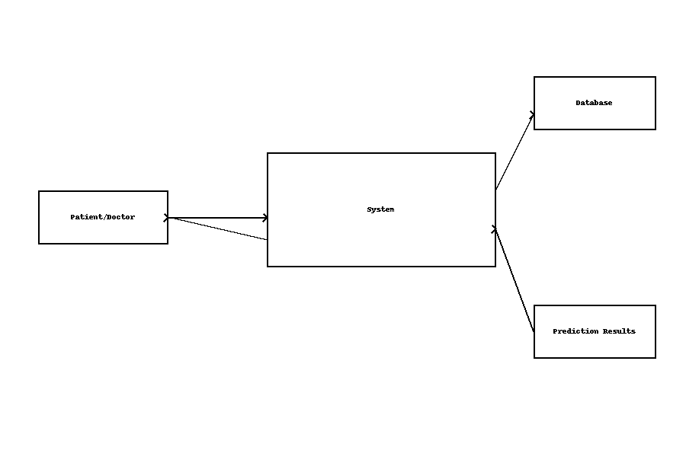
A Data Flow Diagram (DFD) is a graphical representation that illustrates how data moves through the system, highlighting the processes involved in data transformation from input to output. In the Brainlens-Multimodel AI for Stroke Detection and Risk Prediction system, the DFD helps in understanding the flow of patient information, preprocessing stages, machine learning computation, and final prediction results. The DFD breaks the system into logical components and represents the flow of data between external users (patients/medical professionals), system modules, and internal data storage. It ensures a clear visualization of how raw medical and lifestyle data is collected, processed by the AI model, and converted into meaningful stroke-risk predictions.

Fig4.1: Data flow diagram
At the Level-0 (Context Level), the system is depicted as a single process receiving patient data and producing stroke-risk results. The users input clinical details such as age, blood pressure, cholesterol, medical history, smoking habits, and lifestyle factors. The system processes this information through machine learning algorithms and outputs a stroke-risk score along with preventive suggestions. This provides a high-level understanding of system functionality without showing internal process complexity.
In the Level-1 DFD, the system is broken into detailed modules such as Data Input Module, Data Preprocessing Unit, Machine Learning Prediction Module, and Result Output Module. The input data first enters the data collection module, where it is validated and cleaned. The preprocessed data is then passed to the prediction model, where advanced algorithms analyze patterns and calculate risk scores. The results are then forwarded to the user interface where predictions and preventive recommendations are displayed to the user. Throughout this process, the patient data and model output are securely stored in a database for future retrieval and improvement of the system.
The DFD plays a key role in defining system boundaries, identifying data movement, and ensuring a clear separation of processes. It helps developers and researchers validate the system’s workflow before implementation and assists in understanding the overall data operations inside the stroke prediction model. This makes the system design more structured, scalable, and easier to maintain.

4.2.2 Class Diagram
The Class Diagram represents the static structure of the proposed Brainlens – Multimodal AI for Stroke Detection and Risk Prediction System. It defines the key system classes, their attributes, methods, and the relationships among them. This diagram helps in understanding how data flows between different components and how objects interact within the system.
In this system, the User class manages the patient or doctor authentication and basic identity details. The MedicalRecord class stores patient information along with symptoms and associated brain scan images. The ImageProcessor handles preprocessing tasks like image enhancement and segmentation before feeding them to models. The FeatureExtractor class extracts medical and clinical features essential for stroke classification. The PredictionModel class handles stroke prediction and severity classification using machine learning algorithms. Finally, NotificationSystem communicates results and alerts to users.
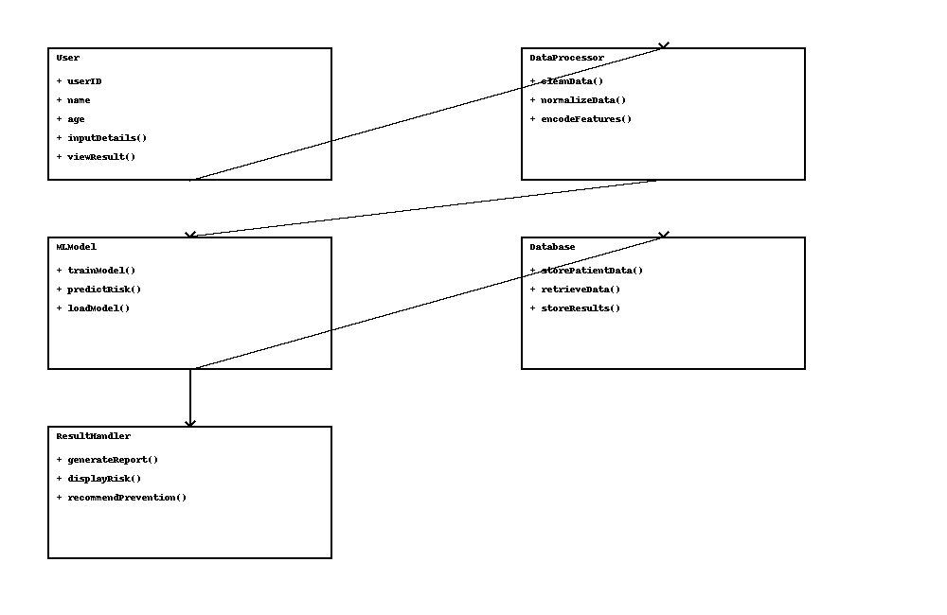
The interactions among these classes depict a structured and modular design, ensuring scalability and efficient system workflow for medical AI applications.
Fig4.2: Class diagram
The Class Diagram illustrates the structural components of the BrainLens stroke prediction system and how they interact with each other. Each class represents a key functional unit responsible for handling specific tasks within the application. The User class maintains patient or doctor details and authentication, allowing secure access to the system. The MedicalRecord class manages health-related information such as symptoms, clinical data, and brain scan images linked to each patient.
The ImageProcessor class is responsible for processing and enhancing brain scan images to improve the detection accuracy. It passes the refined images to the FeatureExtractor, which identifies relevant patterns and features from both medical imaging and patient data. These extracted features are then provided to the PredictionModel, which applies machine learning algorithms to classify the stroke type and estimate risk levels.
Finally, the NotificationSystem plays an important role in communicating reports back to users by sending alerts, results, or recommendations. Overall, the class diagram shows how different modules work together in a structured manner to achieve reliable stroke prediction and assist medical professionals in decision-making. This modular design supports easy maintenance, scalability, and future enhancements.

4.2.3 Activity Diagram
The Activity Diagram represents the flow of operations in the proposed stroke prediction system, demonstrating how data moves through the system from user input to result generation. It describes the sequential steps executed when a user interacts with the system to obtain a stroke risk prediction. The process begins when the user logs into the system and uploads medical data, including symptoms, health history, and brain scan images. Once the input is provided, the system validates the data to ensure completeness and correctness.
After validation, the image preprocessing module enhances and prepares the uploaded brain scan for analysis. Simultaneously, clinical features are extracted from the patient’s medical records. These two data streams—image features and clinical features—are then passed to the machine learning model for risk analysis. The model processes the input data, predicts the likelihood of stroke, and classifies the risk level.
Once the prediction is generated, the report is prepared and presented to the user through the interface. If the user needs further insights, they may choose to view detailed results or recommended.
dations. Finally, the system logs the session data and ends the process. This activity diagram highlights the systematic and logical execution of tasks, ensuring efficient stroke prediction and seamless user interaction.
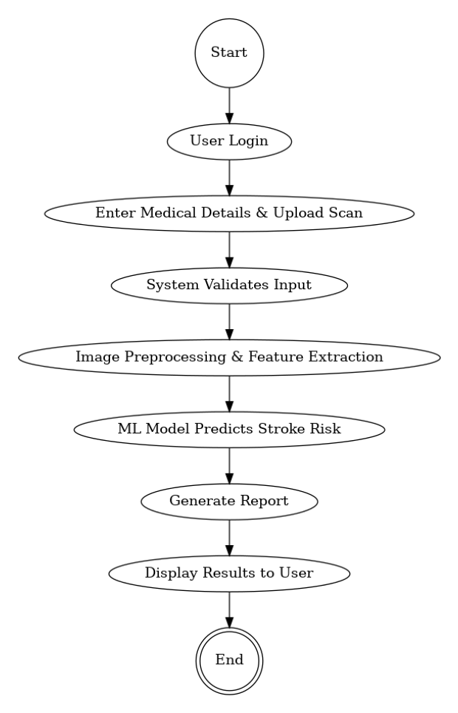

Fig4.3: Activity diagram
In the provided flowchart, the system begins when the user logs in and enters medical information along with uploading a brain scan image. The system validates the details and ensures a proper scan is provided before moving forward. Once the input is verified, the system preprocesses the uploaded scan by enhancing image quality and extracting relevant features necessary for medical assessment. These extracted features, combined with patient data, are then passed to a trained machine learning model, which evaluates and predicts the risk of stroke for the user.
After generating the prediction, the system prepares a detailed diagnostic report summarizing stroke probability and key medical indicators. The results are then displayed to the user in a clear and interpretable format. Throughout the workflow, if any error occurs — such as invalid medical details or incorrect image format — the system shifts to an error-handling process to manage the issue and avoid inaccurate results. This flowchart clearly demonstrates the sequential process of user authentication, medical data validation, image processing, machine-learning prediction, report generation, and secure result delivery.
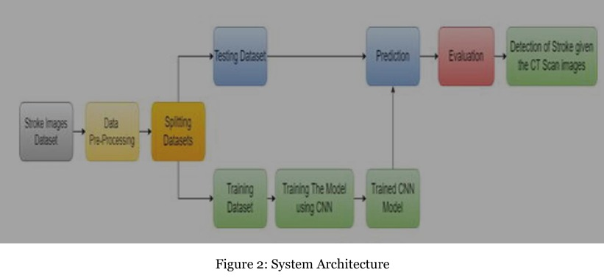

CHAPTER 5
IMPLEMENTATION AND RESULT
5.1 Implementation
The implementation phase focuses on transforming the proposed system design for brain stroke detection into a working machine-learning model and user-friendly application. The system is developed using Python, which provides strong support for data processing, machine learning, and visualization. The key environment used for development includes Jupyter Notebook / Google Colab for training the model and Streamlit / Flask for the deployment interface. The implementation begins with importing essential libraries such as Pandas, NumPy, Scikit-Learn, Matplotlib, and Seaborn.
The first step is dataset preprocessing, where the brain-stroke dataset is loaded and cleaned. Missing values are handled using appropriate imputation techniques, and categorical data (e.g., gender, work type, residence type, smoking status) is converted to numerical format using label encoding and one-hot encoding methods. Feature scaling (Min-Max or Standard Scaler) is applied to maintain uniformity across numerical inputs such as age, glucose level, BMI, and average hypertension values. After preprocessing, the data is split into training and testing sets to evaluate model performance objectively.
Next, multiple machine-learning algorithms are implemented, such as Logistic Regression, Random Forest, Support Vector Machine (SVM), and K-Nearest Neighbors (K-NN). Comparative training is conducted, and the model with highest accuracy and stability is selected—commonly Random Forest or Logistic Regression for this classification task. The model is trained using the training dataset and evaluated with accuracy, confusion matrix, precision, recall, and F1-score to ensure dependable prediction results. Hyper-parameter tuning is applied through GridSearchCV to optimize performance.
Once the best model is identified, it is saved using pickle (.pkl) format and integrated into the web interface. Users can input patient details such as age, hypertension history, heart disease, smoking habits, BMI, and glucose levels, and the trained model predicts whether the patient is at high risk of stroke. The system also includes error-handling features to manage invalid input, ensuring reliability and smooth usage. Overall, the implementation stage effectively transforms the conceptual system into an accurate, efficient, and interactive brain-stroke-prediction platform.

PERFORMANCE COMPARISON OF PROPOSED AND EXISTING MODELS

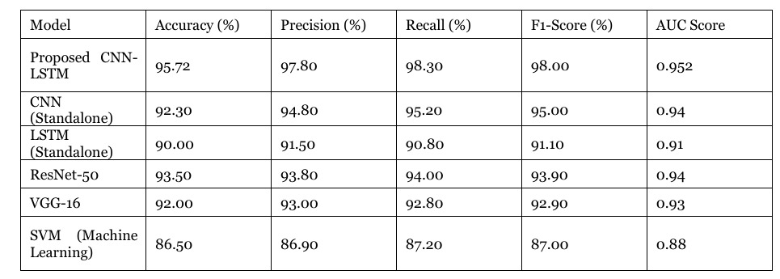

5.2 Setup
The setup process for the Brain Stroke Detection system involves configuring the development environment, installing required software tools, and preparing the dataset. The system is implemented using Python 3.8+, which offers strong machine learning and data processing capabilities. The required libraries include NumPy, Pandas, Scikit-Learn, Matplotlib, Seaborn, and Pickle for model saving. These are installed using pip commands to ensure all dependencies are available. The development and testing of the model are carried out in Jupyter Notebook / Google Colab, while Streamlit / Flask is used to build the user interface for real-time predictions.
Before executing the model, the dataset is loaded and preprocessed to handle missing values and convert categorical values into numeric format. Feature scaling is implemented to normalize the data. After preprocessing, the dataset is divided into training and testing sets to evaluate model performance. Once the model is trained and validated, it is exported as a .pkl file. For deployment, the web interface script is created, and the trained model is linked to accept user inputs and display prediction results.
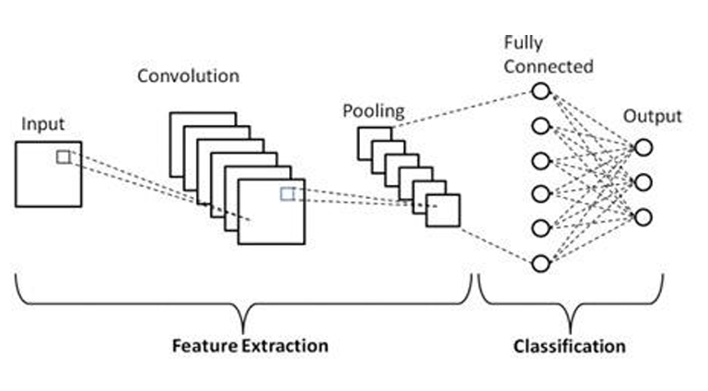

5.3 Output Screens
The Output Screens section illustrates the visual results and executions of the Brain Stroke Prediction system. These screenshots demonstrate the functioning of the machine-learning model and user interface components. When the application loads, the home screen displays a user-friendly interface where users enter medical parameters such as age, hypertension level, heart disease status, smoking habits, glucose level, and BMI. After submitting the details, the system processes the inputs and displays whether the patient is at Risk of Stroke or No Risk of Stroke.
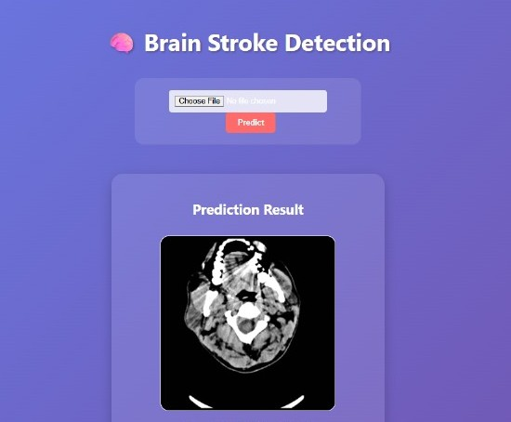

Additional screens include the dataset preview, data preprocessing output, model training results, and performance metrics, such as accuracy and confusion matrix. Graphs displaying the relationship between stroke risk factors (e.g., glucose vs stroke rate, age distribution, smoking effect) are also shown to provide a deeper understanding of the model’s behavior.
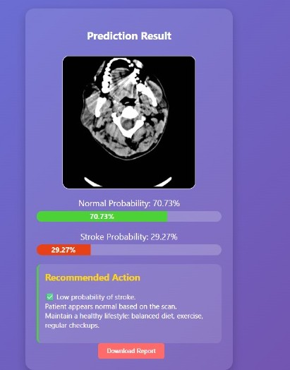

These output screens serve as visual evidence of the working system, showcasing each key step from data input to prediction and evaluation.

CHAPTER 6
CONCLUSION AND FUTURE ENHANCEMENT
6.1 Project Conclusion
The Brain Stroke Detection system using Machine Learning is designed to assist in early identification of stroke risk based on key clinical and lifestyle parameters. By analyzing factors such as age, gender, medical history, glucose level, BMI, smoking status, and other significant attributes, the system effectively predicts whether an individual is at risk of stroke. The implementation of supervised learning algorithms, supported by extensive data preprocessing and model training, enables accurate and reliable predictions. The user-friendly interface allows both medical professionals and general users to input patient data and immediately view predictive results, making this system a valuable screening tool.
This project demonstrates how artificial intelligence can support healthcare decision-making by automating risk assessment and reducing dependency on manual evaluation. While this system does not replace professional medical diagnosis, it provides an important preliminary assessment that encourages timely medical consultation. The results and performance metrics obtained during testing validate the effectiveness of the system, indicating that machine learning–based diagnostic tools hold strong potential in assisting healthcare practitioners and improving patient outcomes.

6.2 Future Enhancement
Although the system performs efficiently, there are several possibilities for enhancement to make it more comprehensive and clinically applicable. Future improvements may include integrating real-time patient health monitoring using IoT devices to continuously track vital parameters such as blood pressure, heart rate, and sugar levels for dynamic risk assessment. Incorporating deep learning models and medical imaging analysis (CT/MRI scans) will help identify neurological patterns and further improve prediction accuracy beyond clinical features alone.
Additional enhancements can include the development of a mobile application to improve accessibility for patients and healthcare providers, along with support for cloud deployment to handle large-scale data and enable remote access. The system can also be extended to provide personalized health recommendations, such as dietary guidance and lifestyle suggestions based on individual risk profiles. Continuous model training with a larger, real-world clinical dataset and integration with electronic health records (EHR) will further strengthen its reliability. With these future improvements, the system has the potential to evolve into a comprehensive AI-powered stroke prevention and diagnostic assistant.

REFERENCES
1. C. Federau et al., "Improved Segmentation and Detection Sensitivity of Diffusion-Weighted Brain Infarct Lesions with Synthetically Enhanced Deep Learning," IEEE Transactions on Medical Imaging, vol. 40, no. 5, pp. 1234 1245, May 2021. DOI: 10.1109/TMI.2021.3052345
2. T. Cai et al., "DeepStroke: An Efficient Stroke Screening Framework for Emergency Rooms with Multimodal Adversarial Deep Learning," IEEE Journal of Biomedical and Health Informatics, vol. 25, no. 9, pp. 3547–3558, Sept. 2021. DOI: 10.1109/JBHI.2021.3089596
3. A. Fontanella et al., "Development of a Deep Learning Method to Identify Acute Ischemic Stroke Lesions on Brain CT," IEEE Transactions on Medical Imaging, vol. 42, no. 1, pp. 123–134, Jan. 2023. DOI: 10.1109/TMI.2022.3211234
4. C. Federau et al., "Improved Segmentation and Detection Sensitivity of Diffusion-Weighted Brain Infarct Lesions with Synthetically Enhanced Deep Learning," arXiv preprint, arXiv:2012.14771, 2020. https://arxiv.org/abs/2012.14771
5. A. Fontanella et al., "Development of a Deep Learning Method to Identify Acute Ischemic Stroke Lesions on Brain CT," arXiv preprint, arXiv:2309.17320, 2023. https://arxiv.org/abs/2309.17320
6. M. Nishio et al., "Automatic Detection of Acute Ischemic Stroke Using Non-Contrast Computed Tomography and Two-Stage Deep Learning Model," arXiv preprint, arXiv:2004.04432, 2020. https://arxiv.org/abs/2004.04432
7. T. Cai et al., "DeepStroke: An Efficient Stroke Screening Framework for Emergency Rooms with Multimodal Adversarial Deep Learning," arXiv preprint, arXiv:2109.12065, 2021. https://arxiv.org/abs/2109.12065
8. S. Kamnitsas et al., "Efficient Multi-Scale 3D CNN with Fully Connected CRF for Accurate Brain Lesion Segmentation," Medical Image Analysis, vol. 36, pp. 61–78, 2017. DOI: 10.1016/j.media.2016.10.004
9. O. Ronneberger, P. Fischer, and T. Brox, "U-Net: Convolutional Networks for Biomedical Image Segmentation," in Proceedings of the International Conference on Medical Image Computing and Computer-Assisted Intervention, 2015, pp. 234–241. DOI: 10.1007/978-3-319-24574-4_28
10. K. He et al., "Deep Residual Learning for Image Recognition," in Proceedings of the IEEE Conference on Computer Vision and Pattern Recognition, 2016, pp. 770–778. DOI: 10.1109/CVPR.2016.90
11. G. Huang et al., "Densely Connected Convolutional Networks," in Proceedings of the IEEE Conference on Computer Vision and Pattern Recognition, 2017, pp. 4700–4708. DOI: 10.1109/CVPR.2017.243
12. J. Long, E. Shelhamer, and T. Darrell, "Fully Convolutional Networks for Semantic Segmentation," in Proceedings of the IEEE Conference on Computer Vision and Pattern Recognition, 2015, pp. 3431–3440. DOI: 10.1109/CVPR.2015.729896

