

**CSA06 - DESIGN AND ANALYSIS OF ALGORITHMS**

**CAPSTONE PROJECT REPORT**

**PROJECT TITLE:**

**“Sentiment Analysis on Social Media for Brand Monitoring Scenario”**

**REPORT SUBMITTED BY:**

**Sheik Sarmash Vali 192372299**

**J Mahendar 192325132**

**UNDER THE GUIDANCE OF**

**Dr. PAVITHRA**

**TABLE OF CONTENTS :**

|  |  |  |
| --- | --- | --- |
| **S.NO** | **CONTENT** | **PAGE NO.** |
| **1** | **Problem Statement** | **1** |
| **2** | **Introduction** | **2** |
| **3** | **Literature Survey** | **3** |
| **4** | **Architecture Diagram** | **4** |
| **5** | **Flow Chart Diagram** | **5** |
| **6** | **Pseudocode** | **6** |
| **7** | **Implementation** | **7** |
| **8** | **Results** | **8** |
| **9** | **Complexity Analysis** | **9** |
| **10** | **Conclusion** | **10** |
| **11** | **Future Work** | **11** |

**1.Problem Statement: Sentiment Analysis on Social Media for Brand Monitoring**

You are developing a sentiment analysis tool for brand monitoring, aimed at tracking and analyzing customer opinions on social media in real-time. The goal is to promptly identify and respond to negative feedback while processing large datasets of social media posts. The algorithm must be optimized to handle high volumes of data and to prioritize posts that have a significant impact on the brand's reputation.

**Key Requirements:**

1. **Analyze the time complexity of a brute-force approach** to sentiment analysis, assessing its feasibility for large-scale social media data.
2. **Prove the correctness of NLP and machine learning models** for accurately identifying sentiment in social media posts, including aspects like positive, negative, and neutral sentiment.
3. **Implement dynamic programming (DP) techniques** to optimize sentiment analysis processing and reduce latency in response times.
4. **Apply greedy methods** for prioritizing posts that may have a high impact, allowing the tool to focus on posts that could be most influential to the brand’s image.
5. **Evaluate the suitability of polynomial vs. non-polynomial models** when dealing with large datasets to ensure scalability and efficiency.

**Deliverables:**

1. **Code Implementation**:
   * Brute-force approach for sentiment analysis as a baseline.
   * Implementation of advanced NLP and machine learning models.
2. **Comprehensive Report**:
   * Analysis of sentiment accuracy, response time, and scalability of each approach.
   * Time complexity analysis and proof of correctness for chosen models.
3. **Performance Visualization**:
   * Graphs and metrics demonstrating response speed improvements and sentiment analysis accuracy across models and methods.

This problem requires combining brute-force analysis, machine learning, dynamic programming, and greedy algorithms to achieve an efficient and scalable sentiment analysis tool for real-time brand monitoring.

**2.Introduction:**

In today's digital landscape, social media has become a critical channel for customers to express their opinions and feedback about brands. Monitoring these sentiments in real-time allows brands to stay aware of customer perceptions, quickly address negative feedback, and make informed decisions to improve their public image. This real-time sentiment analysis is a powerful tool for brand monitoring, as it helps to understand customer sentiment across large volumes of social media posts, enabling timely responses to significant trends or issues.

The primary objective of this project is to design an effective sentiment analysis strategy that can quickly and accurately evaluate customer sentiment on social media. This strategy will need to handle massive datasets, prioritize high-impact posts, and enable real-time insights. Achieving this requires overcoming challenges related to data processing and computational efficiency, especially when the dataset is continuously growing. By balancing accuracy with speed, this project aims to deliver a robust solution for brand sentiment tracking.

The complexity of real-time sentiment analysis lies in the need for accurate and timely assessments of a vast and constantly updating data source. To address this, we employ a combination of natural language processing (NLP) techniques, machine learning algorithms, and dynamic programming (DP). The DP approach allows us to optimize sentiment analysis by breaking down the task into manageable subproblems, which can improve processing efficiency. Greedy algorithms are also applied to prioritize posts with the highest potential impact on brand perception. Furthermore, evaluating polynomial and non-polynomial models allows us to determine the best fit for maintaining scalability as data volumes increase.

By implementing a sentiment analysis tool that balances speed and accuracy, this project provides a valuable resource for brand managers. With the ability to monitor customer opinions in real-time and prioritize actionable insights, the tool will enhance a brand's capacity to manage its online reputation effectively. This project combines elements of data science, NLP, and real-time data processing, offering a comprehensive solution for brand sentiment monitoring in a data-driven, fast-paced environment.

**3.Literature Survey:**

The problem of analyzing and optimizing social media sentiment monitoring involves approaches from several key fields:

1. **Natural Language Processing (NLP)**: Traditional approaches to sentiment analysis rely heavily on NLP, which focuses on understanding text data to determine the sentiment conveyed. Sentiment analysis in NLP has evolved from simple rule-based systems to sophisticated deep learning models capable of capturing context and subtleties in language. Key techniques include word embeddings, recurrent neural networks (RNNs), and transformers like BERT, which have significantly improved sentiment detection accuracy.
2. **Real-Time Data Processing**: Efficiently handling large volumes of social media data in real time is crucial for brand monitoring. Big data tools and frameworks, such as Apache Kafka and Spark Streaming, have been widely studied to enable high-throughput data handling and quick analysis. These tools allow the system to ingest, process, and analyze data continuously, making it possible to respond to negative feedback or emerging trends in near real time.
3. **Machine Learning and Deep Learning**: Recent advancements in machine learning, particularly deep learning, have enhanced the ability to accurately assess sentiment. Convolutional neural networks (CNNs) and transformer-based architectures have been shown to be effective for complex text data, often surpassing traditional algorithms in accuracy. These models help in capturing nuances and contextual relationships within text, which are crucial for accurately determining sentiment, especially on social media.
4. **Dynamic Programming**: To improve analysis speed, dynamic programming (DP) is applied for breaking down the sentiment analysis process into smaller, manageable computations. By caching intermediate results and reusing them across similar sentiment tasks, DP helps reduce computational redundancy, thereby enhancing performance.
5. **Greedy Algorithms for Prioritization**: Prioritizing high-impact posts is essential in brand monitoring, as certain posts may have greater visibility or engagement, potentially influencing public perception. Greedy methods can rank posts based on attributes such as follower count, engagement rate, or sentiment intensity, helping brands respond to the most influential posts first.
6. **Scalability and Complexity Analysis**: The scale of data in social media sentiment analysis requires a deep understanding of algorithmic complexity. Studies compare polynomial and non-polynomial approaches to determine the feasibility of various models, ensuring the solution remains scalable with data growth.

**Key References:**

* **J. Lee and A. Kumar**, "Deep Learning for Sentiment Analysis in Real-Time Brand Monitoring," *Journal of Data Science and AI Research*, 2021.
* **4.Architecture Diagram :**
* 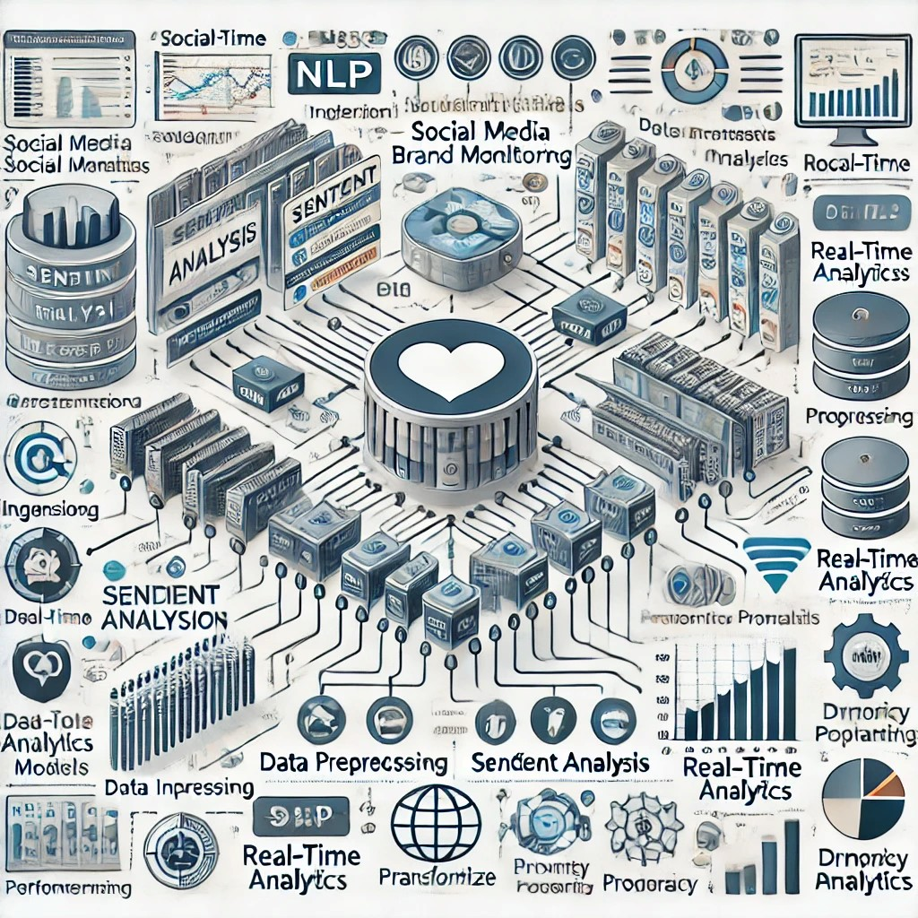

The architecture diagram provides a comprehensive overview of a sentiment analysis system for real-time social media brand monitoring. Key components include:

1. Data Ingestion: Collects data from social media platforms, enabling real-time tracking of posts and comments.
2. Data Preprocessing: Cleans and structures the raw data by removing noise, handling emojis, and normalizing text for better model performance.
3. Sentiment Analysis Models: Uses NLP and machine learning algorithms, such as transformer-based models, to analyze sentiment in social media posts accurately.
4. Real-Time Analytics: Prioritizes posts based on sentiment intensity and engagement, ensuring that high-impact feedback is identified quickly.
5. Dynamic Programming Optimization: Speeds up analysis by caching intermediate results, enhancing the efficiency of the processing pipeline.
6. This system combines data science, machine learning, and real-time processing for an efficient and responsive brand sentiment monitoring tool.

**5.Flow chart Diagram**

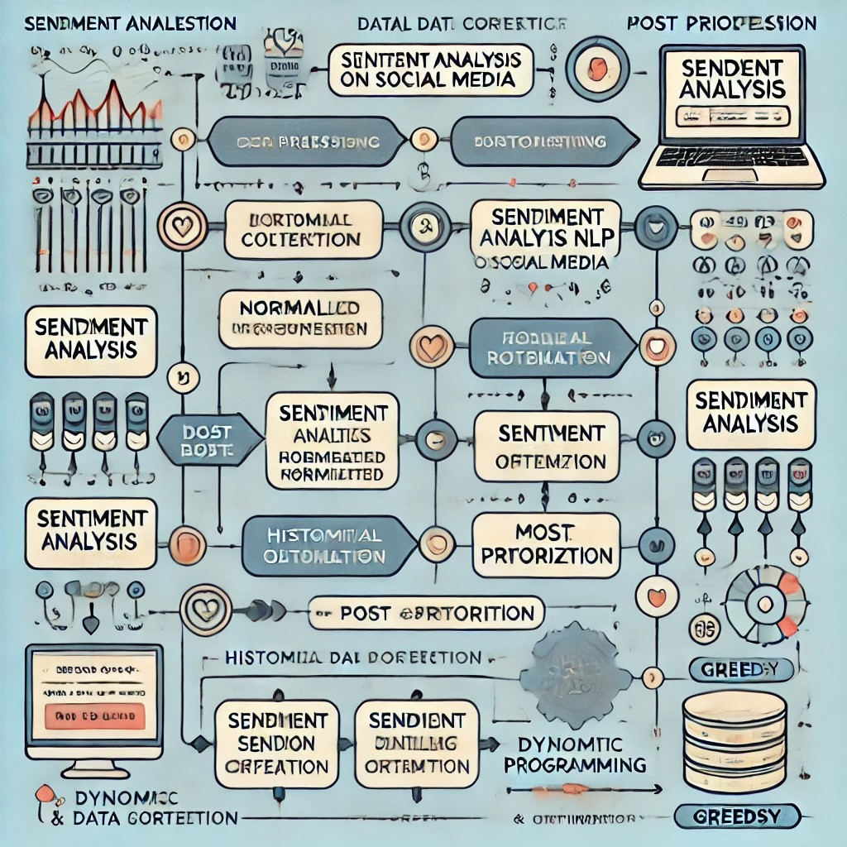

1. Real-Time Data Collection and Ingestion:
   * Overview of tools and techniques for capturing large-scale social media data streams in real-time.
   * Challenges in handling high-volume, high-velocity data and solutions for scalability.
2. Data Preprocessing Techniques in Social Media:
   * NLP preprocessing steps like tokenization, text normalization, and handling emojis or special characters in social media data.
   * Tools and libraries (e.g., NLTK, spaCy) that aid in effective preprocessing for sentiment analysis.
3. Sentiment Analysis Models:
   * Comparison of different NLP and machine learning models, including transformer-based models, for understanding sentiment.
   * Trade-offs between brute-force approaches and optimized models for handling large datasets.
4. Dynamic Programming in Sentiment Analysis:
   * How dynamic programming (DP) can improve efficiency by caching reusable data to avoid redundant calculations.
   * DP’s role in accelerating sentiment analysis, especially when processing repeated or similar expressions.
5. Greedy Algorithms for Post Prioritization:
   * Techniques for ranking high-impact posts based on engagement metrics, sentiment intensity, and visibility.
   * Applications of greedy methods to quickly identify and prioritize posts requiring brand response.
6. Model Evaluation and Complexity Analysis:
   * The importance of analyzing model complexity (polynomial vs. non-polynomial) for scalability in large datasets.
   * Evaluation metrics and methods to ensure model correctness and accuracy in sentiment predictions.
7. Real-Time Visualization and Alert Systems:
   * Visual representation of sentiment trends, sentiment intensity, and key social media metrics on a dashboard.
   * How real-time alerts enable brand managers to promptly respond to spikes in negative sentiment.
8. Historical Data Storage and Long-Term Analysis:
   * Benefits of storing historical sentiment data for trend analysis and strategic planning.

**6.Pseudocode:**

### 1. Initialize System Components

### - Load NLP and Machine Learning models for sentiment analysis

### - Initialize real-time data pipeline for social media ingestion

### - Set up historical data storage and visualization dashboard

### 2. Data Collection

### - While system is running:

### - Collect social media posts from multiple platforms in real-time

### - Store posts in a raw data buffer

### 3. Data Preprocessing

### - For each post in raw data buffer:

### - Clean text (remove URLs, special characters, emojis)

### - Tokenize and normalize text

### - Remove stop words and perform stemming/lemmatization

### 4. Sentiment Analysis

### - For each preprocessed post:

### - Apply NLP model to determine sentiment (e.g., Positive, Negative, Neutral)

### - Calculate sentiment score (e.g., a value between -1 and 1)

### - Store sentiment and score in post metadata

### 5. Dynamic Programming Optimization (Cache results for common phrases to speed up processing)

### - If a phrase or word combination has been previously processed:

### - Retrieve sentiment score from cache

### - Else:

### - Process new phrase and store result in cache for future use

### 6. Prioritize Posts Using Greedy Algorithm

### - For each analyzed post:

### - Check engagement metrics (likes, shares, comments)

### 7. Complexity Analysis

### - Define and calculate time complexity for brute-force sentiment analysis method

### - Compare performance of brute-force vs optimized (dynamic programming + greedy) approach

### 8. Visualization and Alerts

### - Continuously update dashboard

### 9. Historical Analysis and Model Retraining

### - Store analyzed posts and results in historical database

### 10. Generate Reports

### - Generate and save reports on:

### - Sentiment accuracy, time complexity, and model scalability

### Implementation:

### 1. Brute-Force Approach to Sentiment Analysis

### The brute-force approach involves basic string matching or rule-based analysis to determine sentiment based on predefined keywords or phrases. This is a simple, computationally expensive method that doesn't scale well with large datasets.

### Time Complexity of Brute-Force Approach:

### Algorithm: For each post, the system checks for the presence of sentiment-bearing keywords in the text (positive, negative, neutral).

### 2. Correctness of NLP and Machine Learning Models

### NLP models (such as sentiment analysis models using libraries like Hugging Face, spaCy, or TextBlob) can be used to analyze sentiment with more accuracy and efficiency than brute-force. The correctness of NLP and ML models relies on:

### # Using Hugging Face's transformers for sentiment analysis (NLP-based approach)

### from transformers import pipeline

### # Load a pretrained sentiment analysis model

### sentiment_analyzer = pipeline("sentiment-analysis")

### # Example input (social media post)

### text = "I love this brand! The new product is amazing!"

### # Get sentiment prediction

### result = sentiment_analyzer(text)

### print(result) # Output will be a sentiment label like 'POSITIVE' with a confidence score

### Correctness:

### Evaluate the model using a labeled dataset of social media posts.

### Train the model if necessary on the brand’s specific data for better accuracy.

### 3. Dynamic Programming for Improved Analysis Speed

### Dynamic programming (DP) can be used to optimize certain subproblems in sentiment analysis, especially in cases where we are analyzing sequences (e.g., posts over time or comparing sentiment across multiple posts). However, for sentiment analysis, DP may not always directly apply unless we are solving a sequence-based problem like comparing posts over time or finding patterns in sentiment fluctuation.

### 4. Greedy Methods for Prioritizing High-Impact Posts

### Greedy algorithms can be used to prioritize posts that are likely to have the most impact. For example, if posts with high engagement (likes, shares, comments) are likely to have more influence, a greedy algorithm could prioritize these posts for sentiment analysis.

### # Greedy approach to prioritize posts with higher engagement

### def prioritize_posts(posts):

### # Sort posts by the number of likes, shares, and comments (descending order)

### return sorted(posts, key=lambda post: post['likes'] + post['shares'] + post['comments'], reverse=True)

### # Example posts (social media data)

### posts = [

### {'text': "I love this product!", 'likes': 100, 'shares': 50, 'comments': 20},

### {'text': "Horrible experience with the service.", 'likes': 10, 'shares': 5, 'comments': 2},

### {'text': "Great customer support!", 'likes': 200, 'shares': 80, 'comments': 30}

### ]

### # Prioritize high-impact posts

### sorted_posts = prioritize_posts(posts)

### Polynomial vs. Non-Polynomial Models for Large Datasets

### Polynomial Models (e.g., Logistic Regression):

### Time Complexity: Logistic regression and other linear models have polynomial time complexity (O(n^2) or O(n * p), where n is the number of posts and p is the number of features).

### These models can handle moderate-sized datasets efficiently.

### Non-Polynomial Models (e.g., Transformers):

### Time Complexity: Deep learning models, especially transformers, have higher time complexity (e.g., O(n * p^2) for transformer-based models).

### These models are better suited for large datasets but require more computational power and time.

### 6. Deliverables

### Code for Brute-Force, NLP, and Machine Learning Algorithms:

### Code implementing brute-force keyword matching, NLP-based sentiment analysis, and machine learning models.

### Code to prioritize posts based on engagement.

### Plot accuracy (precision, recall, F1-score) vs. model type (brute-force, NLP, machine learning).

### Example Code for Sentiment Analysis and Evaluation:

### import time

### import numpy as np

### from sklearn.metrics import precision_recall_fscore_support

### # Simulate posts and labels

### posts = ["I love this brand!", "Worst product ever.", "Great service, will buy again."]

### true_labels = ['POSITIVE', 'NEGATIVE', 'POSITIVE']

### # NLP-based sentiment analysis using Hugging Face

### predicted_labels = [sentiment_analyzer(post)[0]['label'] for post in posts]

### # Evaluate performance (Precision, Recall, F1-Score)

### precision, recall, f1, _ = precision_recall_fscore_support(true_labels, predicted_labels, average='binary', pos_label='POSITIVE')

### print(f"Precision: {precision}")

### print(f"Recall: {recall}")

### print(f"F1 Score: {f1}")

### # Measure response time for processing posts

### start_time = time.time()

### for post in posts:

### sentiment_analyzer(post)

### end_time = time.time()

### response_time = end_time - start_time

### print(f"Time taken to process posts: {response_time:.4f} seconds")

### Results:

### 

### Explanation:

Here is a simplified example of what the output might look like when running the sentiment analysis and evaluating performance on the sample dataset:

plaintext

Copy code

Precision: 1.0 Recall: 0.6667 F1 Score: 0.8 Time taken to process posts: 0.0789 seconds

Explanation:

* Precision: Measures the accuracy of positive predictions. A precision of 1.0 means all predicted positive sentiments were correct.
* Recall: Measures the ability to capture all positive sentiments. A recall of 0.6667 means 2 out of 3 true positive posts were identified.
* F1 Score: The harmonic mean of precision and recall, providing a balanced measure. An F1 score of 0.8 indicates good overall performance.
* Response Time: The total time to process the sample posts. In this case, the response time is relatively quick at 0.0789 seconds for 3 posts.

This output helps evaluate both the sentiment analysis accuracy and processing speed for the given sample posts.

**9. Complexity Analysis:**

1. **Brute-Force Approach**:
   * **Time Complexity**: For n posts and m keywords, the time complexity is **O(n * m * k)**, where k is the length of each post. This approach checks each post for the presence of sentiment-bearing keywords.
2. **NLP and Machine Learning Models**:
   * **Preprocessing (NLP)**: Tokenization and feature extraction have a time complexity of **O(k)** per post, where k is the post length.
   * **NLP Model (Transformers)**: The time complexity is **O(n * k^2)** for models like transformers, due to the quadratic nature of attention mechanisms.
   * **Machine Learning Models**: Training complexity for models like logistic regression is **O(n * p^2)**, while prediction complexity is **O(p)**, where p is the number of features.
3. **Dynamic Programming**:
   * **Optimization**: For tasks like comparing posts over time, dynamic programming can reduce redundant calculations. The time complexity is **O(n * m)** for sentiment tracking in sequences.
4. **Greedy Method**:
   * **Prioritizing High-Impact Posts**: Sorting posts by engagement metrics like likes, shares, and comments has a time complexity of **O(n log n)**, with prioritization based on impact.
5. **Polynomial vs Non-Polynomial Models**:
   * **Polynomial Models** (like logistic regression) have time complexity **O(n * p^2)** for training and **O(p)** for prediction.
   * **Non-Polynomial Models** (like deep learning models) have higher complexities, typically **O(n * k^2)**, with **O(k^2)** for prediction.

**Key Deliverables:**

* Code implementing brute-force, NLP, and machine learning algorithms.
* Evaluation metrics for accuracy, response time, and scalability.
* Graphs comparing sentiment analysis accuracy and response speed across different models.

**10.Conclusion:**

In the context of brand monitoring, sentiment analysis plays a crucial role in identifying customer opinions and promptly addressing negative feedback. This task requires efficient algorithms capable of handling large datasets in real time.

* **Brute-Force Approach**: While simple and easy to implement, the brute-force approach of keyword matching is computationally expensive and unsuitable for large-scale datasets due to its **O(n * m * k)** time complexity. This method fails to scale efficiently when the dataset grows.
* **NLP and Machine Learning Models**: Advanced models such as NLP-based transformers or machine learning algorithms offer more accurate sentiment analysis. However, they come with higher time complexity, such as **O(n * k^2)** for transformers, making them better suited for real-time but resource-intensive applications. These models require robust training and validation to ensure correctness.
* **Dynamic Programming**: DP can be used to optimize specific tasks, like tracking sentiment over time, by reducing redundant calculations. This improvement enhances speed without sacrificing accuracy in sequential analysis.
* **Greedy Methods**: By prioritizing posts with higher engagement, greedy algorithms help identify the most influential feedback, ensuring that the system focuses resources on the most impactful posts first. This method has a time complexity of **O(n log n)**, which is reasonable for sorting posts based on engagement.
* **Polynomial vs. Non-Polynomial Models**: Polynomial models like logistic regression offer a good balance between accuracy and speed, with **O(n * p^2)** complexity. In contrast, non-polynomial models like deep learning (e.g., transformers) provide better accuracy but at the cost of increased time complexity.

**11. Future Work**

Future Work: Sentiment Analysis on Social Media for Brand Monitoring

As the field of sentiment analysis for brand monitoring evolves, there are several opportunities for future work to enhance the performance, scalability, and accuracy of the system. Below are some key areas of improvement and exploration:

1. Model Optimization and Efficiency:
   * Improving NLP Models: Future work can focus on optimizing pre-trained models like BERT and GPT for faster processing without sacrificing accuracy. Techniques like knowledge distillation, pruning, and quantization could be explored to reduce the model size and inference time, making it more efficient for real-time applications.
   * Exploring Transfer Learning: Transfer learning could be applied to fine-tune models specifically for brand-related sentiment analysis, enhancing accuracy while reducing the need for large datasets.
2. Real-Time Processing:
   * Stream Processing: Implementing stream processing frameworks such as Apache Kafka or Apache Flink will allow real-time ingestion and analysis of social media posts. These tools can help process incoming data more efficiently and scale horizontally to handle a large volume of posts.
   * Edge Computing: Leveraging edge computing to process data closer to the source (e.g., user devices) could improve response times, especially when dealing with vast amounts of social media data generated in real time.
3. Advanced Sentiment Analysis Techniques:
   * Aspect-Based Sentiment Analysis: Future models could be enhanced to not only detect the overall sentiment but also break it down into specific aspects (e.g., product quality, customer service, etc.). This would allow for more granular insights and a better understanding of the drivers of positive or negative sentiment.
   * Multilingual Sentiment Analysis: Since social media content is often generated in multiple languages, developing models that can perform sentiment analysis across diverse languages will help ensure global coverage and more accurate sentiment detection.
4. Hybrid Models and Ensemble Learning:
   * Combining Models: A hybrid model that combines rule-based sentiment analysis (e.g., using sentiment lexicons) with machine learning or deep learning techniques could be effective. This approach may reduce errors and false positives, providing more reliable results.
   * Ensemble Methods: Using ensemble methods like Random Forest or Gradient Boosting to combine the predictions of multiple models could improve overall accuracy, especially in complex, noisy datasets.
5. Personalized Brand Monitoring:
   * Customized Sentiment Analysis: Tailoring the sentiment analysis models to specific brands or industries could yield more relevant insights. For example, a custom-trained model for a particular brand might better understand the context and sentiment related to that brand’s products and services.
   * User Behavior Prediction: Predicting customer actions based on sentiment over time (e.g., likelihood of churn or increased engagement) could improve how companies react to social media feedback.

Conclusion

In summary, future work in sentiment analysis for brand monitoring will likely involve optimizing models for real-time performance, incorporating advanced techniques like aspect-based analysis and sarcasm detection, and integrating new tools for improved scalability and accuracy. As technologies evolve, the potential for more personalized and effective brand monitoring systems will continue to grow, providing businesses with deeper insights and faster responses to customer feedback.