CREATION OF CI/CD PIPELINE

* To Create Code Pipeline log into aws management console .
* Search for the Code Pipe line in the search bar then click on it

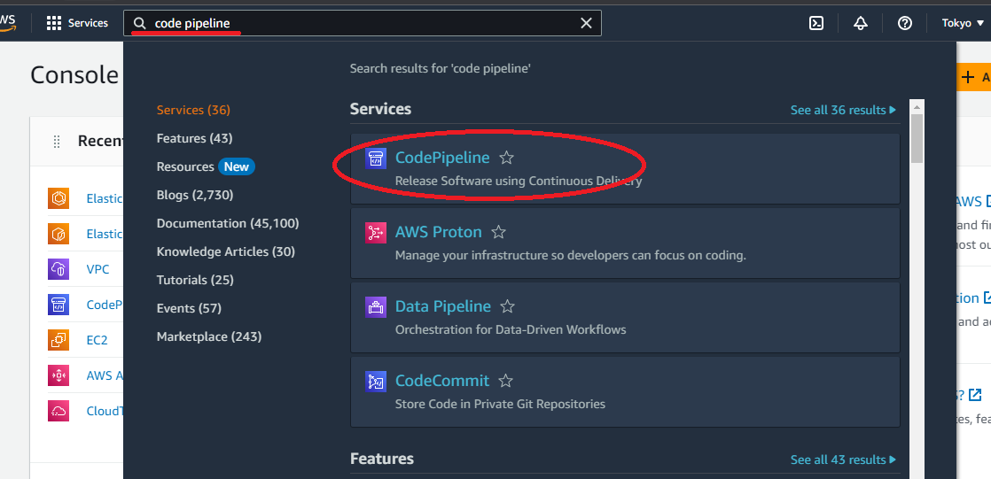

* Then click on create pipeline this will land us in the choose pipeline settings page

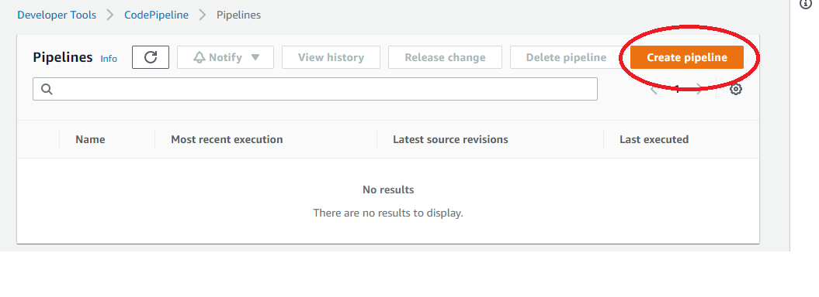

1. Enter the name of the pipeline
2. Click on the existing service role button

|  |
| --- |
| Note :- If we don’t have existing role Create the new role by clicking on new service role button |

1. Select the suitable role arn from the drop down
2. Click on next

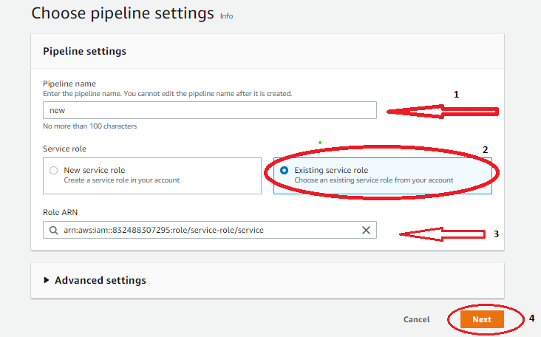

* As we click on next that will land us in add source stage page
* Select the provider form the source provider drop down in our case it is github (version 1)
* Click on connect to git hub

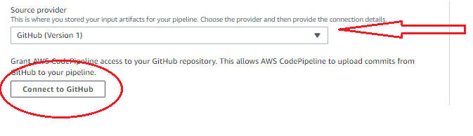

That will pop up a window saying **processing oAuth request** click on confirm button

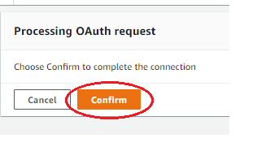

* Select the

1. Repo name from the drop down
2. Branch name from drop down
3. Select AWS code pipeline button
4. Click on next button

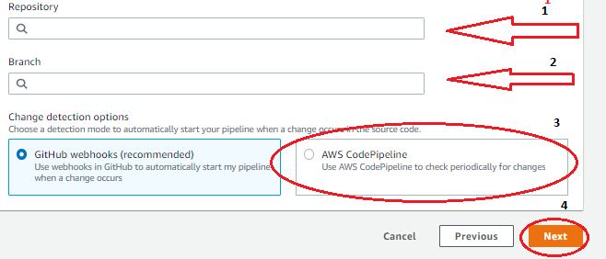

* As we click on next we will be landed in Add build stage page

Select the

1. Build provider from drop down
2. Select region
3. Select the project name from the existing projects
4. Select build type as single build
5. Select build type and then click on next button

|  |
| --- |
| Note:- If the requirement is different from the existing project then create new project by clicking on Create project button |

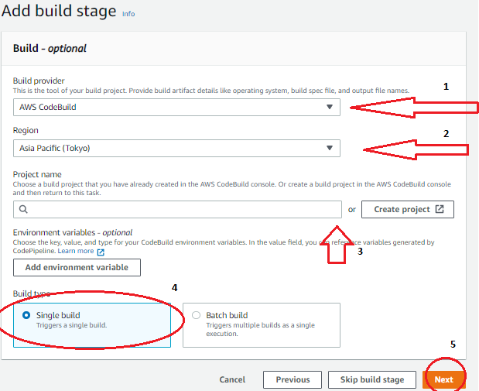

* This will land us in add deploy stage page form there select deployment provider in our case we are skipping this stage by clicking on skip deploy stage button

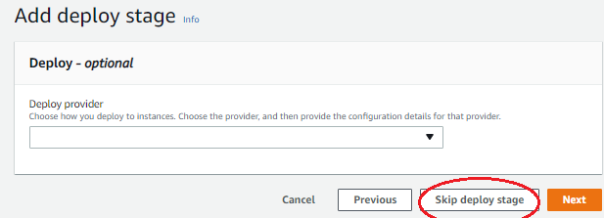

Then click on skip button

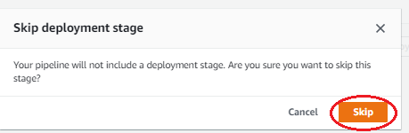

* This will land us in Review page then finally Review the configuration and click on create pipeline button at the bottom of the page

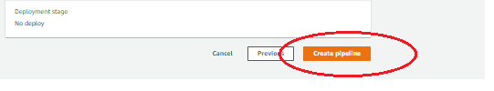

This will create the code pipeline with the given configurations