**PROJECT REPORT ON**

**NGO**

# INDUSTRIAL TRAINING (JAN 2020-MAY 2020)

# Submitted in partial fulfillment for the award of

DEGREE OF MASTER

IN

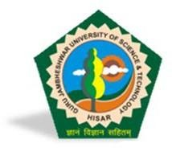 **COMPUTER APPLICATIONS**

# SESSION: 2017-2020

### Under the guidance of *Submitted BY:*

### Mr. Manjit Singh Mahender

**(Director) Roll. No. 170010120035**

**MCA**

**6THSemester**

**GURU JAMBHESWAR UNIVERSITY OF SCIENCE AND TECHNOLOGY**

**HISAR-125001(HARYANA)**