1. Assignment 1: Problem Statement: Install centos 6.4 in virtual box from ISO image
   * Assignment 1: completed as shown below.
2. Name of machine ed
   * 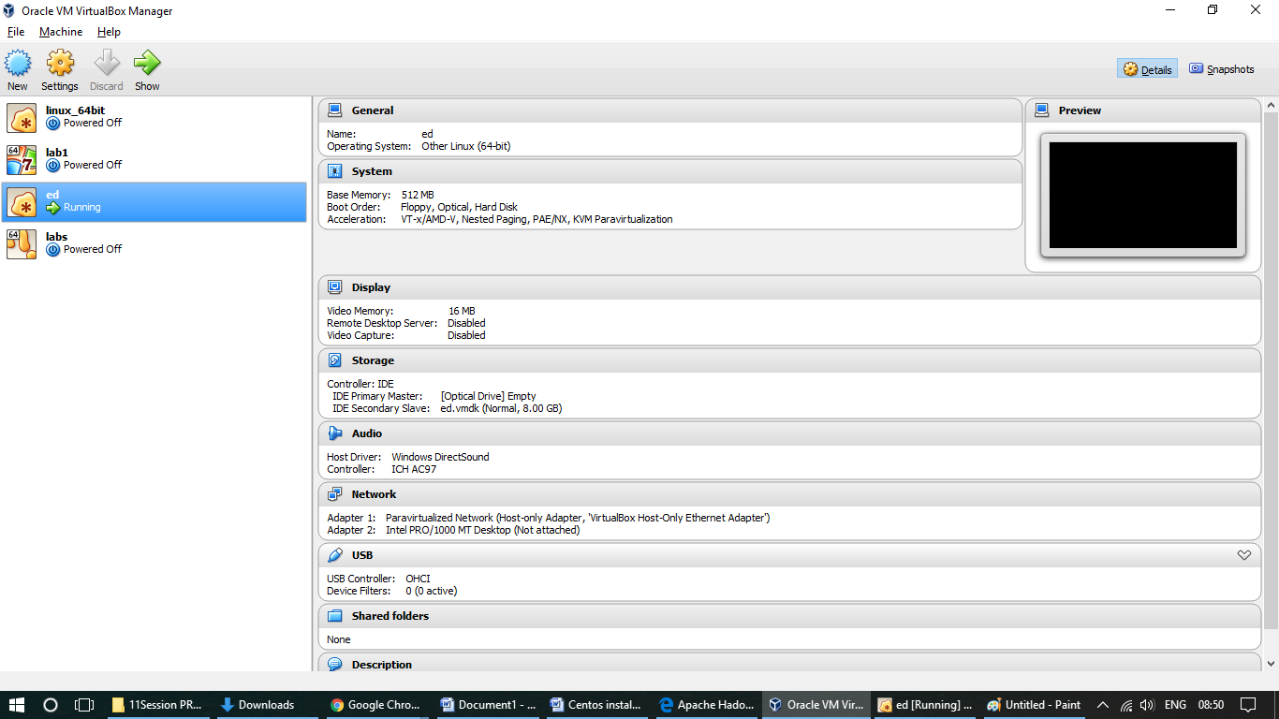
   * 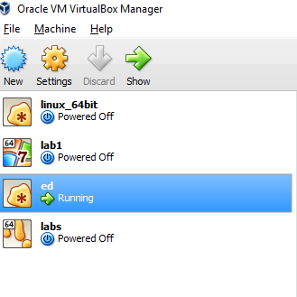
   * 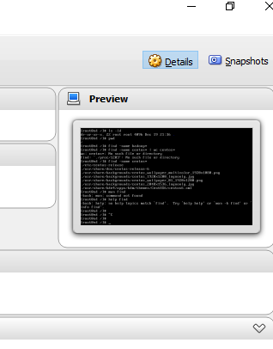
3. centos 6.8 64 bit installation is completed
4. Name of user root password \*\*\*\*\*\*
5. [ root@ed ~]#
6. ls –a command is working
7. ls –la resulting
   * 98 files
8. ls –ld resulting in 22 files at root
9. cd /etc
10. ls –ld -> 63 files present in /etc directory
11. hostname command is resulting
    * ed
12. ifconfig is resulting in
    * loopback ip 127.0.0.1
13. ls host\* is resulting
    * host hosts.conf hosts.allow hosts.deny
14. find –name hadoop\* resulting
    * nothing
15. find –name centos\* resulting
    * 7 files in
    * ./etc and ./usr directory