Malloc( )

void *malloc(size_t size)
malloc() allocates memory in size bytes and returns pointer to the allocated memory. Malloc() internally invokes brk or mmap system call.

In dlmalloc, when two threads call malloc at same time, only one thread can enter into critical section because freelist data structures were shared among all the threads so memory allocation used to take a lot of time in multithreaded application.
While in ptmalloc, each thread maintains a seprate heap, so allocating memory is faster.

When we invoke malloc() in main program, heap memory is created by increasing program break location(using brk system call). Brk system call will allocate 132K of memory, irrespective of what user has requested(Based on user requested size brk or mmap will be invoked, those conditions are listed below). This continuous heap region is called main arena. In particular, if main program calls malloc, the given contiguous space is known as main arena and if thread invokes malloc, then corresponding continuous space is known as thread arena. There is limit on number of arenas can be created. Because any application can create any number of threads, so mapping each arena to each thread is a very huge task, so restriction is applied based on number of cores.
For 32 bit systems:
Number of arena = 2 * number of cores.
For 64 bit systems:
Number of arena = 8 * number of cores.

narenas_limit = NARENAS_FROM_NCORES (n); //glibc malloc code
(where n is number of cores in machine)

If main arena space runs out of space, it can grow again by moving the break location. For main arena, whenever space runs out, only brk location is increased to avail more memory.
Whenever memory is freed using free() library function, virtual addresses are not released to the operating system, they are released to the malloc() function.

In glibc malloc, freelist data structures are known as bins. When program again invokes malloc(), memory is not again requested from kernel, instead malloc() will try to find a free block from these bins, if found the corresponding address will be returned to user.

When main() calls malloc() for the first time, main arena which is already created is used.
(Exact flow will be discussed further).
static struct malloc_state main_arena =
{
.mutex = MUTEX_INITIALIZER,
.next = &main_arena
};

Mainly, malloc will have 3 data structures
- heap_info data structure (Included in arena.c)
A single thread arena can have multiple heaps. Memory is allocated always using mmap(). Initially, when malloc is invoked, only one heap will be there. When you run out of space for this heap, then once again, another heap is created.
Applicable only for thread arena. Main arena will never have multiple heaps so no heap_info data structure.

- malloc_state data structure (Included in malloc.c)
A thread arena can have multiple heaps, but for all those heaps, single arena header is there i.e. malloc state.
This structure contains information about fastbins, top chunk, last_remainder, binmap, etc.

- malloc_chunk data structure (Included in malloc.c)
A heap is divided into many chunks based on user request. Each chunk will be having it's descriptor i.e. malloc_chunk.

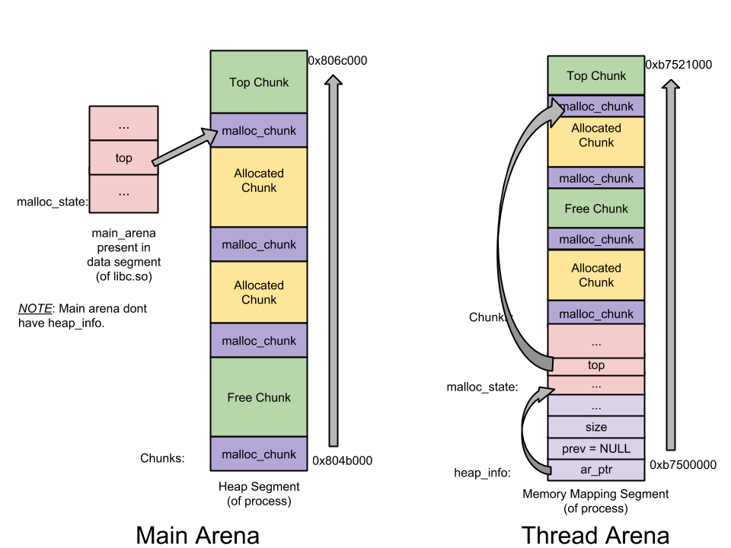

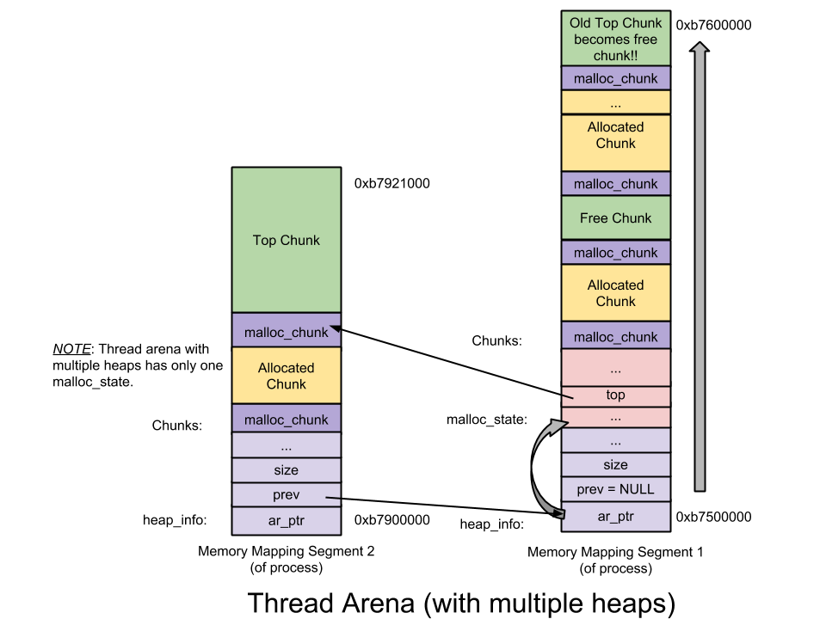
Chunk in malloc() are of 4 types
- Allocated chunk

chunk-> +-+-+-+-+-+-+-+-+-+-+-+-+-+-+-+-+-+-+-+-+-+-+-+-+-+-+-+-+ |
Size of previous chunk, if unallocated (P clear) | |
+-+-+-+-+-+-+-+-+-+-+-+-+-+-+-+-+-+-+-+-+-+-+-+-+-+-+-+-+- |
| Size of chunk, in bytes |A|M|P| |
mem-> +-+-+-+-+-+-+-+-+-+-+-+-+-+-+-+-+-+-+-+-+-+-+-+-+-+-+-+-+--|
| User data starts here... |
. |
. (malloc_usable_size() bytes) |
. |
nextchunk-> +-+-+-+-+-+-+-+-+-+-+-+-+-+-+-+-+-+-+-+-+-+-+-+-+-+-+-|
| (size of chunk, but used for application data) |
+-+-+-+-+-+-+-+-+-+-+-+-+-+-+-+-+-+-+-+-+-+-+-+-+-+-+-+-++-|
| Size of next chunk, in bytes |A|0|1| |

P – This bit is set when previous chunk is unallocated. If previous bit is set, it will contain data of the previous chunk. (PREV_INUSE)
M – This bit is when chunk is mmap'ed (IS_MMAPED).
A – Set when thread arena, 0 if main arena(NON_MAIN_ARENA).
Mem is the pointer which is returned to the user. Why 8 byte alignement, because last 3 bits are used for flags.
Other fields of malloc_chunk data structure like fd(forward pointer), bk(backward pointer) are not used for allocated chunk. In place of these fields, user data is stored.

- Free Chunk
chunk-> +-+-+-+-+-+-+-+-+-+-+-+-+-+-+-+-+-+-+-+-+-+-+-+-+-+-+-+-+-+-|
| Size of previous chunk, if unallocated (P clear) | |
+-+-+-+-+-+-+-+-+-+-+-+-+-+-+-+-+-+-+-+-+-+-+-+-+-+-+-+-+-+-+-|
`head:' | Size of chunk, in bytes |A|0|P| |
mem-> +-+-+-+-+-+-+-+-+-+-+-+-+-+-+-+-+-+-+-+-+-+-+-+-+-+-+-+-+-|
| Forward pointer to next chunk in list | |
+-+-+-+-+-+-+-+-+-+-+-+-+-+-+-+-+-+-+-+-+-+-+-+-+-+-+-+-+-+-+-|
| Back pointer to previous chunk in list | |
+-+-+-+-+-+-+-+-+-+-+-+-+-+-+-+-+-+-+-+-+-+-+-+-+-+-+-+-+-+-+-|
| Unused space (may be 0 bytes long) |
. |
nextchunk-> +-+-+-+-+-+-+-+-+-+-+-+-+-+-+-+-+-+-+-+-+-+-+-+-+-+-+-+- |
`foot:' | Size of chunk, in bytes |
+-+-+-+-+-+-+-+-+-+-+-+-+-+-+-+-+-+-+-+-+-+-+-+-+-+-+-+-+-+-+-|
| Size of next chunk, in bytes |A|0|0| |

P(PREV_INUSE) will be always set, and size will contain previous chunk's data because no two free chunks can be together.
SIZE – size of this chunk in bytes.
Fd(Forward pointer) – Pointer to the next free chunk.
bk(Backward pointer) – Pointer to the previous chunk.

- Top chunk
Chunk which is top of the arena is called top chunk. This chunk is used when there are no free block which can service the user requested size.
2 Situations -
- top chunk > user requested size
top chunk is split into two. User chunk and remainder chunk.
Remainder chunk = top – user chunk.
Then the remainder chunk becomes the next top.

- Top chunk < user requested size
top is extended using sbrk for main arena and mmap for thread arena.

- Last Remainder Chunk
Remainder from last recent split. When chunk > requested size, chunk is split into two. Remainder chunk = chunk – user requested size.

BINS
Bins are the freelist data structures. Bins are used to hold freelist data structures. Based on chunk size, different bins are available.
- Fast bin
- Unsorted bin
- Small bin
- Large bin

Malloc() data structures used to hold these bins are
- mfastbinptr fastbinsY[NFASTBINS];
- mchunkptr bins[NBINS * 2 – 2];

fastbinsY are used to hold fast bins.
Bins are used to hold
Bin 1 – Unsorted bin
Bin 2 to 63 – Small bins
Bin 64 to 126 – Large bin

Fast Bins
Chunk of size 16 to 80 are qualified as Fast bin. When malloc() is invoked, bytes are checked, if bytes are between 16 to 80.
Initially, fast bin indeces are empty (Everytime index will be calculated. Each index holds specific size of bytes list).

For ex. Index 0 = 16 bytes, index 1 = 24 bytes and so on). So fastbinptr will be null. So for the first time, even if size qualifies as fast bin, small bins are checked. When you do malloc(10), then free() and again then malloc(10), so this time, you will be get memory chunk from the fast bin. If you request for (20 bytes), then again index 2 needs to serve this which is empty, so again you will be redirected to small bins.

When you free() any chunk which qualifies as fast bin, again index will be calculated and that chunk is added to the front of the list. Fast bins are managed using single linked list.
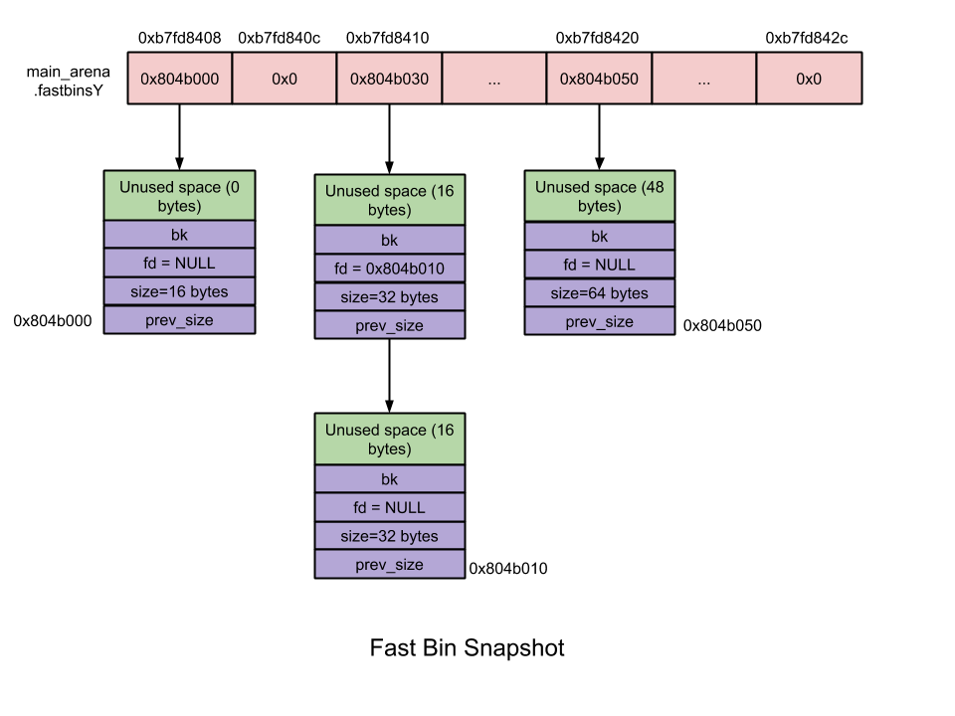
Small Bins
Chunks of size < 512 bytes are qualified as smallbins.
Total number of bins = 63, each of which is exactly 8 bytes apart.
For ex. index 2 = 16 bytes, index 3 = 24 bytes and so on (Index 1 is for unsorted bin).

Initially, when malloc called first time, small bins are NULL, so even if the size qualifies as small bin, it is redirected to use_top. use_top will give specified chunk and the pointer will be changed as seen previously.
Remainder chunk = top – user requested size. And top is changed to the new address.

When small bins are freed, free will check next and previous bins, if they are free, it will combine them, unlink and add them to the unsorted binlist.

Large Bins
Chunk size <= 512 bytes qualifies as fast bins.
Total number of bins = 63.

32 bins contain binlist of chunks of size which are 64 bytes apart.
ie First large bin (Bin 65) contains binlist of chunks of size 512 bytes to 568 bytes.
Second large bin (Bin 66) contains binlist of chunks of size 576 bytes to 632 bytes and so on…
16 bins contain binlist of chunks of size which are 512 bytes apart.
8 bins contain binlist of chunks of size which are 4096 bytes apart.
4 bins contain binlist of chunks of size which are 32768 bytes apart.
2 bins contain binlist of chunks of size which are 262144 bytes apart.
1 bin contains a chunk of remaining size.

Large chunk is stored in the first and then in decreasing order because they are not of equal size.
When malloc() is invoked for the large size
Situations we need to consider
Initially all large bins will be NULL, so again chuck will be given from use_top.

Large chunk >= user requested size
If large bin is not empty, then best fit allocation will be performed. For this from front to rear list is traversed, when we find particular chunk > size, it will be split into 2. (For spliting again there is requirement that the chunk should left with (struct malloc_chunk + MINSIZE(16 bytes)), then only spliting will be done).
User chunk will be given back to the user.
Remainder chunk will be added to the unsorted bin.

Large chunk < user requested size
Then it will be serviced from top, if top < user requested size then again brk or mmap will be called.

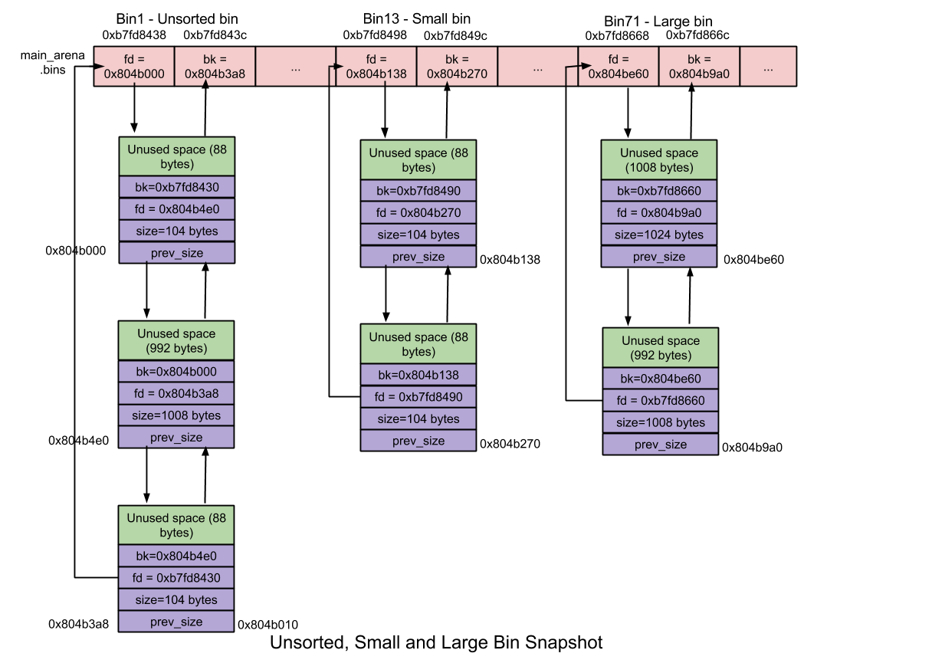

Unsorted Bin
When large or free chunk is freed, it is not added to their respective bins, it is added to unsorted bin list.
Number of bins = 1
Chunk size = any.

Malloc Flow

libc_malloc(bytes = 10)

arena_get - to get the arena(Not applicable when malloc called from main thread)

_int_malloc(bytes = 10)

checked_request2size(bytes, nb) nb will give 16 as for 10 bytes after aligning, nb = 16.

if ((unsigned long) (nb) <= (unsigned long) (get_max_fast ()))
//Fast bins are checked first
//get_max_fast will tell if nb qualified as fast bin or not. Size qualified as fast bin. So next step is index will be calculated. For 16 bytes it is 0.

idx = fastbin_index (nb); //Calculating index

mchunkptr pp = *fb; //fb initially null and pp is assigned to victim

if (victim == NULL)
//Victim is null so loop will be broken.

Again we will see if it qualifies as small bin
if (in_smallbin_range (nb))

/* in_smallbin_range will give you if nb qualifies as small bin */
idx = smallbin_index (nb);

/* index will be calculated for small bin, that will be equal to 2 */
bin = bin_at (av, idx);

/* bin is initially null, so it will be redirected to unsorted chunk list*/

while ((victim = unsorted_chunks (av)->bk) != unsorted_chunks (av))
/*Again unsorted chunks are initially null and when out of bins, redirected to the use_top */

victim = av->top;
/* Current top address is given to victim */
/*spliting is performed */
remainder_size = size – nb ; //size = size of top
set_head (remainder, remainder_size | PREV_INUSE);
This will set new top and new top's previous is in use so IN_USE will be set.
This address will be added with (char *) 8 for struct malloc_chunk and 8 bytes will be given to the user as user has made (int *) malloc(10) so even if you requested 10, you will get 8 bytes.

