|  |  |
| --- | --- |
|  | **Structures** |
|  | |

# Introduction

# A Structure is a collection of one or more variables, possibly of different types, grouped together under a single name for convenient handling.

# Important slides

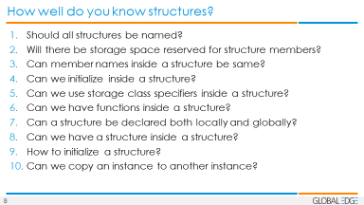

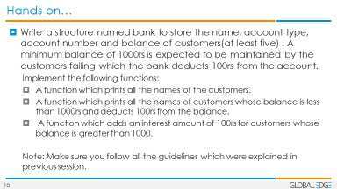

# Sections to refer in KNR

6.1 to 6.4

Appendix A – A8.3

# Links to refer

<http://www.sco.com/developers/devspecs/abi386-4.pdf>

<https://www.geeksforgeeks.org/structure-member-alignment-padding-and-data-packing/>

# Other points and Actions

1. As discussed experiment more structures.

2. Experiment on the size of structures with different datatypes.

3. Experiment on:

Array of Structures.

Structures and functions.

4. Self-referential structures.

5. Refer Slide-10 and write the flow chart / Sequence Diagram for the problem statement

6. All the concepts covered in the session must be used in problem solving.

7. The problem given in slide-10 is just the first set of instructions given to you, we will be adding more complexities to the same problem in further sessions considering the other topics of Structures.

Note: Follow all the coding guidelines that was discussed in previous sessions.

# Questions discussed

1. Why a structure?
2. What are all the legal operations allowed in a structure?
3. What are different ways to assign values to structure?