Lab 3

Net payable amount
#include <stdio.h>
#include <stdlib.h>

int main()
{
int choice;
float price;
float rate;

printf("Item type: \n 1.National items \n 2.Foreign items \n");
printf("Enter 1 or 2 (depending on type): ");
scanf("%d", &choice);

printf("Sales price: ");
scanf("%f", &price);

if(choice == 1)
rate = 0.06;
else if(choice == 2)
rate = 0.13;
else {
printf("Please select between 1 or 2\n");
return -1;
}

printf("Net payable amount (with %.0f %% tax): %.2f\n", rate * 100, price * (1+rate));

return 0;
}

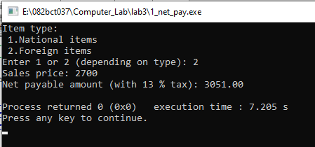

Electricity Charge

#include <stdio.h>
#include <stdlib.h>

int main()
{
int units;
float charge;

printf("Enter units: ");
scanf("%d", &units);

if(units <= 50)
charge = 0.5 * units;
else if(units <= 100)
charge = 100 + 0.65 * (units - 50);
else if(units <= 200)
charge = 230 + 0.80 * (units - 100);
else if(units > 200)
charge = 390 + 1 * (units - 200);

printf("Charge: %.2f\n", charge);
return 0;
}
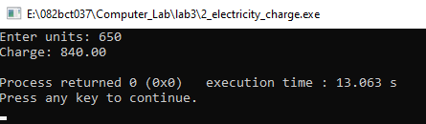

Net payable amount using switch
#include <stdio.h>
#include <stdlib.h>

int main()
{
int item_type;
float sales_price, tax;

printf("Select the type of item:\n");
printf("1. Grocery items\n");
printf("2. Cosmetics items\n");
printf("3. Clothing items\n");
printf("4. Liquor items\n");
printf("Enter item type: ");
scanf("%d", &item_type);

switch(item_type)
{
case 1:
tax = 0.1;
break;
case 2:
tax = 0.15;
break;
case 3:
tax = 0.2;
break;
case 4:
tax = 0.24;
break;
default:
return -1;
break;
}

printf("Enter the sales price: ");
scanf("%f", &sales_price);
printf("Net payable amount: %.2f\n", sales_price * (1 + tax)) ;
return 0;
}

