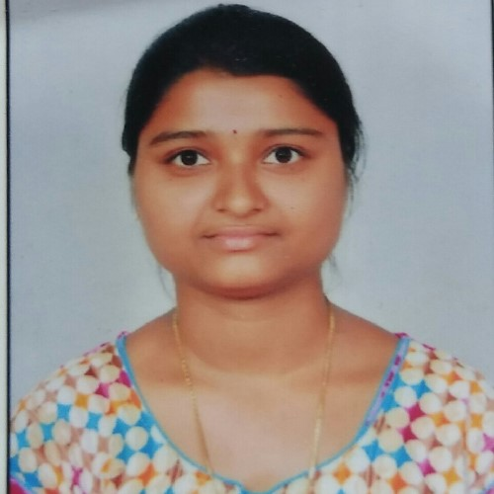
H.No:-1-70, Hasnabad(V), T-palem(M), Khammam(D) Telangana,
India
.
507161
8885270018
|

navyasrikothapally@gmail.com

M.E(Industrial Drives and Control)  8.86(CGPA)  Kakatiya University College of Engineering and Technology  B. Tech(EEE) 85%  Shanthi Junior College  Intermediate  96.6%  Sri Viveka Vardhini High school  10th 94% | 2020  2017  2013  2011
Seeking a challenging career in an esteemed organisation which would provide me an opportunity to enhance my skills reaching the goals of the organisation with the best utilisation of my abilities
Programing: Basics of C language
Operating: Windows 7.10
Other Tools: Matlab

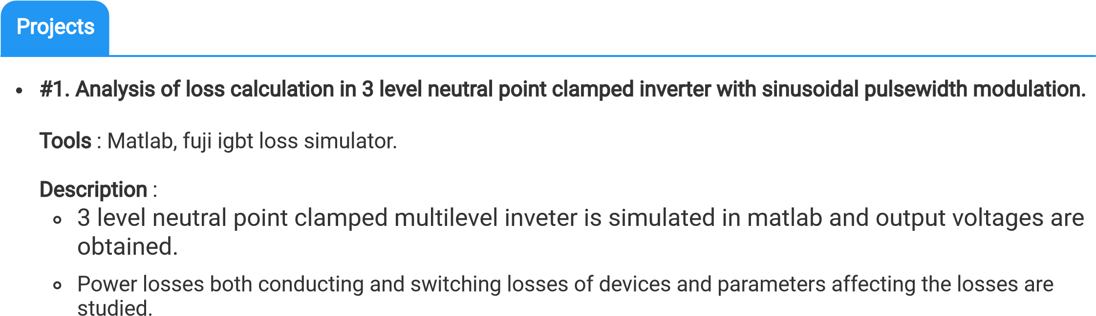
#2. A 15 level asymmetric cascaded H bridge mutlilevel inverter with reduced number of switches.
Team Size : 6
Role : Team leader

Mutiple dc source cascaded H bridge multilevel inverter is connected in series to increase the number of levels with reduced number of switches.
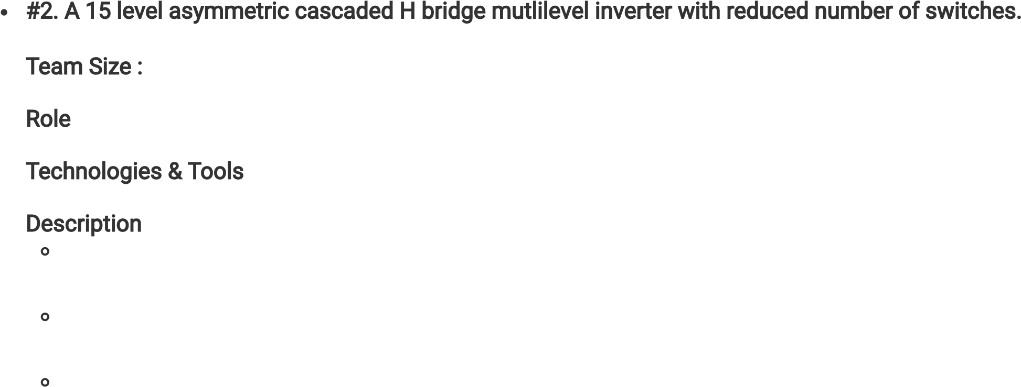
In this topology non uniform voltage levels are applied to asymmetrical cascaded H-bridge multilevel inverter and different voltage levels are obtained in the output.
Phase disposition pulse width modulation technique is used to control the switches and THD is reduced.

Self motivated, Deterministic towards achieving goals, Zeal to learn new things and ability to work as an individual and in a team
I hereby declare the information provided above is true to the best of my knowledge and I assure that I will be obedient to the regulation and sincere to the assigned job profile.
:
Solving puzzles, Dancing and Playing games
English & Telugu

