* Introduction

***This is a complete and error-free Quiz Game Mini Project in C designed as a simple console application.***

***In this project, some questions are asked, and the participant is awarded cash prize for each correct answer given.***

***In this quiz game project, you can store the user name, view the score secured by a participant***

***Additionally, for looks we used graphics.***

***For each correct answer participant win some amount and permission for next question.***

***The game ends at 13th question. Cash prize for last question is 5 lakh***

***For each question asked, there are 4 options,***

***namely A, B, C and D. There are no negative markings,***

***so the user’s accumulated cash money won’t be deducted for wrong answers to the questions.***

***The whole project is designed in ‘C’ language and Data Structures like File handling and some sorting and searching algorithms.***

***It's very easy for administrative and participants to use and operate the system.***

* Existing System

***There are many quiz game system available online.***

***From Which we use those concept concept.***

* Problem Definition

***To create a quiz system which is played by users by entering their name and city. To give the facility to administrator to set the questions and keeping records.***

* Objective of the New System

***The main objective of this project is for making easy for the participants to play quiz game and increase their knowledge . Also, for the administrative is to set questions and keep track of records. This project provides user friendly environment.***

* Core Components

**We have divided this quiz game into two parts:-**

**1.Administrator:- Who can control system setting and set questions.**

**Can see and edit records.**

**Can set questions.**

**2.Participants:- Who can enjoy this game and have fun by winning prize money(Virtually).**

**Can able to play and enjoy game.**

**And able to see the**

* Project Profile

**Project detail**

|  |  |
| --- | --- |
| **Project Name:** | **Quiz Game** |
| **Developed in:** | **In c (by data structure)** |

**Group Details**

|  |  |
| --- | --- |
| **Name :** | **Kunal Bherwani**  **Amit Kalal**  **Mahendra** |
| **Enrollment no:** | **195170686006**  **19517068**  **19517068** |
| **Division:** | **Iet**  **Iet**  **Iet** |

**Guided by- Dr. Shanti Verma**

* Assumptions and Constraints

***Administrator:***

* ***Administrator can only able to excess the system by entering proper valid id and password(case-sensitive).***

***Participant(s):***

* ***Participant only can able to enter into game by entering proper name and their city.***
* ***User cant to edit records***
* Advantages and Limitations of the Proposed System

***Advantages: as it is user-friendly project so, by this user can gain knowledge and take interest as we use graphics.***

***It contains question related to recent things happened or about general knowledge so user can able to learn more from this***

***Limitations: at a time one person is only able to play game is only limitation of our project.***

* Requirement Determination & Analysis
* Requirement Determination

***Our required determination i.e. main purpose of this system is create a user-friendly game in which user is not only playing game but also increasing its own knowledge, and learning facts of day-to-day life.***

* Targeted Users

***1.Administrator:- Who can set questions and keep track of records.***

***2.Participants:- Who can play this game and win prize money(Virtually).***

* Requirement Specification

***Requirement specification of our system is divided into to parts:***

***Administrator and user, where Administrator control game setting and set questions, and do all programming works.***

***And user have to input details that asked by game to start a game.***

***After starting a game user have to answer correctly by choosing from given option, if answer is correct user get bonus points and re-directs to next question.***

***Unfortunately, if user select wrong answer than he/she will be existed from game with their final score.***

* *Functional Requirements*

***Functional Requirements:***

***Administrator:***

* ***To set questions***
* ***To check and modify records of users***
* ***To control system.***
* *Non-Functional Requirements*

***Non-Functional Requirements:***

***User:***

* ***To input valid username or user id.***
* ***To input his/her living city.***
* System Design
* FLOW CHART DIAGRAM

1.Administrator View

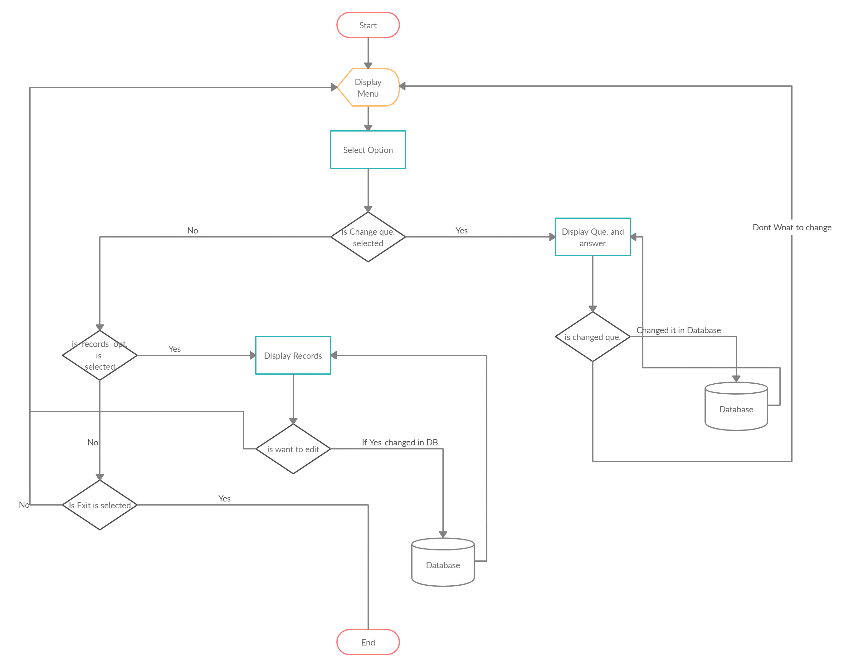

2.Participant View

