**CERTIFICATE**

This is to certify that the work embodied in Project-I (3351908) entitled “Covid Care Solution” was carried out by Parthiv Valand (186330319184), Darshan Thakkar (186330319021), Karan Sugur (186330319175) studying at L. J. Polytechnic, Ahmedabad for the partial fulfillment of Diploma Engineering to be awarded by Gujarat Technology University.

# Date:

**Place:**

**Signature & Name of Guide Signature & Name of H.O.D.**

**Seal of Institute**

**ACKNOWLEDGEMENT**

The presentation of this report gives me the feeling of fulfillment. With immense pleasure I would like to present this report on this Working Model of **“Covid Care Solution”**.

I would like to this opportunity to bestow my acknowledgement to the entire person who have directly or indirectly availed me in making my project feasible and to turn it up in to successful piece of work. I take this opportunity to express my gratitude to all those who motivated, encouraged and helped me in the project work. I am grateful to my supervisor, Prof. Harshul brahmbhatt, for his kind support, guidance and encouragement throughout the project work, also for introducing this topic, which has been very interesting and has give me great insight to the future work on this area.

I am also very grateful to prof. Hitesh Suthar, Head of Mechanical Engineering Department, LJ Engineering College, for his kind support and guidance. I take this opportunity to appeal my profound gratitude to all those who have directly or indirectly help me in my venture.

I am certainly thankful to all my friends, who have always encouraged me and help me to make my work better. I would genuinely like to thank Almighty and my parents for their constant flow of blessings on me.

Parthiv Valand(186330319184)

Darshan Thakkar(18630319021)

Karan Sugur (186330319175) **Index**

Contents

Abstract…………………………………………………...

CHAPTER 1 - Introduction…………………………………

1.1 Robotics In Medical Field………………………....

CHAPTER 2 - Problem Definition………………………….

2.1 Covid 19…………………………………………...

CHAPTER 3 – Literature Survey…………………………..

3.1 Pudubot…………………………………………...

3.2 Pinto……………………………………………...

3.3 Coro-Bot Warrior………………………………….

3.4Service Robot……………………………………...

CHAPTER4 – Market-Survey……………………………..

CHAPTER5 – Problem Solution…………………………..

5.1 2D Dimensions Of Design…………………………

5.2 Justifications……………………………………...

5.3 Calculations………………………………………

5.4 Parts And Their Working…………………………..

5.5 Working

CHAPTER6 - Costing And Specifications…………………

CHAPTER7 – Future Work……………………………….

7.1 Conclution……………………………………….

7.2 Future Work……………………………………...

Swot Analysis…………………………………………...

Bibliography ……………………………………………………

* **FIGURE INDEX**

Chapter 1 - Introduction……………………………………..

* 1. Robot In Hospital………………………...................
  2. Temprature Checking Robot At Hospital………………

Chapter 2 - Problem Definition………………………………

2.1 Total World Wide Deaths Due To Covid-19 Per Million…..

2.2 Covid Can Spread Through Air

2.3 Human To Human Contact Of Doctors And Patients….

2.4 Human To Human Contact Of Nurses And Patients…..

2.5 Intersection Of Medical Staff And Patients……………

2.6 Bored Covid Patients ………………………………….

Chapter 3 – Literature Survey………………………………..

3.1 Pudubot …………………………………………..........

3.2 Pudubot…………………………………………….......

3.3 Pinto Named Robot At Thailand Covid Hospital……..

3.4 Robot At Covid Hospital ……………………………...

Chapter 4 – Market-Survey………………………………….

4.1turnover 2018 And 2019 ,Potential Development …......

4.2 Medical Robots Market ,By Region (Usd Billion) ……….

Chapter 5 – Problem Solution………………………………

5.1 Covid Care Robot ……………………………………….

5.2 Covid Care Robot ……………………………………….

Chapter 6 - Costing And Specifications………………….....

Chapter 7 – Future Work……………………………………

**Covid Care Solution**

|  |  |
| --- | --- |
| **Submitted By** | **Supervised By** |
| Parthiv Valand(186330319021) | Prof. Harshul brahmbhatt |
| Darshan Thakkar(186330319185) | Mechanical Engineering Department |
| Karan Sugur (186330319175) |  |

LJ Polytechnic, Ahmedabad.

**ABSTRACT**

This paper describes the evolving role of robotics in healthcare and allied areas with special concerns relating to the management and control of the spread of the novel coronavirus disease 2019 (COVID-19). The prime utilization of such robots is to minimize person-to-person contact and to ensure cleaning, sterilization and support in hospitals and similar facilities such as quarantine. This will result in minimizing the life threat to medical staff and doctors taking an active role in the management of theCOVID-19 pandemic. The intention of the present research is to highlight the importance of medical robotics in general and then to connect its utilization with the perspective of COVID-19 pandemic, so that the hospital management can direct themselves to maximize the use of medical robots for various medical procedures. This is despite the popularity of telemedicine, which is also effective in similar situations. In essence, the recent achievement of the Korean and Chinese health sectors in obtaining active control of the COVID-19 pandemic was not possible without the use of state of art medical technology.

* **Chapter – 1 introduction**
  1. **Robotics In Medical Field**

Nowadays Many Robots Are Use In Medical Field. In World Many Hospitals Use Robot, Because It Works Very Punctually. Robots Can Help Doctors And Nurses And Make Their Work Easy. This Robot Can Even Help The Patients To Do Some Tasks Without Using Their Body. Nowadays Robotic Technology Is Growing And Has A Booming Market. Many Robots Already Built In The World Can Do Operation, Medicine Delivery, Communication, Supplying Material Etc., And Specially In This Pandemic; Robots Can Be A Great Help In Hospital, In Delivering Medicines, In Checking Body Credentials, In Preparing Food, In Delivering Everyday Needs In Both Hospitals And Homes. There Are Many Tasks In Hospitals Where Pushing And Pulling Of Material Is Required. These Heavy-Duty Tasks Can Be Easily Carried Out By Using Serving Robots. Robots Are Also Deployed To Supply Food To Various Patients Residing In Hospital. They Are Used In The Delivery Of Food And Beverages, Dispensing Of Drugs, Removing Of Unclean Laundry, Delivery Of Fresh Bed Linen, And Transportation Of Regular And Contaminated Waste Etc. Inside The Hospital.

Considering The Current Disastrous Situation, Robots Are Well Up Suited For Caring For The Well-Being Of Covid-19 Patients Thus Replacing Or At Least Sharing The Workload Of The Medical Staff In Under Oversaturated Conditions. A Number Of Robotic Systems Are Used For Medical Support In Hospitals Today . In China, Robots Have Been Assigned Multiple Tasks To Minimize The Spread Of Covid-19,Such As Utilizing Them For Cleaning And Food Preparation Jobs In Infected Areas Hazardous For Humans.

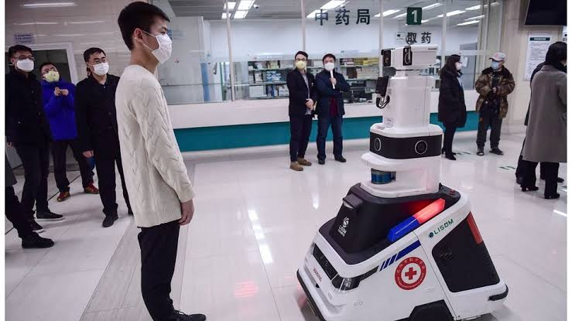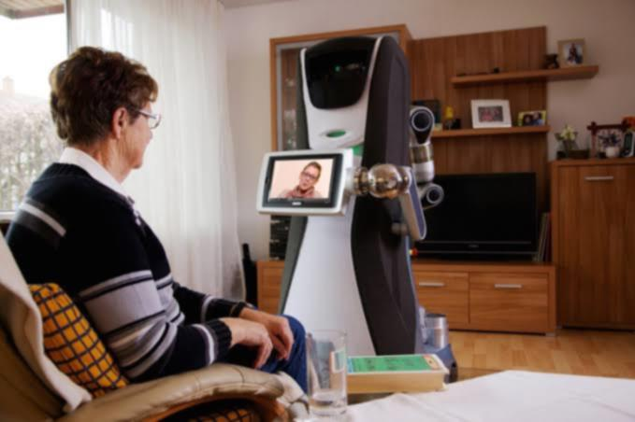

Figure 1.1 Robot In Hospital

FIGURE 1.2 Temperature checking robot at hospital

* **Chapter – 2 Problem Defination**

**2.1 Covid-19**

Nowadays Corona Virus Is Spreading All Over The World. Currently There Are 10 Million Active Covid-19 Cases In The World. The World Health Organization (Who) On January 30, 2020 Publicly Declared The Covid-19pandemic As A “Global Emergency” Because Of The Rapidity At Which It Had Spread Worldwide.The Virus Has Shaken Worldwide Economies Leading To A Stock Market Crash In Many Countries. Since The First Bunch Of Cases Identified In Wuhan City, China, In December 2019, The Coronavirus Pandemic Has Rapidly Spread Across China As Well As Over The Borders, Causin Multiple Incidents In Nearly Allcountries Of The World Except Antarctica As Shown In Figure

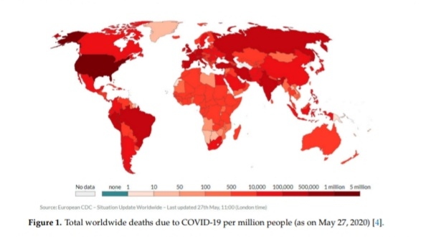

Figure 2.1 total world wide deaths due to COVID-19 per million people

According to the WHO’s situational report 127 published on May 26, 2020, so far, 5,404,512Confirmed cases have been reported worldwide with 343,514 casualties .The death rate is highest. Among older people compared to young ones, while male patients are more susceptible to risk compared to female patients in the same age group. Patients with pre-existing cardiovascular diseases/hypertension, diabetes, cancer, and chronic Respiratory disease have greater probability to pass away due to covid-19 complications compared To patients without comorbid conditions . United States, China, Italy, Iran, Brazil, France, U.K and Germany are so far the most affected countries of the world.

Coronavirus can live on any surface for five to six hours .And it can be spread by air. So it is spreading fast. A separate ward has to be set up to accommodate Corona patients in the hospital. It is very difficult to treat patients as there is no cure for coronavirus. Normally certain types of medicines are given.





**Figure 2.2 Covid can spread through air**

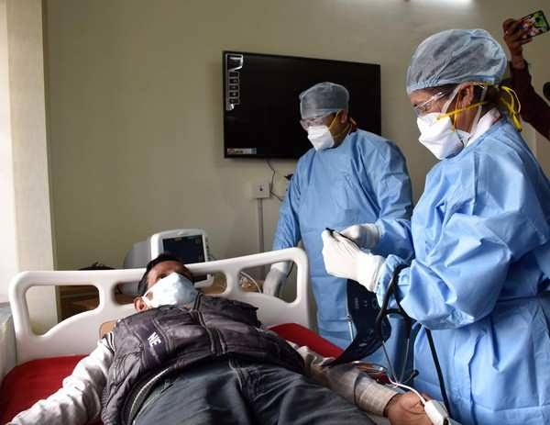

Figure 2.3 Human To Human Contact Of Doctors And Patients

* When a doctor visits a corona patient at Covid Hospital for treatment, the virus is likely to spread due to human-to-human contact. The doctor wears PPP kits and masks for safety, but the corona is likely to spread.

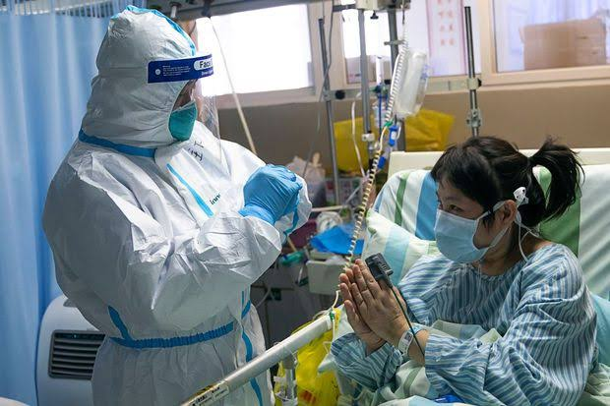

Figure 2.4 Human To Human Contact Of Nurses And Patients

* When a nurse in a covid hospital goes to give medicine to corona patients or to make an announcement, the corona virus can be spread due to human to human contact. Nurses can also be infected with corona. The coronavirus is spread even though nurses work in corona hospitals wearing PPE kits and masks. Many doctors and nurses around the world have been infected with the corona virus despite keeping it safe.

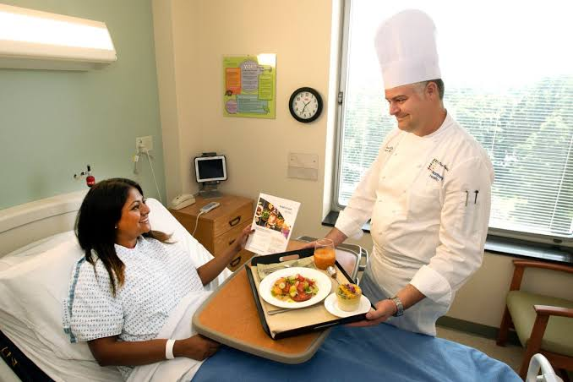

Figure 2.5 Intersection Of Medical Staff And Patients

* At Covid Hospital, when medical staff go to give food to corona patients, coronavirus can be spread due to human to human contact and corona virus also in air of isolation ward . They may be infected with corona. Corona can also spread when goes to collect food dishes.



Figure 2.6 bored covid patients

* His family members cannot come to see the patients at covid Hospital .Because they can also get corona infection if they come to see him .Therefore, permission to visit them is not given by the hospital. They are very bored. They can’t go out anywhere. So they are very lonely.
* **Chapter – 3 literature survey**
* There are many robots in this world that work in Covid-19 Hospitals for different purposes like food delivery, temperature checking etc. In world many robotic companies try to make a robot which can help in Covid-19 hospitals in this situation. This are some examples of it .

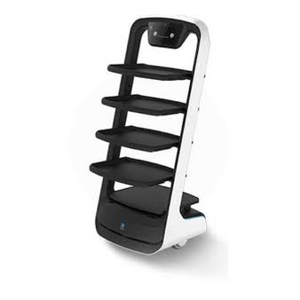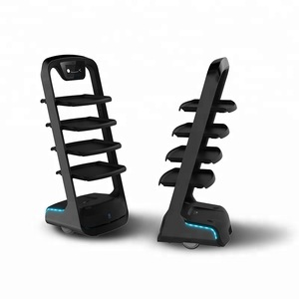**3.1 Pudu bot**

Figure 3.2 pudubot

Figure 3.1 pudubot

* In China, A Company Called Pudu Robotics Has Created A Smart Delivery Robot Called Pudu Bot. It Works Fully Automatic. It Uses A Variety Of Sensors, Which Makes It Work Automatically. It Can Deliver An Item Anywhere By Clicking On The Screen. The Robot Delivers The Item To A Specific Location Using Gps. It Costs US 100 10,000. It Uses Many Advanced Robotics Systems Such As Powerful Chips, More Accurate Inertial Navigation And Positioning, 3d Obstacle Avoidance, Visual Positioning.The Robotics Category Has Been Building To A Kind Of Critical Mass In Recent Years, But The Past Six Months Of The COVID-19 Pandemic Have Pushed Many Otherwise Wary Investors Over The Top. Today, Shenzhen-Based Pudu Robotics Announced That It Has Completed A Series B In Excess Of $15 Million, With Beijing Food Services Group, Meituan As The Sole Investor

**3.2 Pinto**

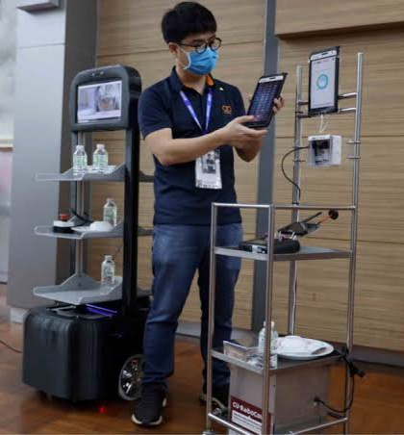

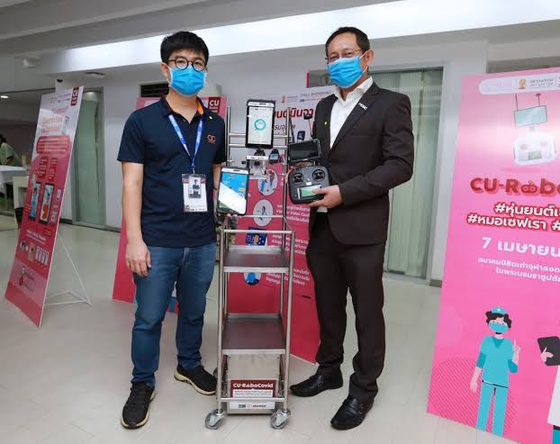

Figure3 .4 robot at covid hospital

Figure 3.3 ‘pinto' named robot at Thailand Covid hospital

`

* They Call The Robot “Pinto” – A Local Word For A Food Delivery Container. With Battery-Powered Motors At The Bottom And Voice-Activated Computers On The Top, Simple Hospital Food Carts Are Now Turned Into Robotic Soldiers On The Frontline Of The Fight Against COVID-19 In Thailand Engineers From Start-Up Companies Teamed Up With Thailand’s Chulalongkorn University To Come Up With Tools That Could Deliver Food And Medicine To Patients And Allow Remote Communication Between Them And Medical Staff. This Helps Doctors And Nurses Reduce Their Risks Of Exposure To Infected Patients As Many Hospitals In Thailand Are Currently Facing A Shortage Of Masks And Protective Suits. Six Of Them Have Already Been Delivered To Three Major Hospitals In The Country. Each Unit Costs 50,000 Thai Baht (€1,400) To Make. Through Donations And Public Funding, The Team Hopes To Make Up To 100 Robots To Be Distributed To Hospitals Nationwide By The End Of The Month. Up To 50 Hospitals Have Already Requested These Units.

**3.3 Coro-Bot warrior**

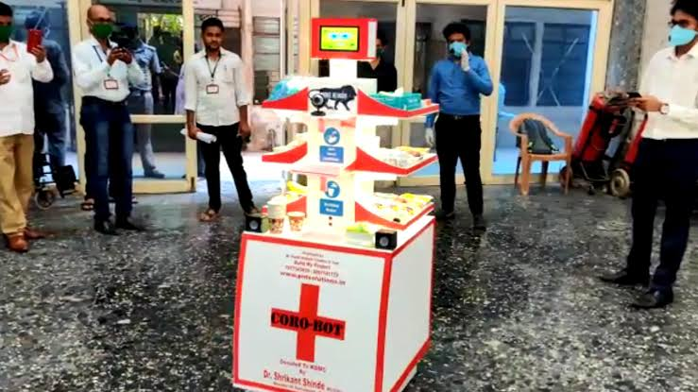

Figure 3.5 A robot at maharastra covid hospital

* KALYAN: A Dombivli Based Engineer With His Team Created A ‘Coro-Bot Warrior’, Which Will Be Now Used By The Covid Hospital Of Kalyan-Dombivli Municipal Corporation (KDMC).“These Robots Can Be Used To Supply Food And Medicines At The Isolation Wards,” Said Pratik Tirodkar Who Created It And Donated Two Robots To KDMC With The Help Of Kalyan Dr. Shrikant Shinde. In A Scenario Where Health Workers Are Increasingly Diagnosed Positive Due To Close Interaction With Patients, In A Bid To Reduce Human Interaction, And His Team Have Created Robot Which Will Be Now Used To Supply Food And Medicines Into Isolation Wards.The Health Experts Believe That This Trolley-Shaped Robot Will Be Very Useful To Treat Covid-19 Patients As It Is Equipped With A Camera And Speaker System.“The Camera Allows The Operator To Operate From A Distance. The Speaker Can Instruct Patients About Things To Be Done And Not To Be Done. This Will Be Of Great Help To Nurses And Ward Boys, Who Can Operate Without Going Near To Patients.The Robot Also Has Sanitiser And Drinking Water Facilities And Patients Before Taking Food And Medicine First Can Sanitised Their Hands. The Robot Can Carry Plenty Of Food And Medicines Which Can Be Served To 15 Patients At A Time In Isolation Wards Without Human Touch.It Is A Battery-Operated Vehicle And Can Work Continuously By Charging Overnight And Remotely Controlled.The Trolley Type Of Robot Carrying Food And Water To Each Patient’s Bed. This Is Of Great Help To The Nurses And Ward Boy.It Cost Is Starting From 60 Thousand To 3 Lacs.

**4. service robot**

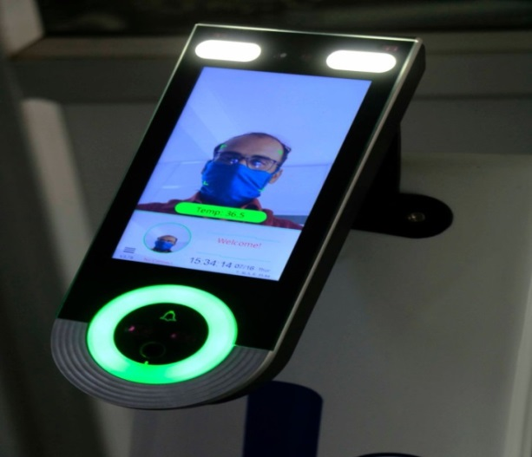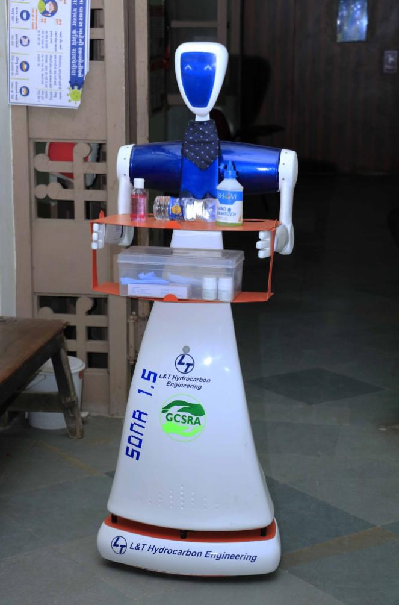

Figure 3.6 Temperature screening by robot

Figure 4.5 Service robot at SSG hospital

Vadodara: Visible In Pictures Here Are 2.5 And 1.5 Service Robots That Can Cater Meal And Medicines To The Patients, Measure Temperature And Can Understand The Instructions In Gujarati Command Another Robot Is Covid-19 Screening Robot, That Can Be Deployed At The Entrance Of The Ward, Do Thermal Screening And Give Mask Detection Alert. It Can Also Register Presence Of Staff And Stop Unauthorized Entries.100 Per Cent ‘Make In India’ Products These Robots Do Work Using Artificial Intelligence. The Robots Can Decide The Path To Reach Particular Patients And Can Change The Path If There’s Obstruction On The Way Screening Robot Can Also Issue Instructions Such As ‘Wear Your Mask’, ‘Wash Your Hand’, ‘Use Sanitizer’ And ‘Maintain Social Distance’. The Robots Can Work For Round The Clock. One-Time Charging Of 2.5 Hours, A Robot Can Work For 8-9 Hours. These Robots Received Through CSR (Corporate Social Responsibility) Will Be Used In ICU And Isolation Wards.

# Chapter – 4 Market Survey Analysis Report

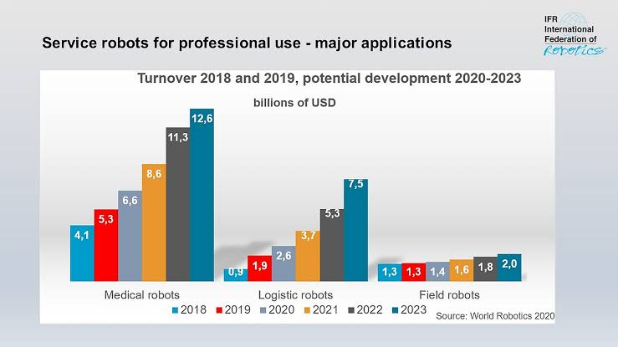

Turnover 2018 and 2019 ,potential development 2020-2023

(billions of usd)

Sales Value Of Professional Service Robots Increased By 32% To USD11.2 Billion Worldwide (2018-2019). The COVID-19 Pandemic Will Further Boost The Market, High Demand For Robotics Disinfection Solutions, Robotic Logistics Solutions In Factories And Warehouses Or Robots For Home Delivery Are Examples Of This Trend. In Terms Of Value, The Sales Of Medical Robotics Accounts For 47% Of The Total Professional Service Robot Turnover In 2019. This Was Mainly Driven By Robotic Surgery Systems, Which Are The Most Expensive Type In The Segment. Sales Hit A New Record Of 5.3 Billion U.S. Dollars – Up 28%. By 2022, Medical Robot Sales Have The Potential To More Than Double By Reaching 11.3 Billion U.S. Dollars. About 90% Of Medical Robots Are From American And European Suppliers. This Is According To World Robotics 2020 – Service Robots Report.

Figure 4.2 medical robots market ,by region (usd billion)

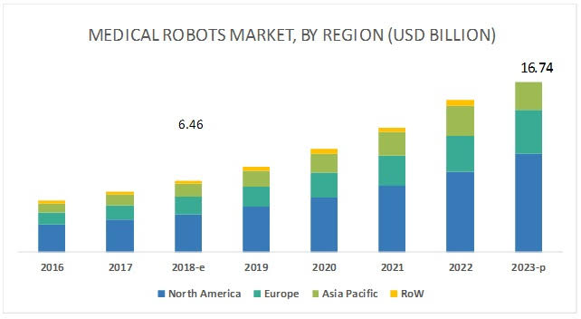

The India Medical Robotics Market Was Valued At INR 7.02 Billion In 2017 And Is Anticipated To Reach INR 26.01 Billion In 2024, Expanding At A CAGR Of 19.8% During The 2019-2024 Period.The Indian Healthcare Industry Started Embracing Medical Robotics During The Mid-2000s. Increase In The Number Of Medical Robots From Six In 2009 To Around 100 In 2019 Has Helped To Shape Up The Domestic Market For Medical Robotics. Adoption Of Robotics In Surgical Intervention Has Provided Enormous Impetus To The Indian Healthcare Sector. Healthcare Facilities In Indian Cities Like Delhi, Gurgaon, Mumbai, Pune, Chennai, Hyderabad, Kochi, And Kolkata Are Offering Robot-Assisted Surgical Services.

In Recent Years, The Indian Healthcare Sector Has Grown Exponentially Owing To The Increased Investment, Both In Public As Well As Private Sectors. According To A Report By NITI Aayog, The Indian Government Will Increase Public Expenditure On Healthcare From 1.1% To 2.5% GDP In The Next Four Years And Subsequently To 5% In The Following Five Years. At Present, The Rising Incidences Of Lifestyle Diseases And Growing Demand For Affordable Healthcare Coupled With Increased Role Of Government In Healthcare Investment Space And Emergence Of Technologies Such As Artificial Learning (AI), Machine Learning (ML) And Robotics Are The Major Driving Factors In Indian Healthcare Industry.

The Affordability And Accessibility Of Technology Is Reverberating The Healthcare Sector In India. AI & ML Is Becoming Increasingly Sophisticated At Doing What Humans Do, But More Efficiently, Quickly And At A Lower Cost. India Produces Only About 50,000 Doctors Every Year – Not Nearly Enough To Get To Minimum Standards. To Get To The WHO Recommended Minimum Of A Doctor Patient Ratio Of 1:1000, India Will Need 2.3 Million Doctors By 2030 And The Nurse: Patient Ratio Is 1:483, Implying A Shortage Of Around Two Million Nurses. Intervention Of AI Is Not Only A Novelty But Also Prove To Be A Vital Part For The Sector. A Discussion Paper Floated By Indian Government’s Niti Aayog Places Healthcare Among One Of The Focus.

.

* **Chapter – 5 Problem Solution**

During this Pandemic lots of people are infected . Too many people in the world have had corona so the hospital has too many patients Doctors and Nurses are highly exposed to Covid-19 positive Patients. This can lead to a lot of danger to the lives of Doctors, Nurses and their Families. So, what is the solution to this problem?

* The solution is Our Robot Appliance.
* Appliance can help all Doctors, Nurses and Patients.
* It can be personalized as per Remote Control or Voice Control.
* It can meet the need for food and medicine delivery to Corona's hospital.
* It Can also fulfill the need to play background music at covid Hospital.
* It Will be of great help to nurses and ward boys, who can operate without going near to patients.
* It Can Helps doctors and nurses reduce their risks of exposure to infected patients as many hospitals.
* Doctors can talk with patients in videocall.
* Patients Relatives can talk with his.

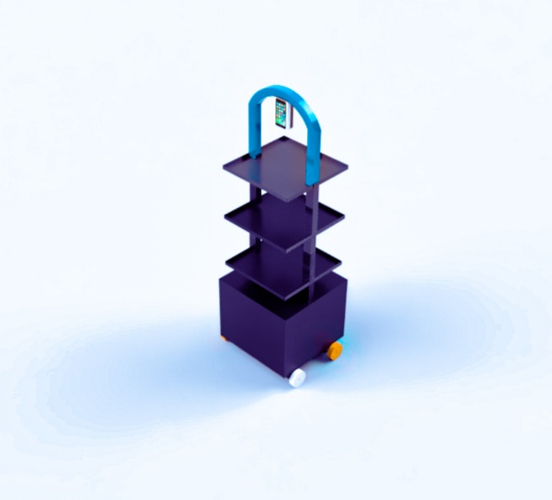

` Figure 5.1 covid care robot

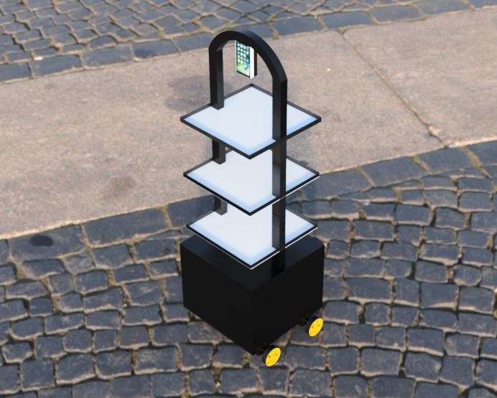

Figure 5.2 covid care robot

**5.1 2D DIMENSIONS OF DESIGN**

# 

# 

* 1. **Justifications**
* we choose aluminum pipe for structure because it is light-weight ,low cost ,high strength and easy to weld **.**
* The reason for increasing the size of the tray is that we can deliver more medicine and food at once. Thickness of tray is kept at 1mm .it can carry 2 or 3 kg load without breaking.
* The reason the size of the structure is big is that it allows anyone to easily take things from Robot.
* Wheels of 100 mm are kept according to the size and weight of the structure.
* We use the clockwise and anticlockwise methods to give the direction of robot because it is very easy.
* We use micro-controller in the robot is Nod Mcu Es8266 . It is cheap and easy to codify.it has in-built wifi module.
* We use relay because it works automatically through the signal of micro-controller.
* Smartphones are used here because they have wifi, hotspot, internet and Bluetooth. Videocalls can also occur.The microcontroller gets internet connection through the hot spot of the smartphone. so that we can operate robot from anywhere.bettery life is high.
* A live recording of Robot phone's camera appears in the operator's mobile. And blynk app is used to configure the way his mobile is controlled.
  1. **Calculations**
* Data
* Weight Of Product = 8 Kg ( Adding Weight Of Food And Medicine)
* Co-Efficient Of Friction = 0.1 N
* Gravity Force = 9.81 N
* Radius Of Wheel = 50mm
* Motor Torque = 1.47 N×M

* Tractive Effort = µ×N

= 0.1(8×9.81)

= 7.85 N

* Tractive Force = 2π × Torque×Gear Reduction

2π×R

7.85 = Torque×1

0.05

Torque = 0.4 N×M

* Circumference Of Wheel =

= 2×

= 31.4 Cm

* Speed Of Robot = Motor Rpm × Circumference Of Wheel

= 150× 0.31m

= 46 Meter/Minute

= 77 Meter/Second

* We Need 0.49 N×M Torque To Move This Robot.
* We Use 4 Motors To Move This Robot . Each Motor Torque Is 1.47 N×M.
* Total Torque = 1.47×4

=5.88 Nm

* Our Motor Torque Is Greater Than Required Torque. So Robot Can Easily Move One Place To Another.

**5.4 Parts And Their Working**

|  |  |  |  |
| --- | --- | --- | --- |
| **Sr. No.** | **Part** | **Working** | **Photo** |
| (1) | Aluminum Pipe | To Create A Strong Structure That Can Withstand Excessive Loads |  |
| (2) | nod mcu | It Gives Signal To The Relay |  |
| (3) | Relay | To Give Current To The Motor By Signal Of Micro- Controller |  |
| (4) | Jumper Wire | To Pass The Current |  |
| (5) | Polycarbonate Sheet | To Cover The Base of Robot |  |
| (6) | Rivets | To Connect Sheet To The Pipe |  |
| (7) | AC To DC Adapter | To Convert AC Current In To DC |  |
| (8) | Bluetooth  Speaker | To Play Music And For Communication |  |
| (9) | Wheels | To Carry The Load And Smooth Rotation |  |
| (10) | Smart Phone | It Use For Camera, Videocall, WiFi ,And Communication |  |
| 11) | Dc Motors | Produce High Thrust Load And Smooth Rotation |  |

* 1. **Working**
* Example: When The Medicine Is To Be Supplied, The Operator First Takes The Robot To The Medicine Department And Puts The Medicine In Different Trays .And He Asks The Staff Nurse What To Give To The Patients Of The Ward. He Takes The Robot To The Ward And Conforms To The Patients Through The Camera And Delivers The Medicine.
* When An Announcement Is To Be Made, The Robot Takes It To The Ward And The Operator Who Plays A File Or Speaks Is Announced From The Speaker In The Robot.
* While The Hospital Will Need To Play Background Music. The Operator Will Then Take Him To An Isolation Ward Or To A Specific Place .And From There He Will Play Music From His Phone. It Is Heard By All Through The Speaker In Robot.
* At Covid Hospital, When A Doctor Needs To Communicate With A Patients, The Operator Takes The Robot To The Ward Or Patient, According To The Doctor Said. Doctor Makes A Video Call On Robot's Phone And The Video Call Is Automatically Received From That Phone. Thus The Patient And The Doctor Can Communicate On Video Call. After The Conversation Is Over, The Doctor Can Cut The Video Call From His Phone. The Operator Will Then Resume The Work That Needs To Be Done.
* According To This Design We Are Going To Make A Prototype Robot That Can Carry A Weight Of Two Or Three Kg.

* **Chapter – 6 Costing and Specification**

|  |  |  |  |  |
| --- | --- | --- | --- | --- |
| **Sr. No.** | **Part** | **No. of Pieces** | **Price Per Piece** | **Total Price** |
| 1 | Aluminum Square Pipe | 10 | 100 /- | 1000/- |
| 2 | Nod Mcu | 1 | 350 /- | 350/- |
| 3 | Relay | 4 | 30 /- | 120/- |
| 4 | Jumper Wire | 5 | 10 /- | 50/- |
| 5 | Polycarbonate Sheet | 5 | 100 /- | 500/- |
| 6 | Rivets | 50 | 2 /- | 100/- |
| 7 | AC To DC Power Supply | 1 | 200 /- | 200/- |
| 8 | Labor Cost | 1 | 300 /- | 300/- |
| 9 | Wheels | 4 | 100/- | 500/- |
| 10 | Smart Phone | 2 | 8000/- | 16000/- |
| 11 | D.C. Motors | 4 | 1000/- | 4000/- |
|  |  |  | **TOTAL** | **23170/-** |

* **Ch-7 Future work**
  1. **Conclusion**

Corona Cases Are On The Rise These Days. It Is Becoming Very Difficult To Treat Patients. Corona Patients Are Treated Faster If Equipped, Low-Cost Robots Are Built. As Well As Preventing The Spread Of Corona. Many Companies Around The World Have Built Robots For Covid Hospitals, But They Are Very Expensive. Many Hospitals In The Country Cannot Afford It. We Have Created A Simple Design By Studying The Robots Of Hospitals Built By Many Companies Around The World. Knowing The Good Features From All The Designs Has Been The Designer After All. It Offers The Same Functionality As All Other Robots At A Lower Cost.

**7.2 FUTURE WORK**

The Name Of Our Project Is Covid Care Solution And We Are Going To Create Prototype Project Of Covid Care Robot In Sem-6.

* **SWOT Analysis**

**S**

**W**

Weaknesses

* 5% - 10% error rate
* Quality checks
* Coding standard
* Performance variance across system
* Exceptions
* Unstructured input for processing
* Limited support for browsers such as Chrome, Firefox etc.
* Rely on other NLP tools for reading and understanding free flow text

Strength

* + Partially Automated
  + Process On time Delivery
  + Customer satisfaction
  + Time Saving
  + Cost Reduction
  + Increased ROI
  + Audit Logs to support compliance
  + Secured Access
  + Continuous improvement
  + Easy to deploy and re-configure
  + Increase productivity by eliminating wastes

Threats

* Cognitive process
* Application downtime
* System crash
* Major change request
* Business process pulls out.
* Unstable process
* Decreased timelines for development team.
* Upgrades to underlining applications poses a challenge

Opportunities

* + RPA learning for business ops
  + Process improvement
  + Strong case to attract other business
  + Leverage FTES to other high skilled jobs
  + Gain share
  + Roadmap for future projects
  + Bulding a COE
  + Effective BCP
  + Incorporating NLP features
  + Incorporating Data Quality Process
  + A strong change management

**T**

**O**

**BIBLIOGRAPHY**

* **Website**
* <https://pudurobotics.uk/>
* [https://www.euronews.com/amp/2020/04/07/robots-help- to-keep-medical-staff-safe-from-coronavirus](https://www.euronews.com/amp/2020/04/07/robots-help-%20%20to-keep-medical-staff-safe-from-coronavirus)
* <https://www.ncbi.nlm.nih.gov/pmc/articles/PMC7312924/>
* <https://health.economictimes.indiatimes.com/>
* <https://www.healthcarefinancenews.com/filter-content/all>
* <https://www.deshgujarat.com/>
* <https://www.globenewswire.com/Index>
* **Books**
* Lonner, J.; Zangrilli, J.; Saini, S. Emerging Robotic Technologies and Innovations for Hospital Process Improvement. In Robotics in Knee and Hip Arthroplasty; Springer, Cham, Switzerland, 2019; pp. 233–243, doi:10.1007/978-3-030-16593-2_23.
* Locsin, R.C.; Ito, H. Can humanoid nurse robots replace human nurses? J. Nurs. 2018, 5, 1, doi:10.7243/2056-9157-5-1.
* Samani, H.; Zhu, R. Robotic Automated External Defibrillator Ambulance for Emergency Medical Service in Smart Cities. IEEE Access 2016, 4, 268–283, doi:10.1109/access.2016.2514263.