List of Bugs on Register Page

Form Validation Bugs

1. Open form and click register button without filling any data. Only password field error is displayed. Expecting to display error for all missing fields.
2. Fields label element’s “for” attribute should match the “id” attribute of the corresponding input field. This might prevent the accessibility tools from working correctly.

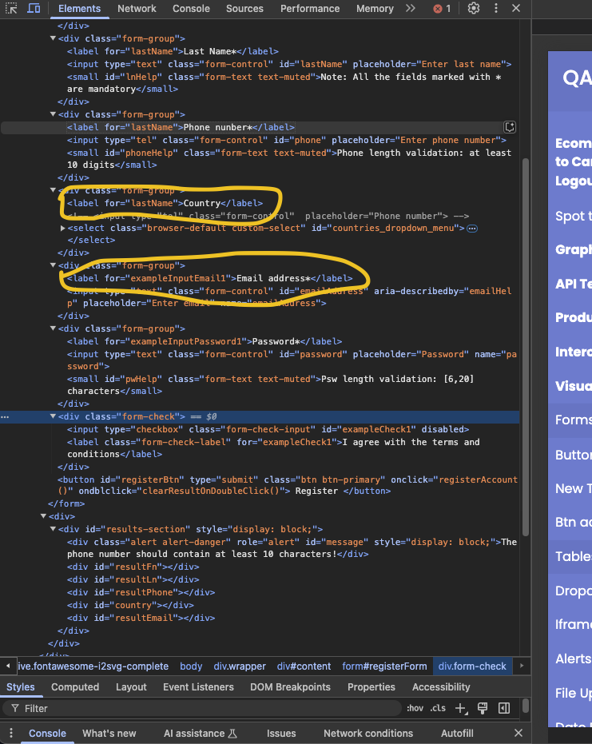

1. Last name field missing mandatory field validation.
2. Phone number field missing type validation. Accepts characters.
3. On successful registration the information displayed for phone number field doesn’t match the input value. Last digit is truncated and is increment by one then concatenated with the first 9 digits and displayed in information field. If last digit is not a number then first 9 digits(or characters since it is missing a validation for phone number to be all digits only) concatenated with “NaN” is displayed.
4. Email address field missing mandatory field validation and email format validation. Also aria-describedby attribute is defined but help text is not provided.
5. Terms and conditions checkbox should be mandatory but missing mandatory field validation. Also this field is disabled.
6. User can register by only entering phone number and password. This should be blocked.
7. Successful registration should clear the form fields, however the Form fields are not cleared.
8. On successful registration the information displayed has a missing character in last name.
9. On successful registration the information displayed for country field is showing default value “"Select a country" when no value is selected from dropdown.
10. 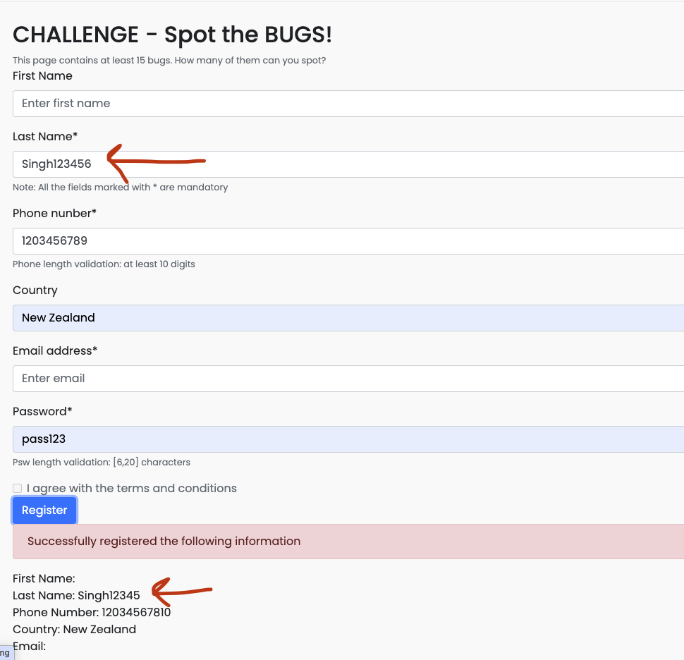

UI Bugs

1. "X" button in header looks out of place.
2. Inconsistent spacing between fields.
3. "Note: All the fields marked with \* are mandatory" text should be displayed on top of the form before first field.
4. Spelling mistake in form field labels.
5. Inconsistent field label naming convention. Some fields have second word starting with capital letter.
6. Country dropdown field icon should be a down arrow.
7. Phone number field length hint should be a tool tip displayed on hover.
8. Password field length hint should be a tool tip displayed on hover. Also a typo in hint text. It should be “Password length validation 6-20 characters.
9. Password field placeholder should be “Enter Password” to keep it consistent with placeholders of other fields.
10. Email field placeholder should be "Enter email address" to make it consistent with other fields.

Mobile View

1. Heading should change size as per mobile view size.
2. Form fields should shrink to mobile view size.
3. Home and Contact header fields change to hamburger icon in mobile view resulting in two menu icons.

