- Kibana setup local environment in windows

- First you have to download elasticsearch, kibana and logstash from there sites.
Here is the link
Elasticsearch -> https://www.elastic.co/downloads/elasticsearch
Kibana -> https://www.elastic.co/downloads/kibana
Logstash -> https://www.elastic.co/downloads/logstash

Put all zip file in D:/elastic/folder and extract it.

Then rename the extracted folder as per your convenient. Here I have renamed with elasticsearch, kibana,
logstash

Then First you have to run elasticsearch
Go to this D:/elastic/elasticsearch/bin path and open cmd and run elasticsearch.bat file then check the
logs of elasticsearch in cmd.

In the logs we have get credential details for elastic user and auth token for kibana user
Save that details in notepad. and open elasticsearch in browser https://localhost:9200/
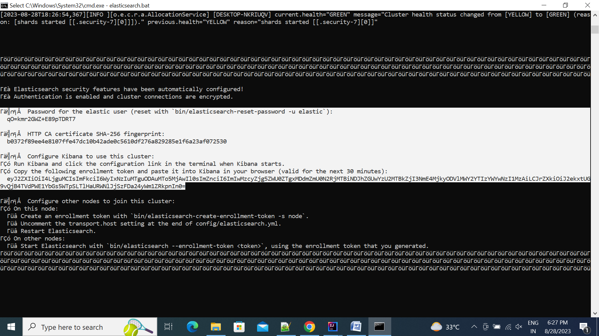

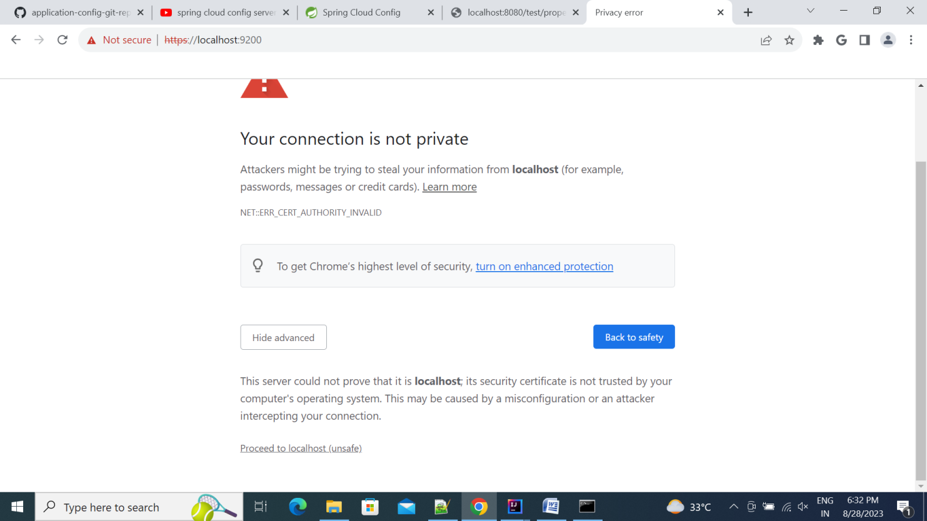
Then enter the elastic user credential where we get into the logs of elasticsearch
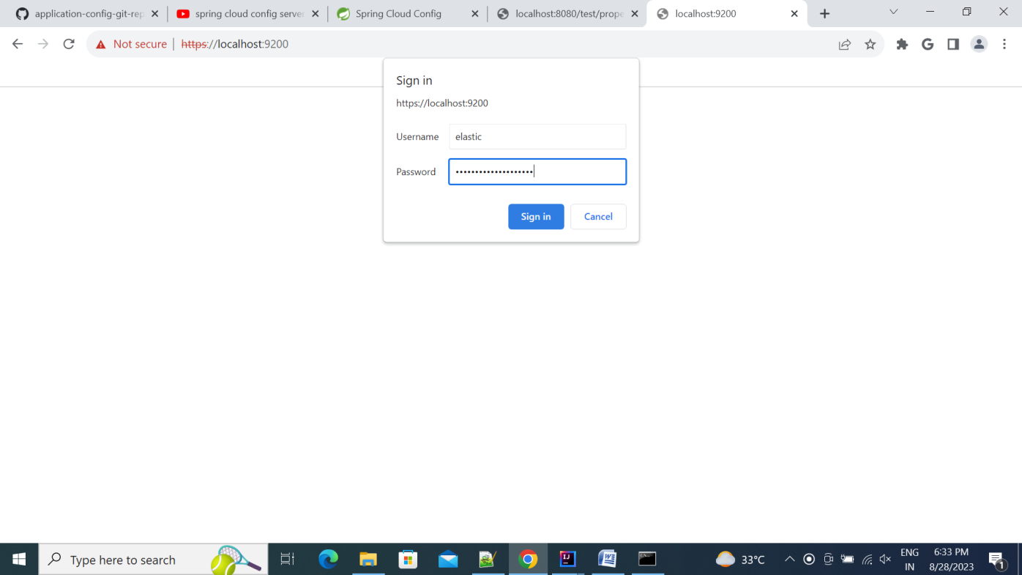
Elastic serach is running now

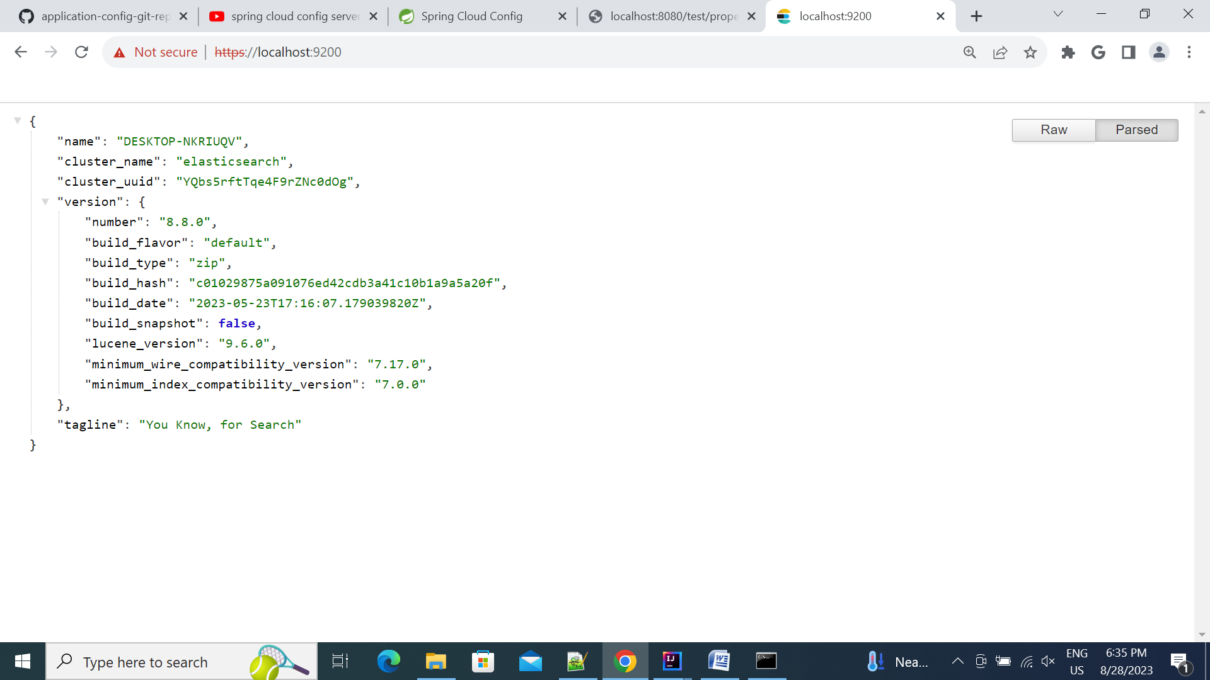

Now you have to disbale security in the elasticsearch configuration
Go to D:\elastic\elasticsearch\config and edit the elasticsearch.yml file
add this line into file
action.auto_create_index: .monitoring*,.watches,.triggered_watches,.watcher-history*,.ml*
update bellow two property and re-run the elasticsearch.bat file
xpack.security.http.ssl:
enabled: false

xpack.security.transport.ssl:
enabled: false

Now the elasticserach is running on http://localhost:9200/

- Now you have to run kibana server
- First you have to uncomment elasticsearch host in kibana.yml file
- Go to D:\elastic\kibana\config and edit the kibana.yml file uncomment bellow line

elasticsearch.hosts: ["http://localhost:9200"]
elasticsearch.username: "kibana_system"
elasticsearch.password: "updated password"

- If the token has expired so you can create new token using command

- Go to this D:/elastic/elasticsearch/bin path and open cmd and run bellow command

For generate New token
elasticsearch-create-enrollment-token -s node

For reset password for elastic, kibana or kibana_system user
elasticsearch-reset-password -u {user}

- Now Go to D:\elastic\kibana\bin Path and open cmd and run kibana.bat file
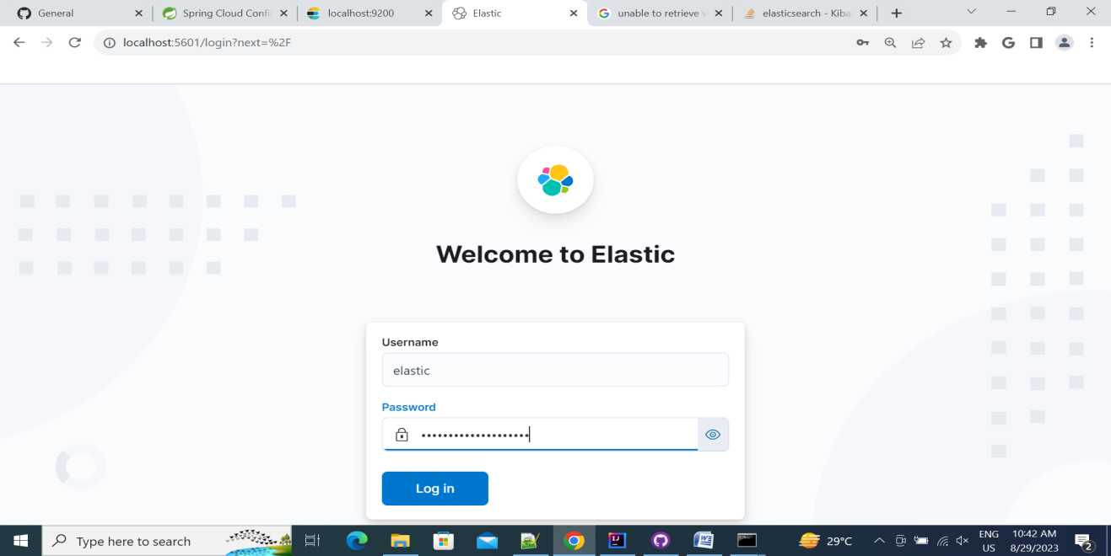
- Then open the http://localhost:5601/ url for kibana UI and login with elastic user

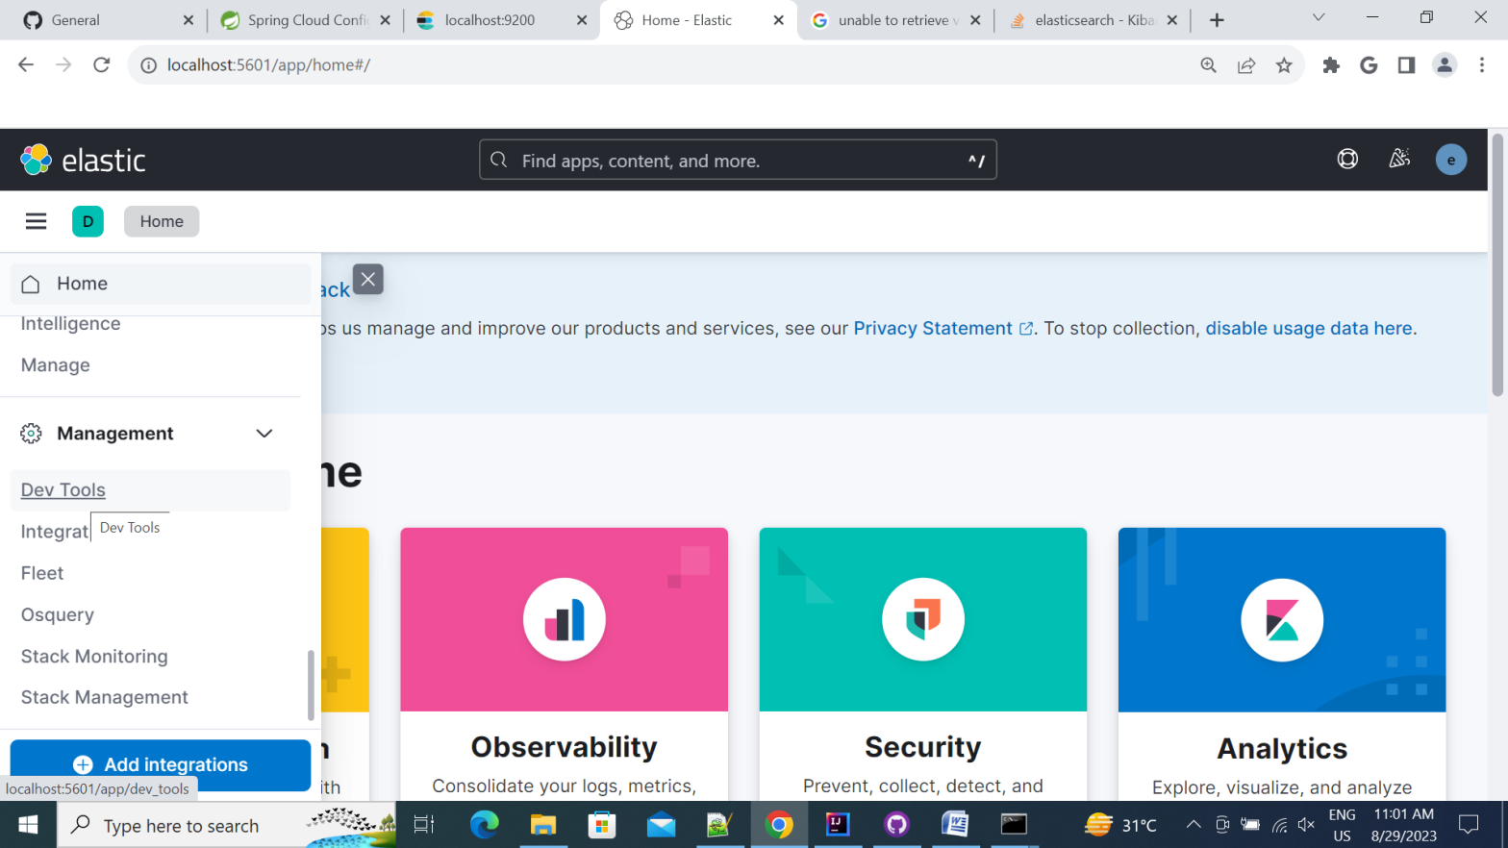
- Now goto devtool

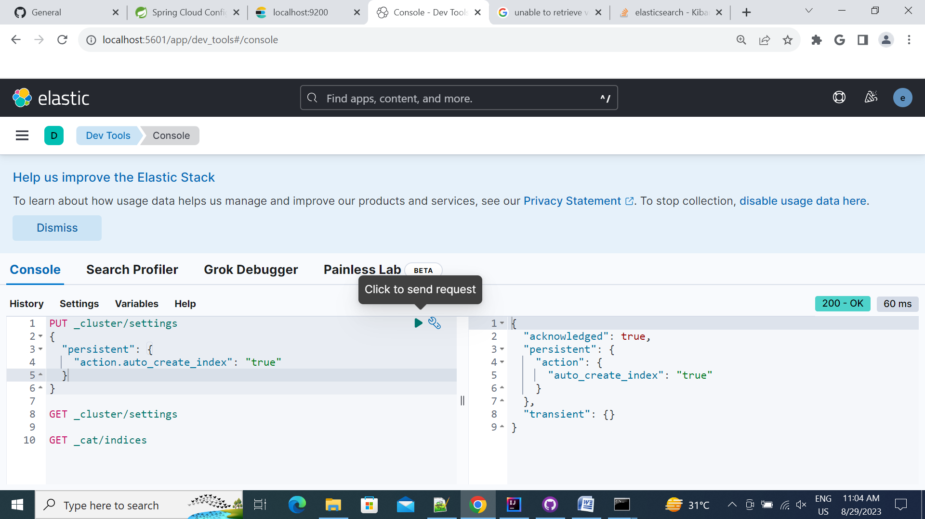
- And enable auto_create_index = true using put endpoint and check using using get endpoint

Now we have to run logstash before run logstash we have create logstash.conf file to read details of logger files and output
Now we have create one microservice and store that service log in c:/logs/ folder using logback.xml configuration
Now provide that log file into logstash.conf file
Bellow is the sample file for logstash.conf file

# Sample Logstash configuration for creating a simple
# Beats -> Logstash -> Elasticsearch pipeline.

input {
file {
type => "department-service"
path => "c:/logs/department_service.log"
start_position => "beginning"
}
file {
type => "user-service"
path => "c:/logs/user_service.log"
start_position => "beginning"
}
#stdin {
#}
}

output {
elasticsearch {
id => "index_two"
hosts => ["http://localhost:9200"]
index => "test.code"
user => "elastic"
password => "i8PnjHXnGE-+FX7J9NoC"
}
stdout { codec => rubydebug }
}

Now run the Put that file into D:\ elastic\logstash\config and goto D:\ elastic\logstash\bin and run bellow command to start logstash

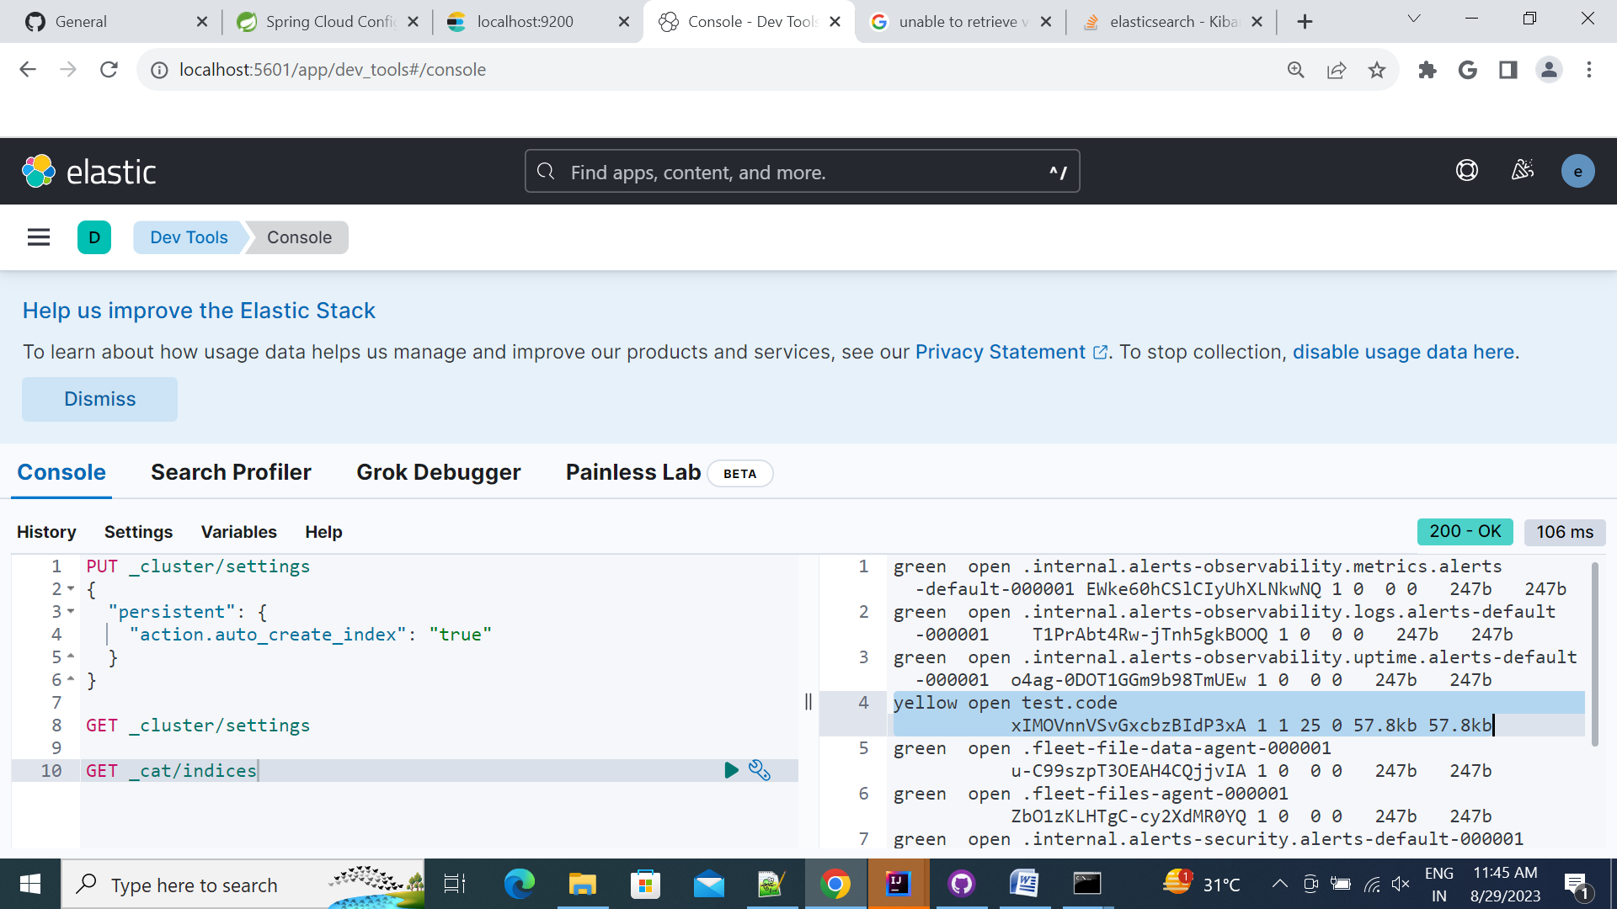
Now check the indices in kibana UI one index is created
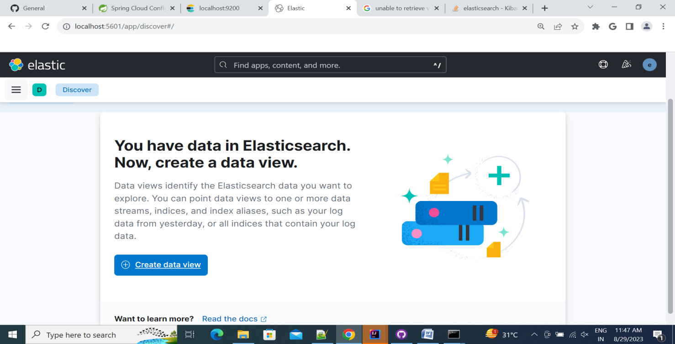
Now go to discover menu and create data view
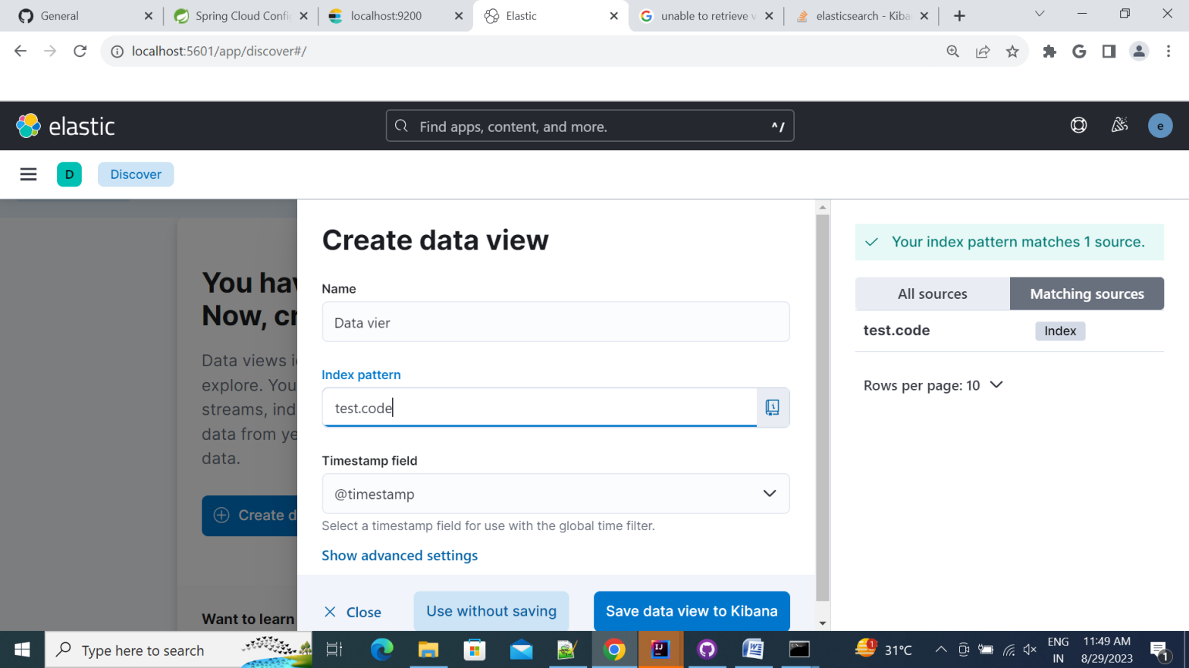
Now you can check the logs and filter as per your require
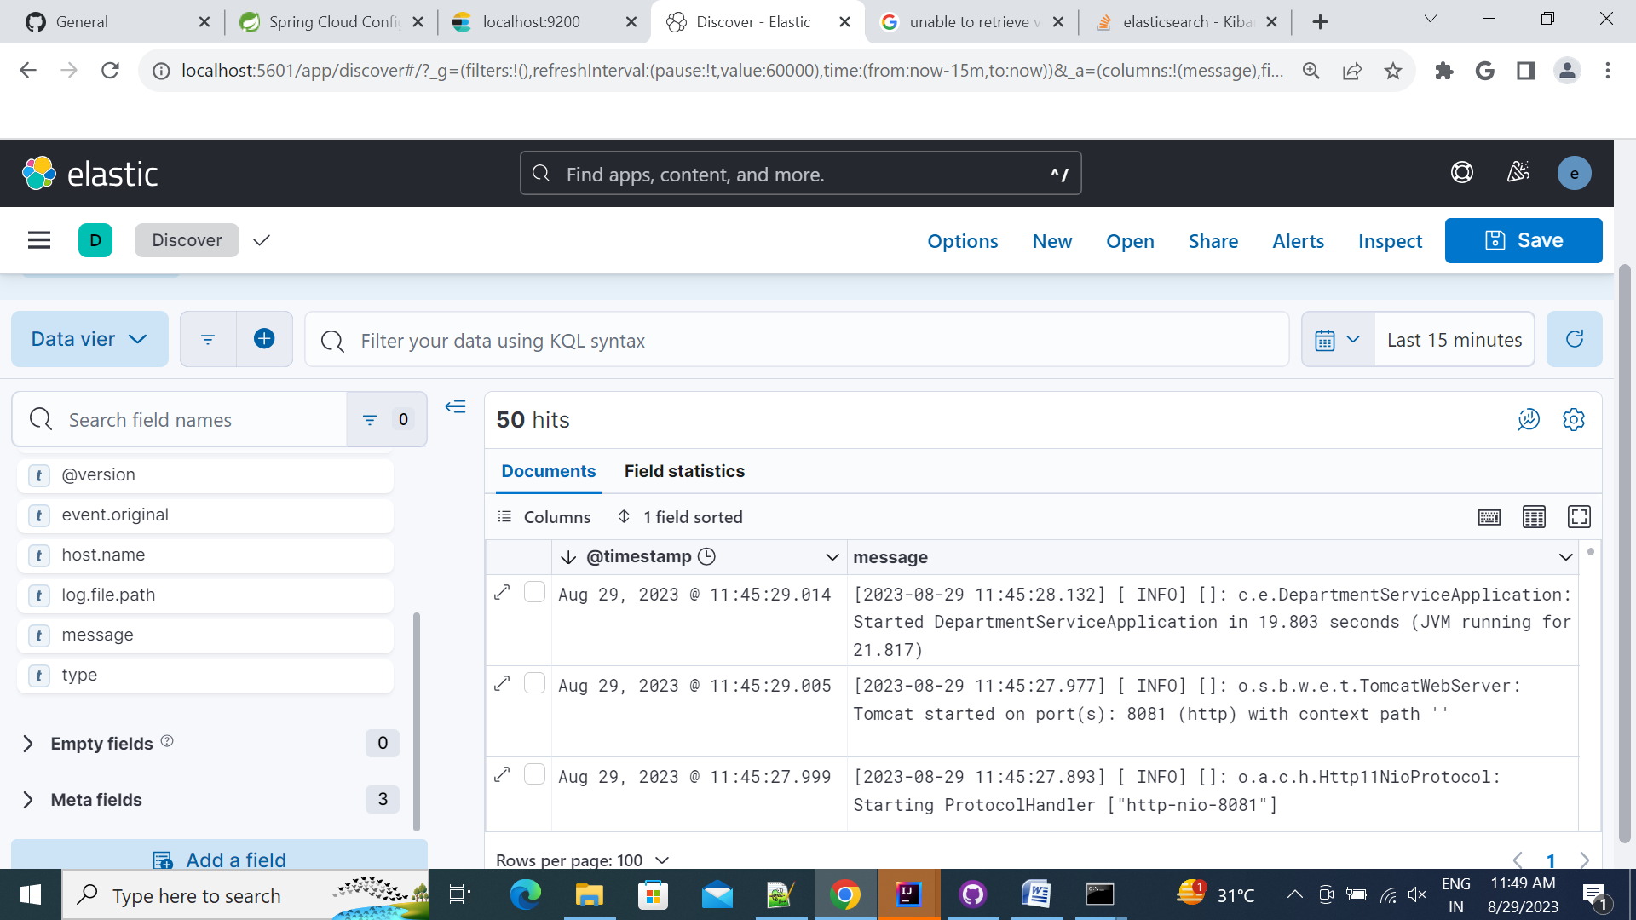
- Kibana setup local environment in docker(in windows)

- First you have to download docker desktop for windows. follow this steps to install docker into windows
https://docs.docker.com/desktop/install/windows-install/
set max_map_count in wsl to run some images
opern powershell and run bellow command

wsl -d docker-desktop
sysctl -w vm.max_map_count=262144

Now we have to create micro service. Which we have to deployed into docker. Create micro service and store that logs into separate file
Here is the link for example of elk service https://github.com/DipenMonani/elk-service
Now Open the powershell to execute docker commands to run and build microservice
- First we have to build microservice to generate docker image from dockerfile
Run docker build command where dockerfile is present
Go to microservice path “D:\Projects\POC\elk-service\user-service” and run bellow command to build image
For build images
docker build -t {imagename} .

view images
docker images

remove image
docker rmi {imageId}

This build command is read docker file and generate image in docker desktop
first we have create docker network to run microservice and mysql in same network. Bellow is the commands for create docker network
Create network
docker network create spring-net

view network
docker network ls

remove network
docker network rm {networkId}
Now Install mysql in docker. Get latest mysql image and pull into docker

Bellow is the command to pull maven image and run in docker
Pull mysql image from the docker hub repository
docker pull mysql:8.0.26

Run above image in same network
docker run --name mysql -d -p 3307:3306 -e MYSQL_ROOT_USER=root -e MYSQL_ROOT_PASSWORD=root mysql:8.0.26

connect mysql container to spring-net network
docker network connect spring-net mysql

Now we have create volume for share that data to all container.
Create volume for share that details to all container
docker volume create log

view volumes
docker volume ls

remove volume
docker volume rm {volumeId}

Now run our microservice image using bellow command
docker run --name user_container -e MYSQL_HOST=mysql -v log:/var/logs --net spring-net -d -p 8080:8080 user_service

Above command is bind docker port to our port and bind log volume to /var/logs folder of container where logs are generated

Then we have to pull elasticsearch, kibana and logstash image from docker hub repository
Bellow is the pull command to build image
docker pull docker.elastic.co/elasticsearch/elasticsearch:8.9.1
docker pull docker.elastic.co/kibana/kibana:8.9.1
docker pull docker.elastic.co/logstash/logstash:8.9.1

After Pulling images.
Create elastic network using docker network command.
Run elasticserach image. bellow is the command to run image
docker run --name elasticsearch --net elastic -d -p 9200:9200 -p 9300:9300 -e discovery.type=single-node -e xpack.security.enabled=false -e xpack.security.enrollment.enabled=false -it docker.elastic.co/elasticsearch/elasticsearch:8.9.1

Now run kibana image
docker run --name kibana -d --net elastic -p 5601:5601 docker.elastic.co/kibana/kibana:8.9.1

Now run the logstash command. Befor that we have to create logstash.conf file and put it into windows
D:/docker/ or put it into log volume in docker. I have putted into D:/docker folder so in bellow command I have bind that folder to /usr/share/logstash/pipeline/
You can put into log volume and bind as –v log: /usr/share/logstash/pipeline/
docker run --name logstash --link elasticsearch --net elastic -v log:/var/logs/ -d -it -v D:/docker/:/usr/share/logstash/pipeline/ docker.elastic.co/logstash/logstash:8.9.1

following same process as above for windows setup. Enable auto_create_index and create data view to see the logs
Now check the logs into kibana UI

Bellow is some command to reset password if we have security enable in elastic search
docker exec -it {containerName} /usr/share/elasticsearch/bin/elasticsearch-reset-password -u kibana_system
docker exec -it {containerName} /usr/share/elasticsearch/bin/elasticsearch-reset-password -u elastic
docker exec -it {containerName} /usr/share/elasticsearch/bin/elasticsearch-create-enrollment-token -s kibana

Docker commands

command | Description
dockur build -t {imagename} . | build image from service
dockur build -f {dockerfile path} | build image from service with specify docker file
docker image ls | list of docker images
docker images | list of docker images
docker image rm {image_name} | remove docker image
docker rmi {imageId} | remove docker image
docker create {image_name} | create docker container
docker run -d {image} -p {port}:{Cport} | run docker image in background with given container port
docker run {image} {command} | run docker image to create container
docker container ls | List of running docker image
docker ps | List of running docker image
docker ps -a | list of all docker images
docker rename {oldname} {newname} | rename docker container
docker container prune {options} | remove all stopped docker containers
docker rm -f {containerId} | remove container forcefully
docker rm {containerId} | remove docker container
docker start {container} | start existing container
docker stop {container} | stop running container
docker kill {container} | kill running container
docker exec -it {containerid} bash | go inside the container
docker network ls | list of network
docker network create {name} | create network
docker network rm {name} | remove docker network
docker volume create {name} | create docker volume
docker volume ls | list of docker volume
docker volume rm {name} | remove docker volume

