HealthAI: Intelligent Healthcare Assistant Using IBM Granite

**PROJECT TITLE : HealthAI: Intelligent Healthcare Assistant**

**Using IBM Granite**

**TEAM SIZE : 4**

**Team Leader : Gangireddy Mahendra Reddy**

**Team member : Bathula Vishnu**

**Team member : Bala Harini Palnati**

**Team member : Deena Mannepalli**

**Team ID : LTVIP2025TMID37458**

**College : Rise Krishna Sai Prakasam Group of Institutions**

# VIRTUAL INTERSHIP PROGRAM

**Intership details : Generative AI with IBM Cloud Internz : Smart Internz & IBM**

**Company : Smart Bridge powdered by Smart Internz**

# 📘 Introduction

# Project Overview

# HealthAI is a real-time intelligent healthcare assistant built using Python, Streamlit, and OpenAI/IBM Granite. It simulates doctor-like responses, predicts diseases, suggests treatments, and visualizes health metrics. It demonstrates how AI can be leveraged to provide meaningful health advice with a simple UI.

# Purpose

# To leverage IBM's Granite LLM for building a reliable, accessible, and AI-powered health assistant that aids users in health-related queries efficiently and securely.

**💡Ideation Phase**

**Problem Statement:**

Many individuals struggle to access quick and reliable health guidance, especially in remote or underserved areas. HealthAI bridges this gap using AI-powered assistants.

**Empathy Map Canvas:**

Think & Feel: Wants accurate medical advice

See: Too much online misinformation

Say & Do: Seeks help through apps

Hear: Concerns about trust in AI

Pain: Long wait times at clinics

Gain: Fast and trusted guidance

**Brainstorming:**

Use AI/ML for health Q&A

Integration with IBM Granite

Chat interface for ease of access

**Data Flow Diagram:**

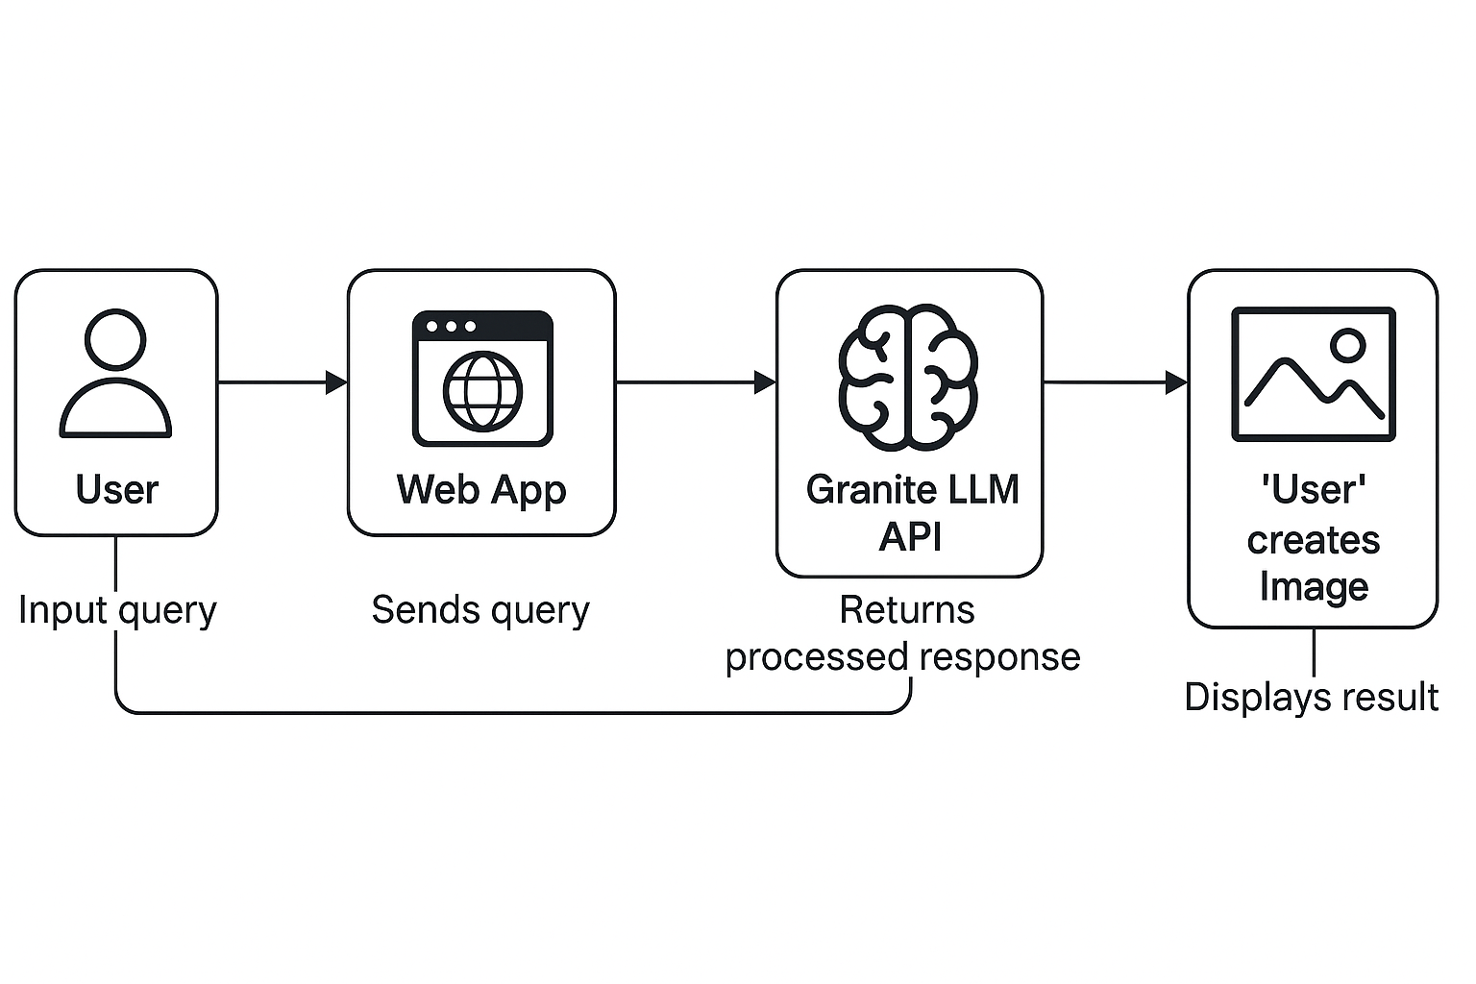

# ✅Reqirement Analysis

**Customer Journey Map:**

User opens app → asks question → receives response → gets suggestions

**Solution Requirements:**

* AI model: IBM Granite
* Backend: Python, Flask/FastAPI
* Frontend: HTML/CSS/JS or Streamlit
* Database (optional)

📜 **Declaration**

We hereby declare that the project titled "HealthAI: Intelligent Healthcare Assistant Using OpenAI" is the result of our original work completed under the guidance of SmartInternz and IBM. It has not been submitted elsewhere for any academic or professional recognition. All development, documentation, and implementation tasks were carried out with sincerity and adherence to academic integrity.

# 🙏 Acknowledgment

We express our heartfelt gratitude to SmartInternz and IBM for providing us this opportunity to work on an industry-relevant guided project. We also thank our faculty members and mentors for their continuous support, technical guidance, and valuable feedback throughout the course of this project.

🧠 **Abstract**

HealthAI is a real-time intelligent healthcare assistant that enables users to interact with an AI system to receive health-related information. Built with Python, Streamlit, and OpenAI, the system offers personalized responses to health queries, provides AI-powered disease predictions based on symptoms, suggests treatment guidelines, and visualizes patient data through insightful graphs. It serves as an educational and awareness tool, empowering users to make informed decisions about their health.

# Ị Problem Statement

Access to timely and professional medical advice remains a challenge for many, especially in rural and underserved communities. HealthAI aims to bridge this gap by offering a virtual assistant capable of providing preliminary health guidance, improving awareness, and reducing dependence on overburdened healthcare systems. It acts as a first point of reference before seeking clinical care.

# 🛠 Tools and Technologies Used

Tool/Technology Purpose

Python Backend logic and data processing

Streamlit Web interface development and deployment

OpenAI (ChatGPT) AI-based natural language understanding and response generation Pandas Health data manipulation and storage

Plotly Health metric visualization through dynamic graphs

GitHub Version control and collaborative development SmartInternz Platform Project structure, guidance, and submission support

# 🧩Modules Implemented

Patient Chat – Offers interactive, AI-generated responses to user health queries using prompt engineering and natural language processing.

Disease Prediction – Accepts symptoms from users and predicts possible conditions using symptom-based AI analysis.

Treatment Plans – Provides standard medical guidance and lifestyle suggestions for known medical conditions.

Health Analytics – Visualizes user health data trends like blood pressure, glucose levels, and heart rate, with AI-generated insights for better health tracking.

# ⚙️How to Use the HealthAI Application

1. Open App:HealthAI Streamlit App

( <https://healthaiproject-9zncftohtgbtxnwcvrkdss.streamlit.app/> )

1. Choose Feature: Patient Chat / Disease Prediction / Treatment Plans / Health Analytics
2. Input Data: Type symptoms or condition
3. Submit: Click generate
4. Output: Get response from AI instantly

# Sample Module Outputs

·.t_*± Home Page:

The **HealthAI homepage** provides an intuitive interface with quick access to modules like Patient Chat, Disease Prediction, Treatment Plans, and Health Analytics. It displays patient details and allows users to begin interacting with the AI assistant immediately.

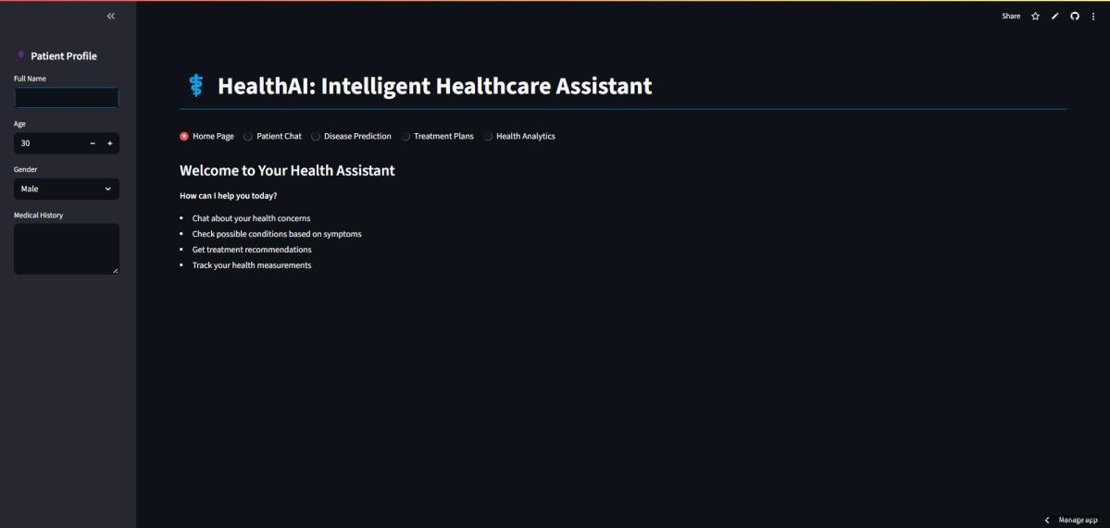

## ·¡_^ HealthAI: Intelligent Healthcare Assistant

Welcome to HealthAI, your virtual healthcare companion powered by AI. This application provides:

* + ˘⬛_*’'Real-time medical chat support using AI
  + C˛* Disease predictions based on symptoms
  + ˙’Personalized treatment plan suggestions
  + /¡ç# Health data analytics and trends

< Module 1: Patient Chat

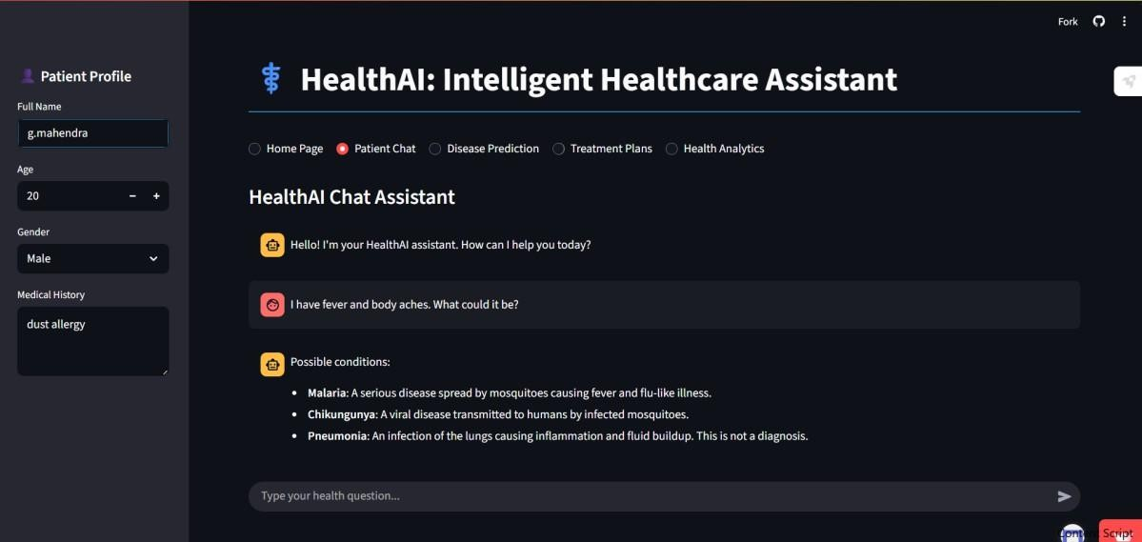

User: I have fever and body aches.What could it be? HealthAI :

* Malaria: A serious disease spread by mosquitoes causing fever and flu-like illness.
* Chikungunya: A viral disease transmitted to humans by infected mosquitoes.
* Pneumonia: An infection of the lungs causing inflammation and fluid buildup. This is not a diagnosis

`^ Module 2: Disease Prediction

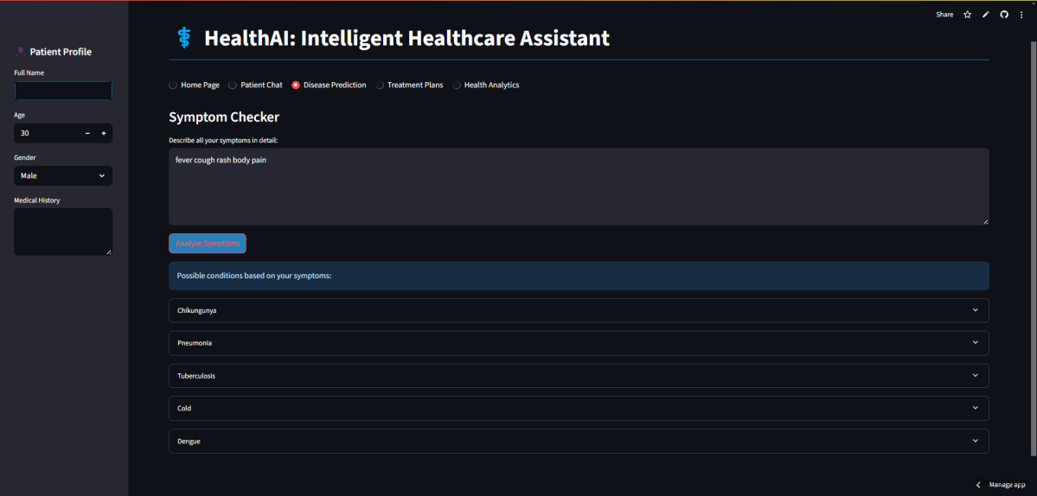

User: fever,cough,rash,body pain HealthAI :

## Analyze Symptoms

**Possible conditions based on your symptoms:**

* Chikungunya
* Pneumonia
* Tuberculosis
* Cold
* Dengue

˙’Module 3: Treatment Plans

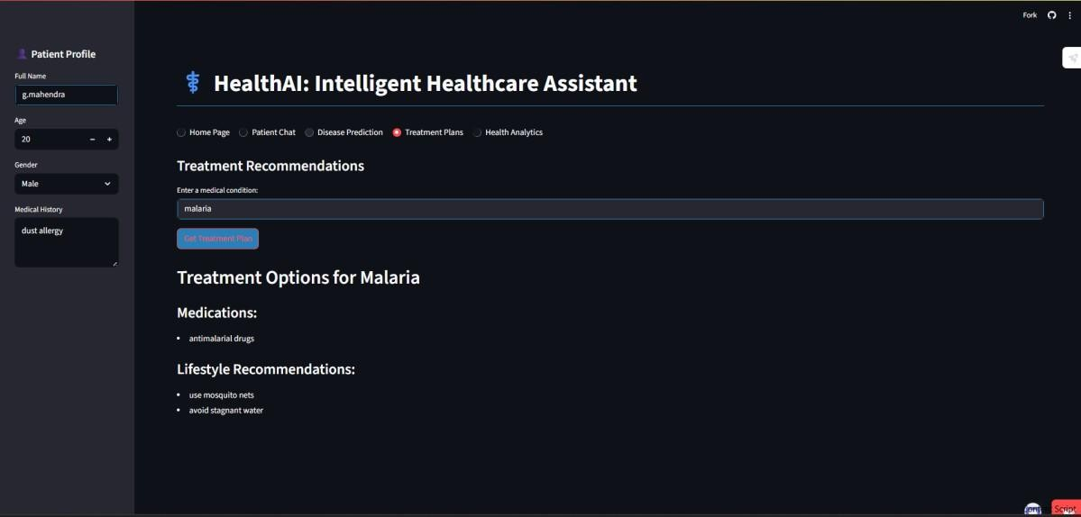

**Treatment Recommendations**

Enter a medical condition:

* Malaria

**Treatment Options for Malaria**

* Medications:
* antimalarial drugs

**Lifestyle Recommendations:**

* use mosquito nets
* avoid stagnant water

#/¡ç Module 4: Health Analytics

Displays 30-day trends of Heart Rate, BP, Glucose with insights.

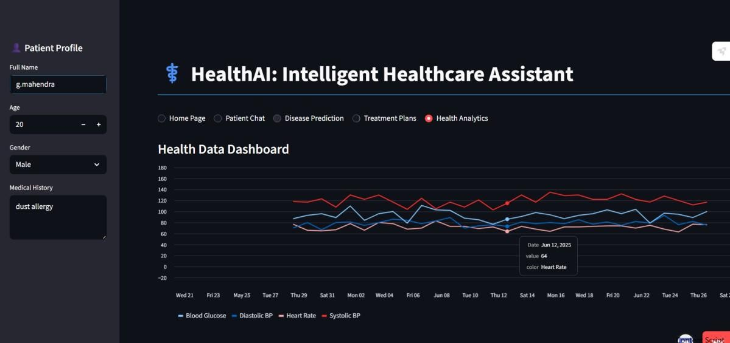

# 🏗 Technical Architecture

**Proposed Solution:**

Interactive chatbot powered by IBM Granite that processes symptoms and suggests outcomes

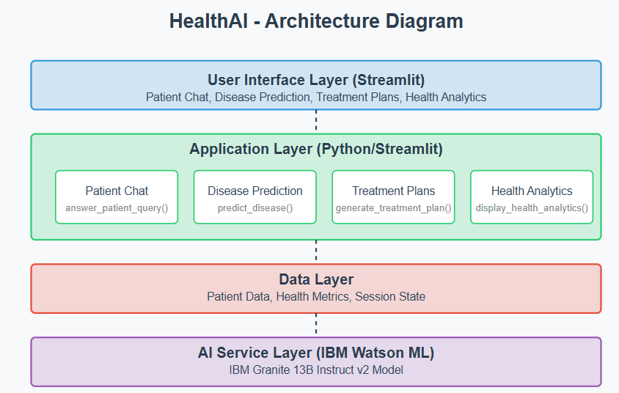

📅 **Project Planning & Scheduling**

**Day 1**: Research&Planning

**Day 2**: Backend & AI Integration

**Day 3**: Frontend Design

**Day 4**: Testing & Debugging

**Day 5**: Documentation

🔁 **Project Workflow**

* Requirement Gathering
* AI Model Selection
* UI/UX Planning
* Development (Frontend + Backend)
* Integration & Testing
* Deployment

# 🚩 Milestone 1: Model Selection and Architecture

We selected OpenAI GPT-3.5 for its powerful conversational abilities. Backend and frontend were designed to interact through clean APIs and modular components.

# 🔧 Milestone 2: Core Functionalities Development

Each module was developed independently:

* AI chat for general queries
* Symptom-based disease prediction
* Condition-based treatment planning
* Time-based health data visualization

# 📜 App.py Development

This main file handles routing, input collection, response display, and connects user interactions to utility logic and the OpenAI model.

🎨 **UI Design**

User interface is built using Streamlit’s built-in widgets and layout elements. Simple yet modern layout using sidebar, form inputs, charts, and response sections.

🚀 **Deployment**

Hosted on Streamlit Cloud. Environment variables securely stored. GitHub for code management and team collaboration.

# 🔮 Future Scope

-Connect with verified doctors

-Use wearable IoT devices

-Add user login and history

-Deploy on cloud with authentication

# ✅Advantages & Limitations

**Advantages:**

Instant AI responses

Easy-to-use interface

Based on reliable IBM/OpenAI models

**Limitations:**

No real-time doctor verification

Requires internet

Accuracy depends on model training

# ✅ Conclusion

HealthAI was a hands-on experience in building AI-integrated health apps. We learned prompt engineering, Streamlit deployment, and OpenAI usage for real-world healthcare problems.

# 🔗 Project Links

🌐 App: <https://healthaiproject-9zncftohtgbtxnwcvrkdss.streamlit.app/>

_¿ □ GitHub: <https://github.com/mahendra4338/HealthAI_Project/tree/main>

▶️ DemoVideo: <https://youtu.be/nyhc0tBoAZQ?si=tzA0AElV9AcZ2XQo>

## 📘 Report Source: IBM Granite Model Documentation