B.Tech. BCSE497J - Project-I

PUMS: LESION-LEVEL JOINT CONFORMAL RISK CONTROL WITH LESION-EQUALIZED PREDICTION SETS FOR MEDICAL IMAGE SEGMENTATION

Submitted in partial fulfillment of the requirements for the degree of

Bachelor of Technology

in

Computer Science and Engineering

by

23BCE0631 | VANSH BHATIYA
23BCE0701 | MAHENDRA SAJJAN CHOUDHARY

Under the Supervision of
Dr. Shashank Mouli Satapathy
Faculty Guide
School of Computer Science and Engineering (SCOPE)



October 2026

DECLARATION

We hereby declare that the project entitled “PUMS: Lesion-Level Joint Conformal Risk Control with Lesion-Equalized Prediction Sets for Medical Image Segmentation” submitted by us, for the award of the degree of Bachelor of Technology in Computer Science and Engineering to VIT is a record of bonafide work carried out by us under the supervision of Dr. Shashank Mouli Satapathy.
We further declare that the work reported in this project has not been submitted and will not be submitted, either in part or in full, for the award of any other degree or diploma in this institute or any other institute or university.

Place : Vellore Date : 19/10/2026
Signature of the Candidates
Vansh Bhatiya (23BCE0631)
Mahendra Sajjan Choudhary (23BCE0701)

CERTIFICATE

This is to certify that the project entitled “PUMS: Lesion-Level Joint Conformal Risk Control with Lesion-Equalized Prediction Sets for Medical Image Segmentation” submitted by Vansh Bhatiya (23BCE0631) and Mahendra Sajjan Choudhary (23BCE0701), School of Computer Science and Engineering, VIT, for the award of the degree of Bachelor of Technology in Computer Science and Engineering, is a record of bonafide work carried out by them under my supervision during Fall Semester 2026-2027, as per the VIT code of academic and research ethics.

The contents of this report have not been submitted and will not be submitted either in part or in full, for the award of any other degree or diploma in this institute or any other institute or university. The project fulfills the requirements and regulations of the University and in my opinion meets the necessary standards for submission.

Place : Vellore
Date : 19/10/2026

Signature of the Guide

Examiner(s)

Dr. Boominathan P
B.Tech. Computer Science and Engineering
ACKNOWLEDGEMENTS

We are deeply grateful to the management of Vellore Institute of Technology (VIT) for providing us with the opportunity and resources to undertake this project. Their commitment to fostering a conducive learning environment has been instrumental in our academic journey. The support and infrastructure provided by VIT have enabled us to explore and develop our ideas to their fullest potential.

Our sincere thanks to Dr. Jaisankar N, the Dean of the School of Computer Science and Engineering (SCOPE), for his unwavering support and encouragement. His leadership and vision have greatly inspired us to strive for excellence, and his dedication to academic excellence and innovation has been a constant source of motivation.

We express our profound appreciation to Dr. Boominathan P, the Head of the SCOPE, for the insightful guidance and continuous support. The expertise and advice have been crucial in shaping the direction of our project, and the constructive feedback and encouragement have been invaluable in overcoming challenges and achieving our project goals.

We are immensely thankful to our project guide, Dr. Shashank Mouli Satapathy, for the dedicated mentorship and invaluable feedback. The patience, knowledge and encouragement provided were pivotal in the successful completion of this project, and the willingness to share expertise and provide thoughtful guidance was instrumental in refining our ideas and methodologies. This support has not only contributed to the success of this project but has also enriched our overall academic experience.

Thank you all for your contributions and support.

Vansh Bhatiya (23BCE0631)
Mahendra Sajjan Choudhary (23BCE0701)

TABLE OF CONTENTS

Sl.No | Contents | Page No.
 | Abstract | x
1. | INTRODUCTION | 1
 | 1.1 Background | 1
 | 1.2 Motivations | 1
 | 1.3 Scope of the Project | 2
2. | PROJECT DESCRIPTION AND GOALS | 3
 | 2.1 Literature Review | 3
 | 2.2 Research Gap | 4
 | 2.3 Objectives | 4
 | 2.4 Problem Statement | 5
 | 2.5 Project Plan | 5
3. | TECHNICAL SPECIFICATION | 6
 | 3.1 Requirements | 6
 | 3.1.1 Functional | 6
 | 3.1.2 Non-Functional | 6
 | 3.2 Feasibility Study | 7
 | 3.2.1 Technical Feasibility | 7
 | 3.2.2 Economic Feasibility | 7
 | 3.2.3 Social Feasibility | 7
 | 3.3 System Specification | 7
 | 3.3.1 Hardware Specification | 7
 | 3.3.2 Software Specification | 8
4. | DESIGN APPROACH AND DETAILS | 9
 | 4.1 System Architecture | 9
 | 4.2 Design | 9
 | 4.2.1 Data Flow Diagram | 9
 | 4.2.2 Use Case Diagram | 10
 | 4.2.3 Class Diagram | 10
 | 4.2.4 Sequence Diagram | 11
5. | METHODOLOGY AND TESTING | 12
 | 5.1 Methodology | 12
 | 5.1.1 Notation and losses | 12
 | 5.1.2 Theory | 12
 | 5.1.3 Lesion-equalized prediction sets | 12
 | 5.1.4 Experimental protocol | 13
 | 5.2 Module Description | 15
 | 5.3 Testing | 15
6. | PROJECT DEMONSTRATION | 16
 | 6.1 Lesion Set Lab | 16
 | 6.2 Research Report Page | 17
 | 6.3 Dashboard and API | 18
 | 6.4 Reproducing the Results | 18
7. | RESULT AND DISCUSSION | 20
 | 7.1 Validity | 20
 | 7.2 H1: The Pixel-to-Lesion Gap | 20
 | 7.3 Cost of the Lesion-Level Guarantee | 21
 | 7.4 E7: Controlled Simulation | 22
 | 7.5 E8: Protecting Multi-Lesion Images (post hoc) | 22
 | 7.6 Discussion | 23
 | 7.7 Cost Analysis | 24
 | 7.8 Limitations | 24
8. | CONCLUSION | 25
 | 8.1 Future Work | 25
9. | REFERENCES | 26
 | APPENDIX A – SAMPLE CODE | 27

List of Figures

Figure No. | Title | Page No.
4.1 | System architecture: the PUMS core (top) and the lesion-level joint risk-control layer (teal). | 9
4.2 | Data flow diagram of the experiment and reporting pipeline. | 10
4.3 | Use case diagram. | 10
4.4 | Class diagram of the calibration extension. | 11
4.5 | Sequence diagram: dashboard request (top) and offline run (bottom). | 11
5.1 | Why equalization helps (illustrative schematic, not a dataset result). | 13
6.1 | The Lesion Set Lab: controls (left), a held-out scan with the thresholding and lesion-equalized sets (centre) and the risk table for the run (right). | 16
6.2 | Lesion Set Lab, lower panels: the 1-D mechanism view with adjustable ρ and cutoff (left) and the recorded real-data results (right). | 17
6.3 | The research report page: contents list, novelty assessment and problem statement. | 18
7.1 | Gap ratio on multi-lesion images; error bars are 95% split intervals. | 20
7.2 | Cost of each guarantee relative to joint thresholding (Kvasir-SEG, α = 0.10). | 21
7.3 | Set-size change in simulation as small lesions become fainter (γ). | 22
7.4 | Multi-lesion miss rate before and after adding the conditional risk (Kvasir-SEG). | 23

List of Tables

Table No. Title Page No.
2.1 Summary of related work (search of 14 October 2026) 3
2.2 Novelty claims and how strongly each is supported 4
2.3 Project plan and deliverables 5
3.1 Hardware used for all reported experiments 7
3.2 Software stack 8
5.1 Datasets 14
5.2 Pre-registered decision rules 14
5.3 Modules added or extended for the lesion-level layer 15
5.4 Test coverage of the lesion-level layer 15
7.1 Gap ratio G at the pixel-CRC threshold 20
7.2 Main comparison, Kvasir-SEG, α = 0.10 21
7.3 Change in set size, lesion-equalized vs joint thresholding (%) 22
7.4 Adding a risk conditioned on K ≥ 2 (post hoc) 23
7.5 Cost of the project 24

List of Abbreviations

API Application Programming Interface
AURC Area Under the Risk–Coverage curve
CCRA-S Conditional Conformal Risk Adaptation (stratified)
CI Continuous Integration
CLS Conformal Lesion Segmentation
CPU Central Processing Unit
CRC Conformal Risk Control
DFD Data Flow Diagram
ECE Expected Calibration Error
FNR False-Negative Rate
GPU Graphics Processing Unit
GT Ground Truth
IoU Intersection over Union
LTT Learn-Then-Test
MICCAI Medical Image Computing and Computer-Assisted Intervention
MRI Magnetic Resonance Imaging
MSD Medical Segmentation Decathlon
PUMS Perception Uncertainty Management System
RF Random Forest
UQ Uncertainty Quantification

Symbols and Notations

α Target risk level (allowed average miss rate)
λ Set-growth parameter; larger λ gives a larger prediction set
λ̂ Calibrated value of λ chosen on the calibration split
p̂(u) Model posterior (probability of lesion) at pixel u
τ Fraction of a lesion that must be inside the set for it to count as found (0.5)
ρ, t₀ Equalization strength and candidate cutoff of the lesion-equalized family
K Number of ground-truth lesions in an image
γ Confidence–size coupling exponent in the simulation
G Gap ratio: lesion-miss rate divided by α at the pixel-CRC threshold
S(λ) Prediction set at parameter λ

ABSTRACT
Medical image segmentation models are increasingly used to outline tumours, polyps and fractures, but a predicted mask alone does not say how far it can be trusted. PUMS (Perception Uncertainty Management System) is a post-hoc, model-agnostic layer that adds calibrated uncertainty to such models without retraining them. Its core estimates pixel, region and image-level uncertainty from model probabilities, applies split conformal risk control (CRC), detects input distribution shift and reports an itemised review signal. On patient-disjoint MSD Hippocampus MRI, the random-forest baseline reached Dice 0.524, ECE 0.111 and an uncertainty–error correlation of 0.512.
This report extends that core to a gap found while testing it. Standard CRC guarantees that the expected pixel false-negative rate (FNR) stays below a target α, but large lesions carry most pixels, so the guarantee says little about whether small lesions are found. At the pixel-CRC threshold on Kvasir-SEG, images with two or more polyps miss lesions at up to 1.56 times the target rate. We therefore (1) define lesion-miss and small-lesion-miss risks on ground-truth connected components and show they are valid CRC risks under any nested prediction-set family, (2) control them jointly with pixel FNR using the maximum of the per-risk CRC thresholds, and (3) propose lesion-equalized prediction sets, a new nested family that normalises each candidate lesion by its own peak confidence so that faint lesions no longer force a low global cutoff.
Hypotheses and decision rules were pre-registered before any result existed. The evaluation used two public datasets (FracAtlas and Kvasir-SEG), six baselines, 3 training seeds × 1000 random splits each, and a controlled simulation. Every method met every guarantee it claims on held-out data. Joint lesion-level control cost at most 0.7% in set size over pixel-only CRC, whereas Learn-Then-Test needed 10–46% larger sets and morphological prediction sets 1–43% larger sets. The pre-registered claim that lesion-equalized sets beat joint thresholding on real data was not supported: they tied, because the weak CPU random-forest backbone leaves the pixel constraint binding. In simulation they reduced set size by up to 47% when small lesions are moderately under-confident.
The method is integrated into the PUMS API and dashboard and is backed by 123 backend tests, 29 frontend tests, continuous integration and a one-command reproduction script. The work is a research prototype and makes no clinical claim. Testing on a strong GPU backbone and on 3-D multi-tumour data is the decisive next step.
Keywords: medical image segmentation, conformal risk control, lesion-level risk, prediction sets, uncertainty quantification, distribution shift, pre-registration.

CHAPTER 1
1. INTRODUCTION
1.1 Background
Machine-learning models now segment anatomical structures and lesions in medical images, turning a scan into a mask that can be measured, visualised and tracked. A mask, however, does not say whether the model can be trusted on this particular image. A model may be confident and wrong when the image is ambiguous, contains artefacts, or differs from the data the model was developed on.
Uncertainty quantification addresses this by estimating how unsure a model is. Pixel-level uncertainty localises ambiguous boundaries, region-level uncertainty summarises a structure, and image-level uncertainty describes the whole prediction. Calibration makes a numerical confidence correspond to observed error. Conformal prediction and conformal risk control (CRC) go further: using a held-out calibration set, they choose a decision rule so that the expected loss on a new image is at most a chosen level α, with a finite-sample guarantee that needs only exchangeability of the calibration and test data.
The first part of this project built PUMS, the Perception Uncertainty Management System: a post-hoc layer that consumes the probabilities of any dense predictor and adds a normalised-entropy uncertainty map, a hierarchical region and global summary, split CRC and temperature scaling, an intensity-based distribution-shift detector and an itemised review risk signal, served by a FastAPI backend and a Next.js dashboard. On patient-disjoint MSD Task04 Hippocampus MRI, the CPU random-forest baseline reached Dice 0.524, IoU 0.361, ECE 0.111, uncertainty–error correlation 0.512 and AURC 0.100.
This report presents the research contribution built on that core. It asks whether the standard CRC guarantee, which controls the expected fraction of lesion pixels missed, also protects lesions, and answers with a measured gap, a joint lesion-level guarantee and a new prediction-set family.
1.2 Motivations
In clinical reading, the unit of harm is a missed lesion, not a missed pixel. A 4 mm metastasis next to a 4 cm primary tumour contributes almost nothing to the pixel false-negative rate (FNR), so a guarantee on pixel FNR can hold while small lesions are routinely missed. The motivation has four parts:
- A pixel guarantee is dominated by large lesions. Missing a small lesion entirely barely moves the pixel average.
- The gap is measurable. At the pixel-CRC threshold on Kvasir-SEG, images with two or more polyps miss lesions at up to 1.56 times the target rate α.
- Existing multi-risk tools are costly. Learn-Then-Test can control several risks but gives a high-probability, conservative guarantee that needs 10–46% larger prediction sets in our tests.
- No prediction-set family is designed for a lesion loss. Thresholding the posterior is the natural ranking for a pixel loss, but for a lesion loss the cutoff is forced down by the faintest lesion, letting background into every image's set.

The research direction was refined after Review 2. The shift-conditional calibration proposed there is retained as future work, because a pilot experiment on Kvasir-SEG showed that the lesion-level gap was the larger and more clinically relevant problem. The pilot and every later decision rule are recorded in the pre-registration.
1.3 Scope of the Project
The scope is post-hoc calibration and risk control for 2-D (and, in the code, 3-D) semantic segmentation. No new segmentation architecture is proposed. The project covers:
- definition of lesion-level risks on ground-truth connected components, and their joint control with pixel FNR;
- a new nested prediction-set family (lesion-equalized sets) and the selection of its parameters on a disjoint tuning split;
- a pre-registered evaluation on FracAtlas and Kvasir-SEG against six baselines, a controlled simulation and a post-hoc analysis;
- integration into the PUMS FastAPI backend and Next.js dashboard, with provenance tags and a live in-browser demonstration.

The scope does not include clinical validation, deployment for patient care, a strong deep-learning backbone (a GPU U-Net and 3-D MSD Task08 pipeline are implemented but were not run in this round), patient-level splits (neither dataset has patient identifiers) or any diagnostic claim. The system is a research prototype, not a medical device.
CHAPTER 2
2. PROJECT DESCRIPTION AND GOALS
2.1 Literature Review
Conformal risk control. Angelopoulos et al. (2024) generalise split conformal prediction to any loss that does not increase as the prediction set grows. With n calibration images and loss bounded by B, the smallest threshold λ̂ satisfying (n·R̂ₙ(λ) + B)/(n + 1) ≤ α gives expected loss at most α on a new exchangeable image. The guarantee is marginal and exact at finite n. For segmentation, the published demonstration controls pixel FNR.
Learn-Then-Test and risk-controlling prediction sets. Bates et al. (2021) and Angelopoulos et al. (2021) obtain high-probability guarantees by testing a grid of parameters with multiple-testing corrections. LTT supports several risks at once, but its guarantee is stronger and its sets are correspondingly larger.
Segmentation-specific conformal methods. Conformal Lesion Segmentation (Tan et al., 2025) calibrates voxel FNR per 3-D volume with a high-probability guarantee; despite its name, its loss counts voxels. CRA, CCRA and CCRA-S (Luo and Zhou, 2025) control pixel FNR per stratum, where the strata are groups of images defined by total predicted mass. ReCIRC (2026) adds a per-image budget. Morphological prediction sets (Mossina and Friedrich, 2025) dilate the predicted mask until it contains the ground-truth mask with high probability. Per-organ recall control (2026) and FDR control for instance segmentation (2025) work at organ or pixel granularity.
Object-level losses. Andéol et al. (2023) apply CRC to object detection with a box-wise recall loss. This is the closest object-level idea, but it addresses detection, controls one risk at a time and does not design the set family.
Table 2.1: Summary of related work (search of 14 October 2026)
Work | Loss granularity | Guarantee | Several risks?
Conformal Risk Control (ICLR 2024) | any monotone loss; pixel FNR in practice | expectation | no
Learn-Then-Test (arXiv 2110.01052) | any loss | high probability | yes, conservative
Conformal Lesion Segmentation (arXiv 2510.17897) | voxel FNR per volume | high probability | no
CRA / CCRA / CCRA-S (arXiv 2504.07611) | pixel FNR, strata of images | expectation per stratum | no
ReCIRC (arXiv 2609.38112) | pixel FNR per image | marginal + approx. conditional | no
Morphological prediction sets (MICCAI 2025) | mask containment (dilation) | high probability | no
Per-organ recall (arXiv 2608.18193) | voxel FNR per organ | high probability | Bonferroni
FDR for instance segmentation (arXiv 2504.04482) | pixel FDR or FNR | expectation | one at a time
Andéol et al., COPA 2023 | box-wise or pixel recall | expectation | one at a time

Uncertainty, calibration and shift in the PUMS core. The Project-I layer uses normalised predictive entropy as the default uncertainty estimator (with margin and least-confidence alternatives), temperature scaling (Guo et al., 2017) as the calibration baseline, and a composite intensity-domain shift detector (Wasserstein and Jensen–Shannon distances, moments and edge density). Kendall and Gal (2017) and Lakshminarayanan et al. (2017) motivate the lightweight single-pass design as an alternative to Bayesian and ensemble methods.
2.2 Research Gap
A literature search on 14 October 2026 covered arXiv and the web from 2021 onward with twelve query strings, including “lesion-wise conformal segmentation”, “multi-risk conformal segmentation” and “Learn then Test segmentation”. It found no segmentation risk-control method that does any of the following:
- states its guarantee on ground-truth lesions (connected components), or on small lesions separately;
- controls pixel, lesion and small-lesion risk simultaneously;
- designs the prediction-set family for a lesion loss.

Table 2.2: Novelty claims and how strongly each is supported
Claim | Status | Reason
1. Risk defined on ground-truth lesions, including small lesions | New, supported | No published segmentation risk control defines its loss on ground-truth components
2. Joint control of pixel, lesion and small-lesion risk | New, but simple | A corollary of CRC monotonicity (maximum of the per-risk thresholds); a new formulation with a measured gap, not a deep theorem
3. Lesion-equalized prediction sets | New, not yet supported on real data | Wins in simulation (up to 47% smaller sets) and ties on both real datasets

The search was thorough but not exhaustive. If prior work on item 3 is found, items 1 and 2 and the measured gap still stand.
2.3 Objectives
Primary objective. Develop and evaluate a post-hoc, model-agnostic framework that guarantees, with finite-sample rigour, that the average pixel, lesion and small-lesion miss rates of a segmentation model stay below a chosen level α, and that keeps the prediction sets as small as possible.
Specific objectives.
- Define lesion-miss and small-lesion-miss risks on ground-truth connected components and prove they are CRC-valid under any nested set family.
- Control them jointly with pixel FNR using union (maximum) and max-form thresholds.
- Design lesion-equalized prediction sets, a nested family intended to reduce set size without losing validity.
- Measure the pixel-to-lesion gap and compare the methods against six baselines under a pre-registered protocol.
- Test the mechanism in a controlled simulation and report negative results openly.
- Integrate the method into the PUMS API and dashboard with full provenance, tests and a one-command reproduction path.

Hypotheses. H1 (gap): at the pixel-CRC threshold the lesion-miss rate on multi-lesion images, or the small-lesion miss rate, exceeds α. H2 (efficiency): under the same joint guarantee, lesion-equalized sets are smaller than plain thresholding. E7 (mechanism): the gain appears when small lesions are less confident than large ones and grows with that coupling.
2.4 Problem Statement
Given a segmentation model that outputs a posterior p̂ᵢ(u) for each image i and pixel u, and a held-out calibration set, choose a prediction set S(λ̂) for new images such that three expected losses are each at most α: the fraction of lesion pixels outside the set, the fraction of ground-truth lesions that are not found (found means at least 50% of the lesion is inside the set), and the same fraction restricted to small lesions. Among all rules that achieve this, prefer the one with the smallest sets, because a larger set flags more healthy tissue and costs the reviewer more attention.
Existing methods control the first quantity only, or control several quantities with a conservative high-probability guarantee, and none designs the set family for the second and third. The problem addressed here is to close that gap with a guarantee as rigorous as CRC and a cost as small as possible.
2.5 Project Plan
Table 2.3: Project plan and deliverables
Phase | Period | Activities | Deliverable
1 | July 2026 | Requirements, literature review, dataset and licence review (Review 1, 29 July) | Problem definition and scope
2 | August 2026 | Preprocessing, random-forest backbone, pixel uncertainty, hierarchy, calibration, shift detector, risk engine, API and dashboard (Review 2, 22 August) | PUMS Project-I core
3 | September 2026 | Kill-test pilot on Kvasir-SEG; theory memo; novelty search plan | Lesion-level gap hypothesis
4 | October 2026 (first half) | Pre-registration and two dated amendments; losses, families and joint rules; 5-fold cross-fitted backbones; experiments E1–E8; simulation | Results files with sha256 manifests
5 | October 2026 (second half) | API endpoint, dashboard tab, showcase demo, paper draft, this report and slides (Review 3, 28 October) | Integrated prototype and documents
6 | Next semester | GPU U-Net / nnU-Net backbone, 3-D MSD Task08, weighted conformal under shift, paper submission | Decisive test of H2

CHAPTER 3
3. TECHNICAL SPECIFICATION
3.1 Requirements
3.1.1 Functional
- Load images (PNG, JPEG, BMP, TIFF, single-frame DICOM) and the public datasets FracAtlas (COCO polygons rasterised to components), Kvasir-SEG and MSD.
- Produce out-of-fold posteriors by 5-fold cross-fitting and record them with a sha256 manifest and environment record.
- Compute, for every image, the pixel loss, the lesion-miss loss and the small-lesion-miss loss on a grid of 1001 λ values.
- Select thresholds by CRC: per-risk, union (maximum), max-form, Learn-Then-Test, morphological (dilation) and CCRA-S-style strata.
- Choose the score family (ρ, t₀) on a tuning split disjoint from the calibration split.
- Evaluate every method on the test split: mean risk for each risk it claims, and set-to-truth ratio.
- Generate pre-registered verdicts (H1, H2, E7) and every number used in the paper from the committed result files.
- Serve the results through GET /api/research/mgcrc and display them in the dashboard's Lesion-level CRC tab and the /showcase demonstration.
- Retain every Project-I function: uncertainty heat-map, hierarchical summaries, calibration, shift warning, risk signal and provenance tags.

3.1.2 Non-Functional
- Validity first. Every method must be checked against the guarantee it claims, on held-out data, before its efficiency is reported.
- Reproducibility. Seeds are fixed; posteriors carry sha256 hashes; one command (scripts/reproduce) regenerates every result, verdict and paper number.
- Provenance. Every number is tagged computed, synthetic or mock; planned methods return HTTP 501 rather than invented values.
- Separation of concerns. Score families, losses, selection rules and experiments live in separate modules; a new backbone only has to supply posteriors.
- Typed contracts. Pydantic schemas in the backend and Zod schemas in the frontend, with a contract test against a real captured API response.
- CPU feasibility. All reported numbers were produced on a CPU laptop; a GPU path exists but is optional.
- Honest scope. The application states that it is a research prototype, not a diagnostic device.

3.2 Feasibility Study
3.2.1 Technical Feasibility
The method needs only the posterior of a segmenter and a few array operations per image (one sort per image gives every lesion's score, by Lemma 2 in Section 5.1), so it is cheap to run and easy to attach to any backbone. All components are open-source and mature: Python, NumPy, SciPy, scikit-learn, FastAPI, Pydantic, Next.js, React, TypeScript and pytest. The whole pipeline, including 5-fold cross-fitting of a random-forest backbone and 3000 random splits per dataset, ran on a CPU laptop. The main technical risks are the modest accuracy of the CPU backbone, which is why the real-data efficiency result is inconclusive, and the approximate exchangeability that cross-fitting provides.
3.2.2 Economic Feasibility
The project uses open-source software and datasets released for research use (FracAtlas under CC BY 4.0, Kvasir-SEG and MSD under their published terms) on an existing laptop, so the incremental monetary cost is nil. The methodological benefit is that lesion-level control adds at most 0.7% to the prediction set, and so adds almost no review cost, while LTT would add 10–46%. No financial return is claimed: this is a research prototype.
3.2.3 Social Feasibility
The work supports human review and does not replace clinical judgement. Its social value is to make a more meaningful promise: “few lesions are missed” rather than “few pixels are missed”. The main risks are over-trust in a numerical guarantee, bias from limited data and misuse of simulation results as clinical evidence. They are addressed by explicit assumptions (the guarantee is marginal, conditional on a lesion being present, and relies on exchangeability), provenance badges, disclosure of every negative result and the statement that no clinical validation has been performed.
3.3 System Specification
3.3.1 Hardware Specification
Table 3.1: Hardware used for all reported experiments
Component | Specification
Processor | 13th Gen Intel Core i9-13980HX (24 cores, 32 threads)
Memory | 15.6 GB RAM
GPU | Not used. A GPU path exists (-Backbone unet-r34 -Size 512) but was not run
Operating system | Windows 11 Home
Storage | About 10 GB for the environment, datasets, posteriors and results

3.3.2 Software Specification
Table 3.2: Software stack
Category | Specification
Backend | Python 3.11+, FastAPI, Pydantic v2
Scientific libraries | NumPy, SciPy, scikit-learn (random forest), scikit-image, Pillow, pydicom, nibabel, joblib
Frontend | Next.js 16, React 19, TypeScript, Tailwind CSS, Recharts, Zod, TanStack Query, Zustand
Testing and CI | pytest, Node test runner, TypeScript type-checking, GitHub Actions
Reporting | LaTeX paper (LNCS / MICCAI), generated tables and macros, Markdown documentation
Optional | PyTorch and segmentation_models_pytorch for the GPU U-Net backbone

CHAPTER 4
4. DESIGN APPROACH AND DETAILS
4.1 System Architecture
The system keeps the Project-I PUMS pipeline unchanged and adds a lesion-level risk-control layer that depends on one thing only: the posterior p̂ produced by the model adapter. Any segmenter that outputs a posterior can therefore be swapped in without changing the new layer.
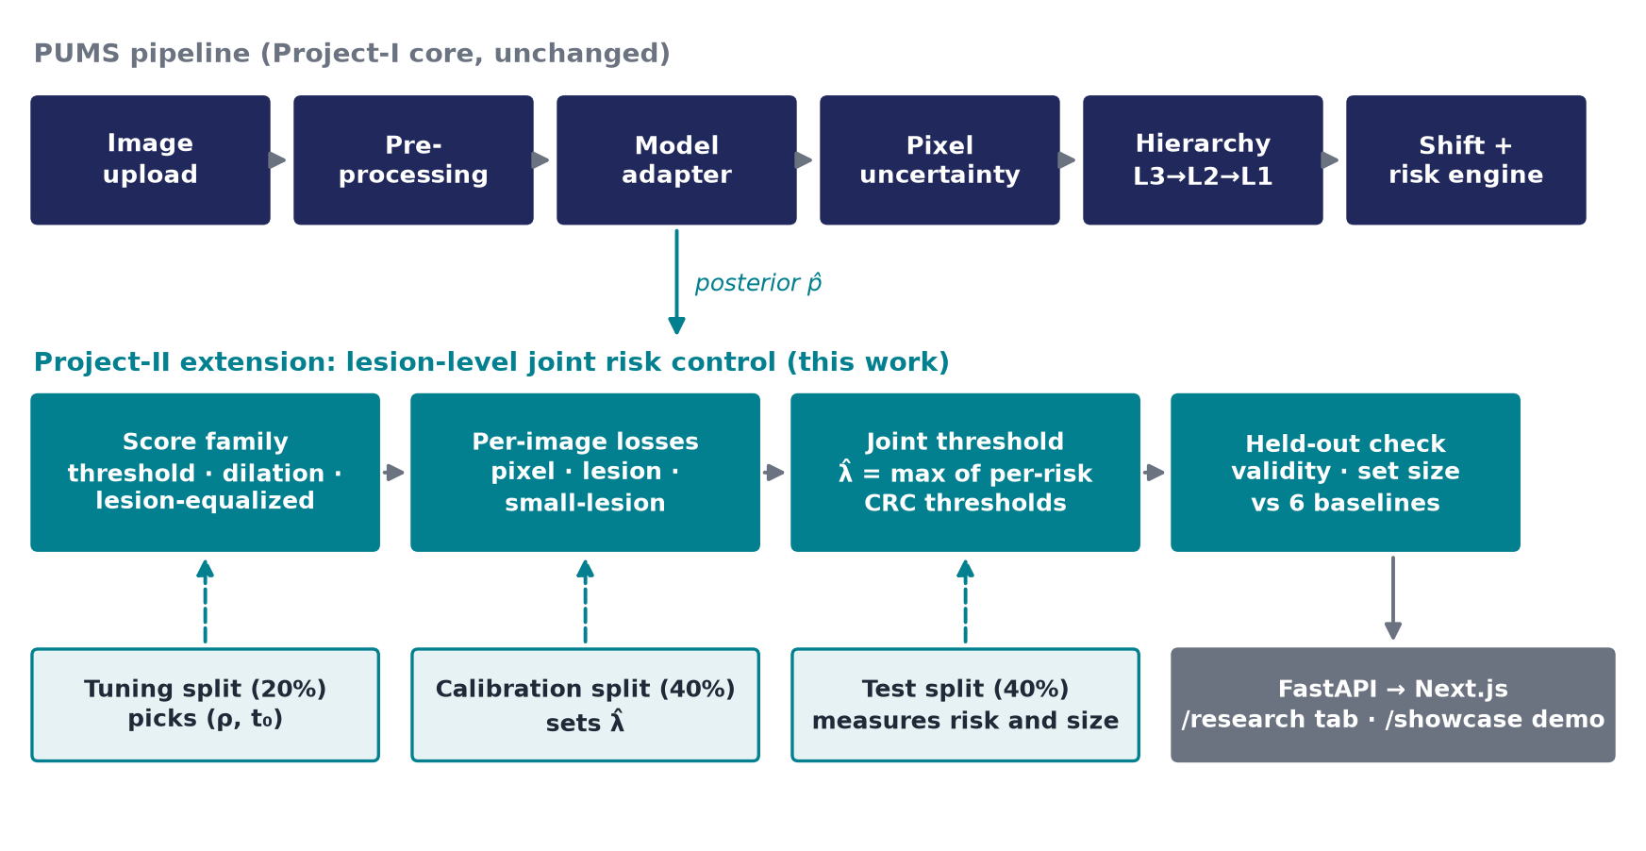
Figure 4.1: System architecture: the PUMS core (top) and the lesion-level joint risk-control layer (teal).
Three disjoint data splits are used in every repetition. The tuning split (20%) chooses the score family (ρ, t₀). The calibration split (40%) sets the thresholds λ̂. The test split (40%) measures the realised risk and set size. Because the family is fixed before calibration, the guarantee is unchanged (Proposition 1 in Section 5.1). The baselines need no tuning, so they calibrate on tuning plus calibration data (60%); this biases the comparison against the proposed method.
4.2 Design
4.2.1 Data Flow Diagram
Public datasets enter the backbone process, which writes out-of-fold posteriors to a hashed store. Per-image lesion losses are computed from the posteriors and the ground-truth components, joint calibration selects λ̂ and the family, an audit process measures validity and set size on the test split, and a final process turns the results into verdicts and dashboard data.
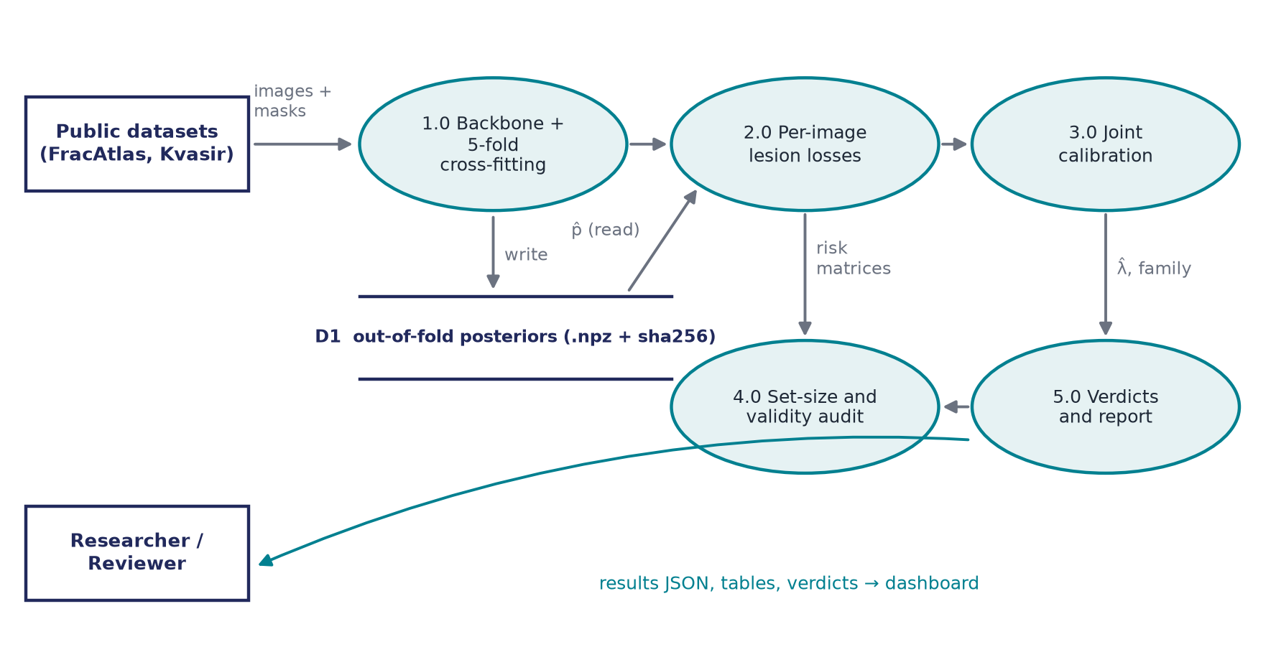
Figure 4.2: Data flow diagram of the experiment and reporting pipeline.
4.2.2 Use Case Diagram
The researcher or reviewer uploads an image, inspects uncertainty, reads calibration and shift warnings, opens the Lesion-level CRC tab and runs the Lesion Set Lab demo. The developer or administrator registers model adapters, runs the experiment pipeline, regenerates verdicts and paper numbers, and checks API health and provenance.
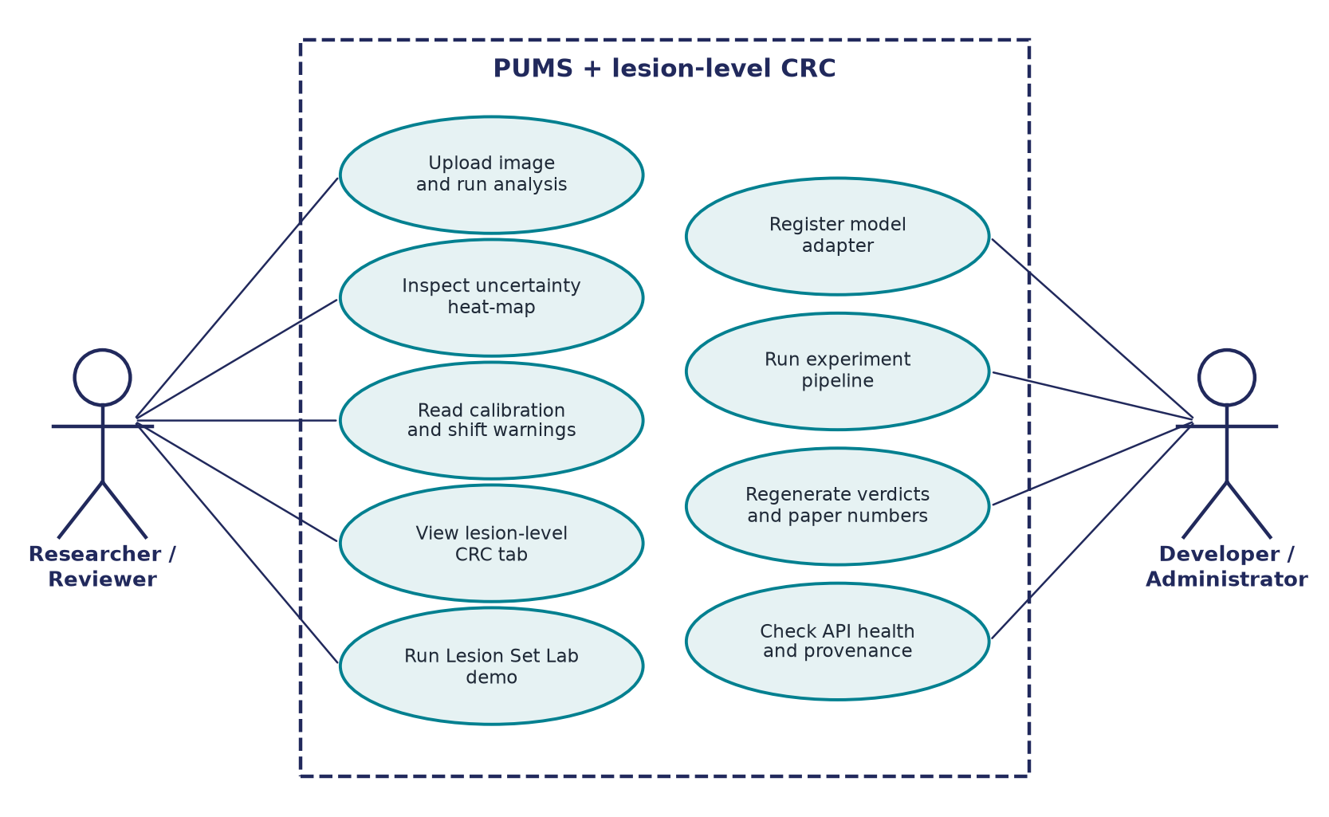
Figure 4.3: Use case diagram.
4.2.3 Class Diagram
StructuredConformalRiskControl is a calibration method registered beside the existing ConformalRiskControl and TemperatureScaling classes (lesion_aware_crc and morphological_conformal in the method registry). It is parameterised by a frozen ScoreFamily (threshold, dilation or lesion-equalized) and consumes StackedStats, the per-image loss grids.
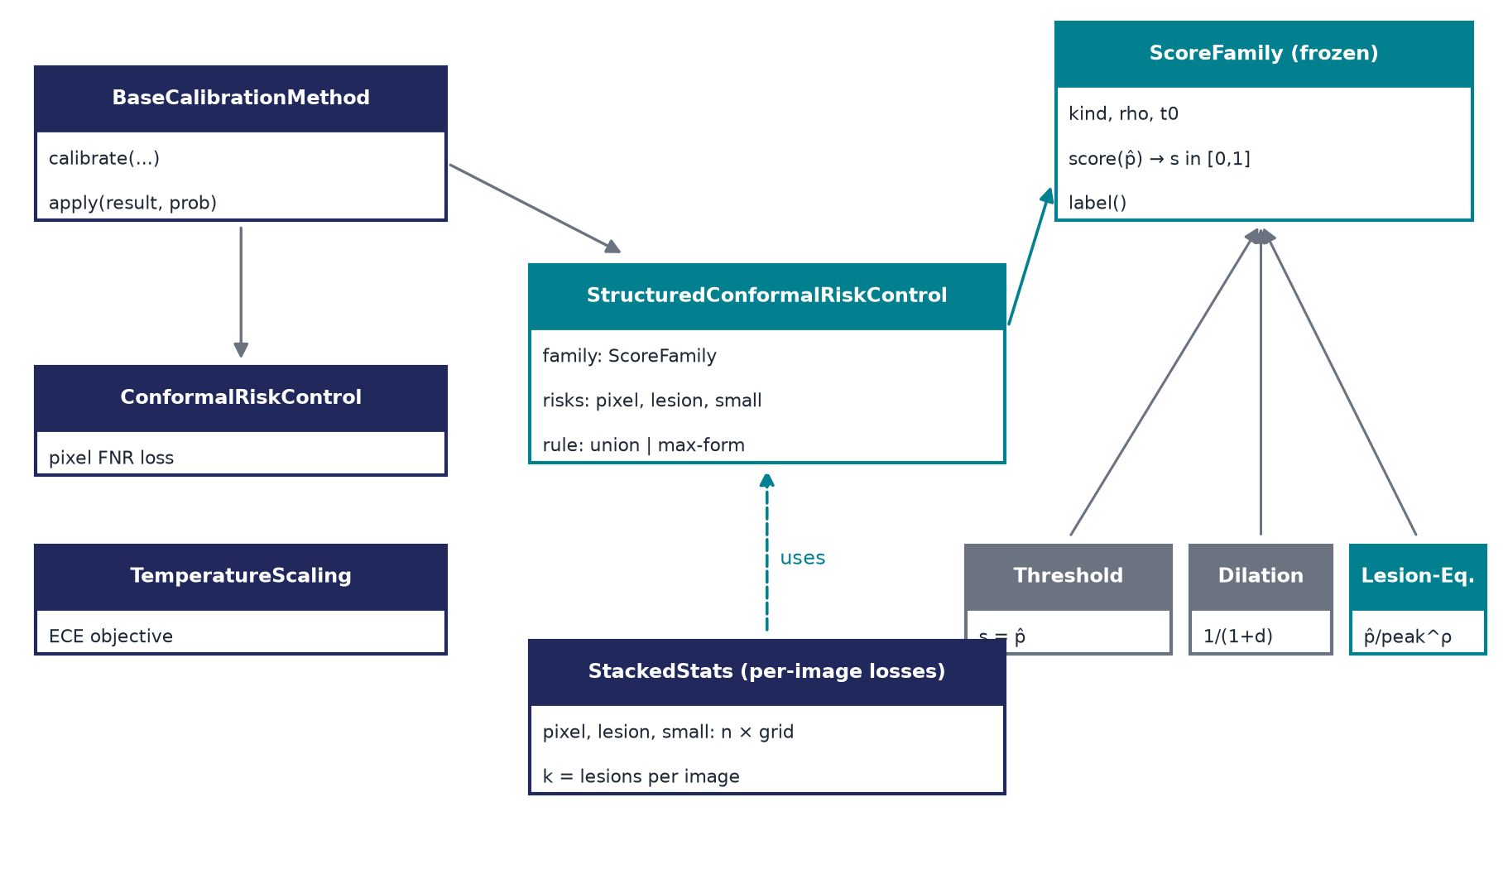
Figure 4.4: Class diagram of the calibration extension.
4.2.4 Sequence Diagram
Online, the dashboard requests the committed result file through a typed endpoint and renders it. Offline, the experiment harness selects λ̂ per risk, takes the maximum, evaluates on the test split and writes results with a sha256 manifest.
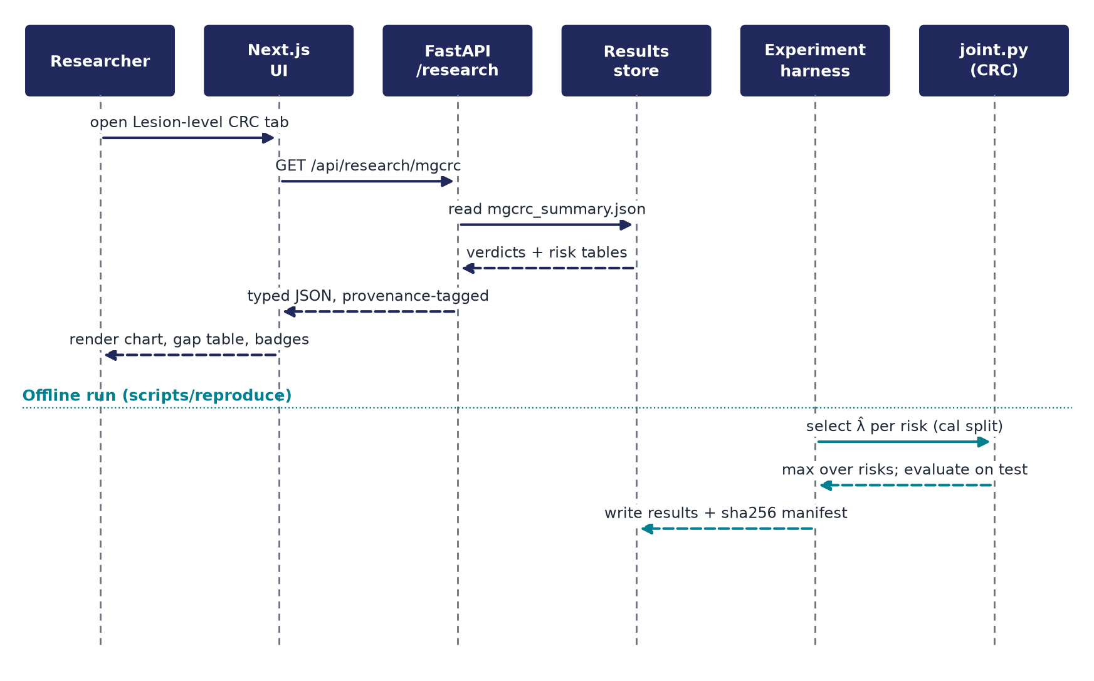
Figure 4.5: Sequence diagram: dashboard request (top) and offline run (bottom).
CHAPTER 5
5. METHODOLOGY AND TESTING
5.1 Methodology
5.1.1 Notation and losses
Let image i have posterior p̂ᵢ(u) ∈ [0, 1] and ground truth Yᵢ, split into connected components Yᵢ¹ … Yᵢᴷ (8-connected in 2-D, 26-connected in 3-D), which are the lesions. A score family is a fixed transform s = T(p̂) that does not look at labels; prediction sets are S_λ = {u : s(u) ≥ 1 − λ}, so a larger λ gives a larger set, and the sets are nested by construction. A lesion is found if at least τ = 50% of its pixels are inside the set. Three losses are defined:
L_pix = 1 − |S ∩ Y| / |Y|
L_les = (1/K) · #{ lesions with less than 50% coverage }
L_small = the same count, restricted to lesions below the 33rd percentile of lesion area
The small-lesion threshold uses labels only and was fixed before testing. Images with no lesion are excluded, and images with no small lesion are excluded from L_small, so each guarantee is conditional on the structure being present.
5.1.2 Theory
- Lemma 1 (monotonicity). If the sets are nested and the loss is a non-increasing function of S ∩ Y, the loss never increases with λ. All three losses qualify under every family, so CRC applies to each.
- Lemma 2 (one number per lesion). Lesion k is found at cutoff c exactly when its ⌈τ·|Yᵏ|⌉-th largest score is at least c. The lesion loss therefore needs one sort per image, the same cost as the pixel loss. The test suite checks this against brute force.
- Corollary (joint threshold). Compute the CRC threshold λ̂ʳ for each risk r and take λ̂ = max over r of λ̂ʳ. By monotonicity every risk is at most α in expectation at once. No Bonferroni split is needed, because each bound is an expectation bound controlled on its own.
- Max-form variant. Apply CRC to max(L_pix, L_les, L_small) per image. This bounds the per-image worst risk, a stronger statement, at a larger threshold.
- Proposition 1 (validity with a tuned family). If the family is chosen on a tuning split disjoint from the calibration split, the guarantee is unchanged: conditional on the tuning data the transform is fixed. Choosing the family on the calibration data would break the guarantee.

The CRC rule itself is: λ̂ is the smallest λ such that (n·R̂ₙ(λ) + 1)/(n + 1) ≤ α, where R̂ₙ is the average loss over the n calibration images and the loss is bounded by 1. The guarantee is marginal, not conditional on any particular image.
5.1.3 Lesion-equalized prediction sets
With plain thresholding (s = p̂), a faint lesion is found only if the global cutoff drops below its confidence. The lesion constraint is therefore set by the least confident lesion, which is usually a small one, and at that low cutoff every background pixel above it joins every image's set. The proposed fix is to find candidate regions Cⱼ, the connected components of {p̂ ≥ t₀} with peak Pⱼ, and rescale inside each candidate:
s(u) = p̂(u) / Pⱼ^ρ if u is inside candidate Cⱼ; s(u) = p̂(u) otherwise (ρ ∈ [0, 1])
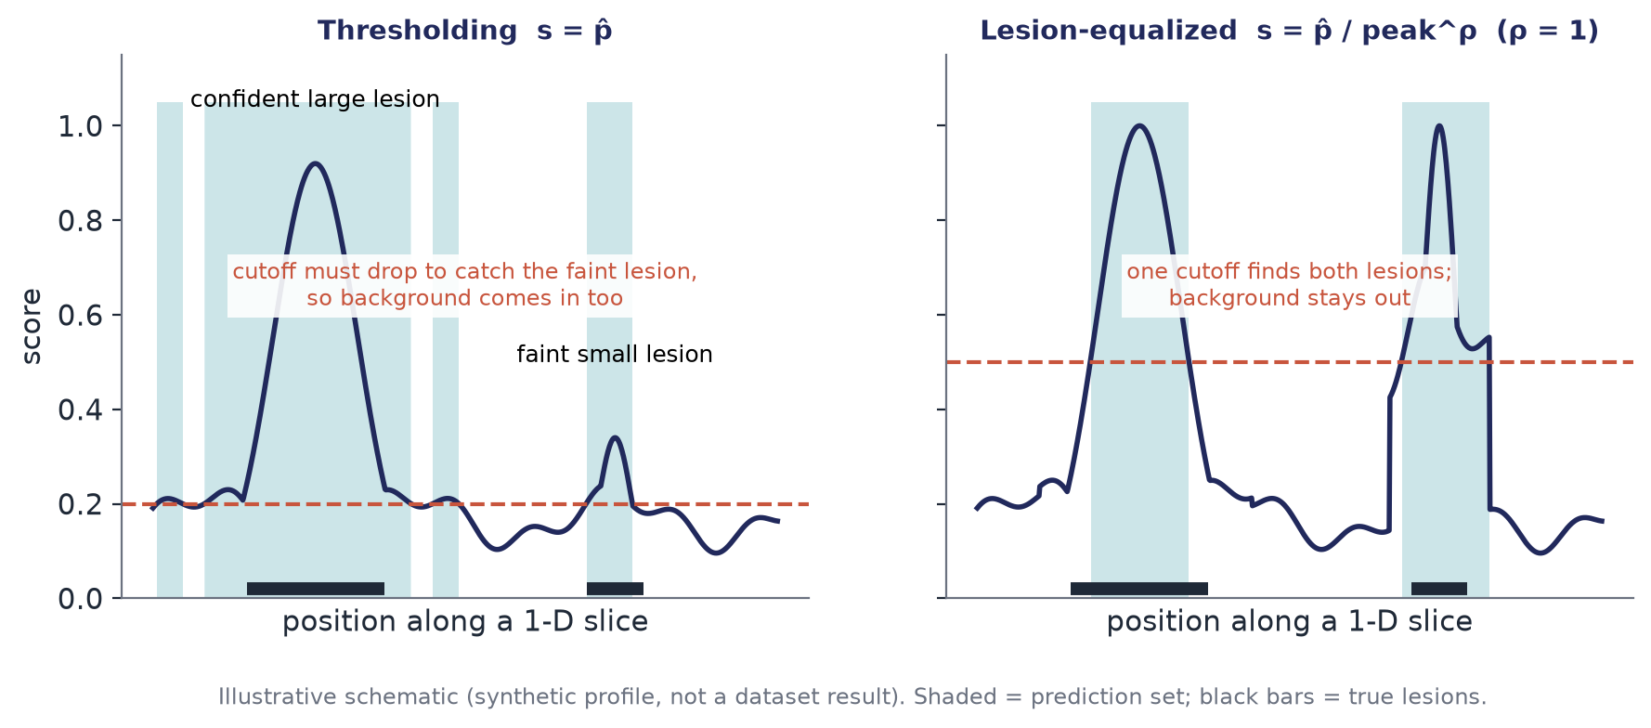
Figure 5.1: Why equalization helps (illustrative schematic, not a dataset result).
- Lemma 3. Scores stay in [0, 1], every candidate pixel outranks every non-candidate pixel, and ρ = 0 gives exactly thresholding, so the baseline is inside the family.
- Proposition 2 (amplitude invariance). If a candidate's posterior is a·g (confidence a times a shape g), then at ρ = 1 the score is g / max g. Whether a lesion is found no longer depends on the model's confidence, only on the shape of its response.
- Proposition 3 (background exclusion). At any cutoff of at least t₀, the set lies inside the candidates; thresholding has no such containment.
- The cost. False candidates (noise blobs above t₀) are also rescaled and join the set. The pair (ρ, t₀) sets this trade-off and is chosen on the tuning split from a 17-member grid: ρ ∈ {0.25, 0.5, 0.75, 1} × t₀ ∈ {0.05, 0.1, 0.2, 0.3}, plus plain thresholding.

This is a sufficient mechanism, not an optimal family; the best nested family for a lesion loss is an open question.
5.1.4 Experimental protocol
The protocol was pre-registered in git before any result existed. Amendment 1 recorded the change of backbone to a CPU random forest because PyTorch and the 9 GB Task08 dataset were not downloaded. Amendment 2 added the controlled simulation and disclosed two debug runs seen beforehand.
Table 5.1: Datasets
Property | FracAtlas | Kvasir-SEG
Modality | Musculoskeletal X-ray (fractures) | Colonoscopy (polyps)
Images | 719 fractured X-rays | 1000
Images with at least 2 lesions | 159 | 48
Images with a small lesion | 234 (area < 104 px) | 312 (area < 3774 px)
Role | Multi-lesion, hard backbone | Near single-lesion control
Out-of-fold Dice of the backbone | 0.057 (near failing) | 0.413

- Backbone. The repository's supervised random forest over a multiscale filter bank at 256 × 256, trained with 5-fold cross-fitting so every image's posterior comes from a model that never saw it.
- Repetitions. 3 training seeds × 1000 random partitions of each dataset into tune 20% / calibrate 40% / test 40%.
- Baselines. (1) pixel CRC; (2) joint CRC with thresholding, the reference; (3) max-form with thresholding; (4) Learn-Then-Test (Hoeffding–Bentkus p-values, fixed sequence, δ = 0.1); (5) morphological (dilation) prediction sets, joint; (6) CCRA-S-style strata on total predicted mass, joint. The proposed method is lesion-equalized, joint (union rule) and max-form.
- Metrics. Set-to-truth ratio Σ|S| / Σ|Y| on test images at a threshold covering all three risks (lower is better). Validity: mean test risk at most α (+0.005 Monte-Carlo slack) for every risk a method claims.

Table 5.2: Pre-registered decision rules
Hypothesis | Decision rule
H1 (gap) | PROCEED if G ≥ 1.5 at α = 0.10 on the multi-lesion or small-lesion subpopulation; KILL if G ≤ 1.1 everywhere
H2 (efficiency) | Supported if the change in set size is below zero, our method is smaller in at least 95% of splits and validity holds
E7 (mechanism) | Gain at every γ ≥ 1 that grows with γ, in simulation

5.2 Module Description
Table 5.3: Modules added or extended for the lesion-level layer
Module | File | Role
Score families | backend/app/calibration/families.py | Threshold, dilation and lesion-equalized score transforms; the 17-member tuning grid
Losses | backend/app/calibration/losses.py | Ground-truth components; per-image grid counts of pixel, lesion and small-lesion misses (Lemma 2)
Selection rules | backend/app/calibration/joint.py | CRC index, union, max-form, Learn-Then-Test, stratified rules, family selection, evaluation
App method | backend/app/calibration/lesion_crc.py | StructuredConformalRiskControl: lesion_aware_crc and morphological_conformal in the registry
Data | backend/app/datasets/loaders.py | FracAtlas COCO-polygon loader (new)
Backbones | backend/scripts/experiments/train_backbone.py, train_backbone_msd.py | 5-fold cross-fitting: random forest (CPU) or U-Net (GPU); 3-D Task08 pipeline
Experiments | mgcrc.py, simulation.py, sim_diagnostic.py, posthoc_multi.py | Main experiments E1–E6, simulation E7, diagnostic, post-hoc E8
Reporting | aggregate.py, paper_macros.py | Pre-registered verdicts, summary tables and LaTeX macros for every number in the paper
API | backend/app/api/routes/research.py | GET /api/research/mgcrc serves the results file as it is
UI | frontend/app/research, frontend/app/showcase | Lesion-level CRC tab; project demonstration with a live in-browser pipeline

The Project-I modules (preprocessing, model adapters, uncertainty estimators and hierarchy, calibration, shift detector, risk engine and evaluation) are unchanged and are described in the Project-I documentation.
5.3 Testing
The backend has 123 tests (pytest) and the frontend 29 tests. GitHub Actions runs pytest, type-checking, linting and the Node tests on every push.
Table 5.4: Test coverage of the lesion-level layer
Area | What is checked
Monotonicity | Every loss is non-increasing in λ for every score family (the precondition of CRC)
Lemma 2 | The one-order-statistic lesion statistic equals a brute-force count of found lesions
Validity | A Monte-Carlo test on exchangeable data confirms each joint risk stays at most α on average
LTT | Learn-Then-Test is at least as conservative as CRC
Family | Scores stay in [0, 1]; ρ = 0 reproduces thresholding exactly; candidate pixels outrank non-candidates
API and UI | Response shape, and a contract test against a real captured API response; the dashboard renders from the same fixture
Provenance | Planned methods return HTTP 501; every number carries a provenance tag

Beyond unit tests, validity is checked empirically on every repetition: for each method, the mean realised risk on the test split is compared with α for every risk the method claims. Posterior files carry sha256 hashes and environment records, seeds are fixed, and one command regenerates every result.
CHAPTER 6
6. PROJECT DEMONSTRATION
The project is demonstrated in two places: the Lesion Set Lab, a standalone page whose whole pipeline runs in the browser, and the Lesion-level CRC tab of the PUMS dashboard, which displays the committed experimental results.
6.1 Lesion Set Lab
The Lesion Set Lab (docs/showcase/lesion-set-lab.html, also available at /showcase in the dashboard) generates 300 synthetic 64 × 64 scans containing Gaussian-bump lesions with disc-shaped ground truth and false-candidate noise bumps. It splits them 60 / 120 / 120 into tune, calibrate and test, calibrates joint thresholds for the three risks with the same split conformal rule on a 201-point grid, picks the lesion-equalized family on the tuning scans, and compares it with plain thresholding on the held-out scans.
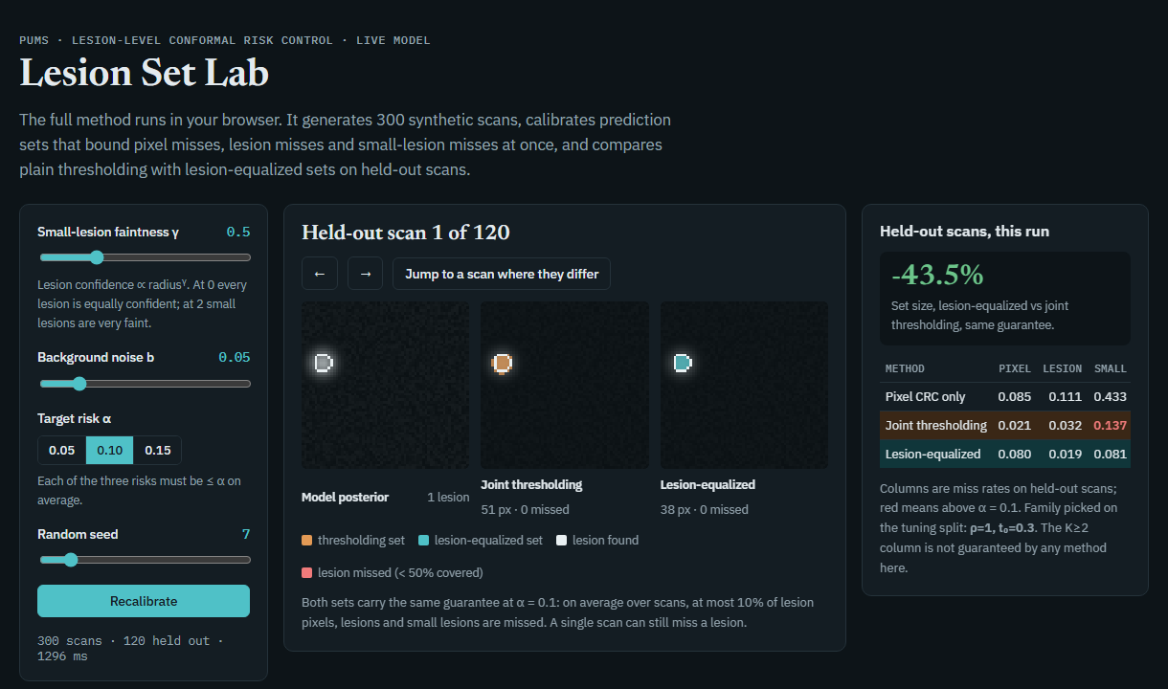
Figure 6.1: The Lesion Set Lab: controls (left), a held-out scan with the thresholding and lesion-equalized sets (centre) and the risk table for the run (right).
Demonstration steps:
- Open the page and note the three panels for a held-out scan: the model posterior, the thresholding set and the lesion-equalized set.
- Move the small-lesion faintness γ slider. At γ = 0 every lesion is equally confident; at γ = 2 small lesions are very faint. Press Recalibrate.
- Read the right-hand panel. At γ = 0.5, α = 0.10 and background noise b = 0.05 the example run shows the lesion-equalized set 43.5% smaller than joint thresholding at the same guarantee, with pixel, lesion and small-lesion miss rates all at most α for the lesion-equalized row.
- Press Jump to a scan where they differ to inspect a scan on which the two prediction sets differ, and check which lesions each one finds or misses.
- Move the equalization strength ρ and cutoff sliders in the lower-left panel to see how rescaling each candidate by its own peak lets one cutoff find both a confident large lesion and a faint small one.

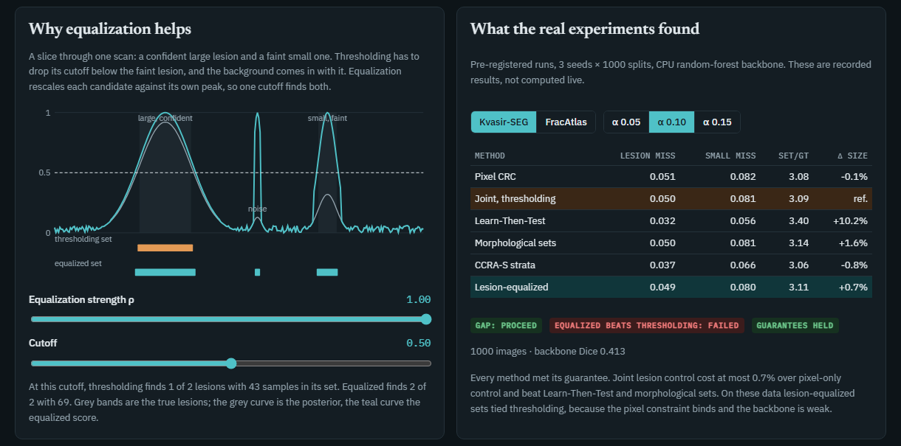
Figure 6.2: Lesion Set Lab, lower panels: the 1-D mechanism view with adjustable ρ and cutoff (left) and the recorded real-data results (right).
The lower-right panel shows the recorded real-data results (not computed live): the table for Kvasir-SEG and FracAtlas at α = 0.05, 0.10 and 0.15 together with the verdict badges gap: proceed, equalized beats thresholding: failed and guarantees held.
6.2 Research Report Page
The second showcase page (docs/showcase/lesion-crc-report.html) walks through the same story as this report in a web format: whether the work is novel, the problem, prior work, method, theory, protocol, results on real data, the controlled simulation, the post-hoc analysis, system architecture, infrastructure, limitations and what decides the open question.
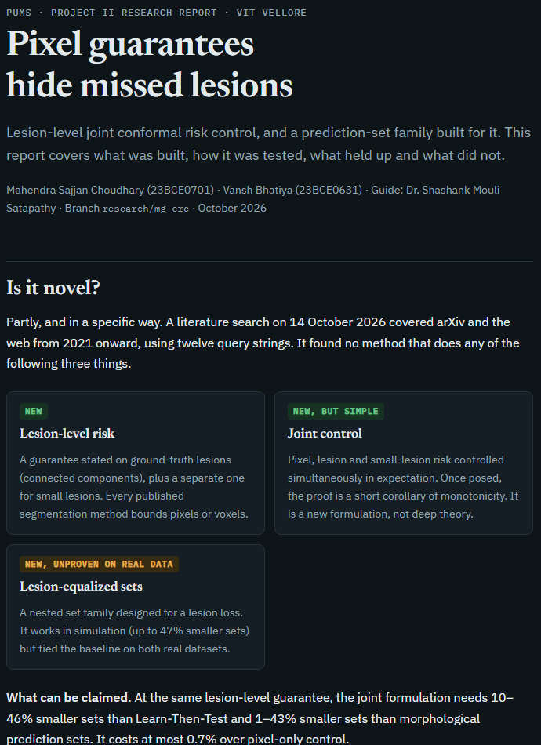
Figure 6.3: The research report page: contents list, novelty assessment and problem statement.
6.3 Dashboard and API
In the PUMS dashboard the Lesion-level CRC tab (under /research) provides an α selector, a set-size chart, the risk and gap tables and the verdict badges. It is fed by GET /api/research/mgcrc, which returns the committed results file unchanged with its provenance tags. The tab renders nothing that is not in the file.
6.4 Reproducing the Results
- Windows: ./scripts/reproduce.ps1 (add -Fast to reuse cached posteriors). Linux and macOS: ./scripts/reproduce.sh.
- The script trains the cross-fitted backbones, runs the experiments, the simulation and the post-hoc analysis, aggregates the pre-registered verdicts and regenerates the paper numbers.
- A GPU run is selected with -Backbone unet-r34 -Size 512 after installing PyTorch.

CHAPTER 7
7. RESULT AND DISCUSSION
Every number in this chapter is copied from the generated results summary (docs/research/results/summary.md) and the committed result files. Means are over 3 seeds × 1000 random splits. Negative and inconclusive results are reported alongside positive ones.
7.1 Validity
Every method met every guarantee it claims on held-out data, at every α, on both datasets. Validity is therefore not the differentiator; efficiency and the gap are.
7.2 H1: The Pixel-to-Lesion Gap
Table 7.1 gives, at the pixel-CRC threshold on the test split, the ratio G = lesion-miss rate ÷ α for all images, for multi-lesion images and for small lesions. A value above 1 means the subpopulation is under-protected by the pixel guarantee.
Table 7.1: Gap ratio G at the pixel-CRC threshold
Dataset | α | G, all images | G, multi-lesion images | G, small lesions
FracAtlas | 0.05 | 0.64 | 0.83 [0.22, 1.64] | 0.72
FracAtlas | 0.10 | 0.76 | 1.14 [0.59, 1.76] | 0.73
FracAtlas | 0.15 | 0.77 | 1.26 [0.78, 1.77] | 0.81
Kvasir-SEG | 0.05 | 0.40 | 0.95 [0.00, 2.24] | 0.73
Kvasir-SEG | 0.10 | 0.51 | 1.56 [0.66, 2.52] | 0.82
Kvasir-SEG | 0.15 | 0.62 | 1.49 [0.72, 2.28] | 0.81

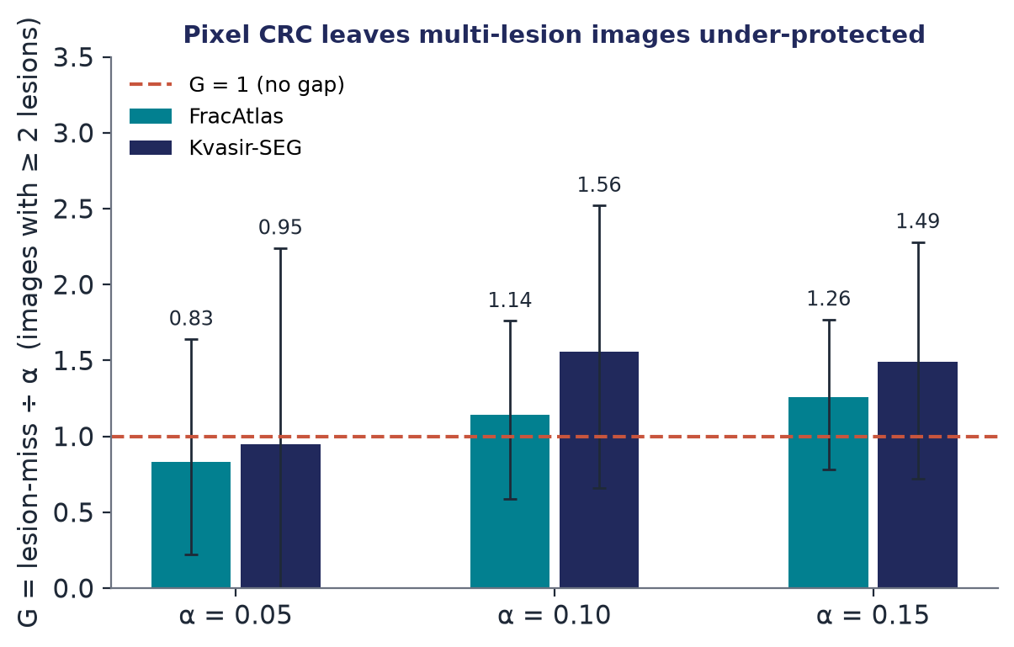
Figure 7.1: Gap ratio on multi-lesion images; error bars are 95% split intervals.
Verdicts. Kvasir-SEG: PROCEED (G = 1.56 at α = 0.10 on images with two or more polyps, above the pre-registered 1.5). FracAtlas: INCONCLUSIVE (G = 1.14, with a wide interval). The intervals are wide because only about 29 (Kvasir-SEG) or 95 (FracAtlas) multi-lesion images fall in each calibration split. Across all images G stays below 1, which is exactly the point: the pixel guarantee holds on average while the multi-lesion subpopulation is under-protected.
7.3 Cost of the Lesion-Level Guarantee
Table 7.2 is the main comparison on Kvasir-SEG at α = 0.10. Set-to-truth ratio is lower-is-better, and Δ is the paired change in set size relative to joint thresholding.
Table 7.2: Main comparison, Kvasir-SEG, α = 0.10
Method | Pixel FNR | Lesion miss | Small miss | Miss, K ≥ 2 | Set / truth | Δ vs joint
Pixel CRC | 0.099 | 0.051 | 0.082 | 0.156 | 3.08 | −0.1%
Joint CRC, thresholding (reference) | 0.098 | 0.050 | 0.081 | 0.155 | 3.09 | ref.
Joint max-form | 0.084 | 0.039 | 0.067 | 0.126 | 3.24 | +5.0%
Learn-Then-Test | 0.071 | 0.032 | 0.056 | 0.098 | 3.40 | +10.2%
Morphological sets | 0.093 | 0.050 | 0.081 | 0.147 | 3.14 | +1.6%
CCRA-S strata | 0.092 | 0.037 | 0.066 | 0.160 | 3.06 | −0.8%
Lesion-equalized (ours) | 0.096 | 0.049 | 0.080 | 0.153 | 3.11 | +0.7%

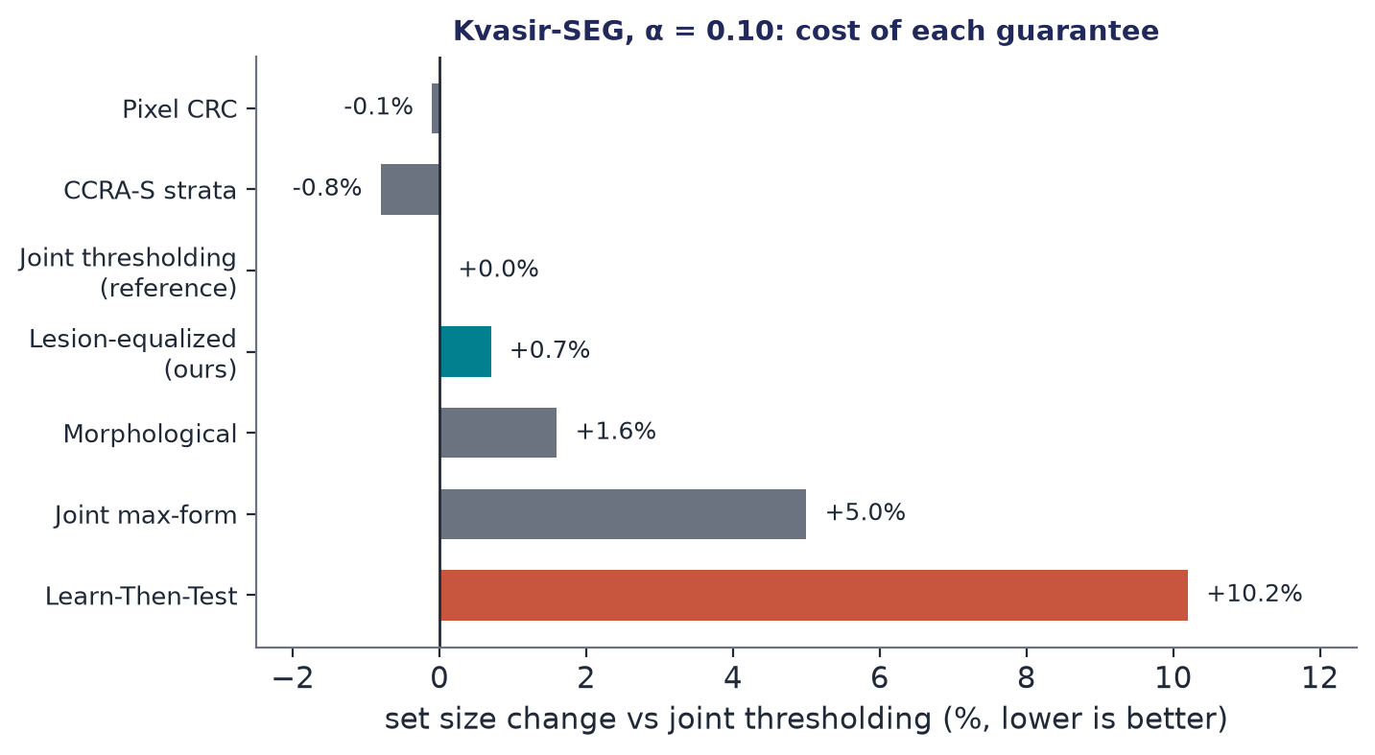
Figure 7.2: Cost of each guarantee relative to joint thresholding (Kvasir-SEG, α = 0.10).
Across all datasets and α values:
- Adding lesion-level control costs at most 0.7% in set size over pixel-only CRC.
- Learn-Then-Test needs 10–46% larger sets. Its guarantee is a stronger, high-probability one, so the comparison is not perfectly like-for-like.
- Morphological sets need 1–43% larger sets.
- CCRA-S ranges from −2% to +16%.
- H2 failed at every α on both datasets. Lesion-equalized sets tied joint thresholding (+0.3% to +3.6%) and were never smaller in at least 95% of splits.

Why H2 failed on real data. With this weak backbone the pixel constraint is the binding one: pixel CRC and joint thresholding differ by under 1%. When the lesion constraint does not bind, equalization has nothing to save. The tuning split often picks plain thresholding itself; on FracAtlas thresholding was chosen most often at α = 0.05.
7.4 E7: Controlled Simulation
In the simulation, lesion confidence scales as a ∝ radius^γ. At γ = 0 confidence is independent of size; at γ = 2 small lesions are very faint. Two background levels b were used, with 600 scans and 500 splits per cell. Table 7.3 shows the change in set size, lesion-equalized versus joint thresholding (negative means ours is smaller).
Table 7.3: Change in set size, lesion-equalized vs joint thresholding (%)
b, α | γ = 0 | γ = 0.5 | γ = 1 | γ = 1.5 | γ = 2
0.05, 0.05 | −4.0 | −25.7 | −19.8 | +0.7 | +0.8
0.05, 0.10 | −2.1 | −41.8 | −30.7 | −0.5 | −0.5
0.05, 0.15 | −1.3 | −40.0 | −45.0 | −0.7 | +0.3
0.15, 0.05 | −3.6 | −33.5 | −0.2 | +0.7 | +1.8
0.15, 0.10 | −2.6 | −47.2 | −2.1 | +1.2 | +0.9
0.15, 0.15 | −2.0 | −38.1 | +4.0 | +1.3 | +0.8

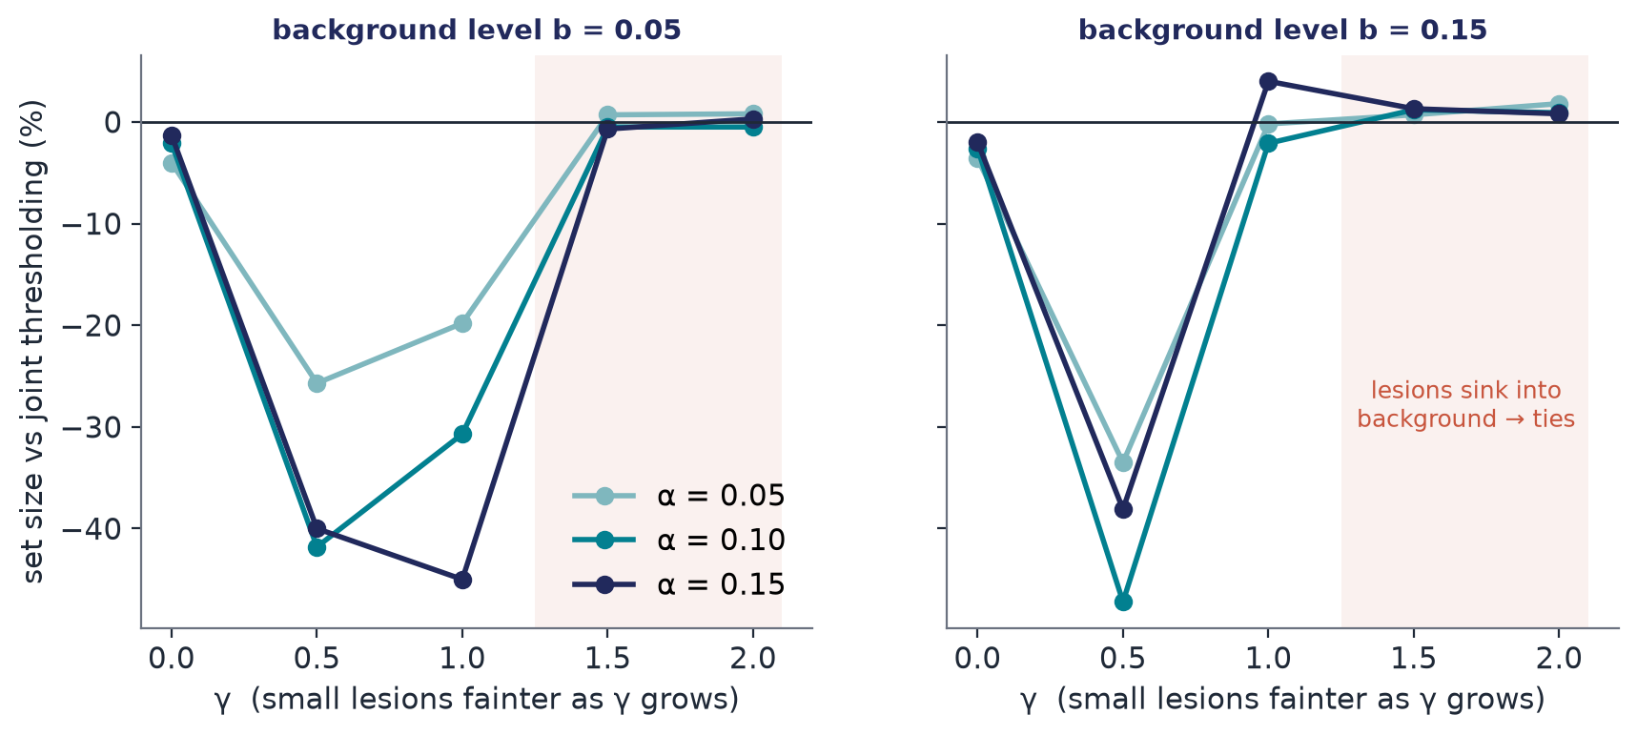
Figure 7.3: Set-size change in simulation as small lesions become fainter (γ).
Verdict under the pre-registered rule: FAILED. The rule required a gain at every γ ≥ 1 that grows with γ. The gain is real but sits in a window: up to −47% at moderate coupling and about 0 at strong coupling. A post-hoc diagnostic explains why: at γ ≥ 1.5, 76–92% of small lesions have a peak posterior that does not rise above the image's 99th-percentile background. No transform of the posterior alone can then separate them from noise, so the precondition of Proposition 3 fails, and the method falls back to thresholding (worst cell +4.0%) rather than doing much worse.
7.5 E8: Protecting Multi-Lesion Images (post hoc)
The joint guarantee averages lesion misses over all images, so multi-lesion images can still exceed α. A lesion loss restricted to images with K ≥ 2 is a valid CRC risk for the same reason as the small-lesion risk: it lives on a subpopulation defined by labels. This analysis was not pre-registered.
Table 7.4: Adding a risk conditioned on K ≥ 2 (post hoc)
Dataset | α | Miss, K ≥ 2 (joint) | Miss, K ≥ 2 (+ conditional risk) | Set / truth change
Kvasir-SEG | 0.05 | 0.048 | 0.024 | +28%
Kvasir-SEG | 0.10 | 0.155 | 0.076 | +16%
Kvasir-SEG | 0.15 | 0.224 | 0.125 | +24%
FracAtlas | 0.05 | 0.040 | 0.038 | +2%
FracAtlas | 0.10 | 0.113 | 0.092 | +7%
FracAtlas | 0.15 | 0.187 | 0.143 | +13%

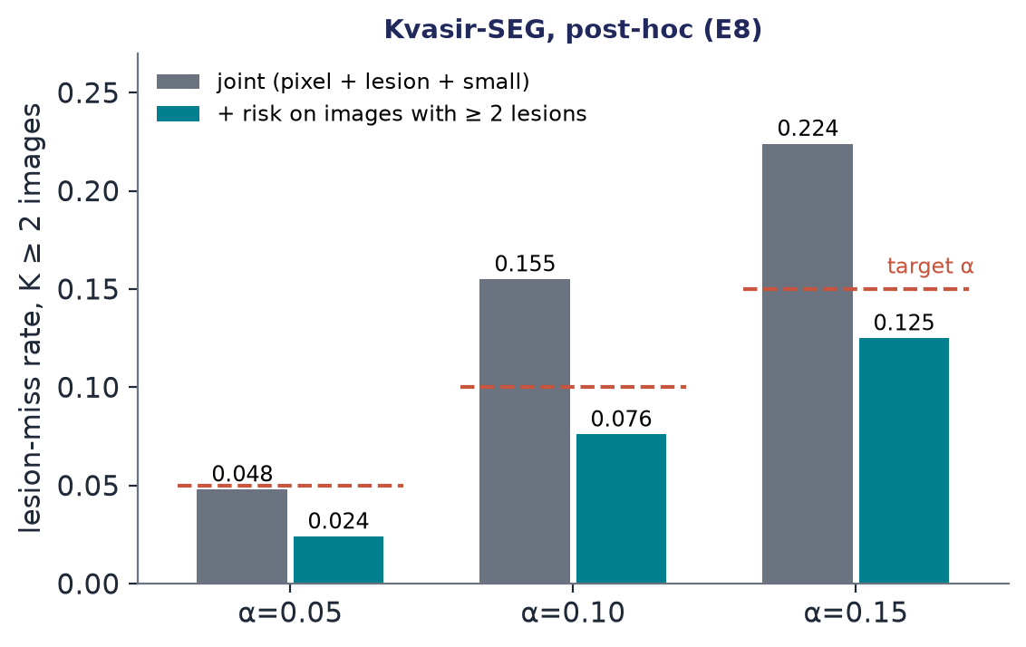
Figure 7.4: Multi-lesion miss rate before and after adding the conditional risk (Kvasir-SEG).
The conditional risk roughly halves the multi-lesion miss rate on Kvasir-SEG and brings it under α, at a 16–28% larger set.
7.6 Discussion
- Pixel guarantees do hide missed lesions in multi-lesion images (1.56α on Kvasir-SEG at α = 0.10); the FracAtlas gap is inconclusive.
- Lesion-level guarantees are cheap to add (at most 0.7%), and the joint formulation is more efficient than the existing multi-risk tools (LTT, morphological sets).
- The new set family works exactly in the regime its theory predicts: small lesions present, under-confident but still above the background. That regime was not present on the real data with this weak model, so H2 failed.
- The decisive open experiment is a strong backbone (GPU U-Net) and 3-D multi-tumour data (MSD Task08). Both pipelines are implemented but have not been run.

7.7 Cost Analysis
Table 7.5: Cost of the project
Item | Cost | Note
Software and libraries | INR 0 | All open source
Datasets | INR 0 | Public datasets for research use; no data are redistributed
Compute | INR 0 incremental | Existing CPU laptop; no cloud or GPU; 3 seeds × 1000 splits × 2 datasets ran on the CPU
Optional GPU run | Not incurred | Needed only for the decisive H2 test; planned for the next semester
Cost to the end user of the method | ≤ 0.7% larger sets | Versus +10–46% for Learn-Then-Test and +1–43% for morphological sets

7.8 Limitations
- Weak backbone. FracAtlas results describe a near-failing segmenter (Dice 0.057). H2 has not been tested where it is most plausible: a strong model whose remaining misses are faint small lesions.
- Cross-fitting. Posteriors come from five fold models, so exchangeability is approximate.
- No patient identifiers in either dataset, so splits are image-wise.
- Small multi-lesion subpopulation (29–95 images per calibration split), so the gap intervals are wide.
- Marginal guarantees, conditional on a lesion being present; not per patient.
- FracAtlas “lesions” are coarse fracture regions, not fracture lines.
- No clinical validation of any kind. This is a research prototype, not a medical device.

CHAPTER 8
8. CONCLUSION
This project extended the PUMS uncertainty-management framework with lesion-level risk control. Its central finding is that pixel guarantees hide missed lesions: at the pixel-CRC threshold, images with several lesions miss lesions at up to 1.56 times the target rate on Kvasir-SEG. Three results follow.
- Lesion-level guarantees are cheap. Defining lesion-miss and small-lesion-miss risks on ground-truth components and controlling them jointly with pixel FNR costs at most 0.7% in set size, and every guarantee held on held-out data.
- The joint formulation beats the existing multi-risk tools on set size. Learn-Then-Test needs 10–46% larger sets and morphological sets 1–43% larger sets (LTT's guarantee is the stronger, high-probability one).
- Lesion-equalized sets work in the regime the theory predicts and tied elsewhere. They cut set size by up to 47% in simulation when small lesions are moderately under-confident, and tied joint thresholding on both real datasets, where the CPU backbone is weak. The pre-registered hypothesis H2 therefore failed on real data, and this is reported openly.

The contribution is a problem formulation with a measured gap, a short validity argument, a new set family with a clearly delimited regime, and a reproducible, pre-registered evaluation integrated into a working, tested system. It is a research prototype and makes no clinical claim.
8.1 Future Work
- Run the decisive test: a strong GPU backbone (U-Net, nnU-Net, MedSAM) and 3-D multi-tumour data (MSD Task08). Both pipelines are implemented.
- Make the conditional multi-lesion risk a first-class option beside the joint guarantee.
- Use weighted conformal prediction to restore validity under the distribution shift that the PUMS detector already flags, which also revisits the shift-conditional direction proposed at Review 2.
- Submit the paper (target: MICCAI UNSURE workshop) once the strong-backbone results are available.

CHAPTER 9
9. REFERENCES
- Abedeen, I., Rahman, M.A., Prottyasha, F.Z. et al., 2023. FracAtlas: A dataset for fracture classification, localization and segmentation of musculoskeletal radiographs. Scientific Data, 10, p.521.
- Andéol, L., Fel, T., de Grancey, F. and Mossina, L., 2023. Confident object detection via conformal prediction and conformal risk control: an application to railway signaling. In: Conformal and Probabilistic Prediction with Applications (COPA), PMLR 204.
- Angelopoulos, A.N., Bates, S., Candès, E.J., Jordan, M.I. and Lei, L., 2021. Learn then test: calibrating predictive algorithms to achieve risk control. arXiv:2110.01052.
- Angelopoulos, A.N., Bates, S., Fisch, A., Lei, L. and Schuster, T., 2024. Conformal risk control. In: International Conference on Learning Representations (ICLR).
- Antonelli, M., Reinke, A., Bakas, S. et al., 2022. The Medical Segmentation Decathlon. Nature Communications, 13, art. 4128.
- Bates, S., Angelopoulos, A., Lei, L., Malik, J. and Jordan, M., 2021. Distribution-free, risk-controlling prediction sets. Journal of the ACM, 68(6).
- Guo, C., Pleiss, G., Sun, Y. and Weinberger, K.Q., 2017. On calibration of modern neural networks. In: Proceedings of ICML, pp.1321–1330.
- Jha, D., Smedsrud, P.H., Riegler, M.A. et al., 2020. Kvasir-SEG: a segmented polyp dataset. In: MultiMedia Modeling (MMM).
- Kendall, A. and Gal, Y., 2017. What uncertainties do we need in Bayesian deep learning for computer vision? In: Advances in Neural Information Processing Systems.
- Lakshminarayanan, B., Pritzel, A. and Blundell, C., 2017. Simple and scalable predictive uncertainty estimation using deep ensembles. In: Advances in Neural Information Processing Systems.
- Lambert, S., Forbes, E., Doyle, C., Dehaene, A. and Dojat, J., 2024. Trustworthy clinical AI: a unified review of uncertainty quantification in medical image analysis. Artificial Intelligence in Medicine.
- Luo, R. and Zhou, Z., 2025. Conditional conformal risk adaptation. arXiv:2504.07611.
- Mossina, L. and Friedrich, C., 2025. Conformal prediction for image segmentation using morphological prediction sets. In: Medical Image Computing and Computer-Assisted Intervention (MICCAI).
- Mossina, L. and Friedrich, C., 2025. Controlling false positives in image segmentation via conformal prediction. arXiv:2511.15406.
- Tan, B., Wang, Z. et al., 2025. Conformal lesion segmentation for 3D medical images. arXiv:2510.17897.
- ReCIRC: rectified conformal risk control, 2026. arXiv:2609.38112.
- Bound-aware per-organ recall risk control for multi-organ CT segmentation under clinical domain shift, 2026. arXiv:2608.18193.
- Statistical management of the false discovery rate in medical instance segmentation based on conformal risk control, 2025. arXiv:2504.04482.
APPENDIX A – Sample Code
Listing A.1: Lesion-equalized score (backend/app/calibration/families.py)
def lesion_equalized_score(p: np.ndarray, *, rho: float, t0: float) -> np.ndarray:
"""Peak-normalise each candidate component of {p >= t0} by P_j ** rho."""
if not 0.0 <= rho <= 1.0:
raise ValueError("rho must lie in [0, 1]")
if not 0.0 < t0 <= 1.0:
raise ValueError("t0 must lie in (0, 1]")
s = p.copy()
if rho == 0.0:
return s
candidate = p >= t0
labels, count = ndimage.label(candidate, structure=connectivity(p.ndim))
if count == 0:
return s
peaks = ndimage.maximum(p, labels, index=np.arange(1, count + 1))
divisor = np.ones(count + 1, dtype=np.float64)
divisor[1:] = np.power(np.maximum(peaks, t0), rho)
inside = labels > 0
s[inside] = np.minimum(p[inside] / divisor[labels[inside]], 1.0)
return s

Listing A.2: Conformal risk control threshold and the joint (union) rule (backend/app/calibration/joint.py)
def crc_index(losses: np.ndarray, alpha: float) -> tuple[int, bool]:
"""First grid index with (n R_n + B)/(n+1) <= alpha. Losses [n, G], non-increasing."""
n = losses.shape[0]
if n == 0:
return 0, True
corrected = (n * losses.mean(axis=0, dtype=np.float64) + LOSS_BOUND) / (n + 1)
feasible = np.flatnonzero(corrected <= alpha)
if feasible.size:
return int(feasible[0]), True
return int(losses.shape[1] - 1), False

def union_index(st: StackedStats, alpha: float, risks: tuple[str, ...] = RISKS) -> tuple[int, bool]:
idx, ok = 0, True
for r in risks:
i, f = crc_index(risk_matrix(st, r)[0], alpha)
idx, ok = max(idx, i), ok and f
return idx, ok

Listing A.3: One order statistic per lesion (Lemma 2), from backend/app/calibration/losses.py
k = int(lab.max()) if truth.any() else 0
stats = np.empty(k)
sizes = np.empty(k, dtype=np.int64)
if k:
order = np.argsort(lab[truth], kind="stable")
comp_ids = lab[truth][order]
comp_scores = flat[truth][order]
bounds = np.searchsorted(comp_ids, np.arange(1, k + 2))
for j in range(k):
sc = np.sort(comp_scores[bounds[j] : bounds[j + 1]])[::-1]
sizes[j] = sc.size
stats[j] = sc[int(np.ceil(tau * sc.size)) - 1]

