## TM-App: Mobile application for Techno Melange Fest

In partial fulfillment of the requirements for the award of

Degree of Master of Computer Applications

**Submitted by**

|  |  |
| --- | --- |
| Rakshith Shetty | 160970042 |
| Shravan Nayak C | 160970055 |
| Sujay S Kamath | 160970057 |
| Tanzil K.M | 160970062 |

**Under the guidance of**

Dr. Poornima Panduranga Kundapur

Associate Professor

Department of Computer Applications

MIT, Manipal- 576104

July 2017

|  |  |  |
| --- | --- | --- |
|  | **DEPARTMENT OF COMPUTER APPLICATIONS**  **F:\images(17).jpg**  **MANIPAL - 576 104** |  |

**Abstract**

The Department of Computer Applications, Manipal Institute of Technology, Manipal organizes a national level technical and cultural fest “Techno Melange” every year for MCA students during the month of October. Until the last year, 2016, this fest followed the traditional pen and paper format for keeping scores and results. This manual process was found to be extremely cumbersome, repetitive and time consuming. More importantly the method did not allow for dynamic display of college standing either to the organizing department or the participants.

As a part of this project an android based mobile application TM-App was designed and developed. It is a concerted effort to automate the entire process of organizing the fest starting with online registration, event scheduling, score card maintenance and live result sheets. Moreover, the app has been designed to be used for promotion of the fest instead of printed posters and brochures used earlier. It drastically reduces the number of posters to be printed making it an eco-friendly go-green product. The biggest challenge, however, was to eliminate the need for escorts for participants thereby increasing audience head count during events of the fest. The main objective of this project was for TM-APP to become the one-stop-information-shop for the participants of Techno Melange.

The app has been developed using Android studio 2.3.3, PHP 5.6.19 and is compatible with android based mobile phones running OS versions 4.4 (KitKat) and above.

**Table of Contents**

|  |  |  |
| --- | --- | --- |
| **Sl. No.** | **Contents** | **Page No.** |
|  | Abstract | 2 |
| 1 | Introduction   * 1. Motivation for the proposed work   2. Objectives   3. Modules   4. Technical Details   1.3.1 Hardware Requirements  1.3.2 Software Requirements  1.5 Project Details  1.6 Users | 4  4  4  5  5  5  6  6  6 |
| 2 | Software Requirement Specification  2.1 Introduction  2.2 Functional Requirements  2.3 Non-Functional Requirements  2.3.1 Performance  2.3.2 Security | 7  7  7  7  7  7 |
| 3 | Design  3.1 Initial Design  3.1.1 Use case Diagram  3.2 Detailed Design  3.2.1 Activity Diagram  3.3 Database Design | 8  8  8  9  10  11 |
| 4 | Implementation and User Interfaces  4.1 Software Development Lifecycle  4.2 User Interface | 11  12  13-14 |
| 5 | Testing  5.1 Unit Testing  5.2 Integrated Testing  5.3 System Testing  5.4 User Acceptance Testing  5.5 Mobile App Test Cases  5.6 Web App Test Cases | 15  15  15  15  15  15  16 |
| 6 | Conclusion | 17 |
| 7 | Future Enhancement | 17 |
| 8 | References | 18 |

1. **Introduction**

“Techno Melange” is the annual technical and cultural fest organized for MCA students by the department of Computer Applications during the month of October. The present scenario of conduction of the fest involves mostly paper work. To encourage use of technology and ease of conduction of this program, an Android application was developed for both the organisers and the participants.

This app aims at reducing dependency on student escorts, includes a new Techno Feed module that is like dynamic news and picture feed option. The app also includes location wise information along with updates on schedule of the events as they happen. Most importantly, the result declaration will be an unbiased and fair mechanism. Overall, this application will help the end user (participant) as well as the developer to automate the entire fest process and make the most use of it in a very efficient way.

* 1. **Motivation for the proposed work**

The Techno Melange Fest organized every year followed the manual procedure of using posters and paper to handle score keeping, event scheduling and announcement of results. A need for automating this process was identified and hence the android and web based applications.

**1.2 Objectives**

The objectives of the project are listed below:

* To develop a hands-on android based mobile application for the Department of Computer Applications, MIT, Manipal designed to handle all the processes targeting both organizers and participants of the technical and cultural fest Techno Melange that includes:
  + - College Registration
    - Event Schedule
    - Results
    - Report
    - Feedback
    - Slot arrangements for each event (each round)
    - Live feed of images and text
* To ensure that this app interfaces with the official web site for Techno Melange.

**1.3 Modules**

* **Registration:** Registration of a team (College) can be done though this module.
* **Event:** Details of various events and Event Heads.
* **Home:** Description of set of rules that are to be followed by any participating team.
* **Schedule:** Timings and venue of various events and programs on both the days.
* **Results:** Results of all the events will be uploaded regularly.
* **Slots:** Slot distributions of participants in various events will be done automatically on a random basis by the application itself.
* **Help Desk:** For any queries to be resolved with respect to the fest or the app, one can get necessary help from this help desk.
* **Techno-feed:** This module is a timeline (miniature instagram) where in people can upload pictures and news of various events and everyone can view them (real time).
* **Sponsors:** Detailed information about the various sponsors of the fest.
* **Feedback:** For Feedback, suggestions, complains, etc. A team or an individual can give a feedback about the fest.

**1.4 Technical Details**

Techno Melange is an Android App developed using android studio 2.3.3, API Platform 15.

Web App developed using HTML5, CSS3, JavaScript, PHP.

**1.4.1 Hardware Requirements**

Table 1.1: Hardware Requirements (Developer)

|  |  |
| --- | --- |
| Processor | Intel Pentium 3 or later |
| RAM | 3 GB or higher |
| Hard Disk | Desktop or Laptops with 10 GB |

Table 1.2: Hardware Requirements (End User)

|  |  |
| --- | --- |
| Processor | Intel Pentium 3 or later |
| RAM | 512 MB or higher |
| Hard Disk | Desktop or Laptops with 10 GB |

* + 1. **Software Requirements**

Table 1.3: Software Requirements (Developer)

|  |  |
| --- | --- |
| Operating System | Window 7 or later (32 or 64 bit) |
| Android OS | Android 4.0 or above |
| Database | MySQL version 5.6 |

Table 1.4: Software Requirements (End User)

|  |  |
| --- | --- |
| Operating System | Window XP or later |
| Android OS | Android 4.0 or above |
| Internet connection | Yes (3G/4G recommended) |

**1.5 Project Details**

Team size: 04

Duration of project: 02 months (May 8thto July 8th 2017)

**1.6 Users**

The main users identified are Admin, Event Head and Participants.

1. **Software Requirements Specification**
   1. **Introduction**

The proposed app is an effort to automate the entire process of Techno Melange, which was used to be manually done from a long time. The Techno-Melange app is an android platform based mobile application that helps the participants to view required details about various events and also view real time event schedule, real time event results. The user (participant) can make online registration. The Techno-Feed is a live timeline where, all can view the images uploaded by various people, also give likes to the images. The user can also upload his/her wished image by authorizing his/her login through either facebook or Google. At the end of the fest the feedback functionality will be active and the user (participant) can login with provided credentials and give his/her feedback about the fest. The other two users Admin and the Event Head will have the backend web application interface provided which will have the additional properties like adding new entry of a college (on the spot registration), the Admin can view/add/edit the event schedule, the Event heads can add/edit results of various rounds of the particular event to which he/she is the Event Head, even the slotting arrangement if required for that particular event that can be done within the web application interface. The Event Head have the privilege to generate reports of his/her event either event wise or team wise, also he can generate the reports of all other contents like schedule report, registration report, feedback report. The report generation is likely to help with avoiding tie clashes and also go back and review once again if a problem occurs.

* 1. **Functional Requirements**

**Mobile Application**

* Registration
* Upload and Like the Images in Techno Feed
* Viewing event details, schedule information, results, sponsors, contact details
* Entering Feedback

**Web Application:**

* Adding and Editing College Registration
* Adding and Editing Schedule
* Adding and Editing Results
* Generating Reports
* Allotting Slots for different Events
* Changing Password
  1. **Non-functional requirements**
     1. **Performance:** Techno Melange app is a real-time based application which can fetch the details in minimum time with a high speed internet connection.
     2. **Security:** Login form for the feedback module gives access to registered college participants and Techno Feed module has authentication from either facebook account or Google account for uploading photos.

1. **Design**
   1. **Initial Design**
      1. **Use Case Diagram**

TMApp

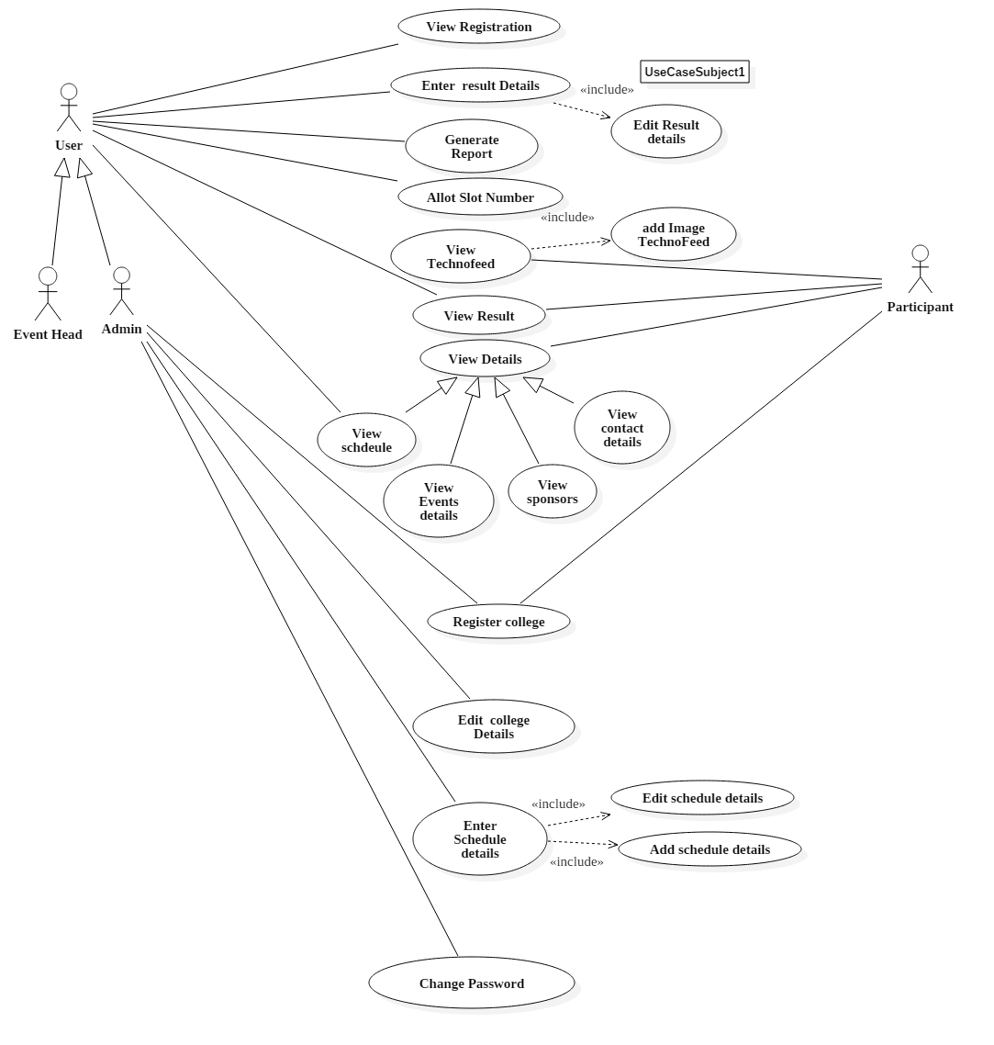

Fig. 3.1 Use case diagram for TM-APP mobile application

* 1. **Detailed Design**

The detailed design for the project includes activity diagram to explain the general workflow of both mobile and web applications.

* + 1. **Activity Diagram for Mobile Application**

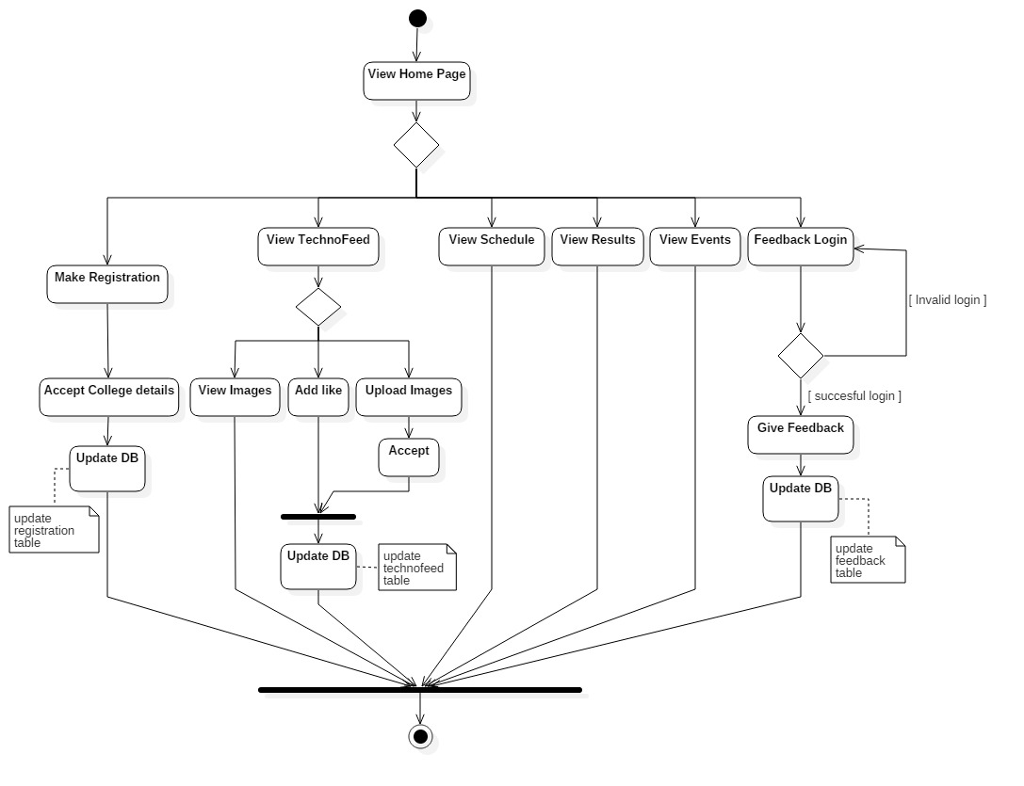

Fig. 3.3 Activity diagram for mobile application workflow

The figure 3.3 displays the activity diagram for working of TM-APP application from viewing home page, online registration, etc.

* + 1. **Activity Diagram for Web Application**

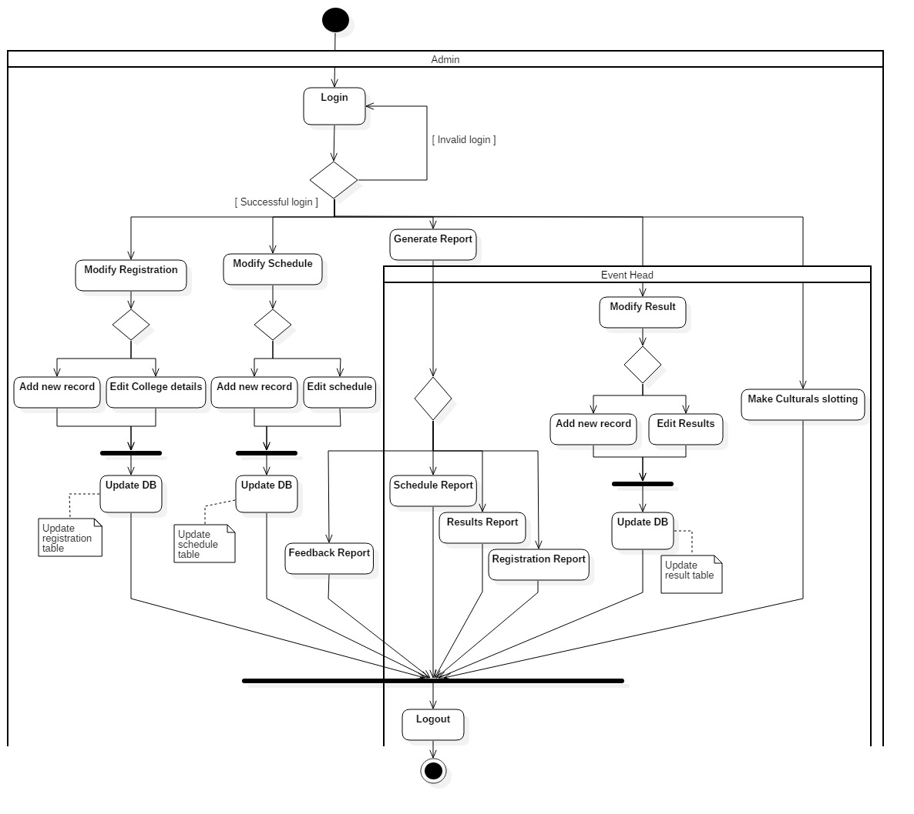

Fig. 3.4 Activity diagram for web application workflow

The figure 3.4 displays the activity diagram for working of the web application part of the TM-APP with the login for admin and event heads, add/edit the contents of various table like registration, schedule, result. Based on the privileges given reports can be generated by admin or event heads.

* 1. **Database Design**

The database design of the application can be understood by the following schema. There are essentially seven tables for storing data accepted from mobile app as well as web application interface given for admin and event heads.

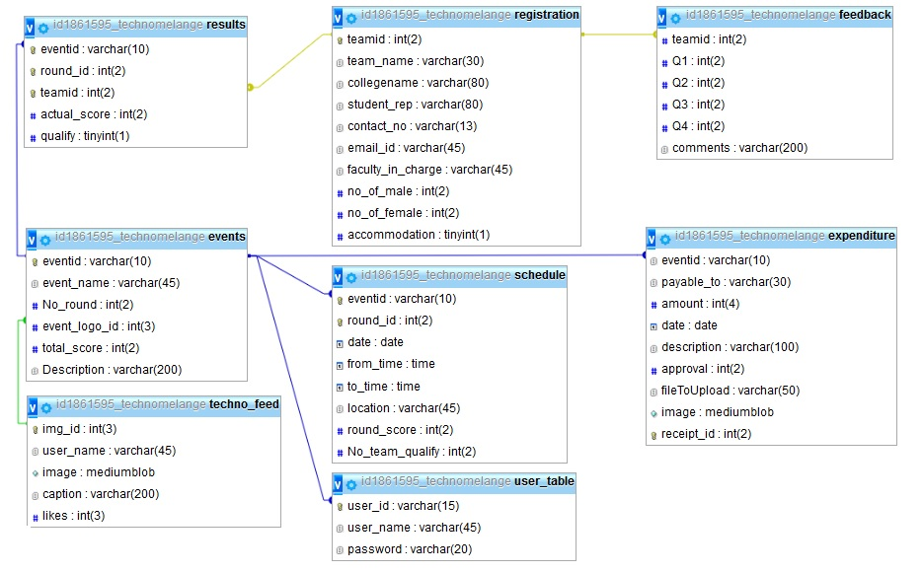

Fig. 3.3 Database schema for TM-APP mobile application

1. **Implementation and User Interfaces**

The implementation of this project was started by studying HTML5, CSS3, JavaScript, and PHP 7.1.1. The information of registered colleges, Event scheduling information, Event results, images uploaded in Techno-Feed, feedbacks given by various participants are stored on the JSON file then later entire information was stored on MySQL database for which a free hosting site was used( 000Webhost.com ). Size of the Techno Melange app is 4.92 MB. PHP is used as server side scripting language.

* 1. **Software Development Lifecycle (SDLC)**

SDLC is a crucial in developing mobile applications. Mobile applications are being developed for deployment in smart phones. Looking at rising need of mobile applications and the associated development complexity, it is imperative to have a dedicated framework lifecycle for mobile applications. We have implemented the **Waterfall model**.

The lifecycle used in this project includes phases like requirements, analysis, design, implementation, testing, deployment, maintenance.

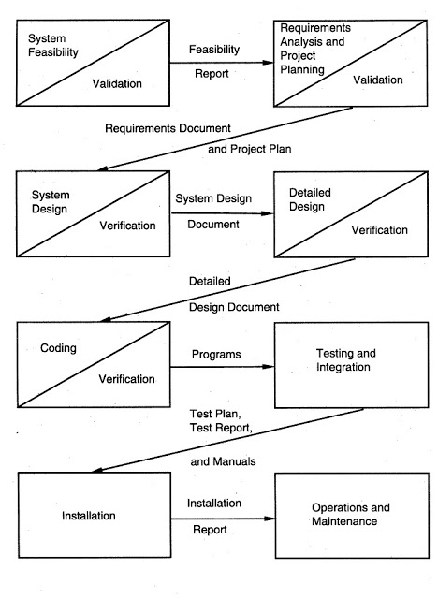

Fig. 4.1 Waterfall model

(Source: Pankaj, Jalote. Integrated Approach to Software Engineering)

* 1. **User Interface for Mobile Application**

TheUI designed for the mobile application are shown in Figures 4.2 to 4.7.

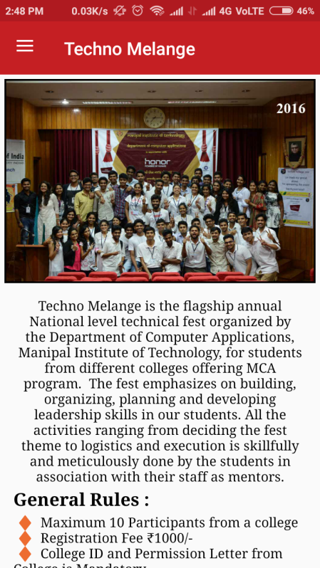 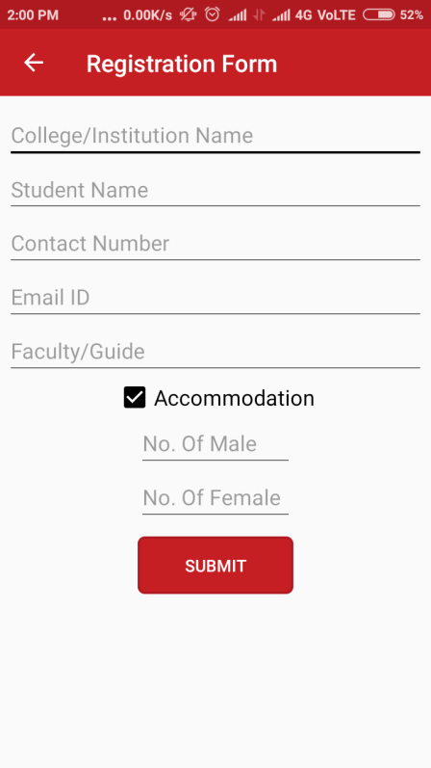 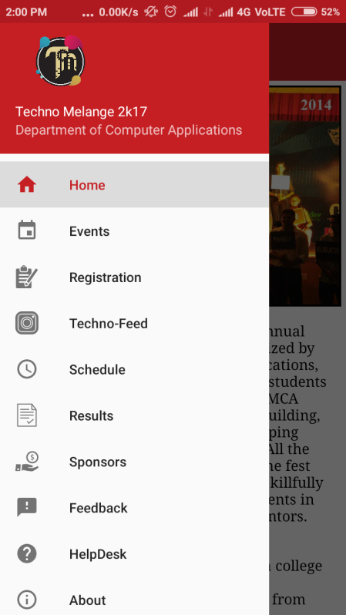

Fig. 4.2 Home page Fig. 4.3 Registration form Fig. 4.4 Navigation Form

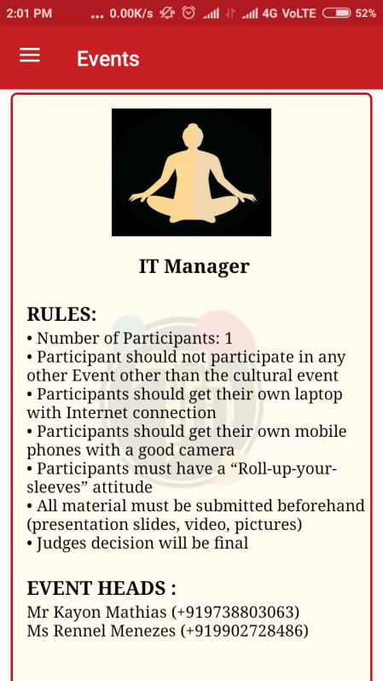 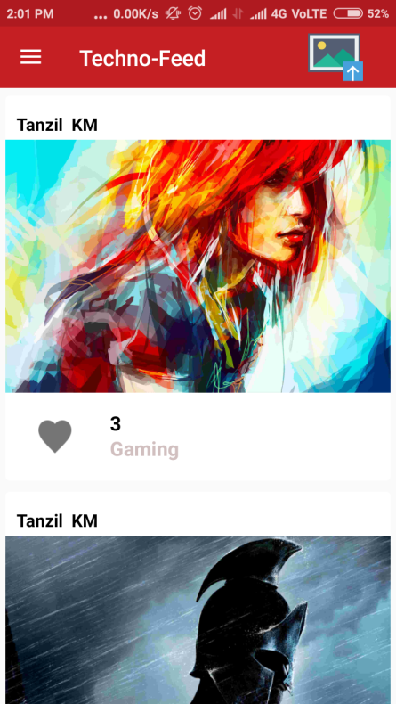 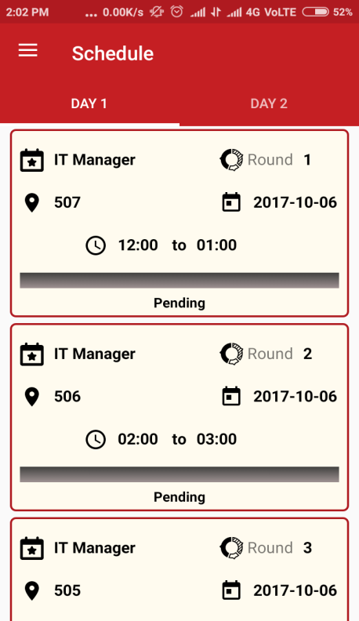

Fig. 4.5 Events page Fig. 4.6 Techno-Feed page Fig. 4.7 Schedule page

* 1. **User Interface for Web Applications**

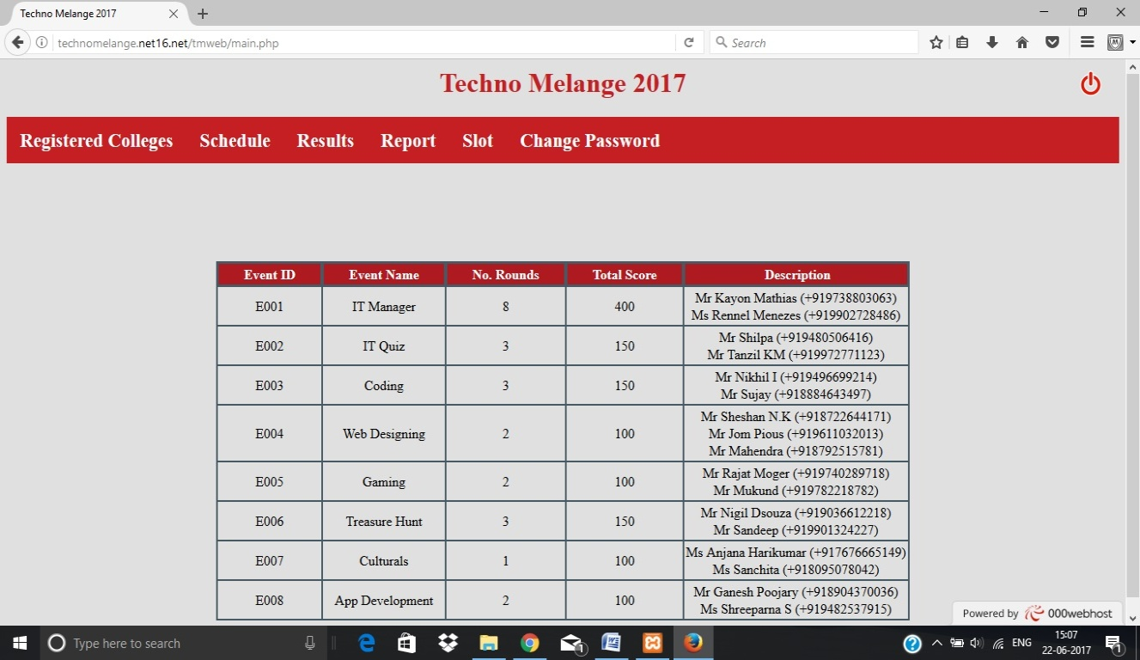

Fig. 4.8 Home Page

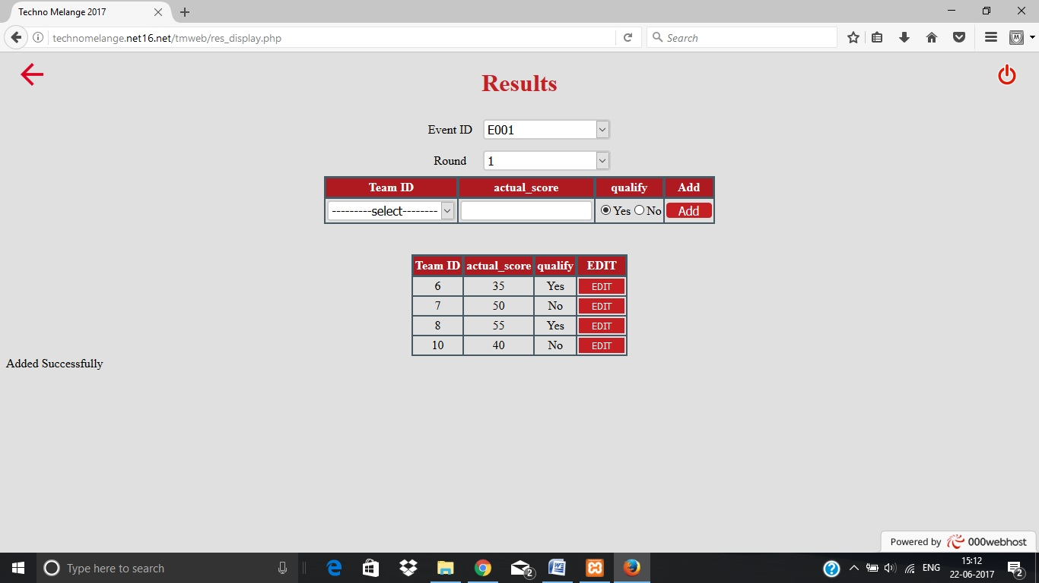

Fig. 4.9 Results page

Figures 4.8 and 4.9 present the UI for the web interface. In Figure 4.9 displays the page where admin or event head would be able to add, edit or view the results based on events and rounds in each event.

**5. Testing**

**5.1 Unit Testing**

Unit testing is a level of software testing where individual units/components of software are tested. The purpose is to validate that each time of the software performs as designed.

**5.2 Integration Testing**

Integration testing is the phase in software testing in which individual software modules are combined and tested as a group. It occurs after unit testing before validation testing. The purpose of integration testing is to verify functional, performance, and reliability requirements placed on major design items.

**5.3 System Testing**

This testing was conducted on a complete, integrated system, to evaluate the system’s compliance with the specified requirements. This is done to check if the system meets its functional and non-functional requirements and is also intended to test beyond the bounds defined in the software/hardware requirement specifications. It will be required to ensure the smooth running of the system as a whole and should perform as expected and as requied.

**5.4 User Acceptance Testing**

Acceptance testing is performed to verify that the product is acceptable to the user and if its fulfilling the specified requirements of that user.

**5.5 Mobile App Test cases**

Table 5.1: Test cases for mobile app

|  |  |  |  |  |
| --- | --- | --- | --- | --- |
| **Test case ID** | **Objective** | **Description** | **Expected Result** | **Actual Result** |
| MA_1 | Team Registration | On behalf of his/her College, a Student can make an online registration for the fest. On entering valid values to the required fields, he/she will get a confirmation message on success | Registration successful alert displayed | PASS |
| MA_2 | Registration Failure | When the student(user) enters any invalid details to the required fields error message will be displayed | “Please enter valid details” Message will be displayed | PASS |
| MA_3 | Login to upload images to Techno-Feed | On uploading an image to Techno-Feed, the user must authorize his identity through either facebook/Google. On Successful login and uploading of the image, success alert message will be received. | Thank you for sharing alert displayed | PASS |
| MA_4 | Schedule updating | On clicking the schedule with having an active internet connection, event schedule details should auto update in the background. | Schedule updated message will be popped up. | PASS |
| MA_5 | Results display | On clicking the results with having an active internet connection, results of latest rounds of various events will be displayed. | Results will be displayed. | PASS |
| MA_6 | Feedback | By logging in with the given credentials, one user will have to enter ratings to various questions displayed and also can enter comments. On Submitting successful message will be displayed. | Thank you for the Feedback alert message will be displayed. | PASS |

**5.6 Web App Test Cases**

Table 5.2: Test cases for web app

|  |  |  |  |  |
| --- | --- | --- | --- | --- |
| **Test case ID** | **Objective** | **Description** | **Expected Result** | **Actual Result** |
| WA_1 | User Login | When User enters user id and password, the system checks to see if the user is valid or not. | Main page will be displayed | PASS |
| WA_2 | Unsuccessful login | When User enters wrong user id or password, the system checks to see if the user is valid or not. If the user is not valid then user login failed | “Invalid user” message will be displayed | PASS |
| WA_3 | College Registration | When User enters college details and clicks submit button College record will be added | “Registration Added “ message will be displayed | PASS |
| WA_4 | Schedule | When User enters Event schedule details and clicks submit button Schedule will be added | “Schedule Added “ message will be displayed | PASS |
| WA_5 | Results | When User Selects event and round and enters score details and clicks submit button Results will be added | “Results Added “ message will be displayed | PASS |
| WA_6 | Slot | When User Selects event and round and enters score details and clicks slot button , the slotting for the particular round will be displayed | Slot Arrangements will be displayed | PASS |
| WA_7 | Report | When user clicks on reports like Schedule, Feedback, results and Registration Report the particular PDF record will be generated | PDF Record will be generated | PASS |

**7 Conclusion**

The mobile application TM-APP was designed using android studio. It was developed, tested and deployed for the Techno Melange fest organized by Department of Computer Applications.

The web application was hosted to allow handling of results, registration, schedule of events, slot arrangement, and generating pdf reports.

**8 Future Enhancements**

In future, the project could use cross platform development to enable access to app on phones running on ios and windows. An additional feature could be to have live audience poling for the cultural event.

**9 References**

**Web references**

* CardView [Online] 2017. Available at: <www.developers.android.com> Last accessed on 28/06/2017
* Multiple CardViews in RecyclerView [Online] 2017. Available at: www.stackoverflow.com Last accessed on 23/05/2017
* Integration for Google Sign In [Online] 2017. Available at: <www.developers.google.com> Last accessed on 12/06/2017
* Integration for facebook Login [Online] 2017. Available at: <www.developers.facebook.com> Last accessed on 27/05/2017
* FPDF Manual [Online] 2017. Available at: <www.fpdf.org> Last accessed on 13/06/2017
* Notifications [Online] 2017. Available at: <www.firebase.google.com> Last accessed on 24/06/2017
* json_decode [Online] 2017. Available at: <www.php.net> Last accessed on 20/06/2017

**Textbook references**

* J.F.DiMarzio, 2016. Beginning Android Programming with Android Studio, John Wiley & Sons, 4th edition, United States of America.
* Neil Smyth, 2017. Android Studio 2.3 Development Essentials, Payload Media, 1st edition, North Carolina, United States Of America.
* Luke Welling, Laura Thomson, 2008, PHP and MySQL Web Development, Addison-Wesley, 4th edition, United States Of America.
* Pankaj jalote, 1991, An Integrated Approach to Software Engineering, Narosa Publishing House/Springer, 3rd Edition, New York.
* Roger S. Pressman, 2009. Software Engineering – A practitioner’s Approach, McGraw-Hill International Edition, 7th Edition.