Google Chrome Dev Tools

Web Page Test -- <https://www.webpagetest.org/webvitals> ---

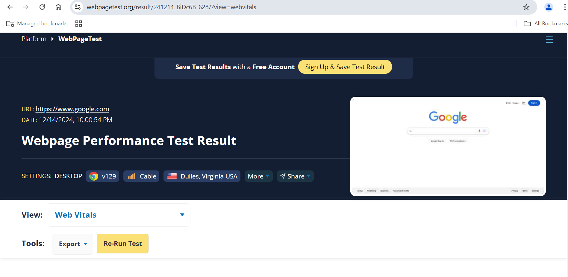

Page Speed Insights --- <https://pagespeed.web.dev/> ---

Lighthouse chrome devtools option

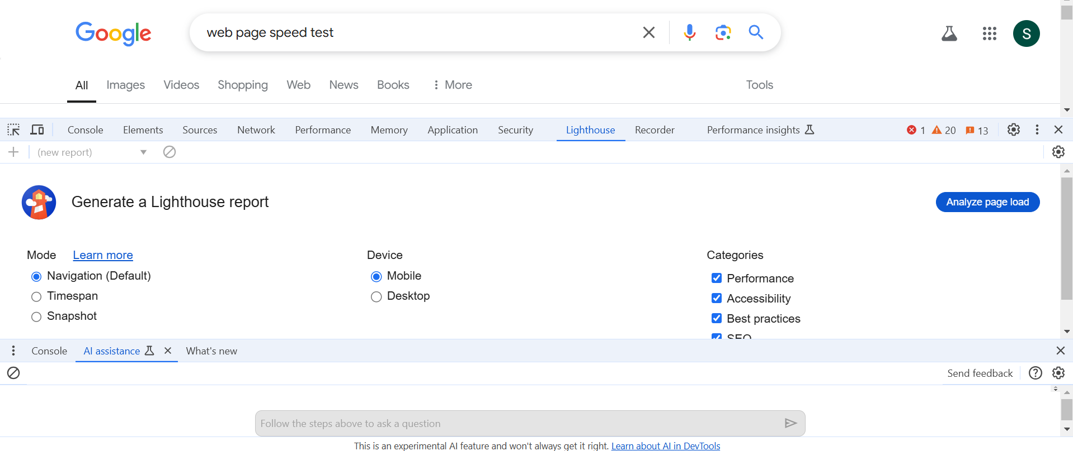

MotoG device for slow/fast option

Performance Panel

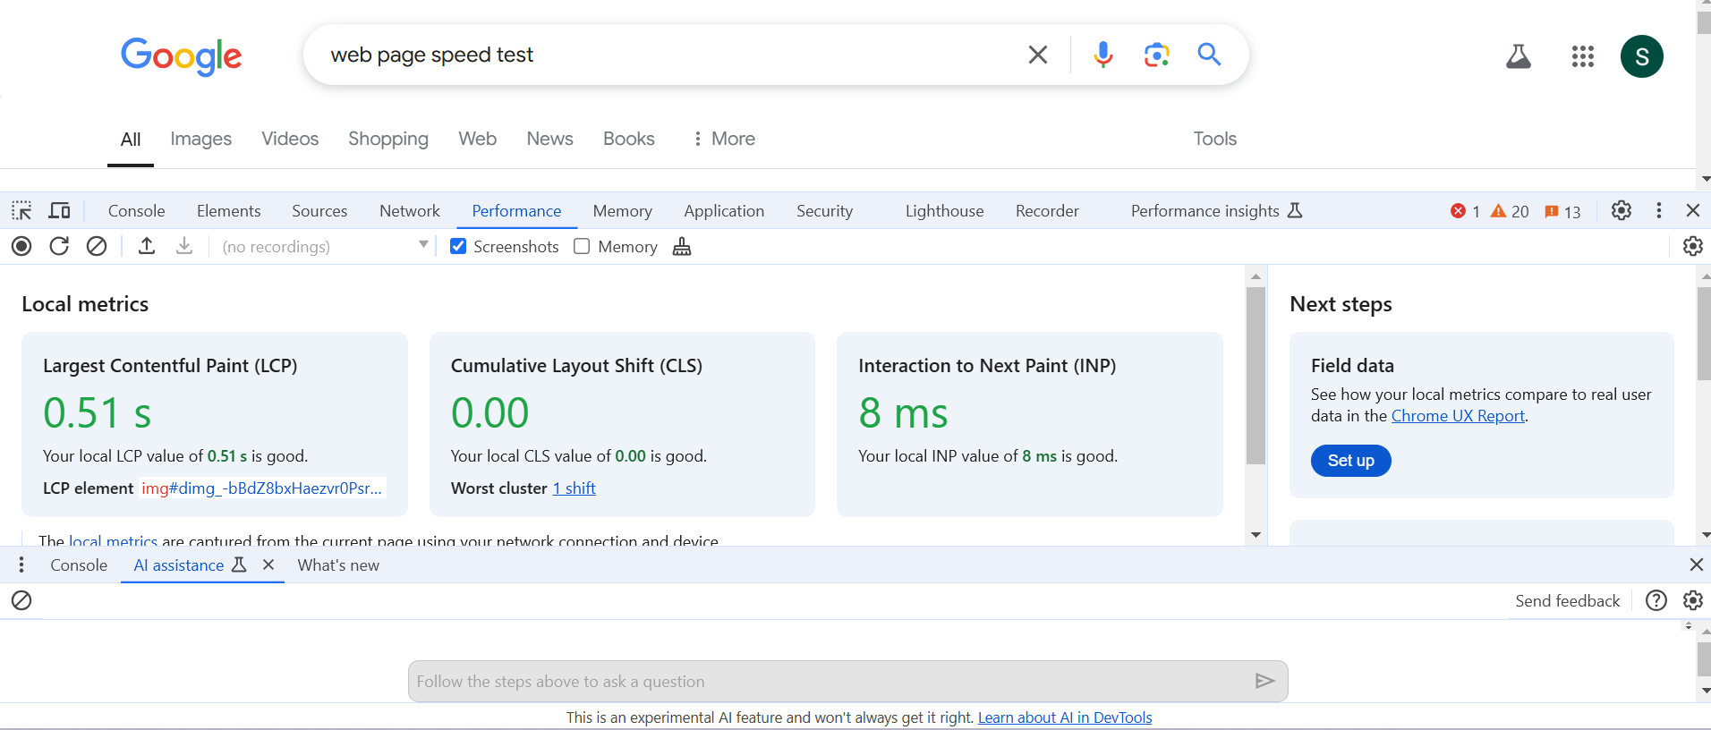

FilmStrip View – check js execution

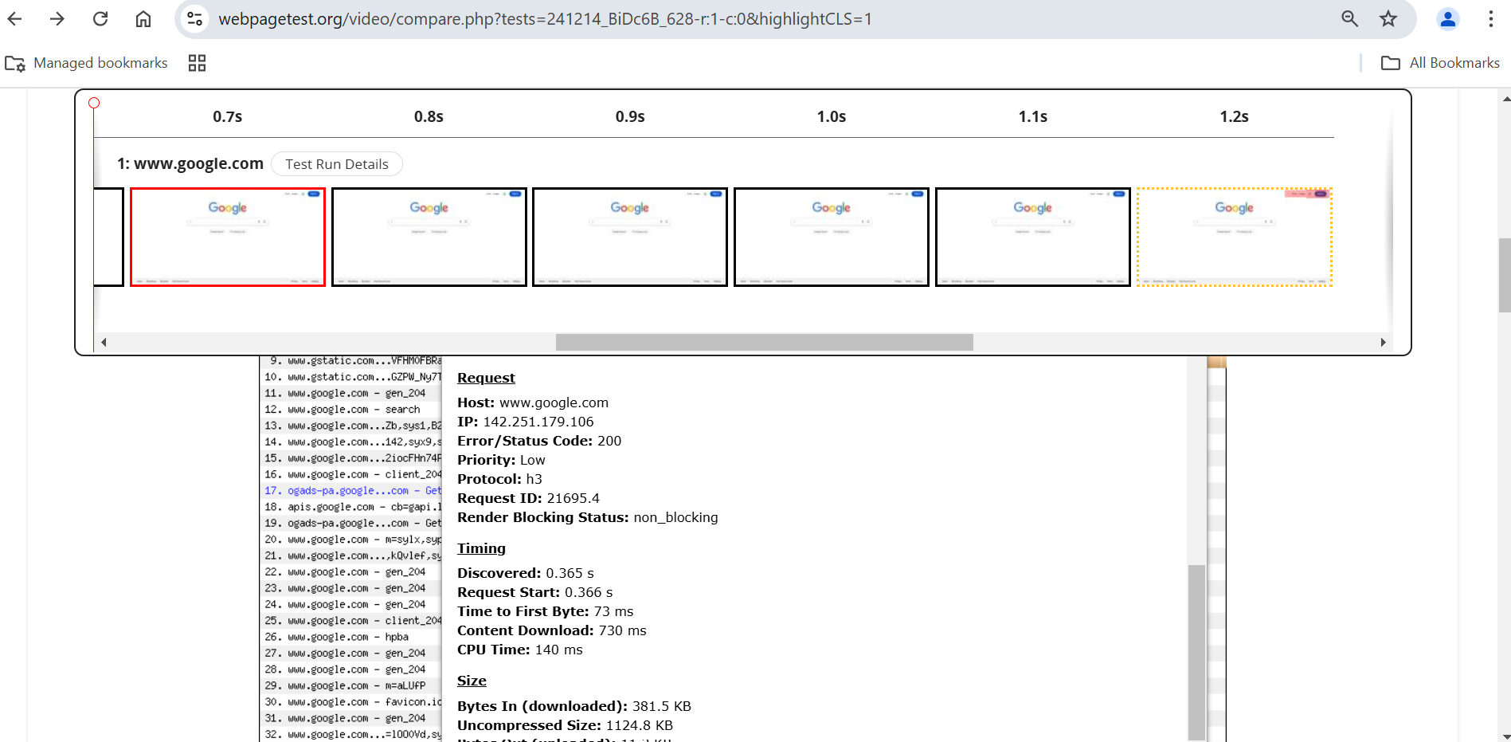

Web Vitals

FilmStrip

Speed Feel Data

Web Vitals --- Compare value/index with Google Benchmarks etc.

FCP – First Contentful Paint (FCP) --

LCP - Largest Contentful Paint (LCP) --

CLS -- Cumulative Layout Shift (CLS) --

INP -- Interaction to Next Paint (INP) ---