# Setup

* **This document guides you to run the Sujaan Riyaaz Application.**
* **You may need to run the program up to 4 times**
* **The Program will check for the setup and help you install one app at a time.**
* **Currently this only works on Windows 10**
* **NOTE: The developer will keep adding more patterns and you can submit your requests too if you have any suggestions.**

## Step 1: Download Sujaan Riyaaz App from this shared location onto your hard disk

<https://drive.google.com/drive/folders/19WhJzKD30cRcPuDT0T9gMFdf8_t0IRMF?usp=sharing>

You will need to request access with a reason and the owner will grant you access.

Please keep visiting this shared location and download the app for latest features that are added.

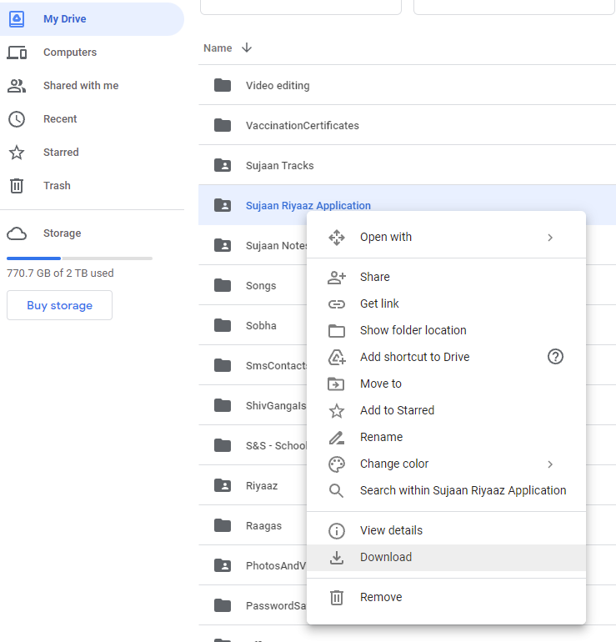

## Step 2: Unzip the Folder

When you download, it will zip the folder and place it in your “Downloads” Folder.

Extract the Folder – Preferably in some other folder on your hard disk.

## Step 2: Setup Python (If not already done)

* Double Click **Start.bat**
* It will detect if you have Python and ask you to install if you don’t
* If this is the first time you will get a screen like this (You may see “Get” instead of Install)
* Click “Get” and then “Install”

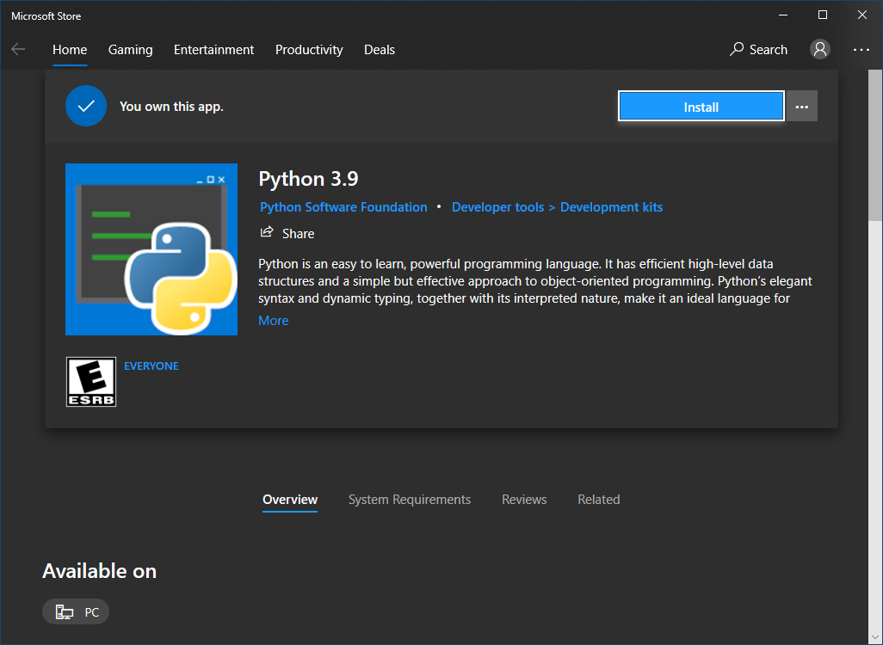

## Step 3: SETUP MuseScore (If Not Already Done)

* Double Click **Start.bat** again
* It will detect if you have MuseScore and ask you to install if you don’t
* Install this on your machine

## Step 4: Start the PROGRAM

* Double Click **Start.bat** again
* The First time it will check whether the program path is set.
* It will set the path.
* It will launch the Program
* If it does not work the first time. Please close and re-try and it should work.

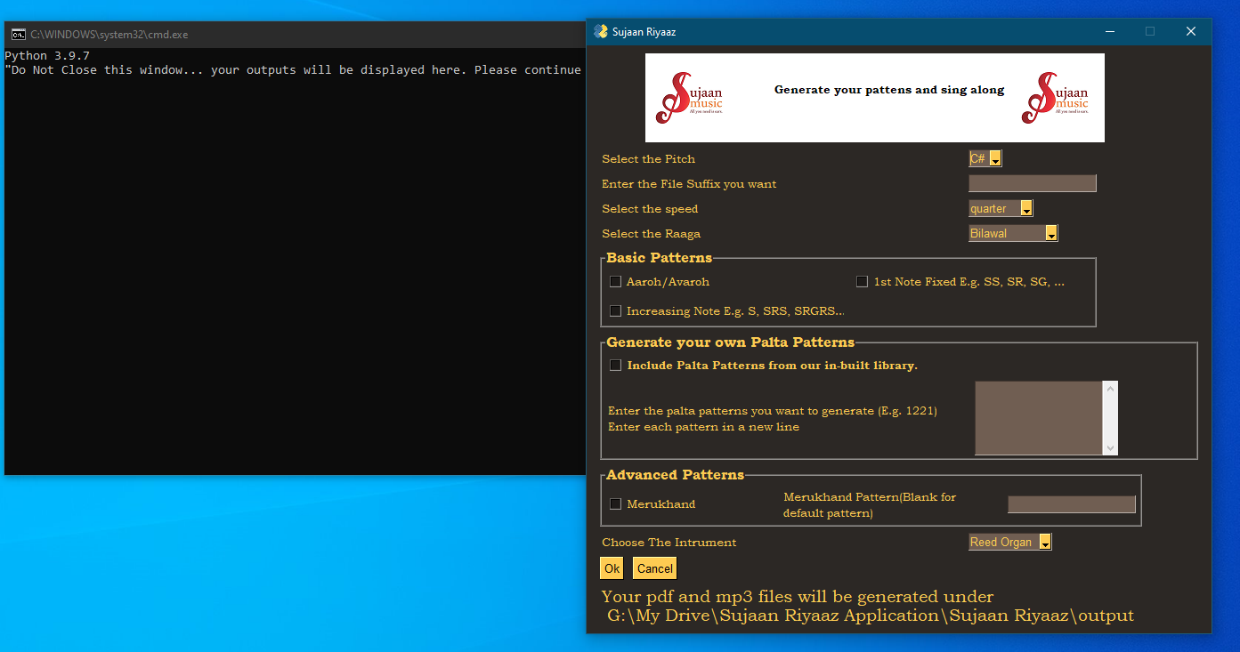

# Using the Program

## What kind of Patterns should I generate?

You can generate multiple files and you should save each file

### Beginner

To start with, you should try these settings

1. Pitch – Select C# if you are Male and A# if you are Female
2. Keep the Speed as quarter – That will be good to start
3. Select Basic Patterns (check all the boxes under Basic Patterns)

In the screenshot below, the File Prefix is “Basic” to indicate we are generating basic patterns

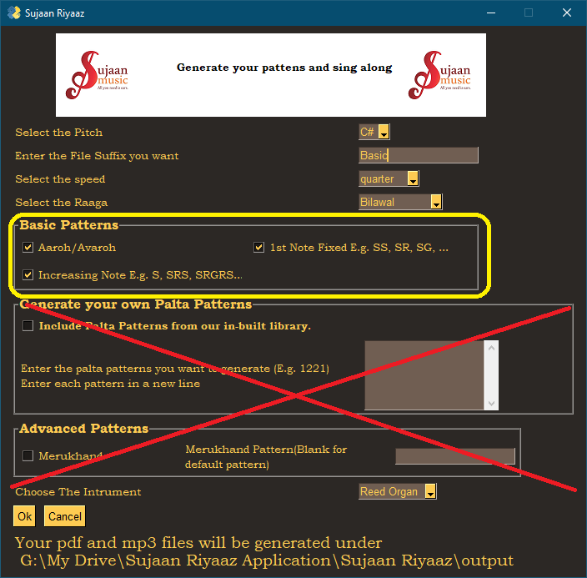

### Intermediate 1

Once you become more conversant, you can then generate another file which you can try with “Include Palta Patterns from our in-built library”

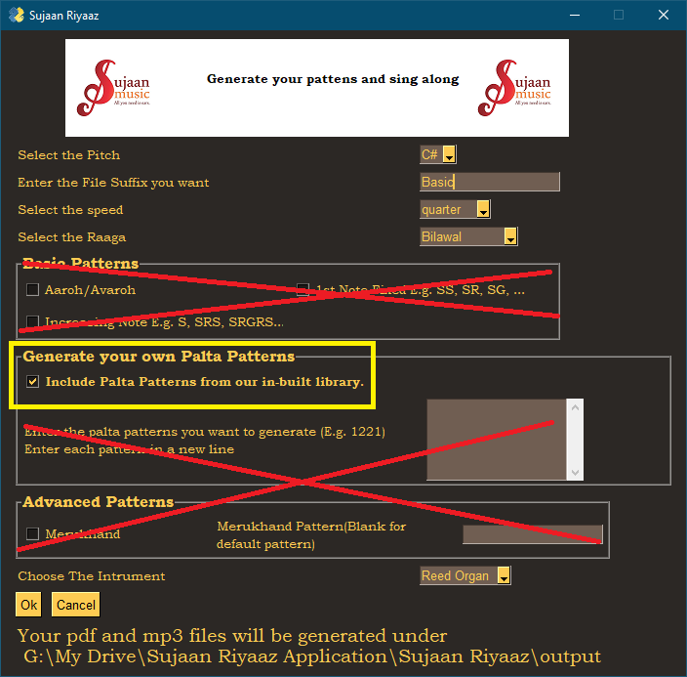

### Intermediate 2

Once you have tried out the built in patterns, enter your own patterns in the box

Every new pattern should be in a new line

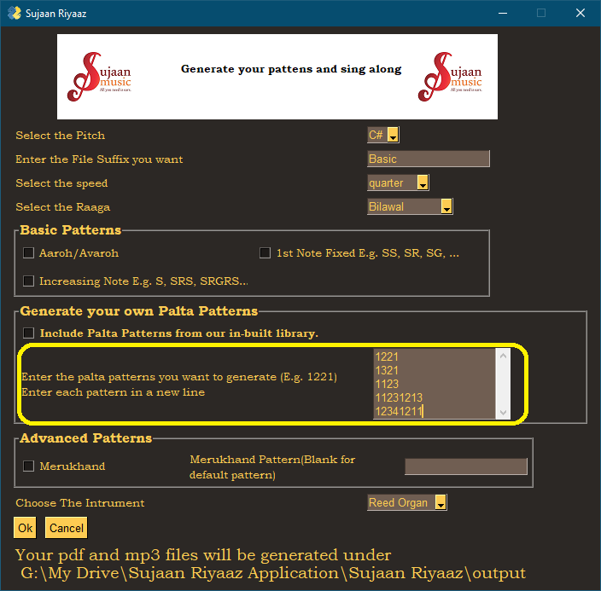

### Advanced

You can try the Merukhand Pattern. To start with check

Let it be the default pattern

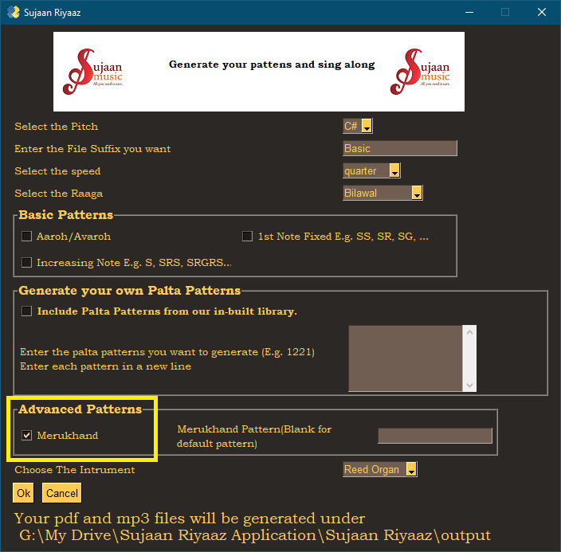

## Futher Advanced

You can try give your own Merukhand Pattern.

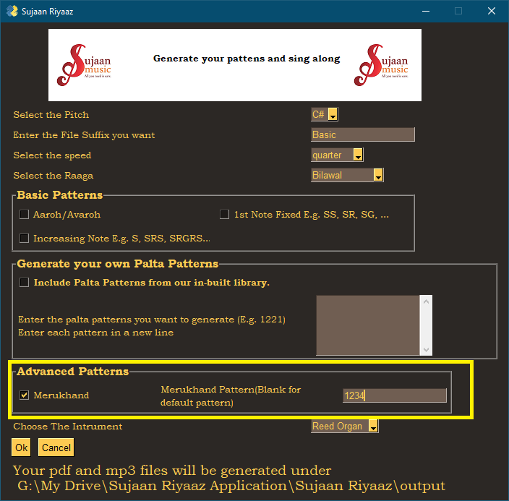

## Generate the full list

You can choose all options and generate a large file which has everything included. Note that this will take some time to generate.

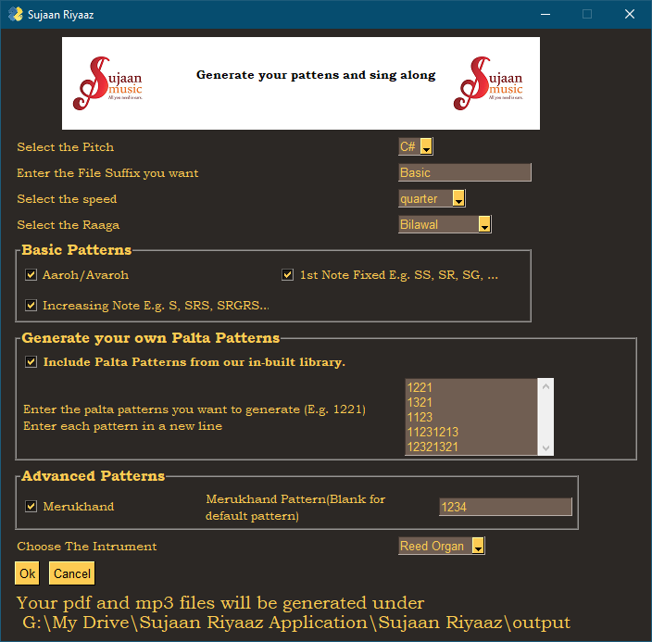

* **For all developers out there.. the code is not very written. I have built it in a very monolithic way incerementally. I intend to rewrite it and make it more modular when I get some time**