TrafficTelligence: Advanced Traffic Volume Estimation with Machine Learning

# 1. Project Overview

TrafficTelligence is an advanced machine learning system designed to predict traffic volume based on various factors such as weather conditions, holidays, and time features. This project provides real-time traffic estimation to assist in traffic management, urban planning, and commuter navigation.

# 2. Objectives

* ✅ Estimate traffic volume using historical and real-time data
* ✅ Enable dynamic traffic management and route optimization
* ✅ Support smart city initiatives with predictive insights
* ✅ Provide a user-friendly interface for traffic volume estimation

# 3. Project Flow

1. User Interaction: Users provide input values via a web-based interface (weather, holiday, date, time)
2. Model Analysis: The trained machine learning model processes inputs and generates a prediction
3. Output Display: The system displays the estimated traffic volume on the UI for users

# 4. Development Process

## A. Data Collection

Collected traffic dataset containing features like:  
- Weather conditions  
- Holiday types  
- Date and Time components (Year, Month, Day, Hour, Minute, Second)  
- Traffic volume (Target Variable)

## B. Data Pre-processing

- Imported required libraries (pandas, numpy, scikit-learn)  
- Handled missing data  
- Encoded categorical features using LabelEncoder  
- Split dataset into training and testing sets  
- Performed feature scaling where necessary

## C. Model Building

- Used Linear Regression for traffic volume prediction  
- Trained the model on historical data  
- Evaluated model performance using appropriate metrics  
- Saved trained model and encoders using Pickle  
  
Generated Files:  
✅ model.pkl - Serialized trained model  
✅ encoder.pkl - Serialized LabelEncoders

## D. Application Development

- Developed a Python Flask web application (app.py)  
- Created HTML templates (index.html, output.html) for user interface  
- Integrated model prediction with web forms  
- Hosted the application locally for testing

# 5. System Requirements

|  |  |
| --- | --- |
| Tool/Technology | Version/Details |
| Python | 3.x |
| Flask | Web Framework for Backend |
| Scikit-learn | ML model development |
| Pandas/Numpy | Data handling |
| HTML/CSS | Frontend Interface |
| Pickle | Model and Encoder Serialization |

# 6. Usage Instructions

1. Run the Flask application using:  
 python app.py  
2. Open browser at: http://127.0.0.1:5000/  
3. Enter input details such as:  
 - Holiday type  
 - Weather condition  
 - Temperature, Rain, Snow  
 - Date and time details  
4. Click Predict to view traffic volume estimation

# 7.Output Interface:

Input page:

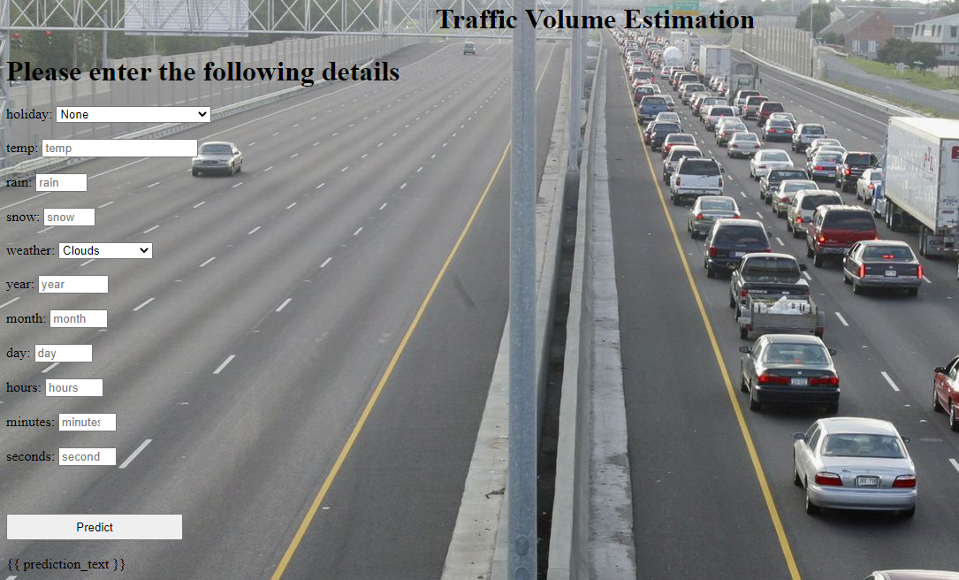

Output page:

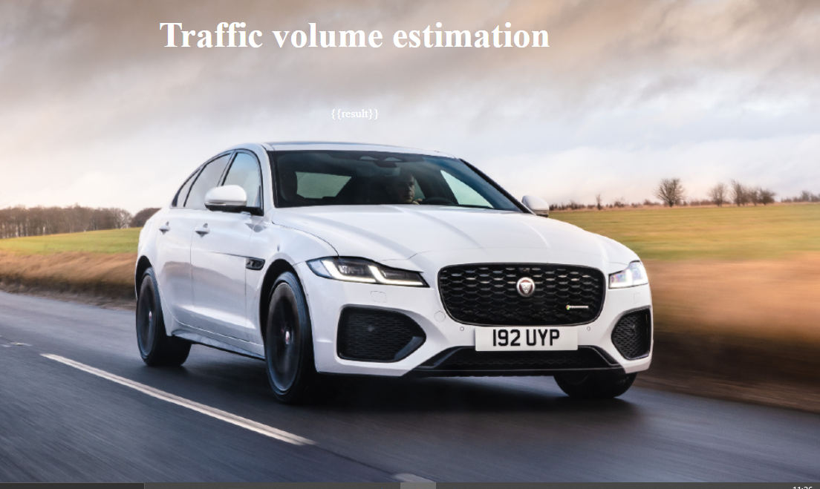

# 7. Future Enhancements

* ✔ Use advanced ML models (Random Forest, XGBoost)
* ✔ Real-time traffic sensor data integration
* ✔ Mobile application support
* ✔ React.js frontend for modern UI

# 8. Conclusion

TrafficTelligence provides a scalable, machine-learning-based approach to traffic volume prediction. It aids in traffic management, commuter convenience, and smart city initiatives by offering accurate, data-driven insights.