Aldor Solutions

Installation and Configuration of the
FDMS Web Reporting Service

David Rollins
June 6, 2006

Prerequisites:
- Install Microsoft IIS (Internet Information Services)
- Install Microsoft .Net 1.1 or above
- Install the latest MySQL-Connector for ODBC (at time of this article 3.51)
- Install Crystal Reports X
- Install and configure Resin application server for FDMS
- Install MySQL database server
- Import the database required for FDMS to MySQL

You will Need:
- WebFDMSReporting Web Service Zip file
- Crystal Reports for FDMS

Editing the Hosts File:
- Go to the following directory in Windows Explorer
- C:\WINDOWS\system32\drivers\etc Or
- C:\WINNT\system32\drivers\etc
- Open the “hosts” file in Notepad.
- Add the following line to the end of the hosts file
- 127.0.0.1 reporting.webfdms.com
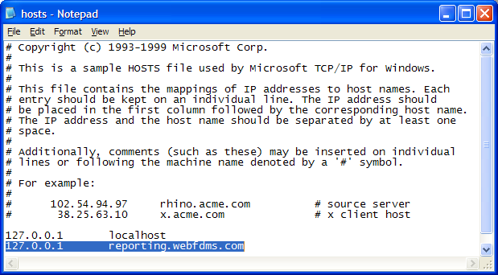
- Save and close
- To test go to a command prompt and type “ping reporting.webfdms.com”
- If successful it should return an IP address of 127.0.0.1

Configuring the ODBC Connection:
The database we are using in this demonstation is “Demo.” If you have a different database, please substitute “Demo” for the name of your database where appropriate.

- Starting at Administrative Tools on your Windows PC.
- Click on “Data Sources (ODBC)”
- Select the “System DSN” tab
- Click “Add...”
- Select the appropriate MySQL ODBC driver
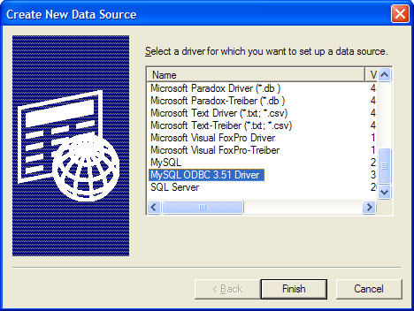
- Click “Finish,” which will open a new window
- You will need to enter the following:
  - Data Source Name: WebfdmsUS
  - Server: reporting.webfdms.com
  - User: webfdms (whatever user you would like to use should go here)
  - Password: webapp (that users password)
  - Database: demo (remember that Demo is that database we are using in this example)
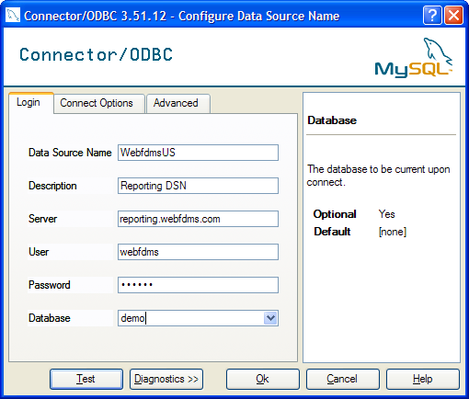
- To Test connection select Test; you should see a successful connection message
- Click OK to close Connector/ODBC screen
- Click OK to close ODBC Data Source screen
- If you wish you may also with to test your connection using Crystal Reports to verify that the connection parameters work.

Installing the Reporting Service
- Extract Webfdms Reporting files to C:\Inetpub\wwwroot\WebfdmsReporting
- Open Web.config in text editor
- Change AppSettings.email.to key to the developer's email address
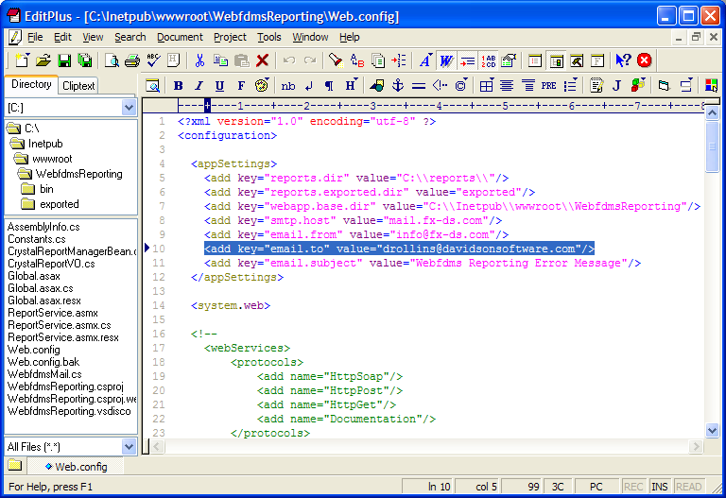
- Save Web.config
- Close text editor
- Go to Start -> Control Panel -> Administrative Tools -> Internet Information Services
- Drill down IIS -> {Computer Name} -> WebSites -> Default WebSite
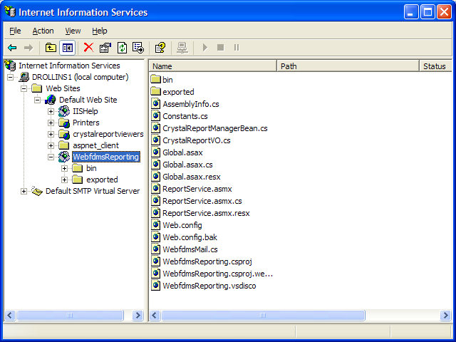
- Right-Click on WebfdmsReporting and click Properties
- On the Director Tab click “Create” next to Application Name
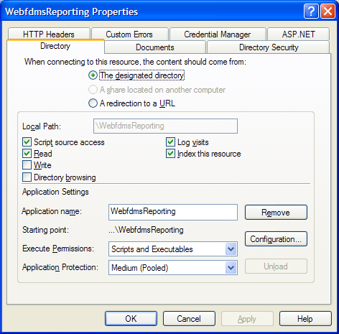
- Click Apply
- Under the ASP.NET tab select an ASP.NET version of 1.1
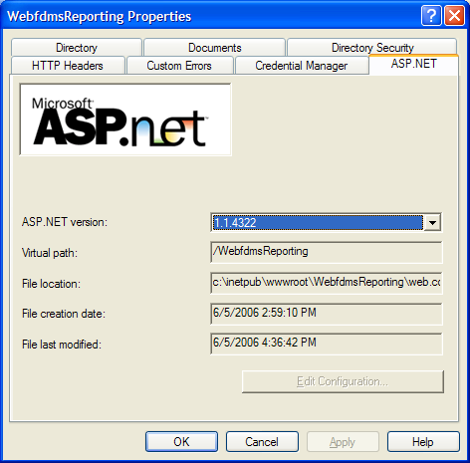
- Click OK
- Right-click on Exported under the WebfdmsReporting folder

- Under the Directory Tab make sure that write permissions have been selected.
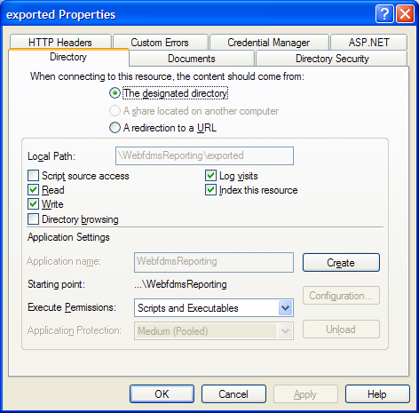
- Click OK to close window
- To Test the installation go to: http://reporting.webfdms.com/webfdmsreporting/reportservice.asmx

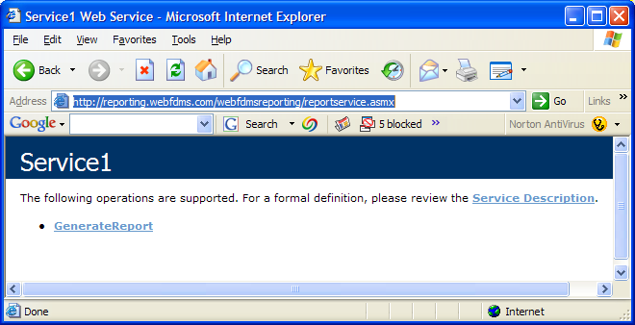
- The GenerateReport option will let you run a report manually for debugging purposes.
- If you have problems with this service please add access ASP.NET to the windows Security of the C:\Inetpub\wwwroot\WebfdmsReporting and exported folders.

Installing Reports
- Extract Crystal Reports RPT files to the C:|Reports folder.

Configuring FDMS in Resin for Reporting Service
- Go to C:\Workspaces\WEBFDMS\WEBFDMSWeb\src
- Edit webfdms.properties in text editor
- Configure the following
  - CrystalServer.IP=reporting.webfdms.com
  - CrystalServer.dsn=WebfdmsUS (Or name of your DSN)
  - CrystalServer.reportsDir=US (Or name of your reports directory)
  - CrystalServer.errorPg=reportError.html
- Save and Close
- Redeploy WebFDMS to Resin
- Restart Resin

Conclusions
Installation should now be complete. If you have any problems check the Event Viewer for .Net related errors and the Resin log file for Java related errors.

