Developed by: Pro IT Solutions (Pvt) Ltd

Ewis Product User Guide

Ewis Peripherals

Table of Contents

Prerequisites 2

Installing Laravel 2

Run Laravel On Web Server 3

Web Server Configuration 4

Pretty URLs 4

Login 5

Admin Home Screen 6

Brands 7

Categories 8

Products 9

Manage User 10

Add New User 10

User Approvals 11

Designations 12

Manage Clients 13

Client Profile 13

Client Users 14

Manage Purchase Orders 15

View Purchase Orders 15

Pending Purchase Orders 16

Partial Completed Purchase Orders 17

Client Login 18

Client Profile Home 19

Client Categories 20

Client Products 21

Client Bucket 22

Client Checkout Order 23

Client User Detail 24

Client User Edit 25

# Prerequisites

The Laravel framework has a few system requirements. Of course, all of these requirements are satisfied by the [Laravel Homestead](https://laravel.com/docs/5.3/homestead) virtual machine, so it's highly recommended that you use Homestead as your local Laravel development environment.

However, if you are not using Homestead, you will need to make sure your server meets the following requirements:

* PHP >= 5.6.4
* OpenSSL PHP Extension
* PDO PHP Extension
* Mbstring PHP Extension
* Tokenizer PHP Extension
* XML PHP Extension
* Composer Should be installed in to project folder

## **Installing Laravel**

Laravel utilizes [Composer](https://getcomposer.org/) to manage its dependencies. So, before using Laravel, make sure you have Composer installed on your machine.

* Go to the project directory and run composer install.
* After that run composer update.

## **Run Laravel On Web Server**

#### Public Directory

After installing Laravel, you should configure your web server's document / web root to be the public directory. The index.php in this directory serves as the front controller for all HTTP requests entering your application.

#### Configuration Files

All of the configuration files for the Laravel framework are stored in the config directory. Each option is documented, so feel free to look through the files and get familiar with the options available to you.

#### Directory Permissions

After installing Laravel, you may need to configure some permissions. Directories within the storage and the bootstrap/cache directories should be writable by your web server or Laravel will not run. If you are using the [Homestead](https://laravel.com/docs/5.3/homestead) virtual machine, these permissions should already be set.

#### Application Key

The next thing you should do after installing Laravel is set your application key to a random string. If you installed Laravel via Composer or the Laravel installer, this key has already been set for you by the php artisan key:generate command.

Typically, this string should be 32 characters long. The key can be set in the .env environment file. If you have not renamed the .env.example file to .env, you should do that now. **If the application key is not set, your user sessions and other encrypted data will not be secure!**

#### Additional Configuration

Laravel needs almost no other configuration out of the box. You are free to get started developing! However, you may wish to review the config/app.php file and its documentation. It contains several options such as timezone and locale that you may wish to change according to your application.

You may also want to configure a few additional components of Laravel, such as:

* [Cache](https://laravel.com/docs/5.3/cache#configuration)
* [Database](https://laravel.com/docs/5.3/database#configuration)
* [Session](https://laravel.com/docs/5.3/session#configuration)

## **[Web Server Configuration](https://laravel.com/docs/5.3/installation" \l "web-server-configuration)**

### Pretty URLs

#### Apache

Laravel includes a public/.htaccess file that is used to provide URLs without the index.php front controller in the path. Before serving Laravel with Apache, be sure to enable the mod_rewritemodule so the .htaccess file will be honored by the server.

If the .htaccess file that ships with Laravel does not work with your Apache installation, try this alternative:

Options +FollowSymLinks

RewriteEngine On

RewriteCond %{REQUEST_FILENAME} !-d

RewriteCond %{REQUEST_FILENAME} !-f

RewriteRule ^ index.php [L]

#### Nginx

If you are using Nginx, the following directive in your site configuration will direct all requests to the index.php front controller:

location / {

try_files $uri $uri/ /index.php?$query_string;

}

Of course, when using [Homestead](https://laravel.com/docs/5.3/homestead) or [Valet](https://laravel.com/docs/5.3/valet), pretty URLs will be automatically configured.

# Login

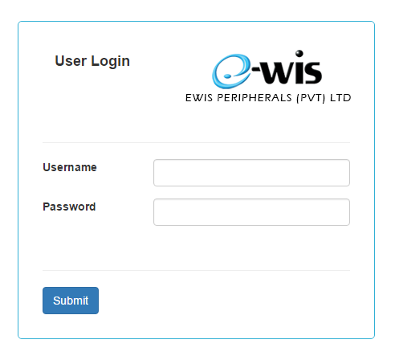

The Login screen is the screen you get when you load the webpage.

From here you just have to enter valid information to login as an Admin, Marketing Head or Sales agent.

Client users also can login using this page. They will be automatically redirected to their Profile home page. (Please refer page “18-19” Client Login and Client Profile Home.)

# Admin Home Screen

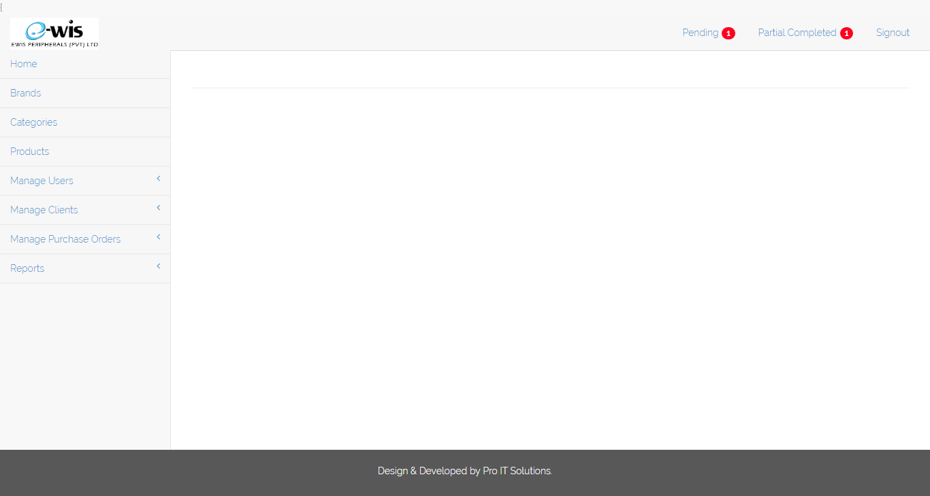

This is probably be your admin home page. On the left side there is the main menu.

Top right to left you can see Logout and another two items named Pending and Partial complete with notification badges.

You can go to pending or partial completed PO views when you click each of them.

# Brands

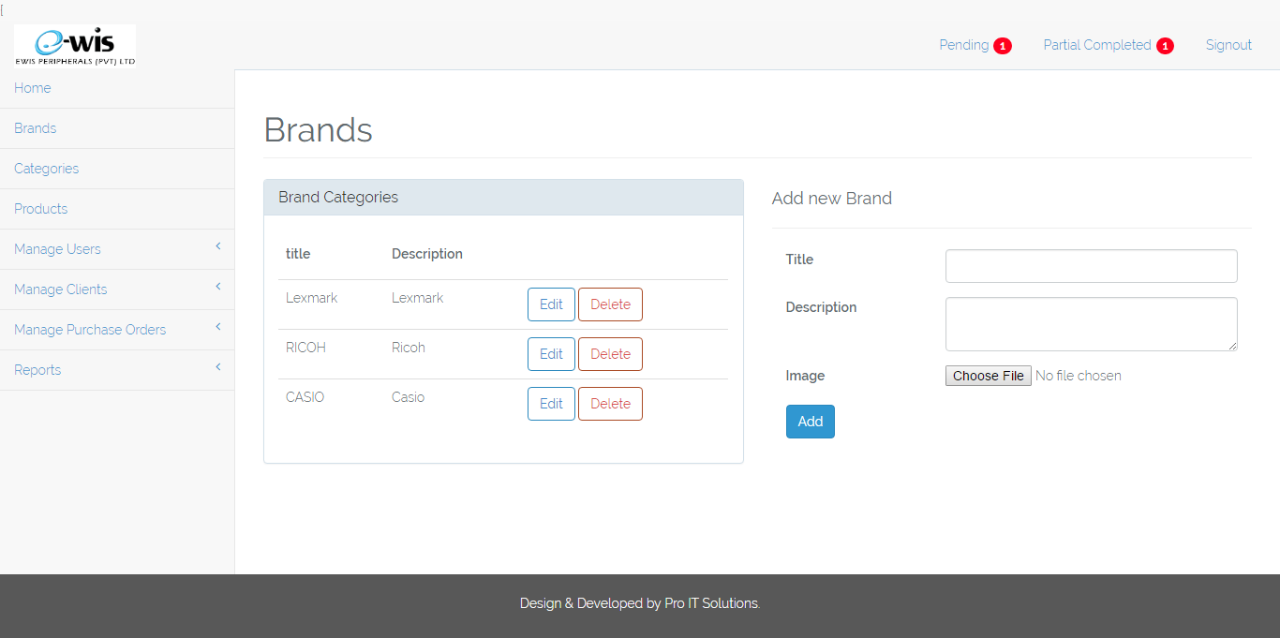

If you click on the Brand on left menu you will be taken to above screen.

From here you can add Brands by simply filling the form on right side.

You can edit or delete a brand as per your requirement using the left side table.

# Categories

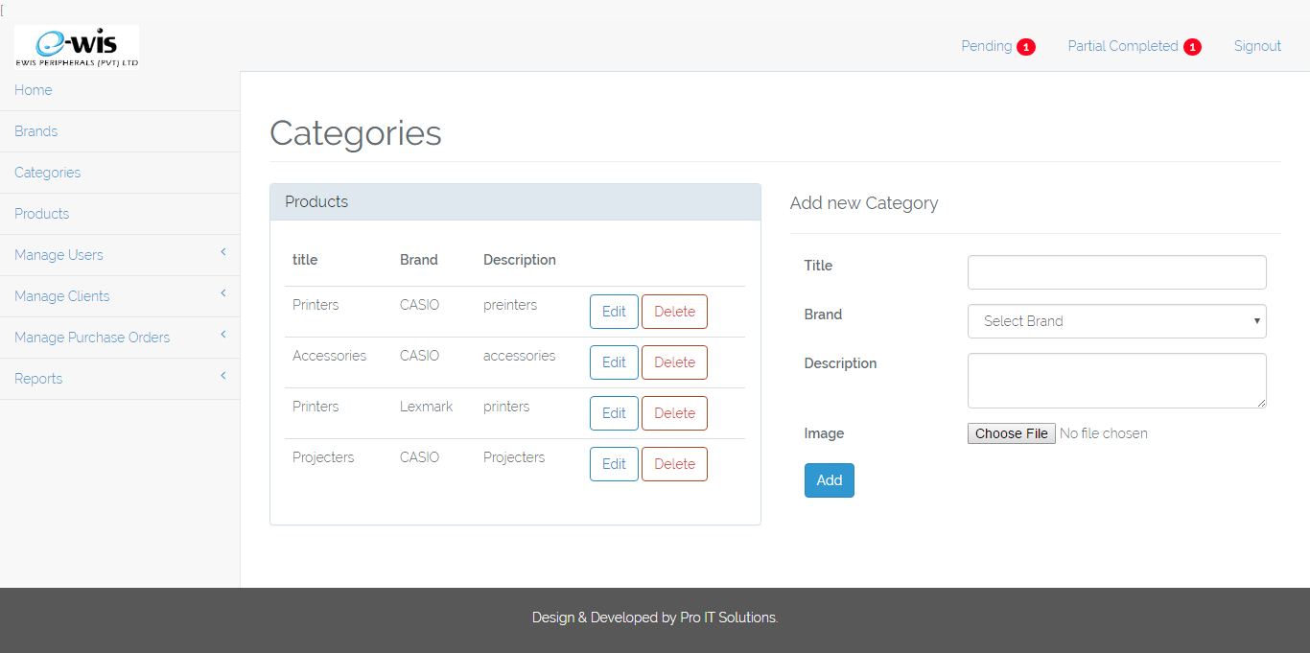

In the Categories page you can add categories by filling the right hand side form and remember you must choose a brand from the dropdown menu of the form.

You can use left hand side table to delete or edit necessary Categories.

# Products

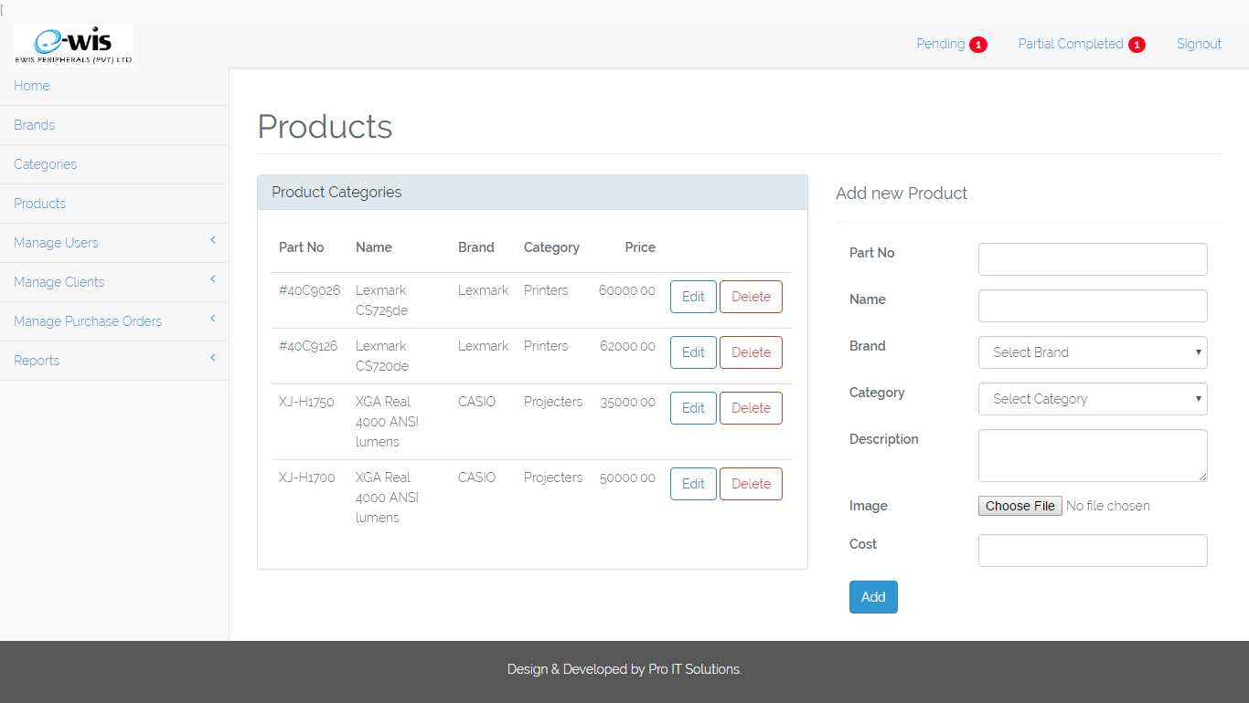

From the Products page you can add products to your Brands and Categories.

You can add new products by filling right hand side form or you can edit or delete using left hand side table.

Important: - You must choose proper branding and categories when adding products otherwise the Client users will get wrong products and branding.

# Manage User

## **Add New User**

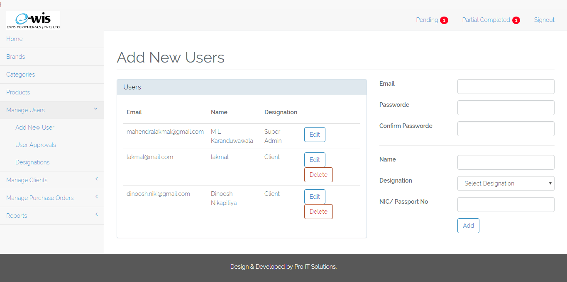

Manage User menu is a dropdown menu. When you click there will be 3 subcategories as Add New User, User Approvals and Designations.

On add new users page as above screenshot you will see table of users on left side and a form on right side.

If you are super admin you can add users using right side form or edit and delete using user table.

When you are adding clients this page will automatically redirected to edit client page.

(for more details please refer manage clients on page 13 )

Important: - Please be careful when you edit or delete any user from the table client users and others will not be able to login if you edit or delete any of the users on the list.

## **User Approvals**

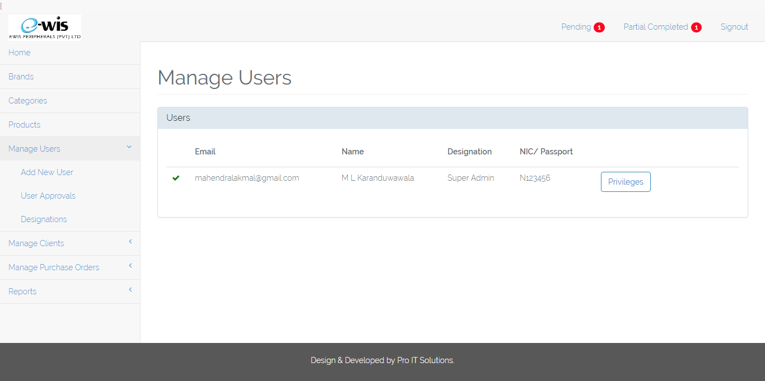

You can approve Local users in this page and also you can assign privileges to users.

In here you cannot edit or give privileges to client users. You can only update privileges and approve company users only.

## **Designations**

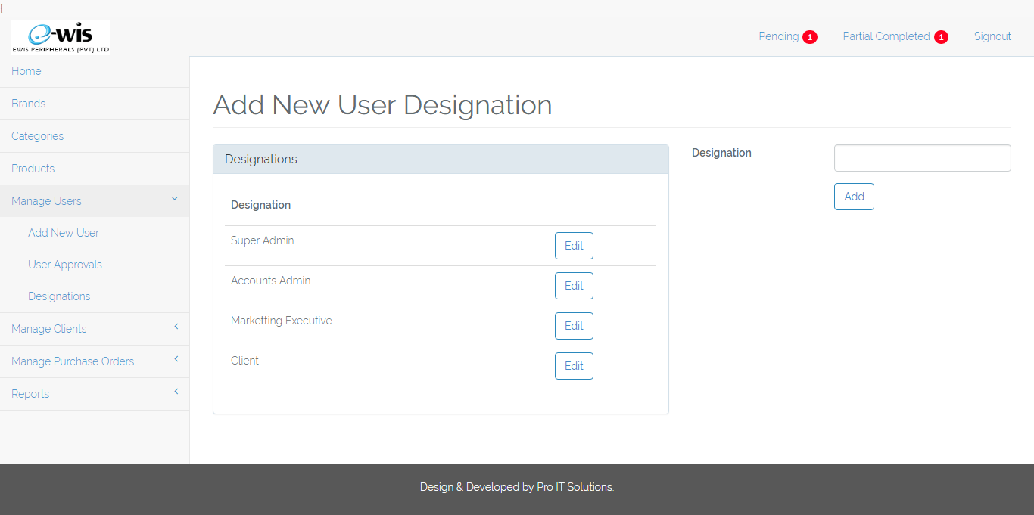

In here you can add designations (user levels).

Important: - You cannot delete user level or designation from here. You can just edit the designation.

# Manage Clients

## **Client Profile**

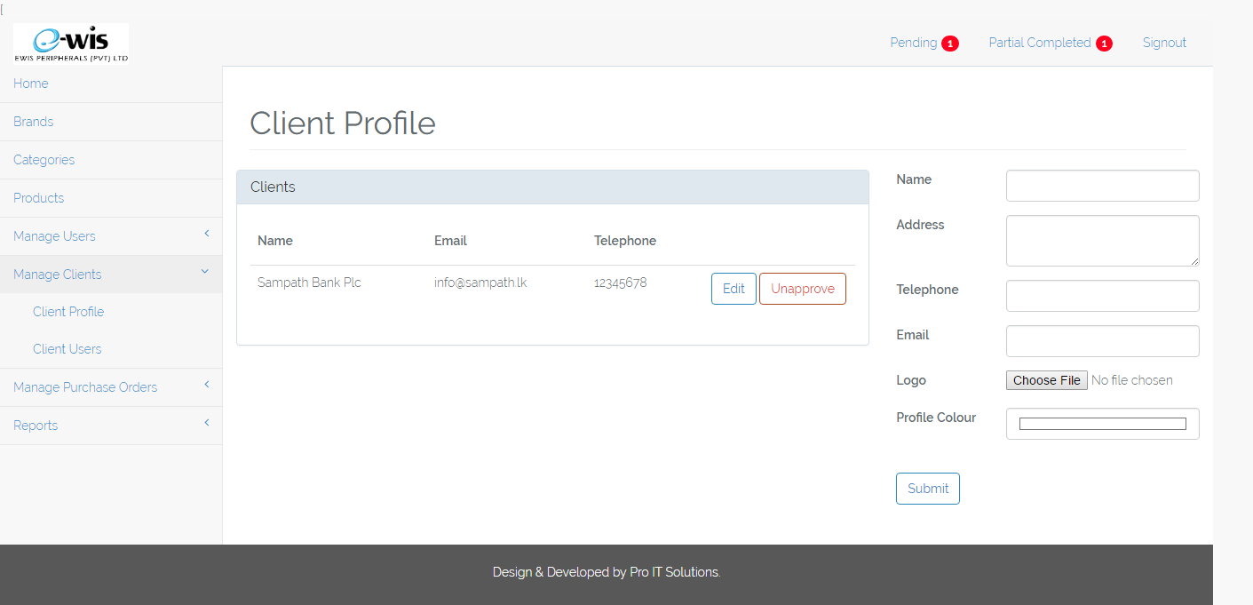

In above screenshot you can add or edit client profile. When you are adding a client user you will be automatically redirected to this page.

Here you can choose a logo for the client and also the best suited colour theme. You can also approve or unapproved a client using left side table.

## **Client Users**

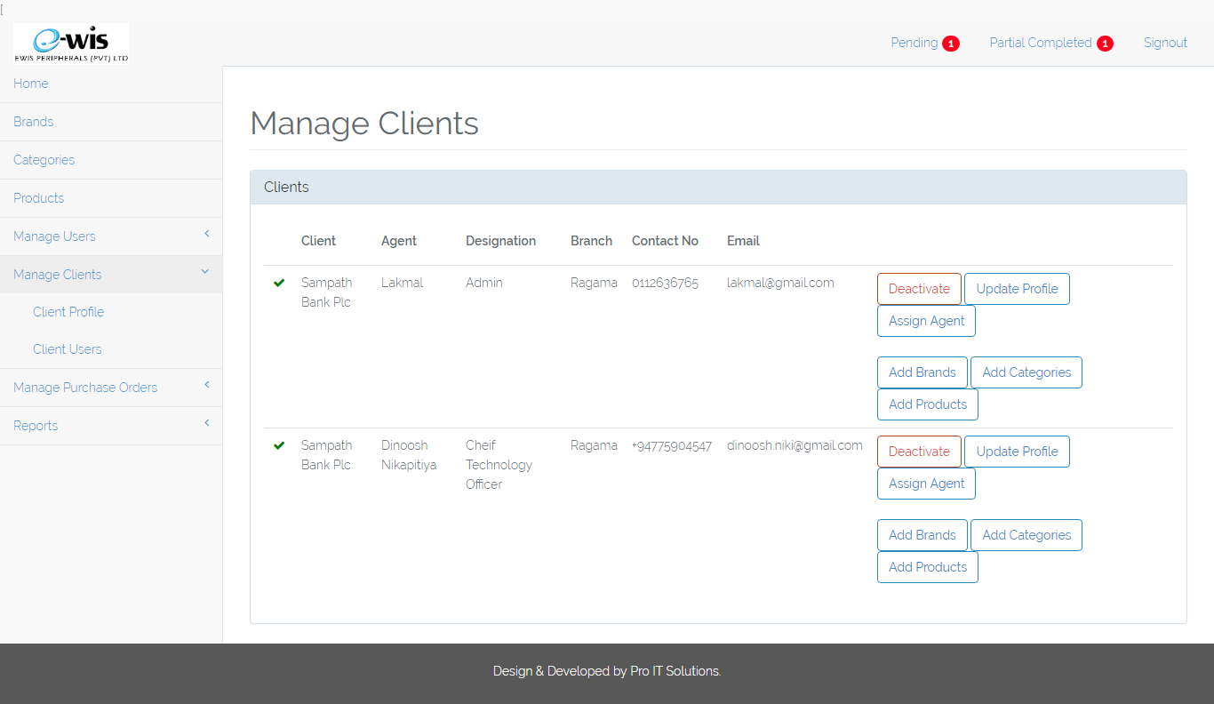

In this interface you can Activate or Deactivate client users.

Update client user profile and assign an agent to the client or client user.

Using right side buttons you can assign brands, categories and products to client user.

If client user is already activated you can see a ✔ mark at the start of the table row.

Important: - Unless you have activate the client user you will not be able to login as the client user.

# Manage Purchase Orders

## **View Purchase Orders**

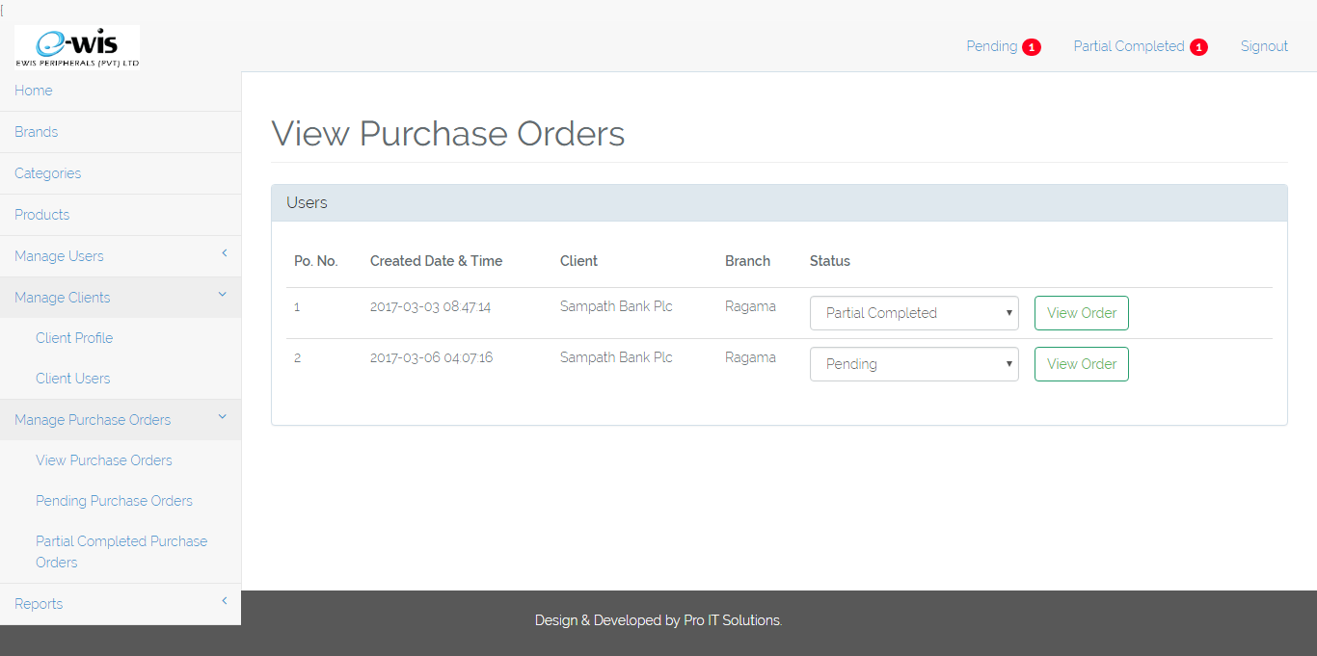

Manage Purchase Orders (PO) dropdown you can see another 3 subcategories. There you can view purchase orders as in above screenshot.

When client user send a PO the status of the PO will automatically show as Pending.

As in above screen User can change status of the purchase order to Pending, Partial Completed or Completed according to the actual status of the order.

Also user can view the order by clicking on view order button.

## **Pending Purchase Orders**

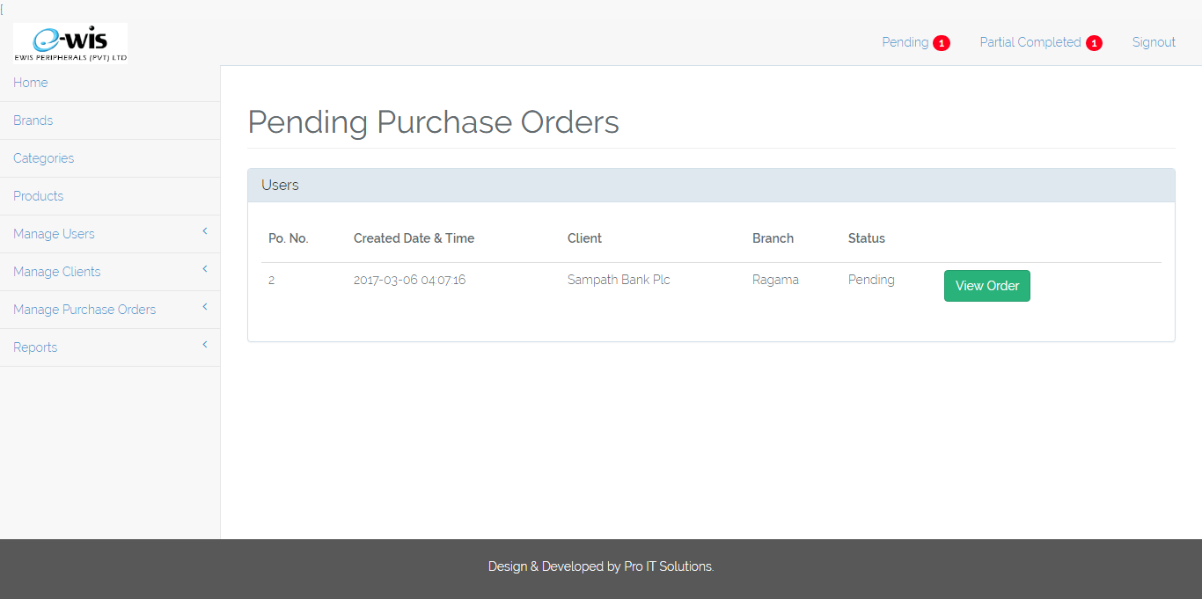

In this screen you can see All Pending Purchase Orders.

To view this page you can use 2 methods,

1. You can navigate to Manage Purchase Orders -> Click on Pending Purchase Orders
2. Or you can directly click on the notification on the top right.

You can also view items of the Order by clicking on the view order button.

## **Partial Completed Purchase Orders**

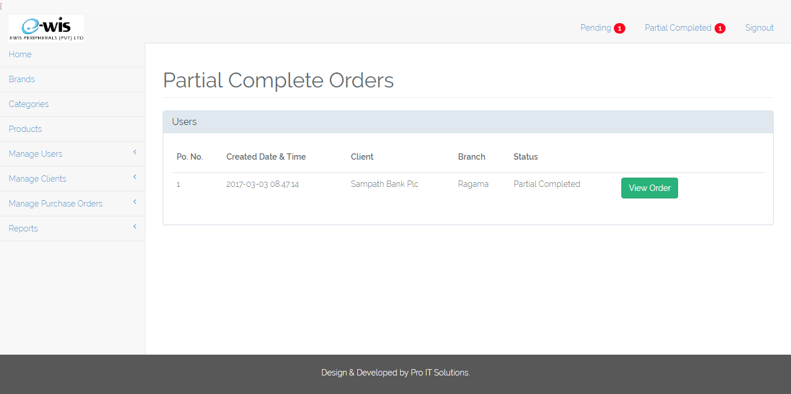

In this screen you can see All Partial Complete Purchase Orders.

To view this page you can use 2 methods,

1. You can navigate to Manage Purchase Orders -> Click on Partial Complete Purchase Orders
2. Or you can directly click on the notification on the top right.

You can also view items of the Order by clicking on the view order button.

# Client Login



Clients also can use the same login screen as the Ewis employee.

After entering Client email and password Clients will be able to login to their customized Home page.

Important: - Clients will not be able to login unless Super Admin activate client user account.

## **Client Profile Home**

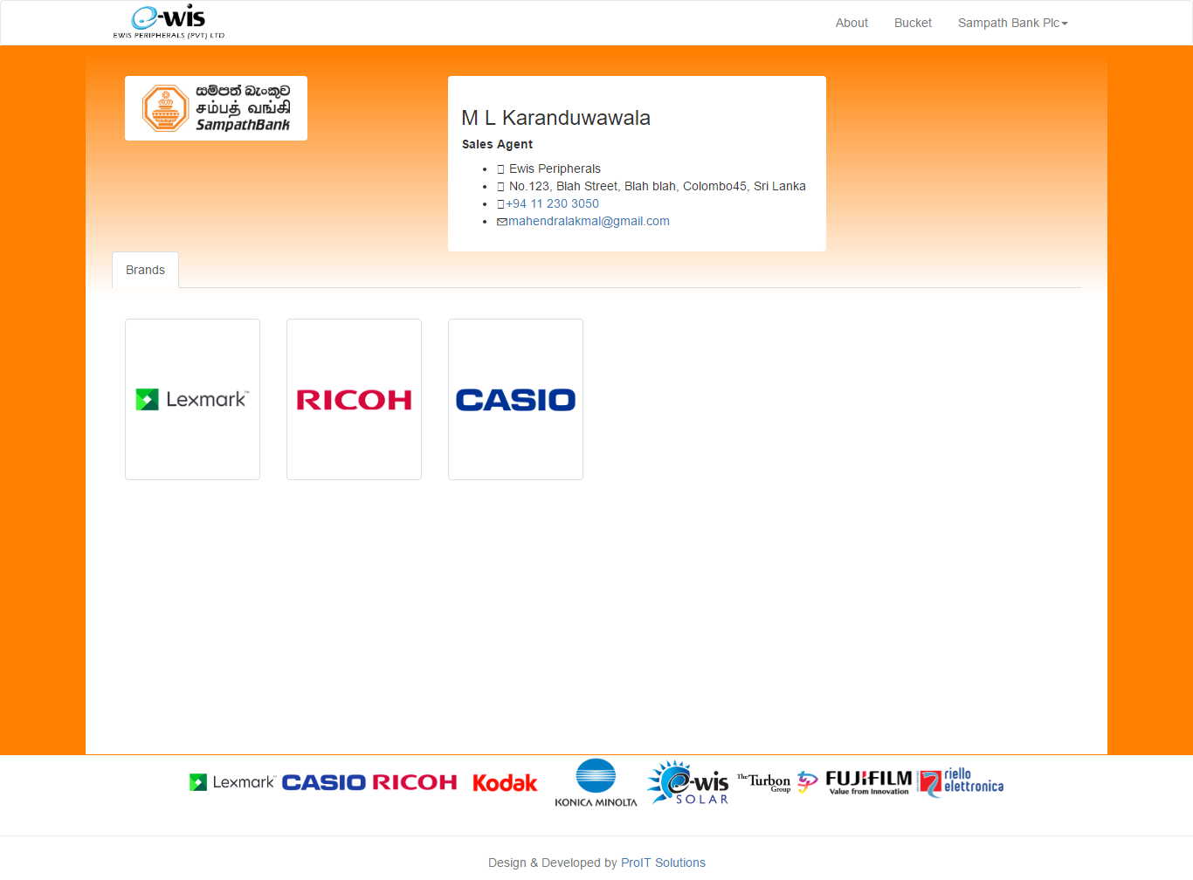

This is the Client Profile Home. This will also be the first step of the Ordering process.

User can select the Brand from this screen to proceed to add products to the bucket.

## **Client Categories**

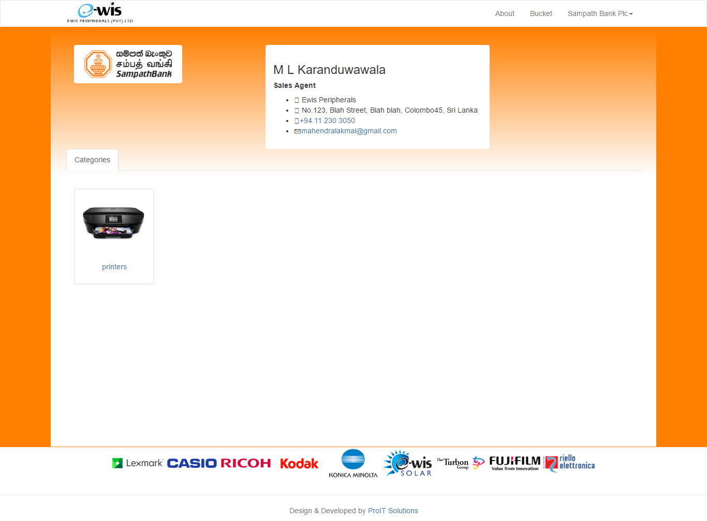

After user selects a brand user will redirected to above category screen.

Here you can select a category like Printers, Copiers etc.. After selecting this only User can navigate to the products page.

## **Client Products**

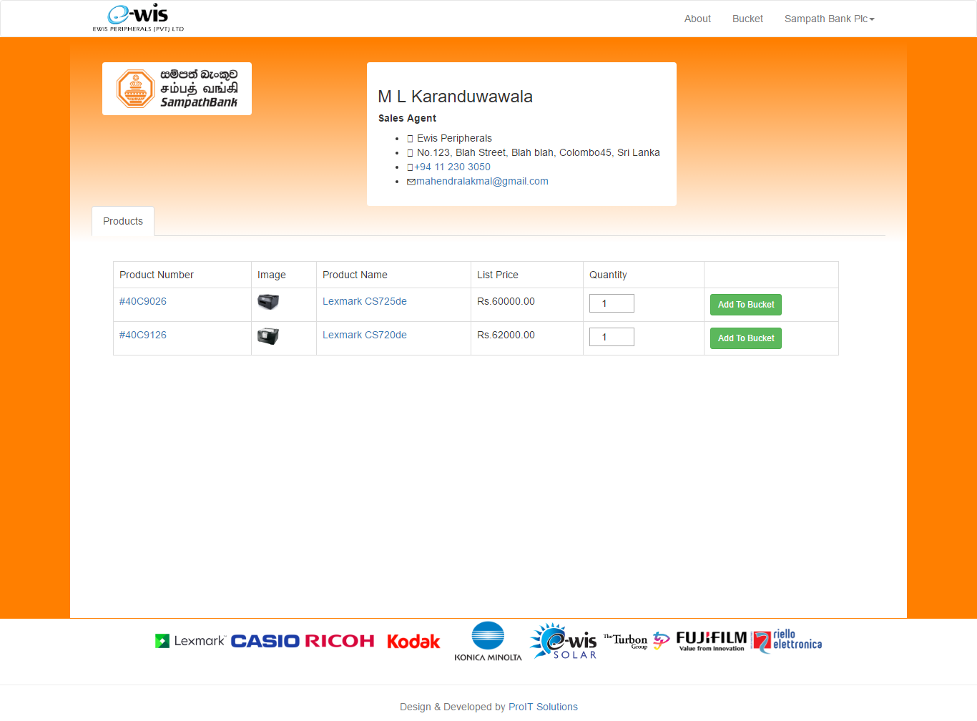

As in above screenshot, User will see a product list of each category of the Brand.

Here user can select multiple products and add them to bucket.

Default value of the quantity field will be 1. You can add more by clicking upper arrow or you can simply type the quantity you need to add to bucket for the purchase.

## **Client Bucket**

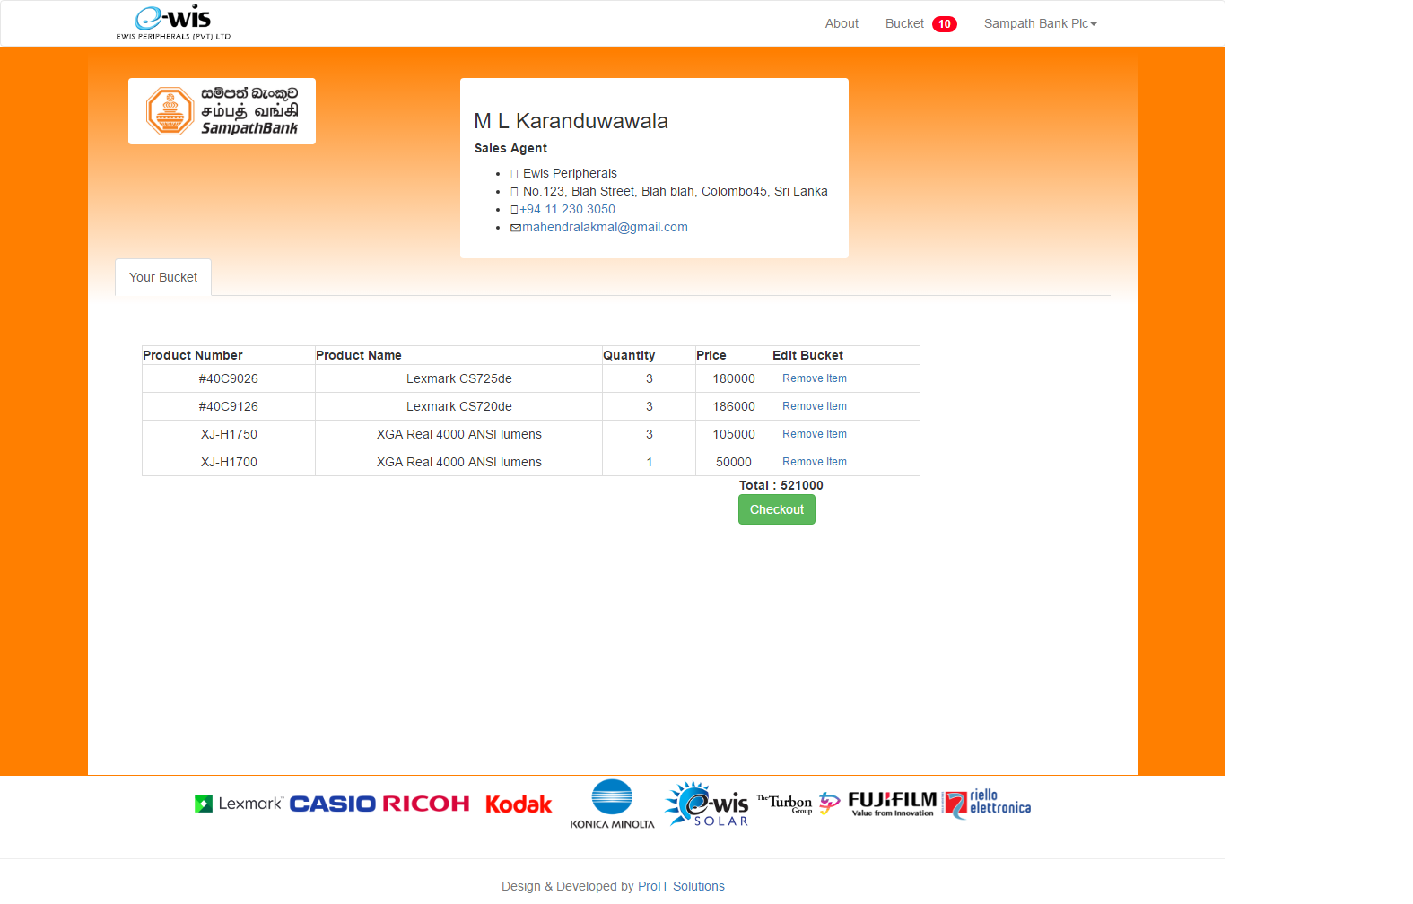

This is the Client User Bucket.

You can view this page by clicking on Bucket notification link on top right of the site.

Here the user can see the list of products user already added to the bucket. From here you can remove items from your bucket.

If you are satisfied with your list you can proceed to checkout your order by clicking checkout button.

## **Client Checkout Order**

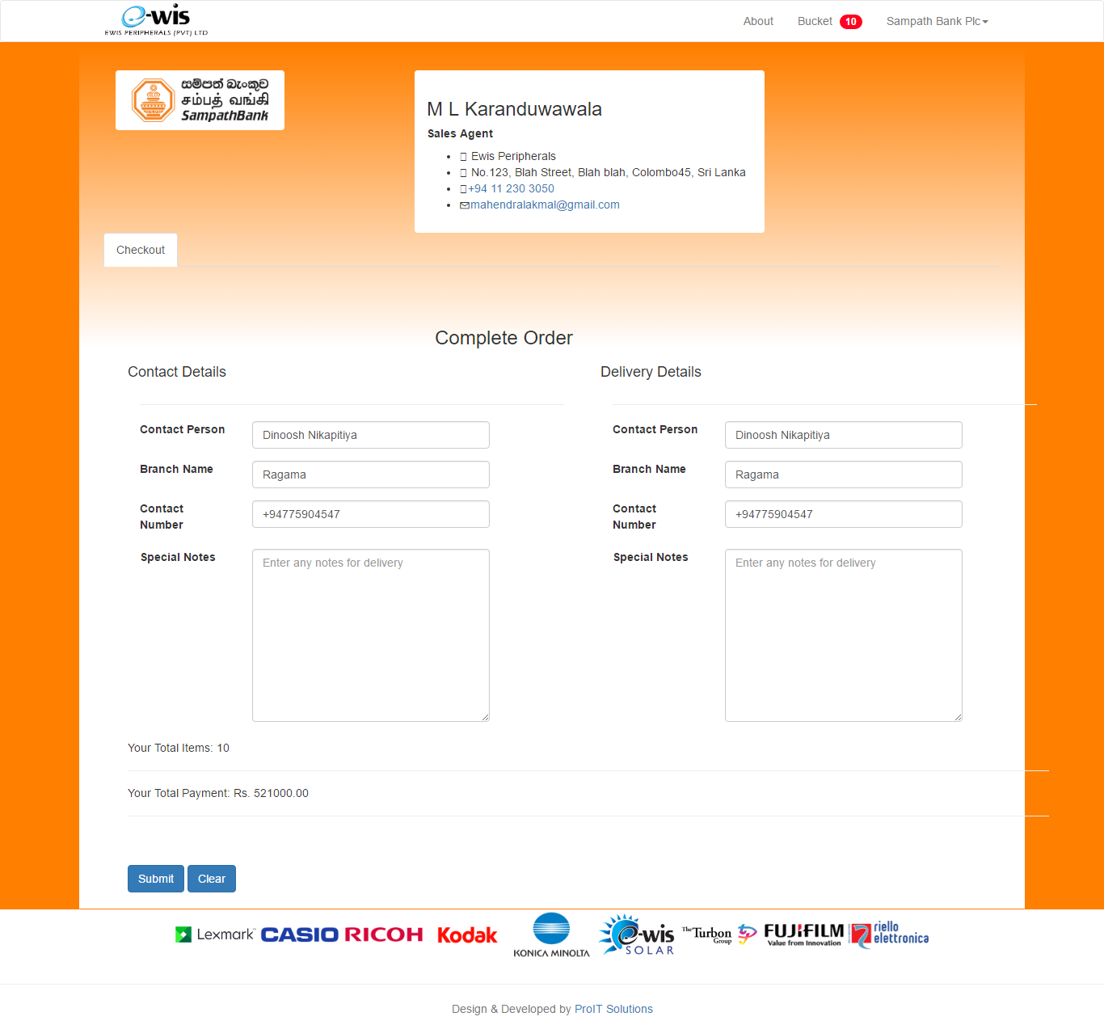

After clicking Checkout button on Bucket page user will redirect to this page.

Here you can add 2 types of details.

1. Contact Details

This will be Contact persons details this part will be auto filled according to the user that is already logged in.

1. Delivery Details

This will be Delivery Details form. Here you can enter different contact person if necessary.

## **Client User Detail**

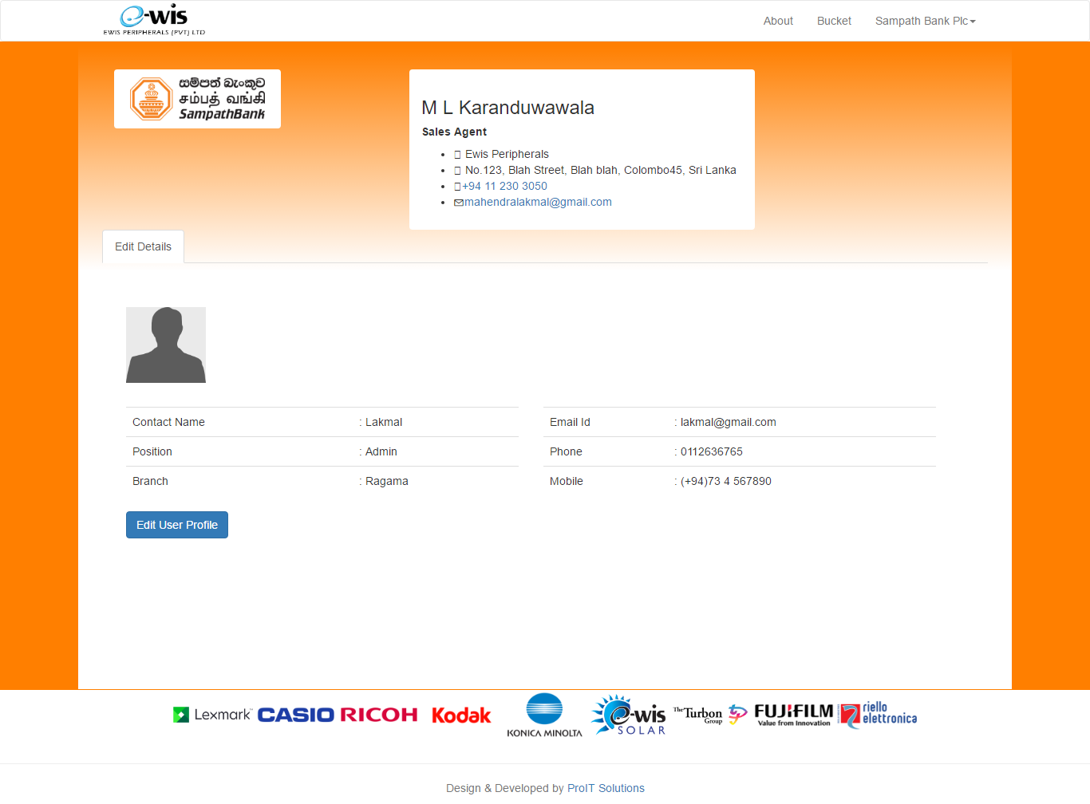

This is your Profile page.

You can Access this page by navigating to top right dropdown Sampath Bank Plc (this can be changed according to the client) -> User Profile.

Here you will see client user details. You can change these details by clicking on Edit User Profile button.

## **Client User Edit**

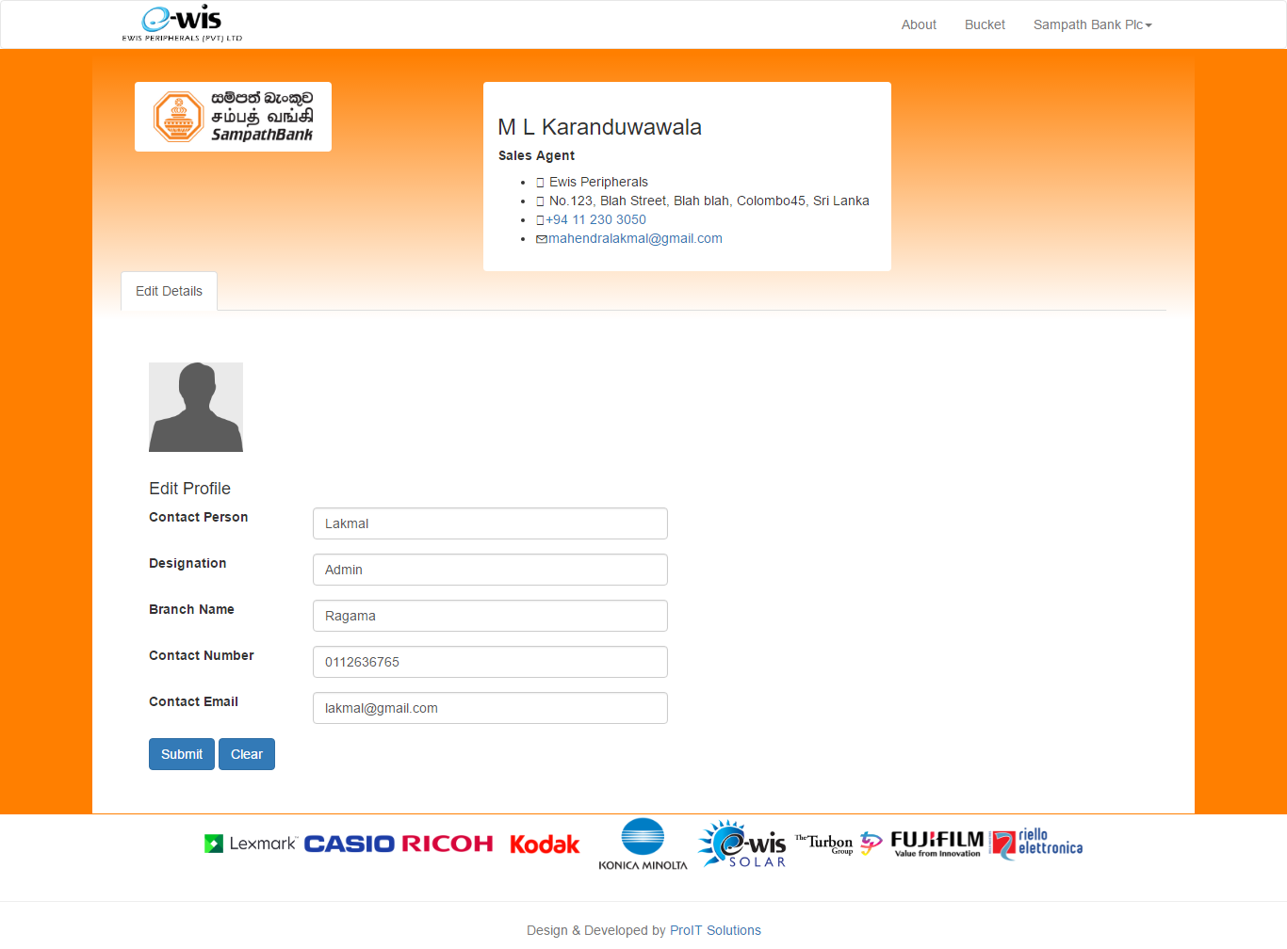

After clicking Edit User Profile button this will be your edit user interface.

Here you can change your (Client user) details and submit.