BUG REPORT
The following defect reports are documented using a consistent structure to ensure clarity, accuracy, and ease of review.

BUG 1

Bug Title: Category filter is not applied when searching catalogue by product name

Description: When a product search is performed and the category is subsequently changed, the search results do not respect the selected category. Products matching the search text are displayed even though they belong to a different category.

Steps to Reproduce:
- Navigate to the Catalogue page.
- Enter butter in the search field.
- Search and observe that Butter products from the Dairy category are displayed.
- Change the category to Cleaning.
- Click Search.
- Observe the results.

Actual Result: Butter products belonging to the Dairy category continue to be displayed even though Cleaning is selected.

Expected Result: The search should apply both the search text and selected category. Products should only be displayed when they match both criteria. If no butter products exist under Cleaning, a clear no matching products result should be shown.
Type: Functional Bug
Suggested Severity: Medium
Priority: P2 (Normal)

Screenshot Evidence:
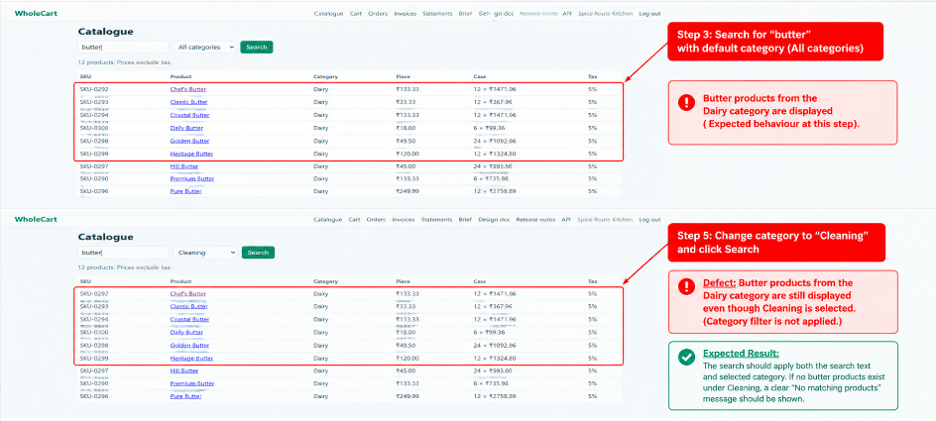

BUG 2

Bug Title: Seller order actions are not displayed on the Orders page

Description: On the seller Orders page, the Actions column is displayed, but no action buttons are available for the orders. According to the expected behaviour, applicable actions should be displayed based on the current order status.

Steps to Reproduce:
- Log in as a seller.
- Navigate to the Orders page.
- View the available orders.
- Check the Actions column.

Actual Result: The Actions column is empty, and the seller cannot perform any action on the displayed orders.

Expected Result: Applicable action buttons should be displayed in the Actions column based on the current status of each order.
Type: Functional Bug
Suggested Severity: Medium
Priority: P2 (Normal)
Screenshot Evidence:
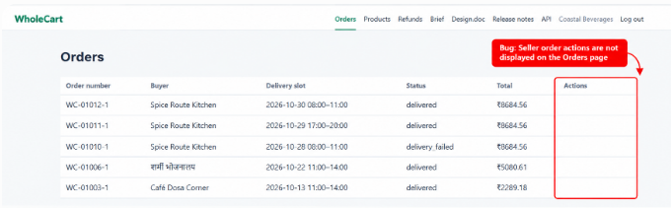

BUG 3

Bug Title: No validation error displayed when importing products with empty cells

Description: When a CSV file containing empty cells is uploaded through Import products, the system does not display any validation error for the missing values.

Steps to Reproduce:
- Log in as a seller.
- Navigate to My products.
- Prepare a CSV file with one or more required cells left empty.
- Select the CSV file and click Upload.
- Observe the import behaviour.

Actual Result: No validation error is displayed for the empty cells in the uploaded CSV file.

Expected Result: The system should validate required fields during CSV import and display a clear error indicating the row and field containing the missing value.
Type: Functional Bug
Suggested Severity: Medium
Priority: P2 (Normal)
Screenshot Evidence:
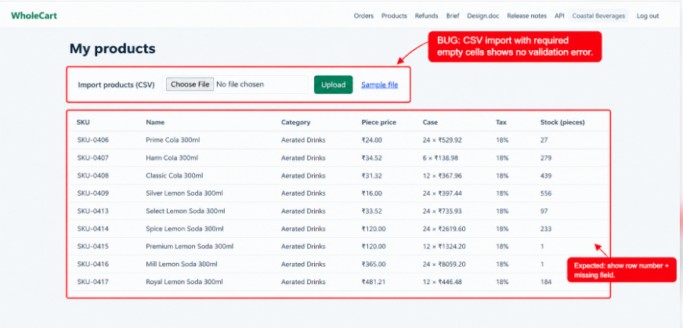

BUG 4

Bug Title: “Message seller” button is not working on the buyer Orders page

Description: On the buyer Orders page, a Message seller button is available for each order. However, clicking the button does not trigger any action or provide any feedback to the user.

Steps to Reproduce:
- Log in as a buyer.
- Navigate to the Orders page.
- Locate any existing order.
- Click Message seller.
- Observe the behaviour.

Actual Result: Nothing happens when the Message seller button is clicked. No messaging interface, navigation, or feedback is displayed.

Expected Result: Clicking Message seller should trigger the intended messaging functionality and allow the buyer to contact the seller.
Type: Functional Bug
Suggested Severity: Medium
Priority: P2 (Normal)
Screenshot Evidence:
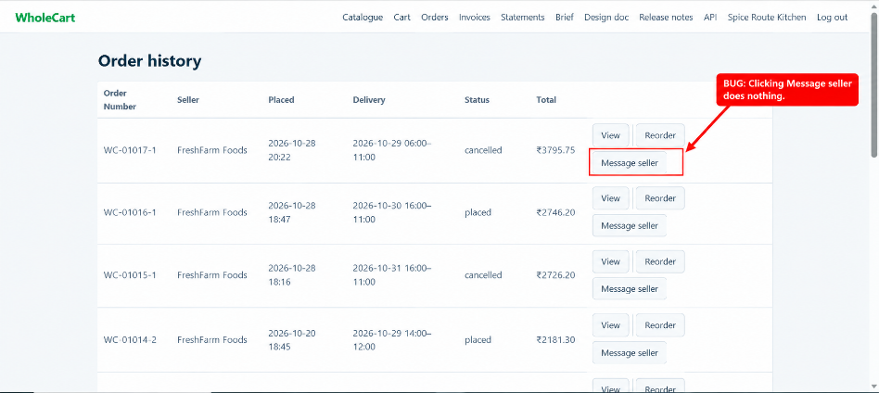

BUG 5

Bug Title: Empty quantity update redirects to raw error response instead of showing validation message

Description: On the Cart page, when the quantity field is left empty and Update is clicked, the application does not validate the input on the page. Instead, the user is redirected to a raw error response showing that the quantity field is required.

Steps to Reproduce:
- Log in as a buyer.
- Add a product to the cart.
- Navigate to the Cart page.
- Clear the quantity value for a product.
- Click Update.

Actual Result: The user is redirected away from the Cart page and a raw backend validation/error response is displayed.

Expected Result: The user should remain on the Cart page. The update should be prevented and a clear validation message should be displayed near the quantity field indicating that a quantity is required.
Type: Functional / Input Validation Bug
Suggested Severity: Medium
Priority: P2 (Normal)
Screenshot Evidence:
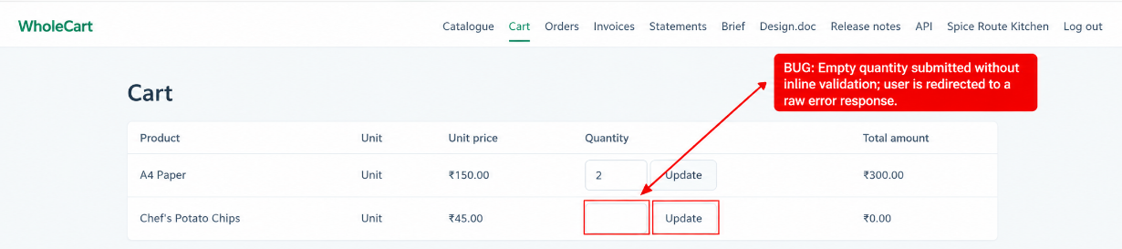
Error Message

BUG 6

Bug Title: Invoice total amount is displayed with inconsistent styling and poor visibility

Description: On the Tax Invoice page, the Total amount is displayed in a different, very light colour compared with the Net and Tax amounts. The Total value is difficult to read and does not have consistent visual emphasis.

Steps to Reproduce:
- Log in as a buyer.
- Navigate to Invoices.
- Open any invoice.
- Check the Net, Tax and Total values displayed at the bottom.

Actual Result: The Total amount is displayed in a very light colour and appears visually inconsistent with the other invoice amounts.

Expected Result: The Total amount should be clearly visible and use consistent, readable styling, with appropriate emphasis as the final invoice amount.
Type: UI/Visual Bug
Suggested Severity: Low
Priority: P3 (Low)
Screenshot Evidence:
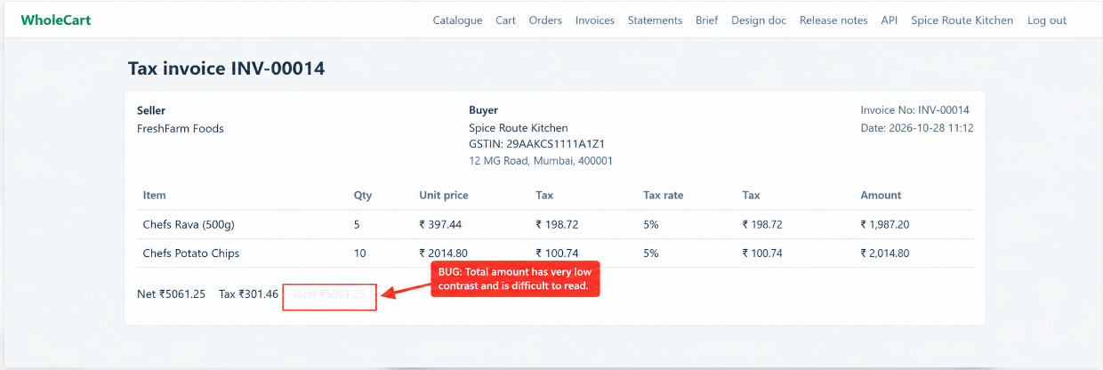

BUG 7
Bug Title: Catalogue search returns a product outside the selected category..
Steps to Reproduce:
- Open the WholeCart Catalogue page.
- Enter SKU-0288 in the search field.
- Select Spices from the Category dropdown.
- Click Search.
- Observe the displayed search result.

Expected Result: The catalogue should return only products matching both the SKU search term and the selected category. If no products match both criteria, the result count should be 0 products, and the table should contain no product rows, as shown in the expected screenshot.

Actual Result : The application returns Village Paneer (SKU SKU-0288) under the Dairy category even though Spices is selected.
Type: Functional Bug
Suggested Severity: Medium
Priority: P2 (Normal)
Screenshot Evidence:
The provided screenshot shows the search term SKU-0288, selected category Spices, and returned product Village Paneer in category Dairy.
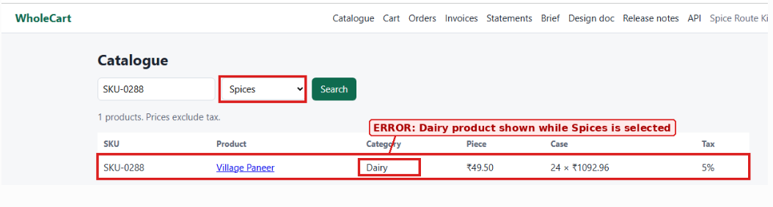

BUG 8
Bug Title: Missing validation errors for empty CSV cells and imported rows not displayed on the My Products screen
Description: When a CSV file containing empty cells is uploaded through the Import products feature, the system does not display validation errors for missing required values. Additionally, the imported product row is not displayed on the My products screen after the upload process.
Steps to Reproduce:
- Log in as a seller.
- Navigate to the My products page.
- Prepare a CSV file containing one or more required cells left empty.
- Select the CSV file for import.
- Click Upload.
- Observe whether validation errors are displayed for the empty cells.
- Navigate to or remain on the My products screen after the import process.
- Check whether the imported product row is displayed.
Actual Result:
- No validation error is displayed for empty required cells in the uploaded CSV file.
- The imported product row is not displayed on the My products screen after the upload process.
Expected Result:
- The system should validate all required fields during CSV import and display clear validation errors identifying the row number and field name containing the missing value.
- The system should display successfully imported product rows on the My products screen.
- If a product row cannot be imported because of missing required values, the system should clearly indicate the import failure and explain which fields need to be corrected.
Type: Functional Bug
Suggested Severity: Medium
Priority: P2 (Normal)
Screenshot Evidence: Sample file
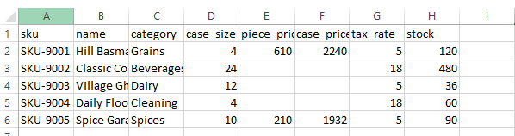
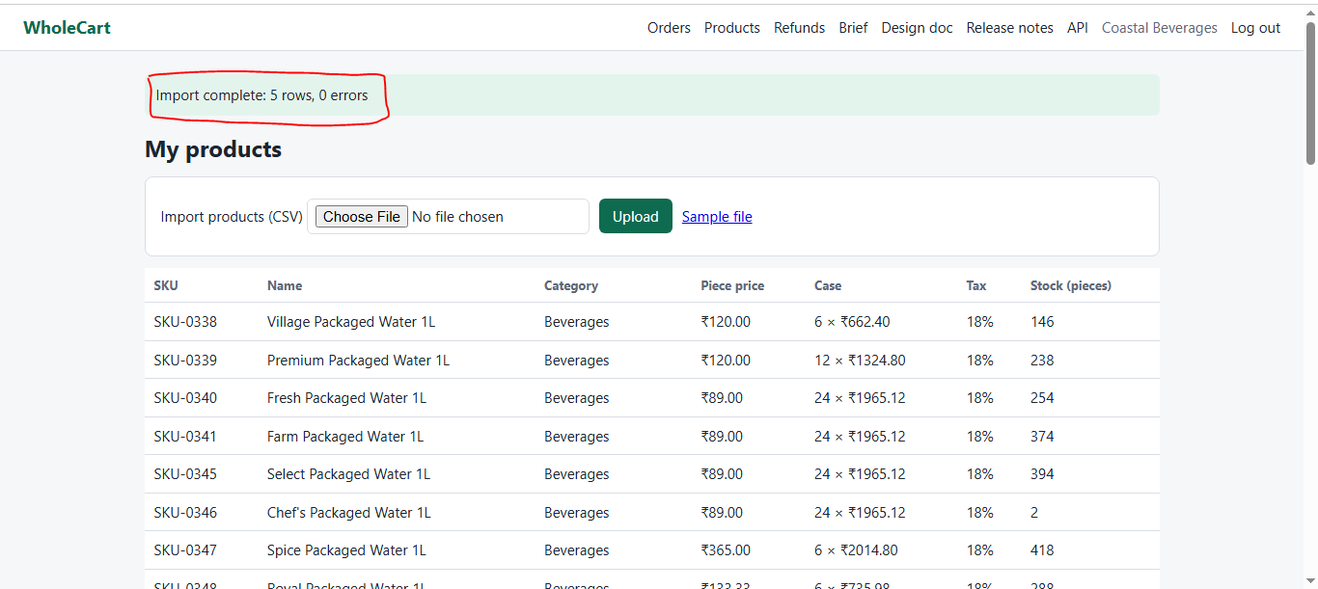

IMPROVEMENT AND FUNCTIONAL ENHANCEMENT

IMPROVEMENT 1
Title: Add Edit, Update, and Delete Functionality to the My Products Page
Description: The My Products page allows sellers to import products through a CSV file. However, there are no visible options to edit product details, update stock quantities, or delete individual products after import.
Actual Result: Sellers can view imported products, but no visible actions are available to edit, update, or delete individual products.
Expected Result: The My Products page should provide appropriate product management options, allowing sellers to edit product information, update stock quantities, and delete products that were imported incorrectly or are no longer required.
Type: Functional Enhancement
Priority: Medium
Screenshot Evidence:
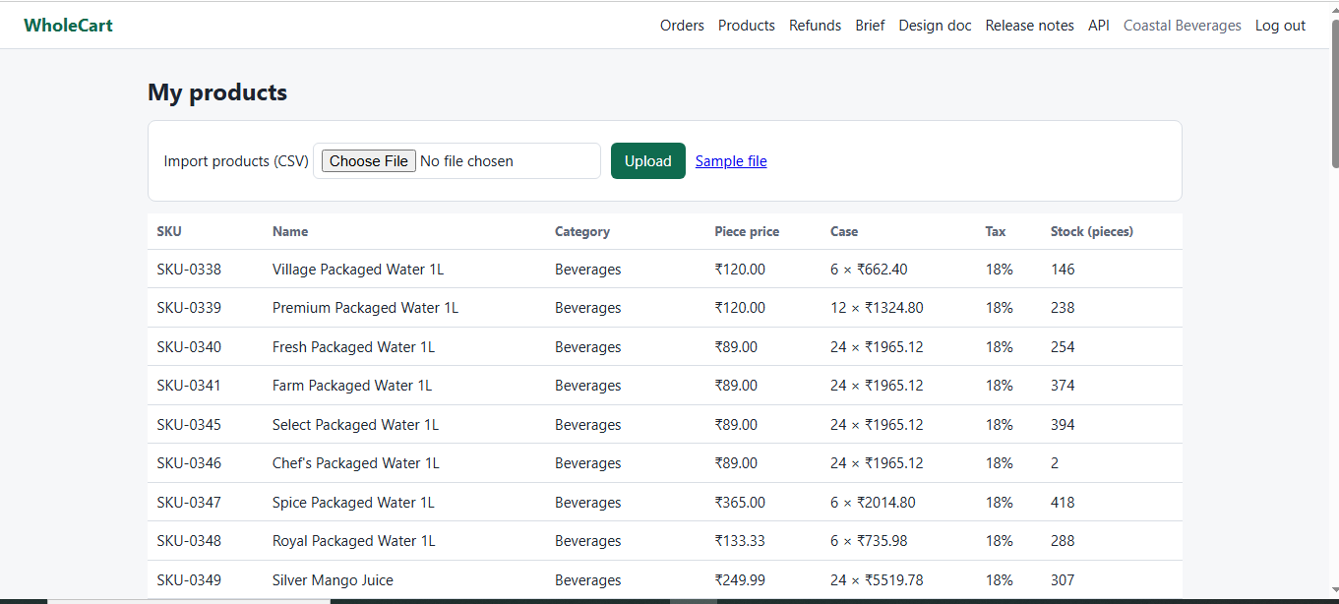

IMPROVEMENT 2
Title: Improve Pagination Information and Navigation on the My Products Page
Description: The My Products page provides basic Previous and Next navigation. However, the pagination interface does not provide sufficient information about the seller's current position within the product list.
Actual Result: Sellers cannot easily identify the current page, the total number of pages, or the total number of products while navigating through the product list.
Expected Result: The pagination interface should provide clear navigation information, including the current page number, total number of pages, total product count, and appropriate page navigation controls.
Type: Usability Enhancement
Priority: Low

Screenshot Evidence:
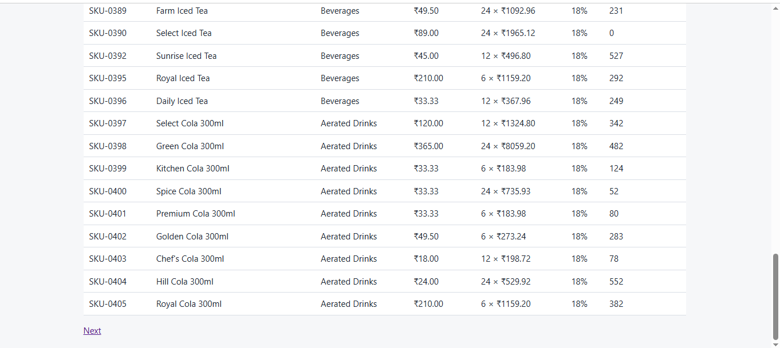

IMPROVEMENT 3
Title: Add Product Search Functionality to the My Products Page
Description: The My Products page does not provide a visible search option, making it difficult for sellers to locate specific products when managing a large product catalogue.
Actual Result: Sellers must manually browse through the product list and navigate between pages to locate a specific product.
Expected Result: The My Products page should provide a search field that allows sellers to quickly locate products using relevant identifiers, such as product name or SKU.
Type: Functional Enhancement
Priority: Medium
Screenshot Evidence:

