**Angular2 – HomeStay**

Requirement Document

**Version No. 0.2**

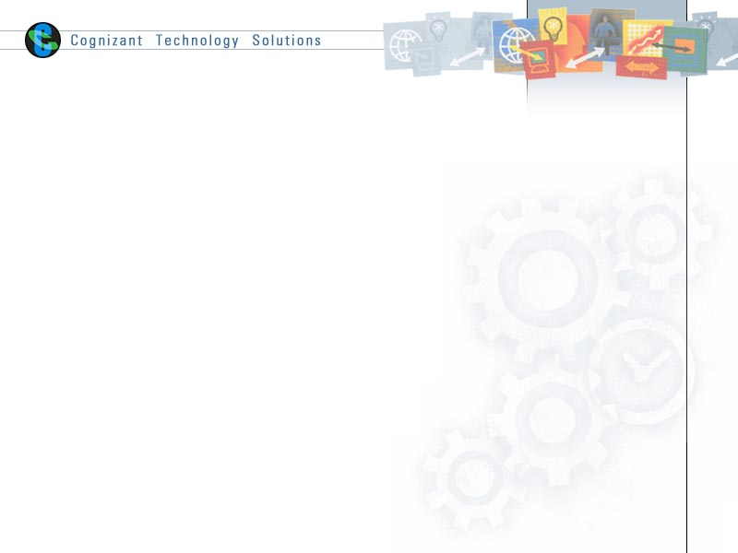

Contents

1. Case study Description 2

2. Low level design/Flow Diagram: 3

4. Code Skeleton: 4

5. Instructions to Associates: 4

6. Case study Requirements 7

# Case study Description

People often tend to worry about the place of stay when they travel to a new city. The app ‘HomeStay’ services can help save people from situations such as this. It’s easy and simple to use. One just needs to log on and place their individual requirements for the stay.

# Low level design/Flow Diagram:

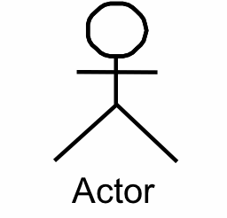

1. **High Level Design/Flow Diagram:**

Enter requirements like BHK size, city, budget search

No results found for given search criteria

Get list of properties for the search criteria

Enquire property

***Achieve all the below requirements using the above flow diagram.***

# Code Skeleton:

Code skeleton contains the basic libraries and base files of the skills, so that the exercise

Solutions can be built on top of it seamlessly.

# Instructions to Associates:

The code skeleton contains a full-fledged working node.js API for all the required GET and POST HTTP requests from the UI. It also contains the basic libraries and base files of the front-end so that the solutions can be built on top of it seamlessly.

* Please download the project code skeleton. The code skeleton contains a full-fledged working node.js API for all the required GET and POST Ajax calls from the UI. It also contains the basic libraries and base files of the front end, so that the exercise solutions can be built on top of it seamlessly
* Note :
  + Necessary software are available @ VDI Desktop -> Academy Digital Folder
  + Mongodb is available @ “C:\Program Files\MongoDB\Server\3.3\bin“
  + Use the GitBash instead of the command prompt as given in the case study requirement document.
* Follow the below steps as provided in the screenshot to start the mongodb, node server and the project application

##### 

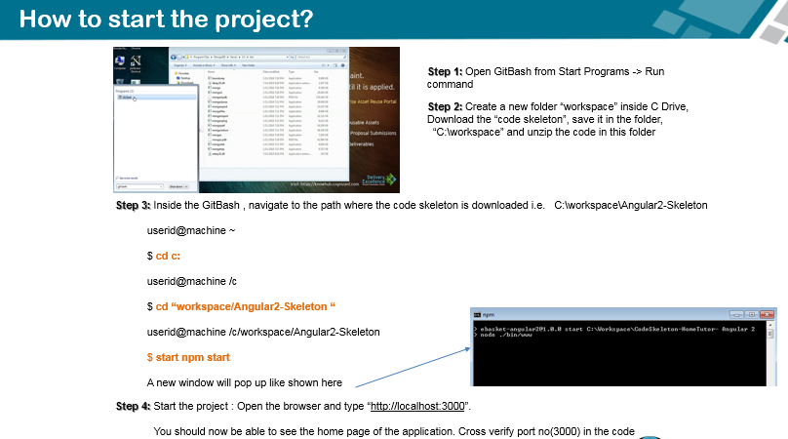

***Please note: After each code update you might have to refresh the browser for changes to reflect and correspondingly you can see the logs in the console***

**Execute the below command for code changes to be built automatically:**

Execute the below command from project root folder. E.g: ”C:/Workspace/Angular2-Skeleton”

**$ npm run-script build**

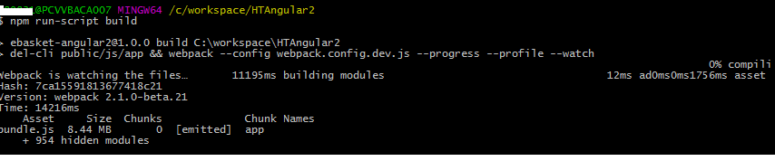

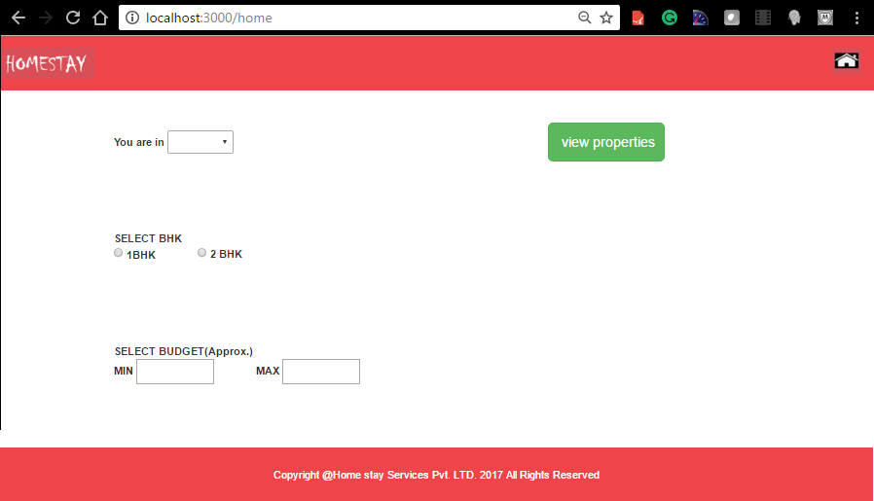Snapshot of Application Home page :

# Case study Requirements

**Requirement 1:**

|  |  |
| --- | --- |
| Problem Statement | Design the page which has a custom header, footer, and options to customize the selection of property of your choice.   * Drop-down showing the list of cities i.e. Delhi, Bangalore * Radio select button for 1 BHK and 2 BHK size * Input box for minimum budget * Input box for maximum budget * All fields must be validated and proper error message must be shown in case of any error. Min budget can’t be greater than the Max budget. |
| Design Consideration | |  |  |  |  | | --- | --- | --- | --- | | Name & Model Name | Field Type | Restrictions | Mandatory | | city | Select Drop down | Delhi/Bangalore | Yes | | bhkVal1 | Radio | 1 BHK, 2 BHK | Yes | | minBudget | Number | Only number  Minimum value: 0 | Yes | | maxBudget | Number | Only number  Maximum value: 10000000000 | Yes |   Make sure you have the app name in the header and copyright symbol in the footer.  There should be an option to select the city name, type of flats, min-max budget. |
| Business Rules and Process | Clicking ‘View Property’ must send the below mentioned mandatory fields to the server:   1. Home 2. City 3. Minibudget 4. MaxBudget   For example: <http://localhost:3000/homes?home=2BHK&city=Bangalore&minBudget=1&maxBudget=100000000> |
| Skills and Features | * @angular/core * @angular/http * @angular/router * @angular/forms * Rxjs   Forms, Dom Manipulation, ngFor, Http, Routing and navigation, Component, Services, Pipes, NgIf, Event handling |
| Time Required | 1.5 hours |
| Connected Code in Skeleton | \assets\app\home   1. [Home.component.ts](http://Home.component.ts): TODO1, TODO2 2. Home.component.html 3. Data.service.ts: TODO3, TODO5, TODO6 |

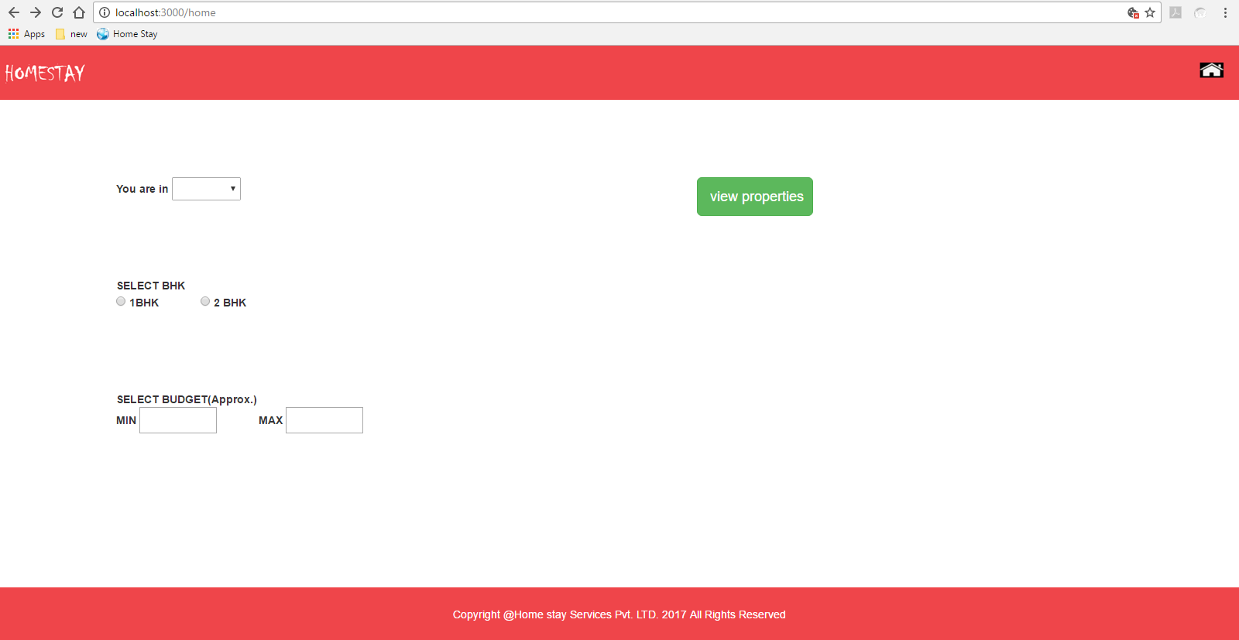

Figure 1 Home page

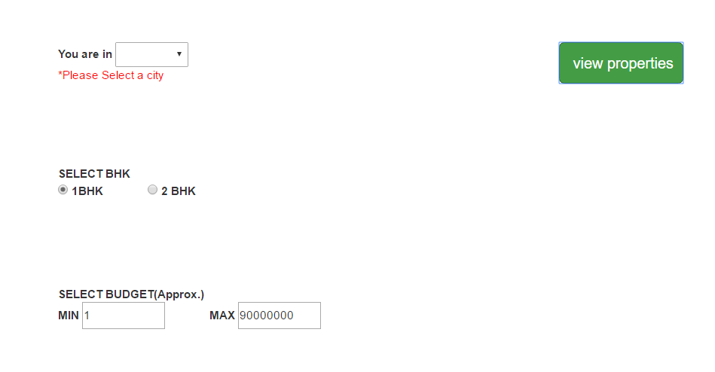

Figure 2 Error message

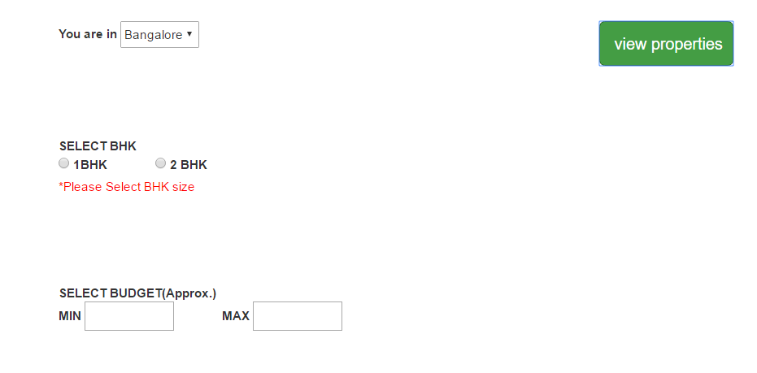

Figure 3 Error message

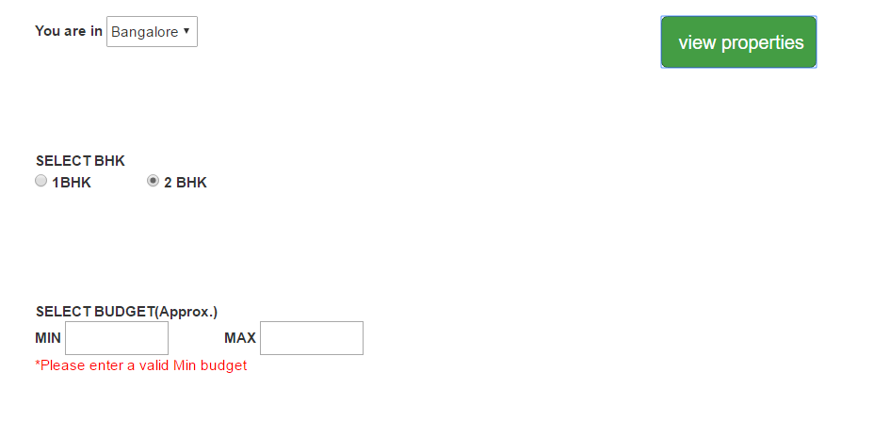

Figure 4 Error message

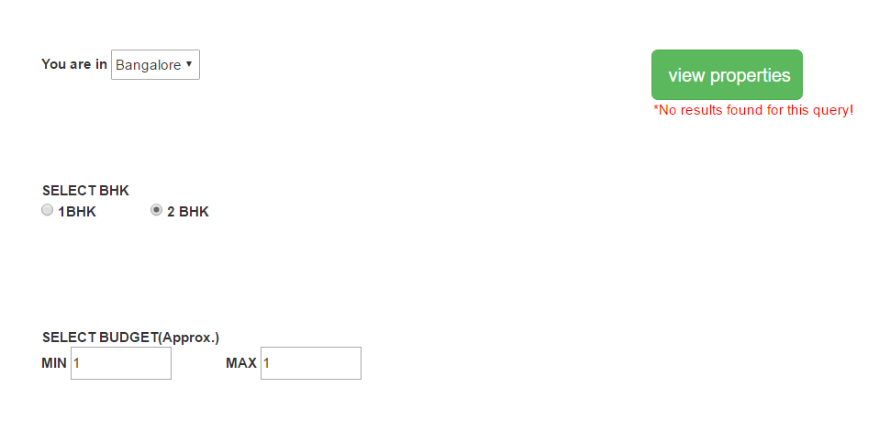

Figure 5 No result found

**Requirement 2:**

|  |  |
| --- | --- |
| Problem Statement | Design a page to get the property details based on custom selection where each tile will consist of:   * Information like description, built up area, average price, EMI rates etc. * Property image * Have an “Enquiry property” button |
| Design Consideration | Each tile should possess the house image on the left side. The relevant detail pertaining to the property should be returned in a JSON form, from the server on the right side. The format should be as shown below.    Have an “Enquiry property” button on the top right side of a tile. |
| Business Rules and Process | Get the details from the server based on the request sent and display it.  All the UI components should be aligned as per the design provided.  On click of enquiry button, user should get an alert message as “Your enquiry has been sent and our team will get back to you shortly.” |
| Skills and Features | * @angular/core * @angular/http * @angular/router * @angular/forms * Rxjs/add/operator/map * Rxjs/add/operator/catch   Services, Data Bindings, Routing, Navigation, Http, JSON, promises, Observables, currency filter |
| Time Required | 1.5 hours |
| Connected Code in Skeleton | \assets\app\results   1. Results.component.ts: TODO7 2. Results.component.html   \assets\app\home   1. Data.service.ts : TODO4 |

On clicking the ‘View Properties’ button, we should be able to get the below screen.

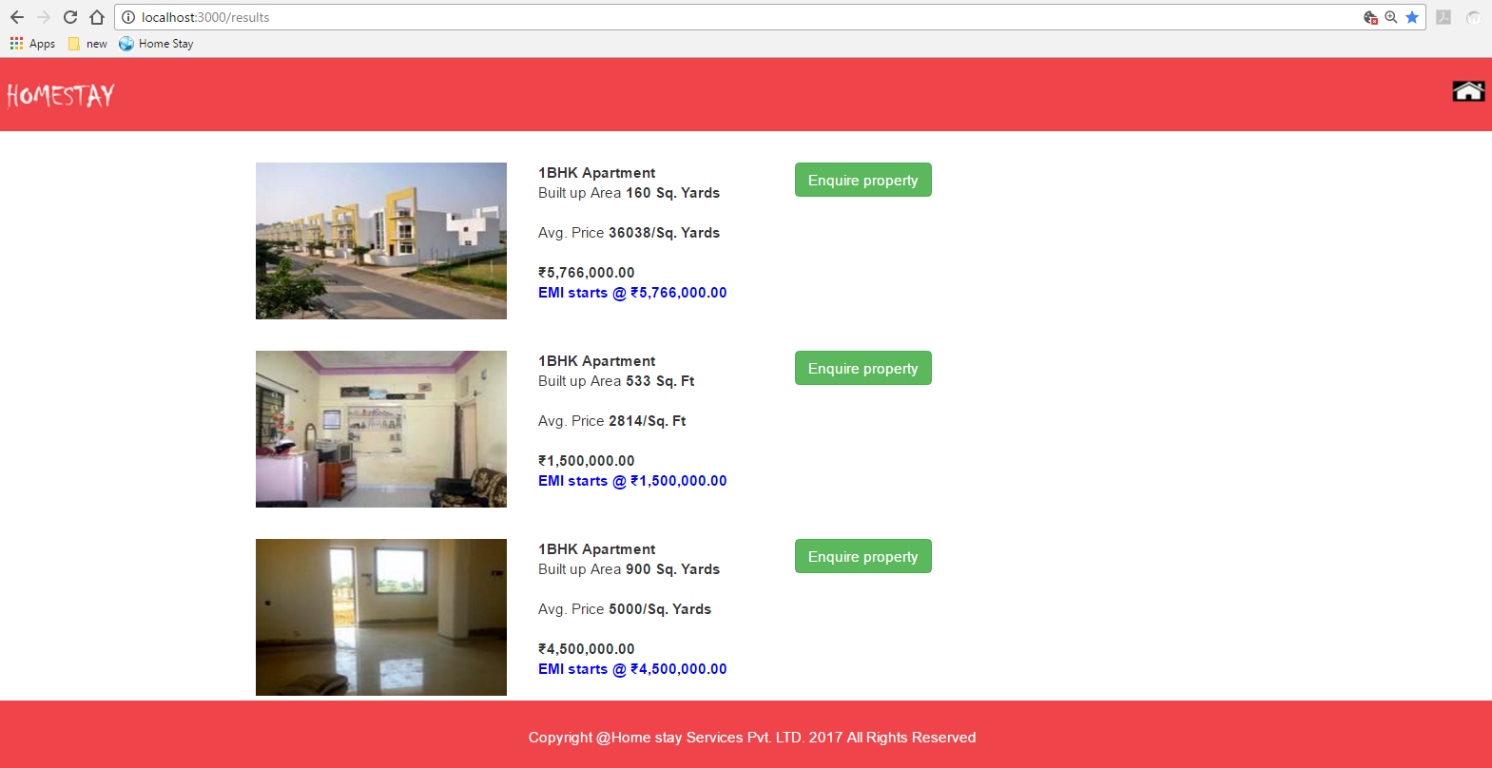

Figure 6 Results page

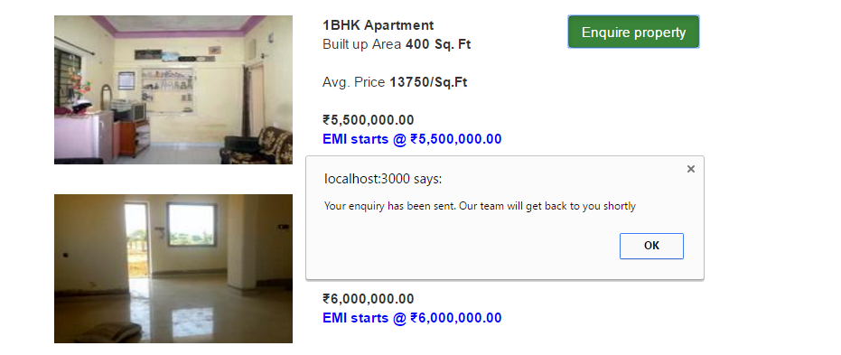

Figure 7 enquire button alert

**API Endpoints:**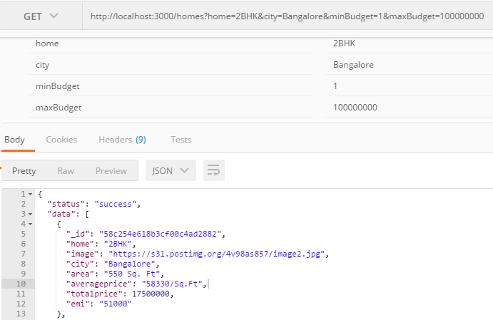

======================End of the document====================