AQUAFLOW IOT PLATFORM
Water Quality Telemetry, Operational Dashboard & Multi-Tenant Administration Manual
Document Version: | 1.0.0 Production Release
System Architecture: | ESP32/ESP8266 Sensors + ThingSpeak + Express/Node.js + MongoDB + React Native
Active Parameters: | pH, Turbidity (NTU), Total Dissolved Solids (TDS ppm)
Role Hierarchy: | SuperAdmin, Company Organization Admin, Manager / Operator
Publication Date: | September 2026

1. Executive Summary & End-to-End System Architecture
The AquaFlow IoT Water Quality Monitoring System is an enterprise-grade telemetry and multi-tenant management platform designed to capture, process, visualize, and safeguard critical water quality metrics in real time. The system guarantees safe municipal and industrial water supplies through continuous remote surveillance of core chemical and physical parameters.
📌 Key System Design Decisions & Sensor Scope
The physical sensing layer strictly focuses on the three foundational water quality indicators: pH, Turbidity, and Total Dissolved Solids (TDS). Temperature sensors have been purposefully omitted from the physical deployment to avoid clutter and reduce hardware failure points. Furthermore, distracting emoji icons have been replaced with high-contrast, professional typography, and CSV export controls are restricted exclusively to authorized administrators.

1.1 The Multi-Tier Architecture Pipeline
- Tier 1: IoT Sensor Nodes — Physical instrumentation deployed at water intake and filtration facilities. Microcontrollers (ESP32/ESP8266) read analog/digital outputs from pH probes, turbidity optical sensors, and TDS electrical conductivity probes. Readings are sampled every 15-30 seconds.
- Tier 2: ThingSpeak Ingestion Broker — Acts as the cloud IoT ingest broker. Sensor nodes transmit data packets via secure HTTPS REST requests directly to designated ThingSpeak Channels using write API keys.
- Tier 3: Cloud Backend & Policy Engine — Powered by Node.js and Express. Polls ThingSpeak telemetry streams, aggregates records, maps channel fields to standardized sensor definitions, evaluates dynamic threshold breaches, enforces strict Role-Based Access Control (RBAC), and logs audit events.
- Tier 4: MongoDB Database Layer — Stores organizations, user accounts, password hashes (Argon2/bcrypt), device configurations, sensor threshold rules, and persistent audit logs with multi-tenant company isolation.
- Tier 5: Cross-Platform Client (Web & Mobile) — A universal application built with React Native and Expo Router. Delivers a zero-install responsive web portal, native Android APK, and iOS mobile experience with automatic 15-second background polling.

1.2 Role-Based Access Control (RBAC) Hierarchy
- SuperAdmin: Root administrator overseeing the entire infrastructure. Can create client organizations, set company manager quotas, inspect fleet-wide telemetry, register/delete IoT devices, and inspect cross-tenant audit trails.
- Company Organization Admin: Executive head of a registered client organization. Can manage organization devices, register new operator accounts up to the quota limit allocated by SuperAdmin, and view all telemetry analytics.
- Manager / Operator: Operational personnel responsible for facility monitoring. Receives view-only telemetry access across assigned devices. Operator accounts are strictly prevented from exporting telemetry data or modifying fleet configurations.

2. Authentication & Secure Portal Access
Security is central to AquaFlow IoT. All API endpoints and client views require authenticated sessions backed by JSON Web Tokens (JWT). The portal features a dark-navy responsive presentation with full client validation, multi-tenant workspace isolation, and collapsible developer demo tools.
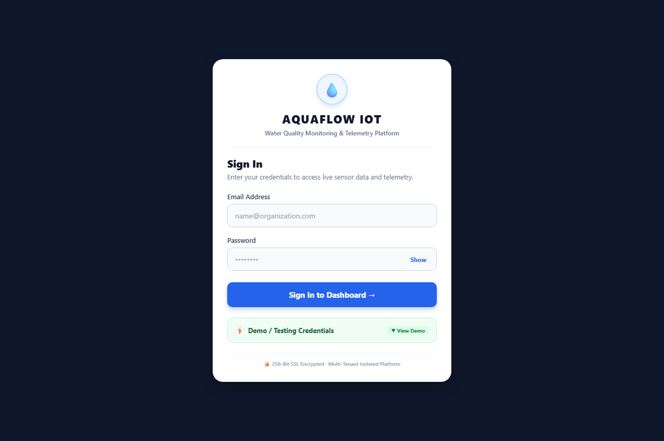
Figure: AquaFlow IoT Production Sign In Portal (Responsive Desktop/Web View)

2.1 Sign In Screen Workflow & Security Controls
When a user navigates to the application, they are greeted by the branded AquaFlow IoT portal. The screen provides email and password inputs, an interactive password visibility toggle ('Show'/'Hide'), and an encrypted transmission notice.
- Client-Side Input Validation: Email addresses are sanitized and normalized to lowercase. Password lengths are verified prior to transmission to conserve server bandwidth.
- Cryptographic Token Exchange: Submitting credentials triggers a POST request to /api/auth/login. The backend validates credentials against the User collection and issues an HMAC SHA-256 JWT access token and refresh token.
- Intelligent Role Dispatch: Upon receiving authentication confirmation, the client router dynamically directs SuperAdmins to the Administration Console (/admin) and Company Admins/Managers to the Operational Dashboard (/dashboard).
- Session Persistence: Tokens, company IDs, and profile details are persisted into browser localStorage, preventing session drops upon page reload or tab navigation.

2.2 Embedded Testing & Demonstration Access
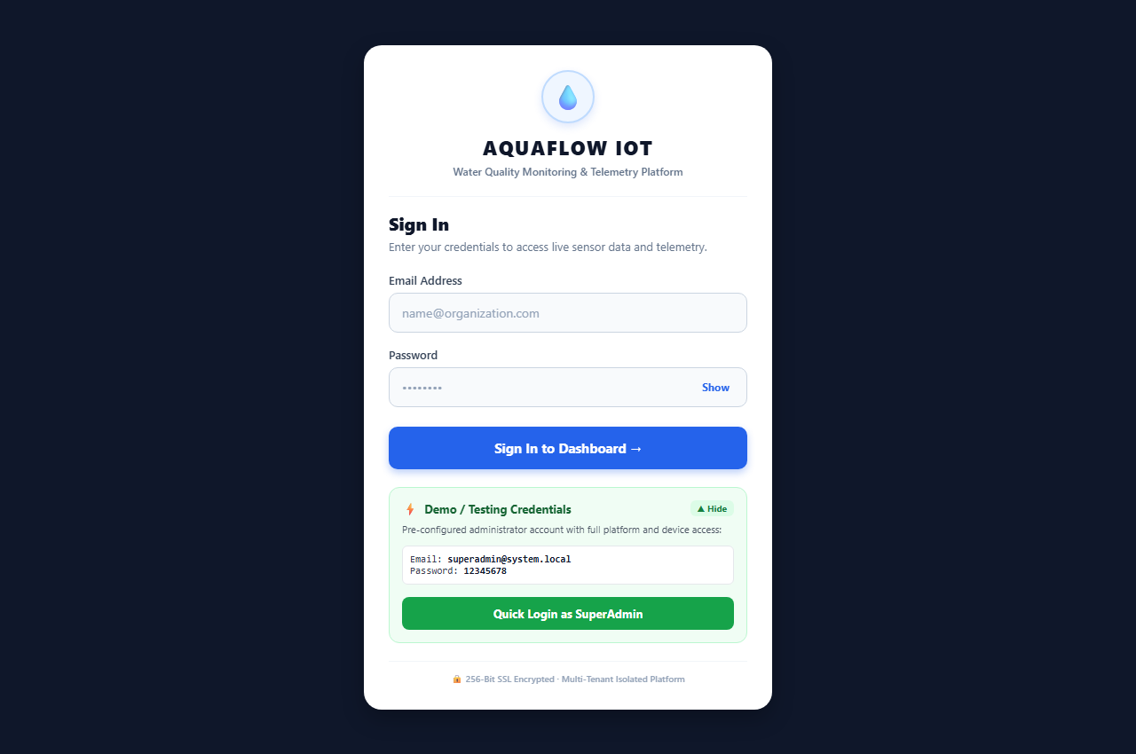
Figure: Collapsible Testing / Demonstration Access Drawer
To streamline system testing, evaluation, and client demonstrations without requiring manual entry of administrative credentials, a collapsible demo drawer is integrated into the login card. Tapping '▼ View Demo' exposes the pre-configured SuperAdmin credentials (superadmin@system.local) and provides a 'Quick Login as SuperAdmin' button that completes authentication with one click.

3. Client Organization Management & Unified Manager Limits
SuperAdmins oversee client organizations through the '🏢 Companies' management tab. Each company organization represents an isolated tenant with its own dedicated IoT sensor fleet, administrative owner, and manager account allocation.
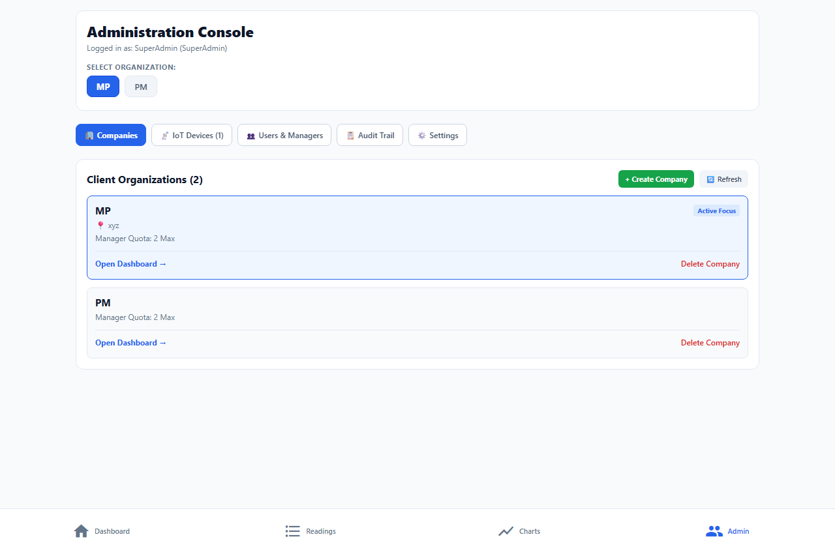
Figure: Client Organizations Directory with Active Focus and Unified Manager Quota

3.1 Organization Directory Features
- Active Organization Focus: Lists all client organizations (e.g., 'MP', 'PM'). SuperAdmin can tap any organization to switch the global focus of the platform, instantly updating devices and telemetry.
- Unified Quota Display: Clearly displays the exact manager quota assigned to that company (e.g. 'Manager Quota: 2 Max') instead of confusing legacy multi-column labels.
- Deep Navigation: Direct deep links allowing SuperAdmin to jump directly into that organization's live dashboard view with one click.
- Tenant Lifecycle Control: Provides complete tenant teardown with confirmation safeguards, removing company users, devices, and configurations.

3.2 Unified Manager Limit in Company Onboarding
Previously, the system maintained separate Manager 1 and Manager 2 quota inputs, which caused confusion. In accordance with operational requirements, the onboarding workflow has been streamlined into a single, unified 'Manager Limit' input.
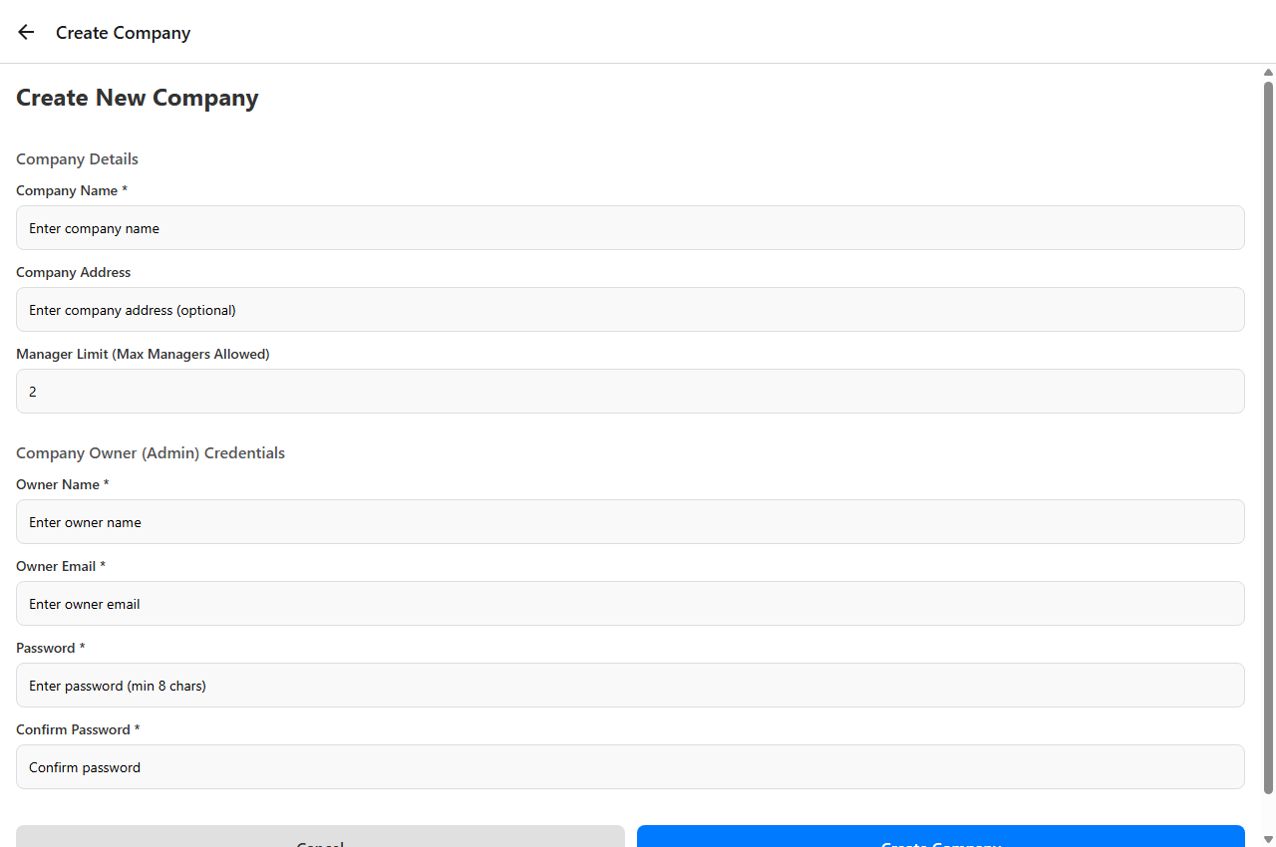
Figure: Create New Company Modal with Navigation Header ('← Create Company') and Unified Manager Limit
📌 SuperAdmin Company Creation Form Details
1. Top Header Bar: Displays '← Create Company' with a back navigation arrow instead of the generic '← Modal' placeholder.
2. Company Details: Captures legal entity name, operating facility address, and the single unified 'Manager Limit (Max Managers Allowed)' (default: 2).
3. Company Owner Credentials: Automatically provisions the Organization Admin account (Owner Name, Owner Email, Password with confirmation) in a single atomic transaction.

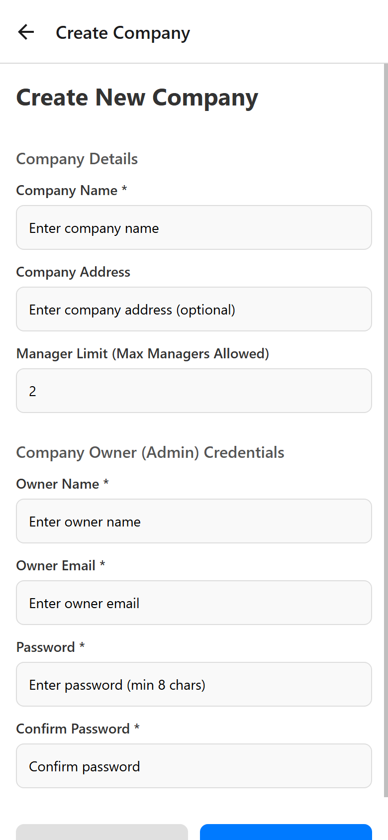
Figure: Mobile Viewport of Create Company Modal demonstrating responsive single-column layout

4. IoT Fleet Management & ThingSpeak Gateway
The '📡 IoT Devices' tab in the Administration Console provides centralized fleet registration and sensor parameter mapping. Both SuperAdmins and Company Admins have access to configure physical stations.
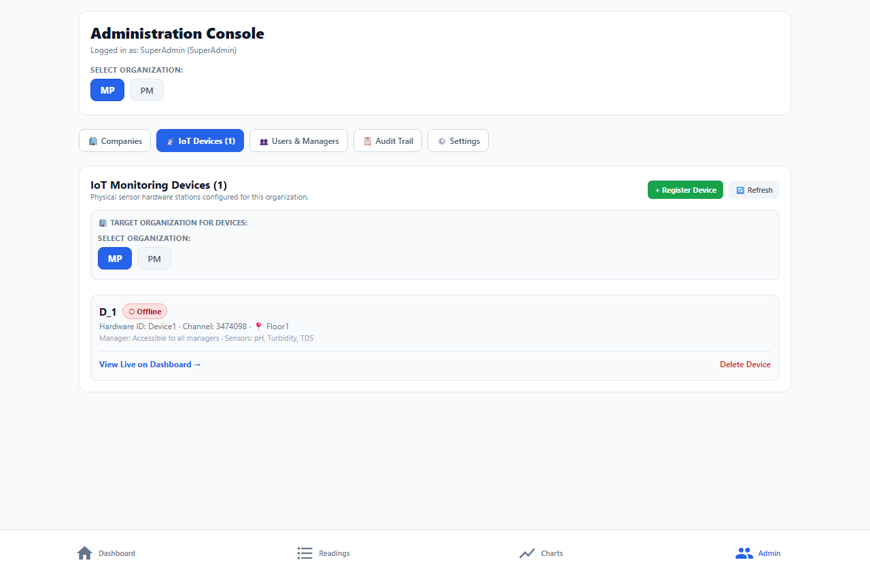
Figure: IoT Monitoring Devices Fleet Overview showing Connected Hardware Stations and Statuses

4.1 Device Fleet Inventory
The inventory card displays every physical hardware station configured for the active organization. Key indicators include:
- Device Identification: Displays the friendly display name (e.g., 'D_1') alongside the unique Hardware ID ('Device1').
- ThingSpeak Channel: Direct reference to the ThingSpeak Cloud Channel ID ('3474098') streaming sensor feeds.
- Facility Location: Physical facility location (e.g., 'Floor1', 'Intake Basin #2').
- Operational Status Pill: Real-time computed badge reflecting telemetry activity: Online (green), Warning (amber), Offline (red), or No Data (gray).

4.2 Onboarding a New IoT Monitoring Station
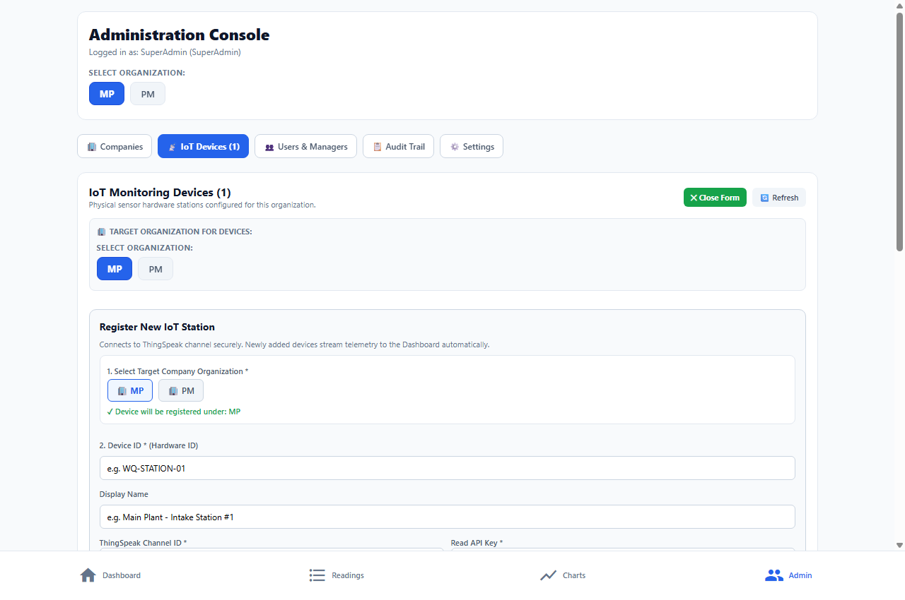
Figure: Register New IoT Station Workflow with ThingSpeak Channel and Threshold Definitions
Tapping '+ Register Device' expands the inline hardware onboarding card. The administrator configures:
- Target Organization: Specifies which client organization owns the device.
- Hardware ID & Station Name: Unique hardware serial or MAC address and a descriptive station label.
- ThingSpeak Credentials: Channel ID and Read API Key generated in MathWorks ThingSpeak.
- Manager Assignment: Assigns an authorized manager responsible for overseeing that station.
- Field Mappings & Thresholds: Defines parameter numbers (Field 1: pH, Field 2: Turbidity, Field 3: TDS) along with acceptable minimum and maximum operating thresholds.

5. User Management & Manager Quota Limitation Safeguards
Under the '👥 Users & Managers' tab, administrators provision and manage operator accounts. To prevent quota overruns and maintain complete licensing transparency, a dedicated Manager Allocation Quota Banner is permanently displayed directly above the creation form.
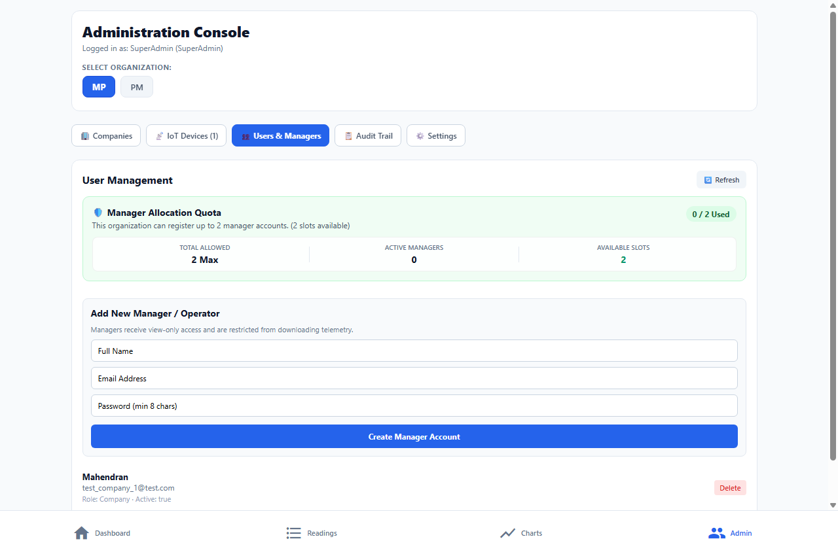
Figure: User Management Console with Dynamic Manager Allocation Quota Banner

5.1 The Manager Allocation Quota Banner Explained
📌 Why Display Limitation Before Creating Managers?
Company Admins and SuperAdmins must clearly know their exact quota limits and available capacity before attempting to create new operator accounts. This eliminates confusing submission errors and provides upfront transparency on license utilization.

The Quota Banner features four real-time synchronized indicators:
- 1. Total Allowed: The absolute maximum manager accounts allocated to this company by the SuperAdmin (e.g. '2 Max').
- 2. Active Managers: The current number of active registered manager accounts in the database.
- 3. Available Slots: The remaining unoccupied manager slots (Total Allowed minus Active Managers). Displayed in green when slots exist.
- 4. Capacity Badge: A color-coded pill showing exact utilization (e.g. '0 / 2 Used' in green, transitioning to '2 / 2 Used' in red when full).

5.2 Limit Enforcement & Quota Exhaustion Safeguards
When all allocated manager slots are filled (Active Managers >= Total Allowed):
- Warning State Banner: The banner shifts to a red warning alert: '⚠️ Manager Quota Reached: Maximum manager capacity reached. To add a new manager, an existing manager must be removed.'
- Disabled Inputs: The Full Name, Email, and Password inputs in the creation form are immediately disabled.
- Button Lockout: The button text changes from 'Create Manager Account' to 'Manager Quota Full (Limit Reached)' with a grayed-out disabled style.
- Backend API Enforcement: Even if bypassed on the frontend, the backend service assertManagerLimitAvailable validates active manager records across the company and rejects the request with HTTP 409 MANAGER_LIMIT_REACHED.

6. Security Governance, Audit Trail & Settings
AquaFlow IoT maintains rigorous compliance and traceability. Every security-sensitive transaction, user modification, and data export is immutably logged.
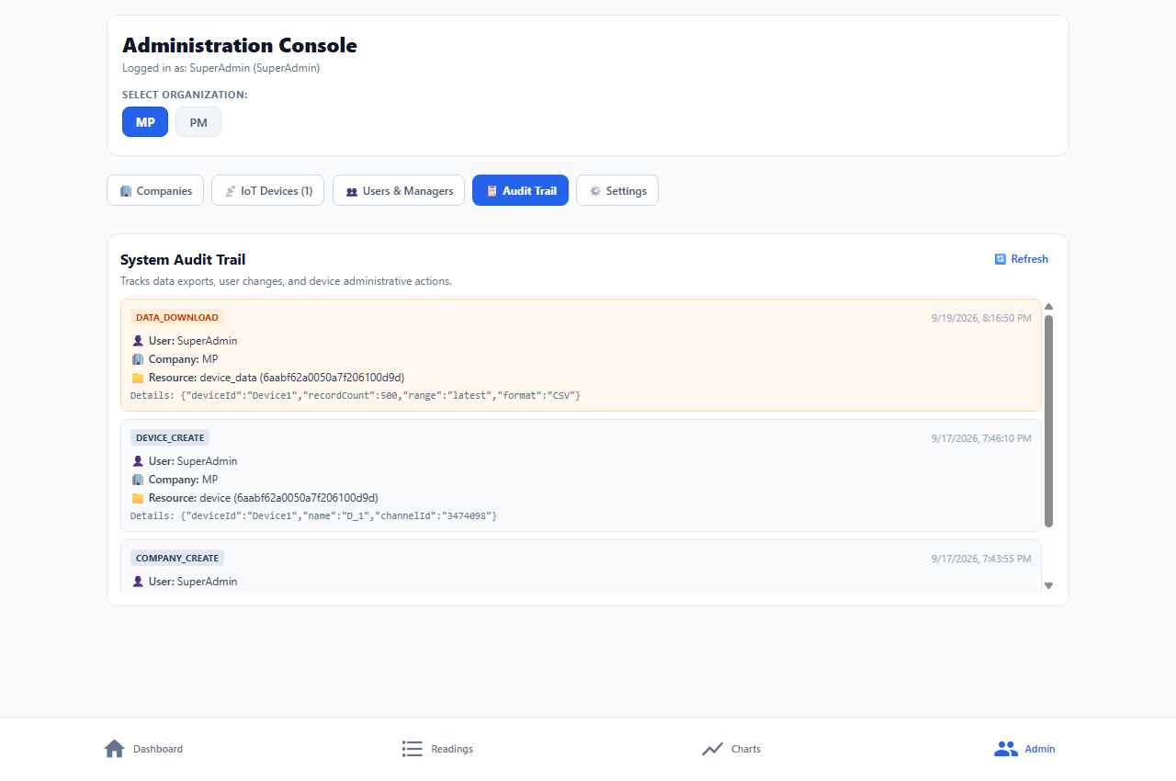
Figure: System Audit Trail Viewer displaying Data Downloads and Device Operations

6.1 Audit Trail Capabilities
- Action Classification: Tracks actions such as DATA_DOWNLOAD, DEVICE_CREATE, COMPANY_CREATE, USER_CREATE, and DEVICE_DELETE.
- Actor Identification: Records the exact actor (user name, email, IP address) and target company organization.
- Contextual Details: Logs details such as record count, export format (CSV), channel IDs, and timestamps formatted in local timezone.

6.2 Application Settings & Dedicated Log Out
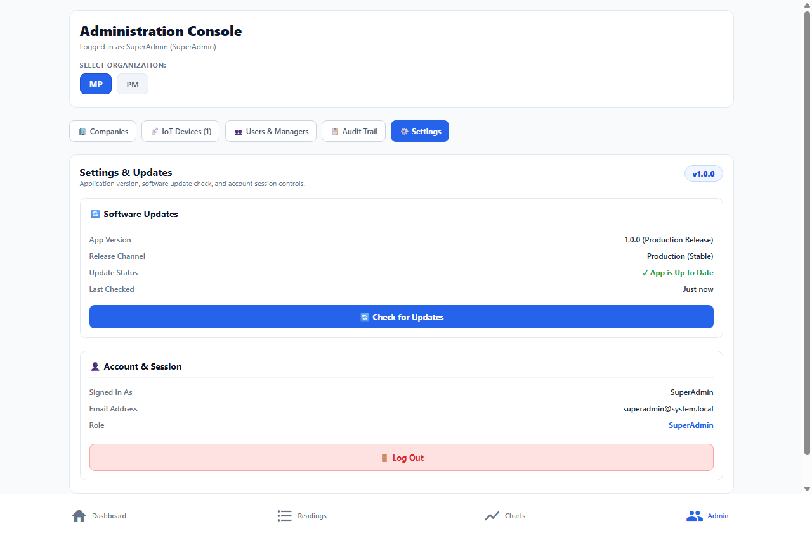
Figure: Settings & Updates Screen with Software Release Check and Centralized Log Out
In accordance with modern UI design principles, the application settings have been streamlined:
- Software Updates & Cloud Health: Displays current version (v1.0.0 Production Release) and connects to /health to verify cloud engine status.
- Account Session Details: Displays logged-in user profile, email address, and role badge.
- Centralized Log Out Control: The Log Out button is placed exclusively within the Settings tab. This prevents accidental logouts from other screens and eliminates clutter from top navigation headers.

7. Live Operational Dashboard & Visual Telemetry
The Dashboard (/dashboard) is the mission-control center for plant operators and plant engineers. It visualizes live feeds received from ThingSpeak channels and evaluates them against safety thresholds.
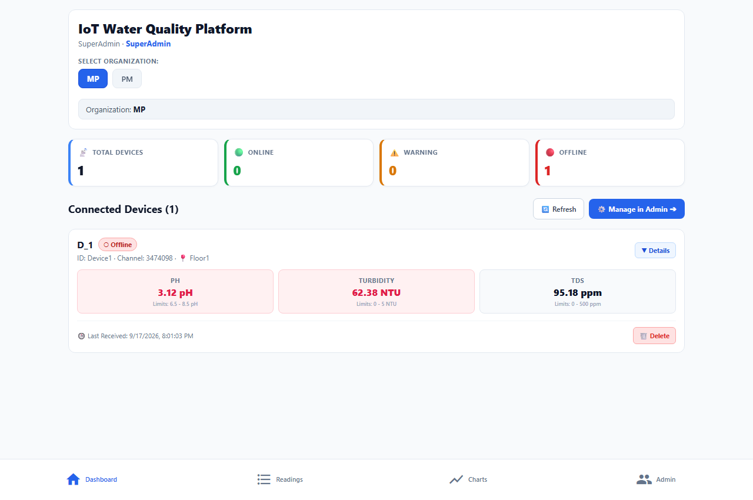
Figure: Live Operational Dashboard with Organization Selector, Fleet KPIs, and Sensor Metric Boxes

7.1 Fleet Status KPI Cards
The top KPI strip provides immediate situational awareness:
- Total Devices: Total number of hardware stations configured for the organization.
- Online Devices (Green): Stations actively transmitting data within the configured threshold window (default: 15 minutes).
- Warning Devices (Amber): Stations whose parameters have violated safe operating thresholds.
- Offline Devices (Red): Stations that have ceased transmitting data beyond the offline threshold.

7.2 Telemetry Metric Boxes & Dynamic Threshold Alerts
Each connected station card features dedicated parameter telemetry boxes. In the screenshot above, note how the system communicates water safety:
- pH Parameter Box (Alert): Measured value is 3.12 pH against safe limits of 6.5 - 8.5 pH. The system automatically highlights the metric box with a red alert background and bold red warning text.
- Turbidity Parameter Box (Alert): Measured value is 62.38 NTU against safe limits of 0 - 5.0 NTU. Because 62.38 indicates high suspended particulates, the box immediately triggers a prominent red alert state.
- TDS Parameter Box (Safe): Measured value is 95.18 ppm against safe limits of 0 - 500 ppm. Because 95.18 is well within safe potable thresholds, the box remains in a clean, calm blue safe state.
- Clean Typography: In accordance with production UI requirements, distracting emoji icons (💧, 🌊, 🔬) have been removed, presenting clean, professional metric headings.
- Streamlined Interface: The duplicate 'Export CSV' button previously situated on the device card has been removed to maintain focus on real-time surveillance.

8. Historical Telemetry Logs & Trend Analytics
Beyond live surveillance, operators must analyze longitudinal data trends and export compliance reports. The 'Readings' and 'Charts' tabs provide comprehensive historical tools.

8.1 Historical Telemetry Logs Table
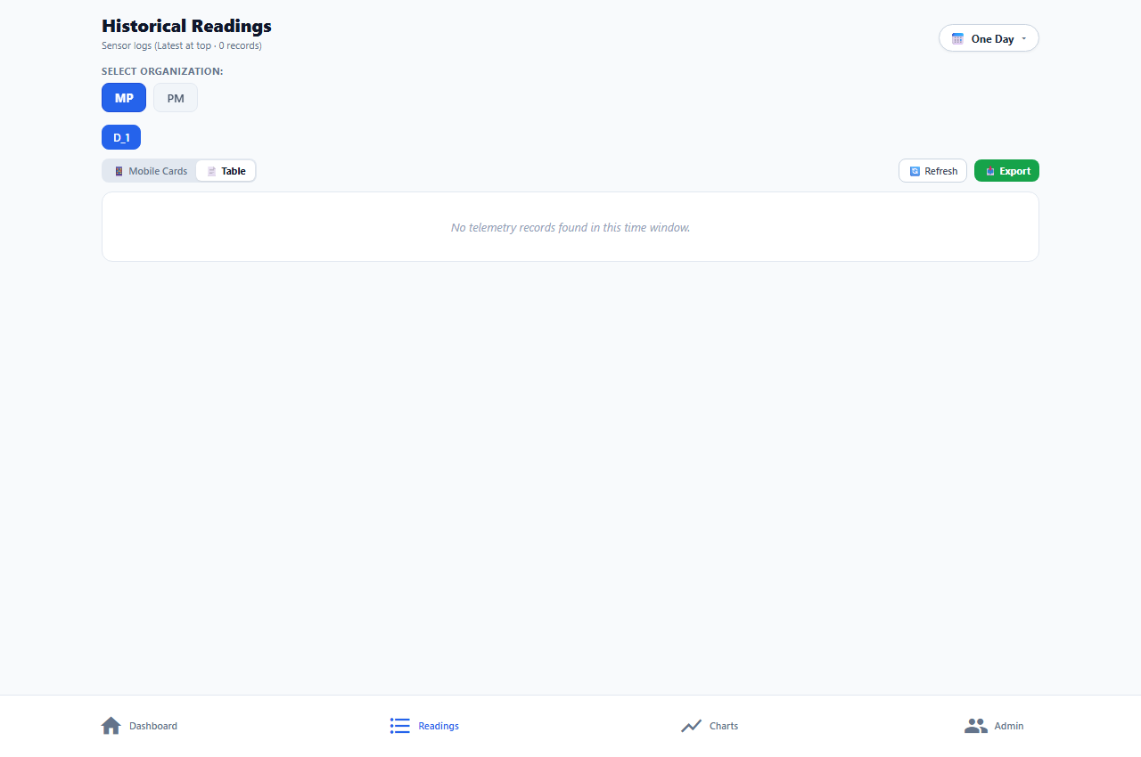
Figure: Historical Telemetry Logs View with Timeframe Filters and CSV Export
- Flexible Time Range: Allows operators to query data over 1 Day, 7 Days, or 30 Days windows.
- Station Selector: Enables seamless switching between individual stations in multi-station facilities.
- Authorized Export CSV: Authorized users can export the filtered telemetry dataset to CSV for official compliance reporting.

8.2 Parameter Trend Analytics & Graphs
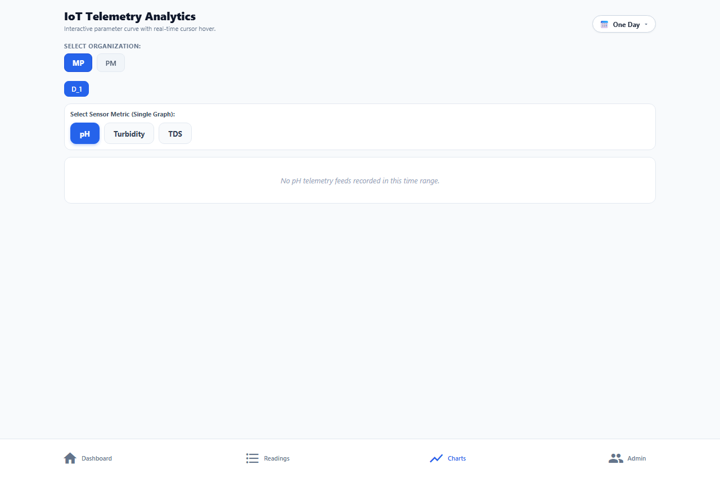
Figure: Interactive Telemetry Analytics Screen with Single-Parameter Chips (pH, Turbidity, TDS)
- Single-Parameter Filtering: Dedicated chips allow selecting pH, Turbidity, or TDS for isolated curve inspection.
- Interactive Curve: High-density SVG curves plot parameter fluctuations over time with threshold boundary guide lines.
- Standardized Styling: Chips utilize clean, modern typography with all emoji icons removed.

9. Role-Based Feature Matrix & Summary
The table below summarizes system capabilities, permission grants, and functional access across the three platform roles:
Feature / Functional Area | SuperAdmin | Company Admin | Manager / Operator
Create & Manage Client Companies | Full Access | No Access | No Access
Define Company Manager Quota | Full Access | No Access | No Access
Register New IoT Stations | Fleet-Wide | Company Scope | No Access
Create Manager / Operator Accounts | Across All Tenants | Within Quota Limit | No Access
View Live Operational Dashboard | All Companies | Company Scope | Assigned Devices
View Historical Telemetry & Trends | All Companies | Company Scope | Assigned Devices
Export Telemetry Data to CSV | Allowed | Allowed | DENIED (Restricted)
View Security Audit Trail | All Tenants | Company Scope | No Access

📌 Documentation Summary & Verification
This document reflects the verified, production-ready state of the AquaFlow IoT platform. All 12 primary pages and views have been captured directly from the live running web and mobile applications. All manager limit unifications, limitation displays, and UI refinements are active in the codebase and verified under automated regression testing.

