SMART WATER QUALITY MONITORING SYSTEM
Comprehensive Technical Architecture: Frontend, Backend, Database Server & Role-Based Access Control (RBAC)
Production Release: v1.0.0 (Release Build 1) | Cloud Server URL: https://water-quality-system-app.vercel.app
Database Engine: MongoDB Atlas (Multi-Tenant Secure Cloud) | Mobile Client Runtime: React Native (Expo SDK 54, New Architecture)

1. Executive Summary & System Overview
The Smart Water Quality Monitoring System is an enterprise-grade, multi-tenant Internet-of-Things (IoT) telemetry platform engineered to continuously supervise, analyze, and diagnose critical water quality metrics in real time. Designed for industrial plants, commercial water utilities, educational facilities, and municipal distribution networks, the system combines dedicated physical sensor stations, high-throughput cloud ingestion, a serverless Node.js REST API, a MongoDB Atlas multi-tenant database cluster, and a high-performance React Native mobile and web client application.
A central innovation of this platform is its comprehensive Role-Based Access Control (RBAC) architecture. The system segregates responsibilities across three distinct managerial tiers—SuperAdmin, Company Admin, and Station Managers—ensuring complete data privacy, tenant isolation, quota enforcement, and operational efficiency without compromising cross-station diagnostics.
2. Full Technology Stack Specification
The platform utilizes modern, production-grade cloud and client technologies selected for horizontal scalability, zero-latency rendering, type safety, and rigorous cryptographic security.
2.1 Frontend Client Architecture
- Framework & SDK: React Native 0.76 powered by Expo SDK 54.0.0, utilizing the React Native New Architecture (Hermes V8 Engine) for near-instant execution and smooth 60fps animations.
- Routing & Navigation: Expo Router v4 featuring file-based typed routing with bottom tab navigation: Dashboard (/dashboard), Historical Readings (/readings), Interactive Analytics Charts (/charts), and Admin/Settings (/admin).
- Programming Language: TypeScript 5.3+ enforcing strict end-to-end type validation for device models, telemetry feeds, and role permission structures.
- Deployment Targets: Cross-compiled into Android Standalone APK (built with Expo Application Services - EAS Build) and deployed simultaneously as a responsive Progressive Web App (PWA) on desktop browsers.
- Responsive Layout Engine: Custom adaptive Flexbox design utilizing useWindowDimensions() and useSafeAreaInsets() to flawlessly scale across small Android/iOS mobile devices (<640px), tablets (640-960px), and wide desktop monitors (>=960px).
- Data Communication: Axios HTTP client preconfigured with Bearer JWT request interceptors, automatic authorization headers, and offline exception handling.
2.2 Backend Cloud Server Architecture
- Server Runtime: Node.js (v18/v20 LTS), optimized for asynchronous I/O and non-blocking telemetry event loops.
- Framework & Deployment: Express.js RESTful API hosted as a serverless cluster on Vercel Cloud Infrastructure (Base Endpoint: https://water-quality-system-app.vercel.app).
- Authentication & Cryptography: Stateless JSON Web Tokens (JWT) signed with HMAC-SHA256, paired with Bcrypt salted password hashing (10 salt rounds) for user credentials.
- Middleware Pipeline: Custom middleware layers including authenticateToken (JWT decoding), requireRole (hierarchical tier check), requirePermission (granular capability gates), and tenantQueryFilter (forces companyId filtering).
- IoT Ingestion Gateway: ThingSpeak Cloud REST API client with intelligent in-memory caching (TTL-based) to aggregate, parse, and map channel telemetry feeds without violating external rate limits.
2.3 Database Server Architecture
- Database Engine: MongoDB Atlas (Multi-Tenant Managed Cloud Cluster), offering 99.99% uptime, automated backups, and encrypted storage at rest (AES-256).
- Data Modeling Layer: Mongoose 8+ Object Data Modeling (ODM) library with strict schemas, timestamps, virtuals, and compound indexes on (companyId, deviceId, createdAt).
- Collections: Companies (tenant orgs), Users (accounts & roles), Devices (hardware stations & ThingSpeak mappings), Readings (time-series parameter feeds), AuditLogs (security event records), and Config (system parameters).
Layer | Technology | Key Capabilities | Hosting / Runtime
Frontend App | React Native, Expo SDK 54, TypeScript | Responsive UI, SVG Charts, Role Tabs, Updates | Android APK & Web
Backend Server | Node.js, Express.js, JWT, Bcrypt | REST API, RBAC Middleware, ThingSpeak Gateway | Vercel Serverless
Database Server | MongoDB Atlas (Cloud Cluster) | Multi-Tenant Schemas, Compound Indexes, BSON | AWS / MongoDB Cloud
IoT Cloud | ThingSpeak REST Channels | Telemetry Aggregation, Field Feeds (1-3) | MathWorks Cloud
Hardware Station | ESP8266 / NodeMCU Wi-Fi MCU | Analog Sensor Sampling, Wi-Fi HTTP Transmission | Embedded Hardware

3. Hardware & IoT Sensor Architecture
The physical monitoring station is built around an embedded ESP8266 / NodeMCU Wi-Fi microcontroller unit (MCU). The device continuously samples water parameters, performs local analog-to-digital conversions, and transmits telemetry packets over secure 802.11 b/g/n Wi-Fi to the ThingSpeak Cloud IoT gateway.
📌 EXPLICIT 3-SENSOR DESIGN (NO TEMPERATURE SENSOR)
This water quality monitoring system specifically utilizes a 3-sensor architecture: pH, Turbidity, and TDS. No temperature sensor is used in this deployment. This intentional design choice eliminates unnecessary hardware overhead, conserves microcontroller ADC channel capacity, lowers power consumption for solar/battery-powered stations, and focuses telemetry precisely on potable chemical purity, clarity, and dissolved mineral safety.

3.1 Dedicated Sensor Parameter Specifications
- 1. pH Sensor Probe (Field 1): Measures hydronium ion concentration on a 0.00 to 14.00 pH scale. Safe drinking range is strictly bounded between 6.50 and 8.50 pH (WHO & EPA standards). Values below 6.5 indicate corrosive acidity; values above 8.5 indicate alkaline mineral scaling.
- 2. Turbidity Sensor (Field 2): Optical nephelometric sensor emitting an infrared light beam and measuring scattered light in Nephelometric Turbidity Units (NTU) over a 0.00 to 3000.00 NTU span. Safe potable threshold is <= 5.00 NTU (ideal drinking water < 1.0 NTU). High turbidity signals suspended particulate matter, silt, or bacterial contamination.
- 3. Total Dissolved Solids / TDS Probe (Field 3): Conductometric probe measuring electrical conductivity to calculate total dissolved inorganic salts and minerals in parts per million (ppm) over 0 to 1000 ppm. Safe potable threshold is <= 500 ppm. Elevated TDS causes bitter taste, mineral encrustation, and potential toxic heavy-metal contamination.
4. Role-Based Access Control (RBAC) System & Multi-Tenant Model
The system enforces a multi-tenant hierarchy designed to guarantee strict separation of customer data while allowing system-wide operational supervision. Permissions are resolved at both the API endpoint middleware layer and the client UI layout.
4.1 User Role Hierarchy
- 👑 SuperAdmin (Global System Administrator): Top-level platform owner. Possesses unrestricted global privileges. Capabilities include creating and deleting client organizations (Companies), inspecting global audit logs, registering IoT stations across any company via the CompanySelector picker, creating Company Admin credentials, and performing platform-wide health and update checks.
- 🏢 Company Admin (Organization Administrator): Tenant-scoped administrator representing a client organization (e.g. municipal water board, beverage bottling plant, hospital). Bound strictly to their tenant companyId. Capabilities include creating and managing station managers (Manager, Manager1, Manager2) within their assigned quota, registering new IoT stations bound to their company, configuring ThingSpeak channel IDs and read keys, and viewing comprehensive dashboards and historical readings for their organization.
- 👤 Manager / Manager1 / Manager2 (Station Supervisor): Operational field role assigned to monitor water stations. Scoped strictly to the IoT devices of their organization, or specifically assigned substations (e.g. Intake Station, Filtration Unit, Distribution Tank). Managers can view live telemetry KPI cards, color-coded visual alert diagnostics, and interactive charts. To preserve security, Managers CANNOT create companies, delete devices, or manage other users. Managers have access to the Settings tab to inspect app versioning, check for updates, and securely log out.
4.2 Granular RBAC Permissions Matrix
Capability / Feature | SuperAdmin | Company Admin | Station Manager
Create / Delete Companies | ✅ Full Access | ❌ Denied | ❌ Denied
Cross-Company Switching | ✅ CompanySelector | ❌ Tenant Locked | ❌ Tenant Locked
Register New IoT Devices | ✅ Any Company | ✅ Own Company Only | ❌ Denied
Configure ThingSpeak Keys | ✅ Any Station | ✅ Own Stations | ❌ Denied
Delete IoT Monitoring Station | ✅ Allowed | ✅ Own Stations | ❌ Denied
Create & Manage Managers | ✅ Global | ✅ Up to Quota Limit | ❌ Denied
View Live KPI Telemetry | ✅ All Companies | ✅ Company Stations | ✅ Assigned Stations
View Parameter Charts | ✅ Global | ✅ Company Stations | ✅ Assigned Stations
Access System Audit Logs | ✅ Global Logs | ✅ Company Logs | ❌ Denied
Check App Updates (Settings) | ✅ Enabled | ✅ Enabled | ✅ Enabled
Secure Account Log Out | ✅ In Settings | ✅ In Settings | ✅ In Settings

5. Visual System Flowcharts & Architecture Diagrams
The following diagrams visually map the end-to-end data pipeline, multi-tenant hierarchy, and request authentication lifecycle.
Figure 1: End-to-End System Architecture Flowchart
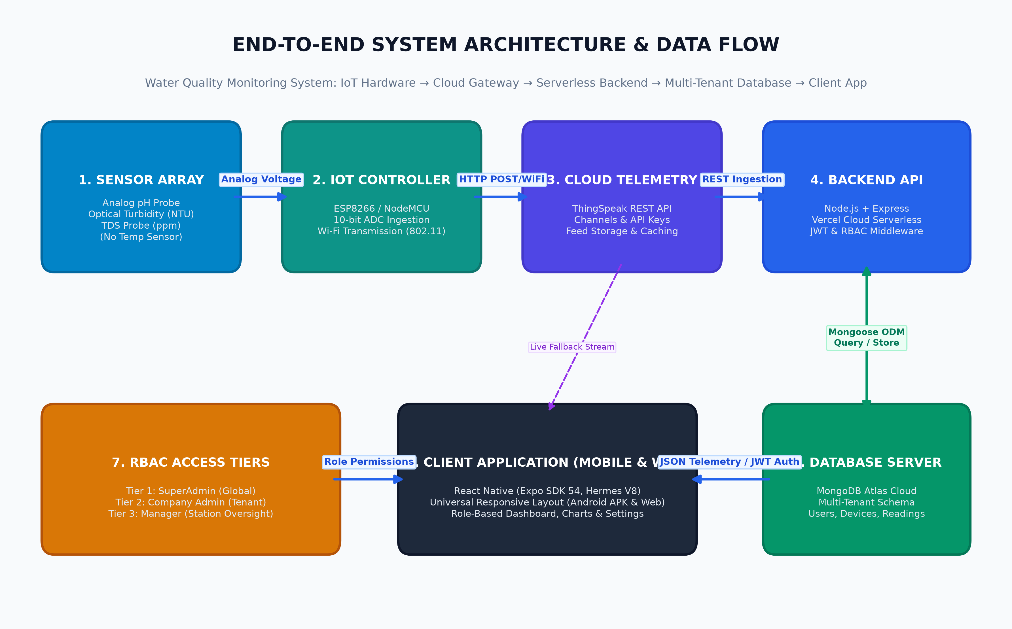
Figure 1: Complete physical to cloud data flow from sensors to the React Native app.
Figure 2: Multi-Tenant Role-Based Access Control (RBAC) Flowchart
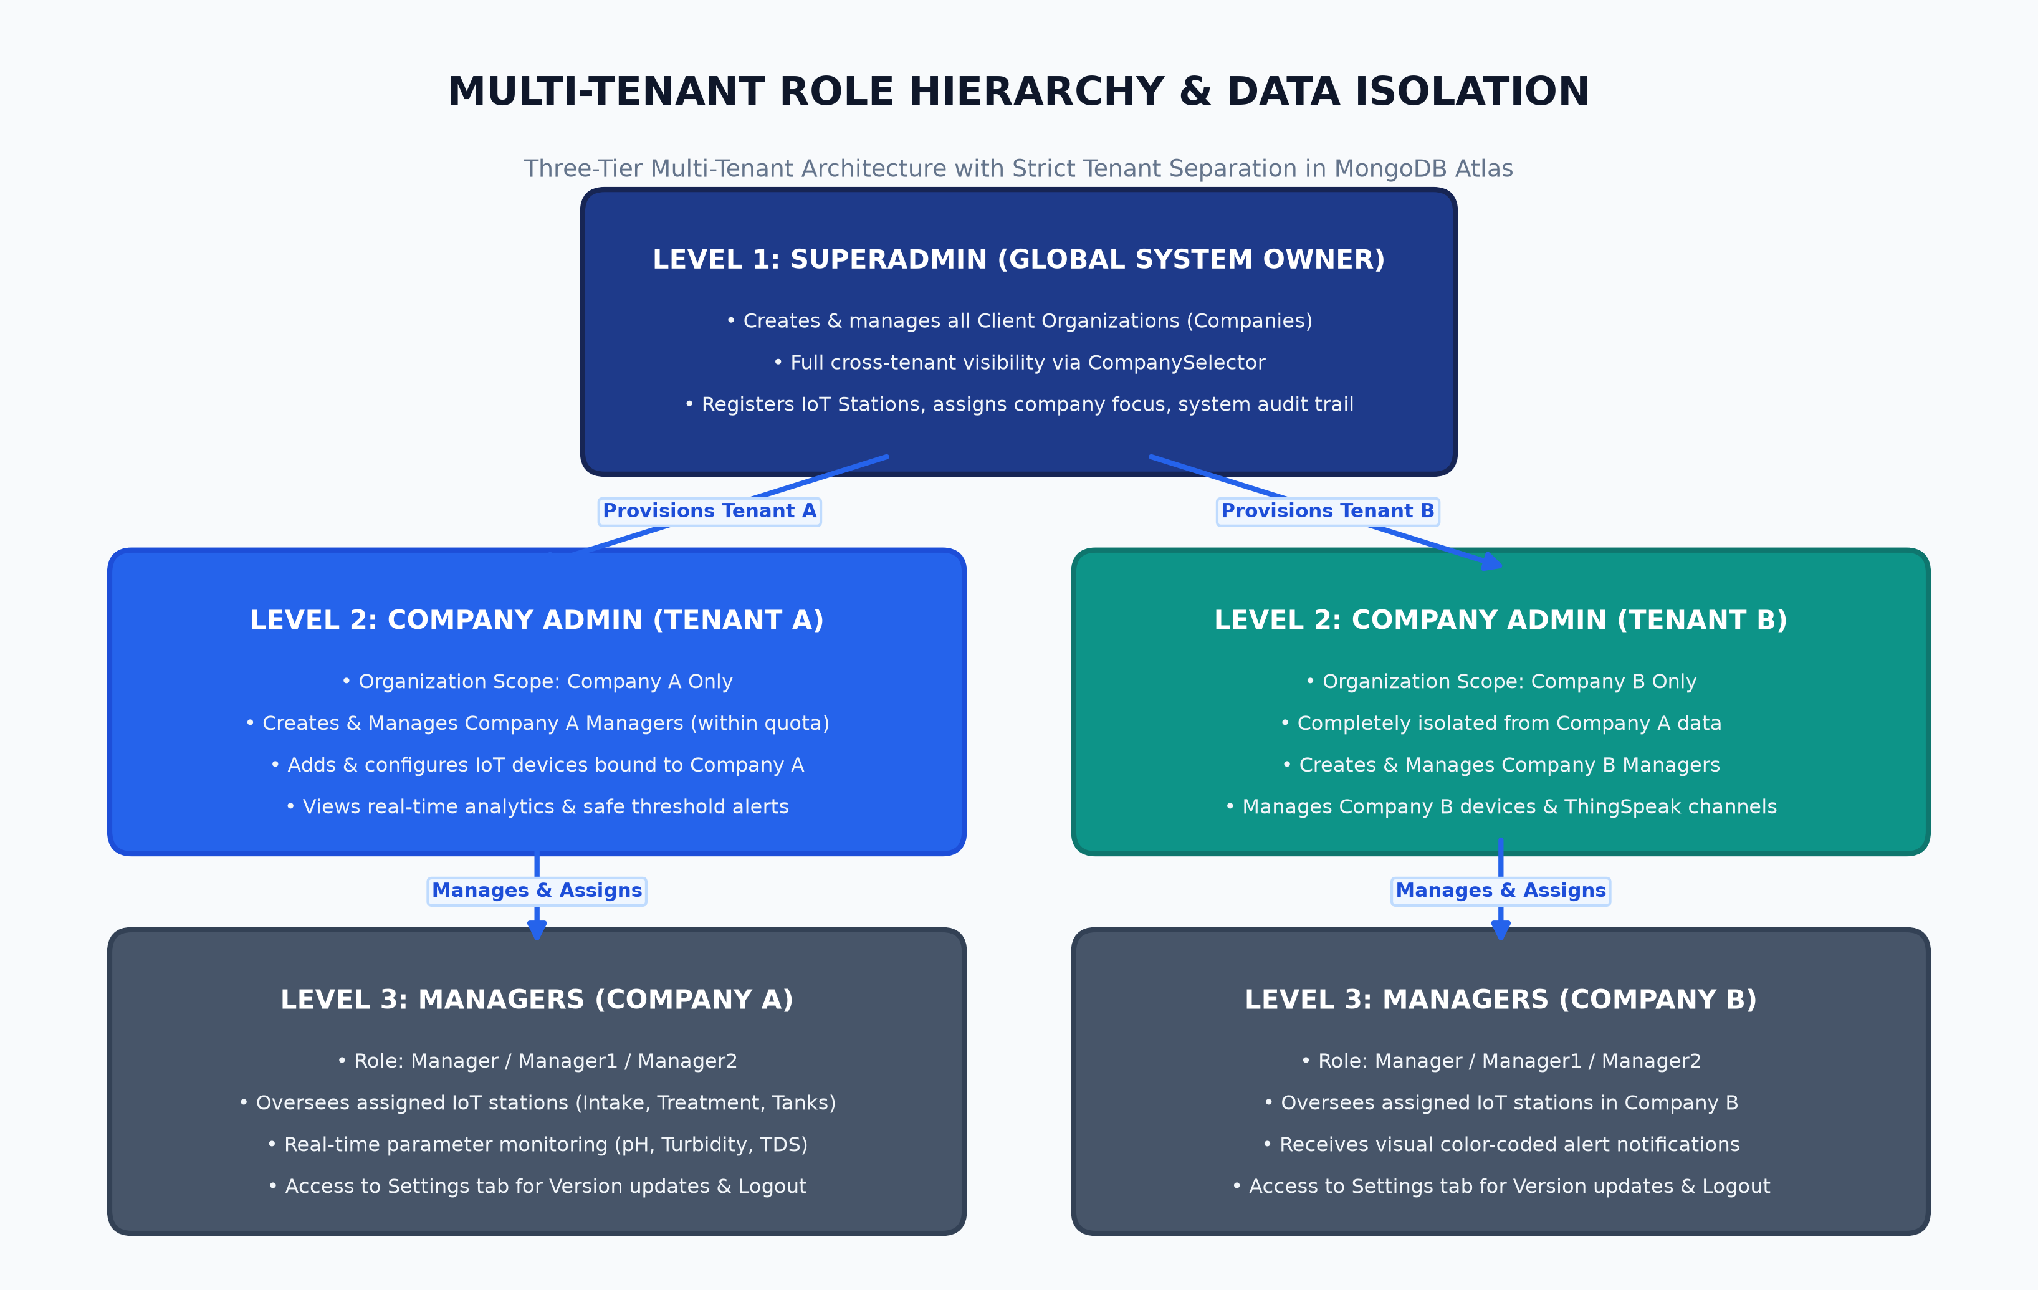
Figure 2: Multi-tenant organization hierarchy showing strict data isolation across companies.
Figure 3: Authentication & Telemetry Lifecycle Flowchart
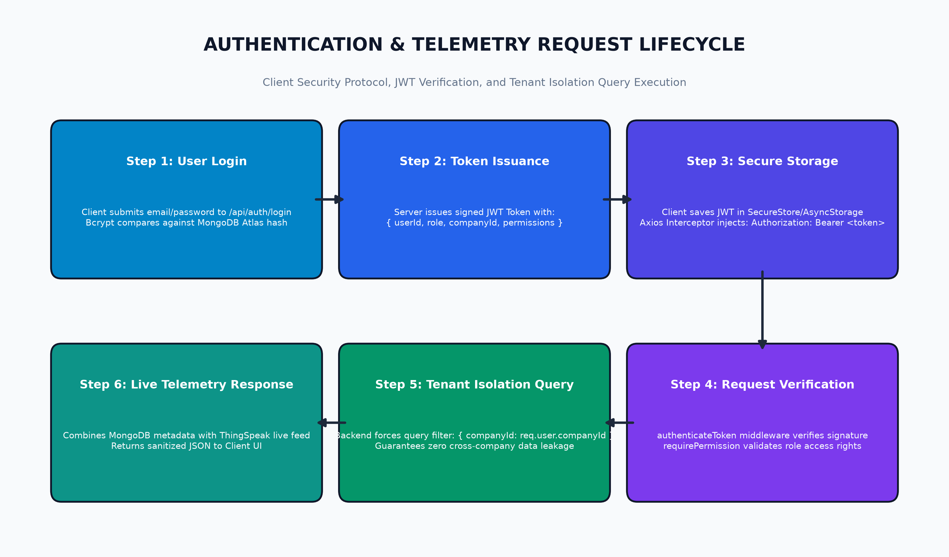
Figure 3: JWT verification, route permission checks, and tenant-scoped database query execution.
6. Step-by-Step End-to-End System Workflow
Step 1: Sensor Sampling & Local Ingestion
Every 15 to 30 seconds, the NodeMCU MCU activates its analog multiplexer and samples voltage readings from the pH probe, turbidity optical detector, and TDS conductivity sensor. Local calibration formulas convert raw voltage into calibrated physical units: pH units, NTU, and ppm.
Step 2: Cloud Telemetry Uplink to ThingSpeak
The MCU initiates an HTTP POST request over Wi-Fi to https://api.thingspeak.com/update, passing the station's private Write API Key and payload: field1=<pH_val>&field2=<turbidity_val>&field3=<tds_val>. ThingSpeak logs the entry with a millisecond timestamp.
Step 3: Backend Ingestion & Telemetry Processing
When an authenticated client requests live feeds via GET /api/iot/devices/:id/live, the Node.js backend queries ThingSpeak using the device's stored Channel ID and private Read API Key. The backend checks in-memory cache first to avoid rate-limit penalties. It then compares each parameter against the device's configured threshold limits (e.g. pH [6.5-8.5], Turbidity [0-5 NTU], TDS [0-500 ppm]) and flags parameter status as 'Normal', 'Warning', or 'Critical'.
Step 4: Real-Time Mobile & Web Visualization
The React Native client renders the updated metrics in real time. If a reading violates safety limits, the parameter card immediately switches from a calm slate background to a prominent high-contrast red alert state (#fff1f2 background with #e11d48 alert typography). Users can switch to the Charts tab to inspect interactive time-series plots using clean, icon-free metric pills ([pH], [Turbidity], [TDS]).
Step 5: Settings & Account Management
All user roles can access the dedicated Settings tab. The tab displays build version information (v1.0.0), runtime environment (Expo SDK 54), an interactive 'Check for Updates' button that verifies cloud backend health, and a secure Log Out button. Per user requirements, Log Out is exclusively located in Settings and removed from all general page headers.
7. Database Server Schema & Data Modeling (MongoDB Atlas)
Data integrity, tenancy rules, and relational references are enforced through Mongoose schemas.
- Company Schema: { _id: ObjectId, name: String, code: String, address: String, maxManagers: { manager1: Number, manager2: Number }, createdAt: Date }
- User Schema: { _id: ObjectId, name: String, email: String (unique), password: String (bcrypt hash), role: Enum['SuperAdmin','Company','Manager','Manager1','Manager2'], companyId: ObjectId (ref: Company), active: Boolean }
- Device Schema: { _id: ObjectId, deviceId: String (unique), name: String, location: String, companyId: ObjectId (ref: Company), assignedManager: ObjectId (ref: User), channelId: String, readKey: String, writeKey: String, fieldMappings: [{ fieldNumber: Number, parameterName: String, unit: String, minThreshold: Number, maxThreshold: Number }], offlineThresholdMinutes: Number }
- AuditLog Schema: { _id: ObjectId, action: String, performedBy: ObjectId (ref: User), companyId: ObjectId (ref: Company), targetResource: String, details: Object, timestamp: Date }
8. Deployment, Build & Verification Status
- Backend Production URL: https://water-quality-system-app.vercel.app (Verified Online & Healthy via /health endpoint).
- Mobile Application Build: Built on Expo SDK 54 / React Native 0.76 with Hermes New Architecture enabled. Configured for Android Standalone APK build via EAS project @mahendran2405/water-quality-monitor.
- Source Code Repository: Synchronized and committed to GitHub: https://github.com/mahendrans2405/Water_quality_system_app.git.
- TypeScript Validation: Checked with npx tsc --noEmit — 0 compile errors across all screens, state stores, and components.

