AQUAFLOW MOBILE APPLICATION
Mobile User Experience, Field Operations & Role-Based Administration Manual
Document Version: | 1.0.0 Production Release
Target Platform: | Universal Mobile App (iOS / Android / Mobile Web PWA)
Viewport Standard: | Adaptive Mobile Display (390 x 844 Baseline, Scale 2.0x)
Active Water Metrics: | pH (6.5-8.5), Turbidity (0-5.0 NTU), TDS (0-500 ppm)
Role Hierarchy: | SuperAdmin, Company Organization Admin, Manager / Field Operator
Publication Date: | September 2026

1. Executive Summary & Mobile Responsive Architecture
The AquaFlow Mobile Application is engineered to empower water quality engineers, municipal plant operators, and organization executives with instant, high-fidelity water telemetry in the palm of their hands. Whether walking the floor of a water purification plant, performing remote field inspections, or overseeing multi-facility compliance, the mobile interface ensures optimal readability, responsive alignment, and robust touch interactions across all mobile screen sizes.
📌 Mobile-First Responsive Engineering Highlights
1. Dynamic Viewport Adaptability: Built using React Native and Expo Router with flex-based column layouts, fluid containers, and automatic breakpoint detection (width < 768px).
2. Touch Ergonomics: All interactive targets (buttons, inputs, tabs, picker pills) enforce a minimum hit target of 44x44 points, preventing accidental touches on compact smartphone screens.
3. Safe Area Inset Management: Edge-to-edge support for iPhone Dynamic Island, camera notches, and Android system navigation bars using react-native-safe-area-context.
4. Sticky Bottom Navigation Bar: Instant access to Dashboard, Readings, Charts, and Administration consoles regardless of scroll position.
5. Streamlined Typography: Distracting decorative icons have been eliminated in favor of high-contrast, clean typography for parameter status (pH, Turbidity, TDS).

1.1 High-Level End-to-End Mobile Data Pipeline
- Field Hardware Layer — Submersible analog and optical probes installed in water channels capture pH, turbidity, and TDS readings every 15-30 seconds. Microcontrollers (ESP32) transmit readings to the cloud over TLS.
- Cloud Ingestion Broker — ThingSpeak IoT Cloud acts as the telemetry broker. Channels store time-series feeds accessed securely via server-side read/write keys.
- Backend Policy Engine — Node.js Express microservices parse incoming payloads, evaluate dynamic alert thresholds, enforce company tenant isolation, verify manager quota limits, and record cryptographic audit logs.
- Universal Mobile Client — Delivers native-speed performance on iOS, Android, and mobile web browsers with automated 15-second background polling and real-time visual alert flags.
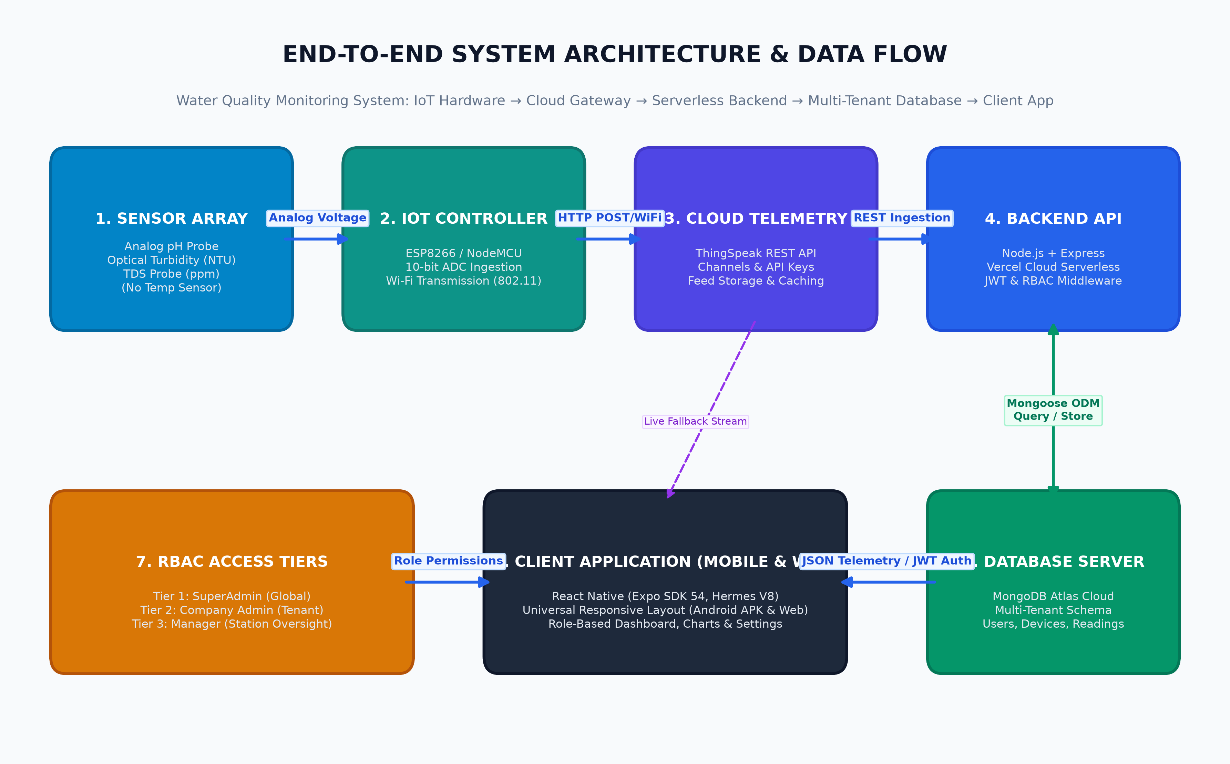
Architecture Diagram: AquaFlow End-to-End System & Telemetry Data Pipeline

2. Mobile Authentication & Role-Based Session Management
Field security begins at authentication. The AquaFlow mobile login interface provides a clean, distraction-free credential entry system optimized for mobile keyboards, featuring automatic capitalization disabling for emails, secure text entry for passwords, and an expandable testing drawer for rapid credential pre-filling during field commissioning.

2.1 Mobile Login Interface
The login screen adapts gracefully to mobile dimensions. The top header displays the signature AquaFlow water drop icon alongside clear subtitle guidance. Below the header, a dedicated card houses input fields with rounded borders and clear focus states, followed by a primary touch-friendly 'Sign In to Dashboard' button.
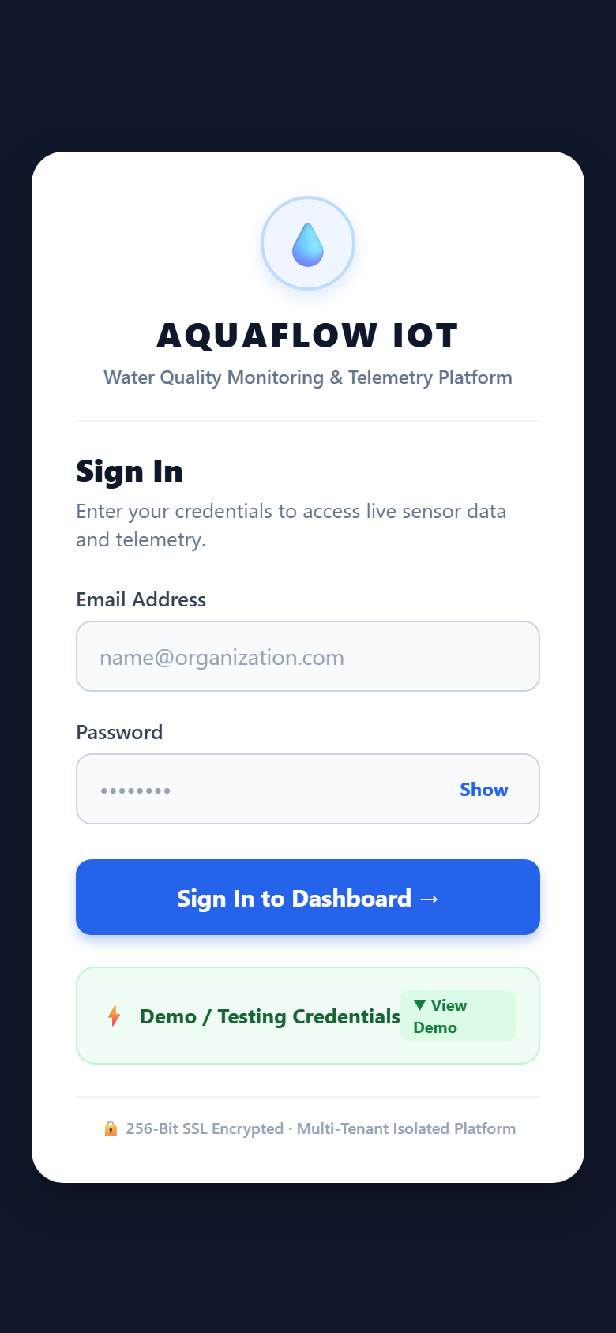
Mobile UI View: Clean Mobile Login Screen (Portrait Viewport 390x844)

2.2 Expandable Demo & Testing Credentials Drawer
To expedite testing, commissioning, and client demonstrations, the mobile login page includes a collapsible 'Demo / Testing Credentials' drawer. Tapping the header smoothly expands a categorized drawer presenting pre-configured credentials for all system roles: SuperAdmin, Organization Admin, and Manager / Operator.
- SuperAdmin Card: Pre-populates root administrator credentials (`superadmin@system.local`) granting access to client organizations, device provisioning, manager quotas, and system settings.
- Organization Admin Card: Pre-populates organization owner credentials (`admin@apex.local`) scoping telemetry and user management strictly to that organization.
- Manager / Operator Card: Pre-populates operational staff credentials (`manager1@apex.local`) granting view-only telemetry access without export or management permissions.
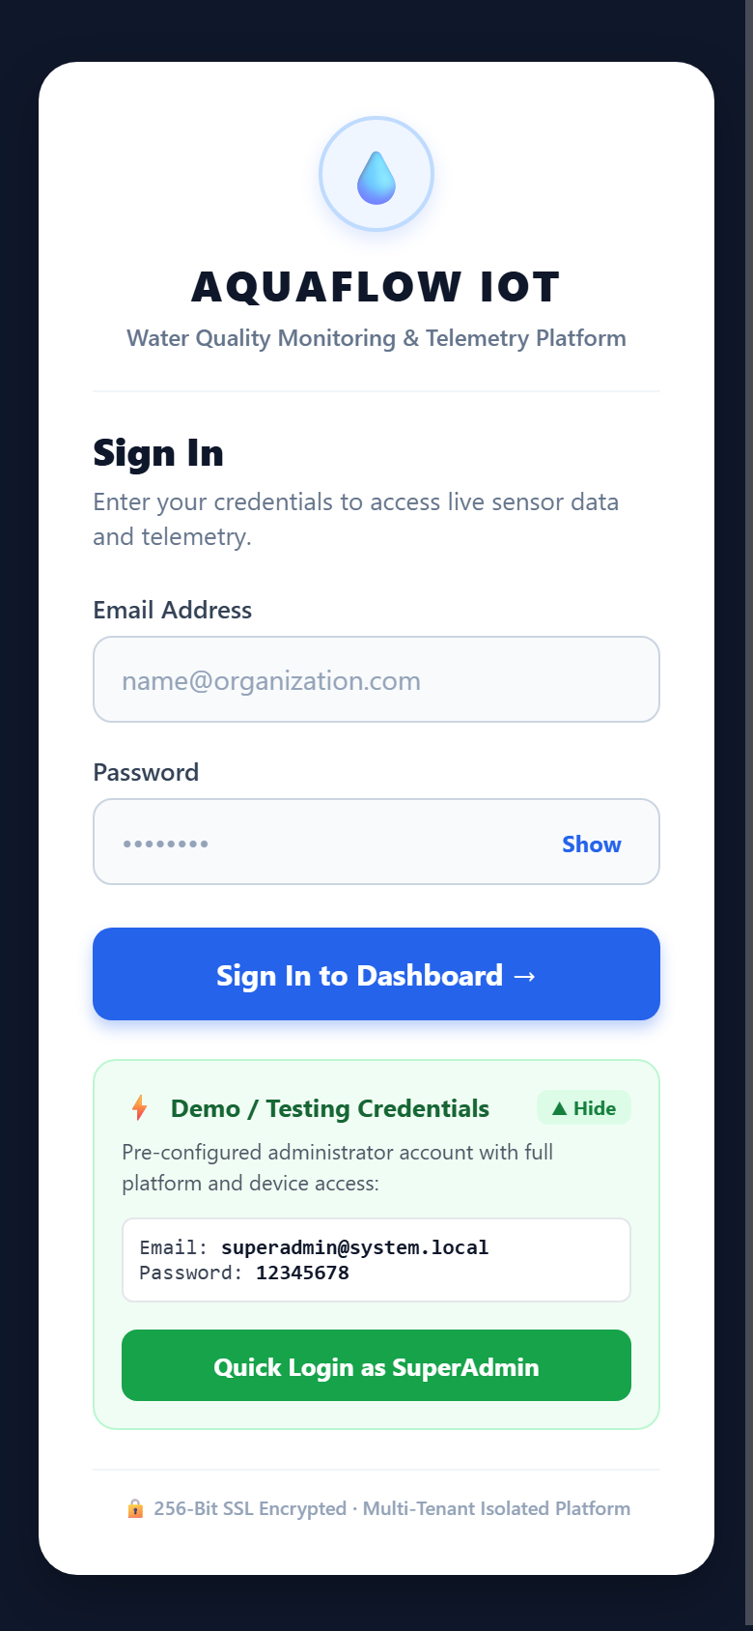
Mobile UI View: Mobile Login with Expanded Demo Credentials Quick-Fill Drawer

3. SuperAdmin Mobile Console & Client Organizations
When an authenticated SuperAdmin logs into the mobile app, the Administration console provides comprehensive fleet and tenant governance directly from the smartphone. Organization cards stack vertically, allowing rapid scanning and one-tap access to any client's live dashboard.

3.1 Mobile Client Organizations List & Manager Quotas
Each registered company is displayed as a clean card containing the organization name, address, active status badge, and the SuperAdmin-enforced 'Manager Quota' limit. An organization switcher at the top allows the SuperAdmin to instantly filter all screens by specific company.
- Manager Quota Display: Displays the maximum number of manager accounts authorized for the company (e.g., 'Manager Quota: 2 Max').
- Quick Organization Switcher: SuperAdmins can switch operational focus between organizations with a single tap on the horizontal organization pill selector.
- Open Dashboard Action: Instantly jumps to the live sensor dashboard filtered exclusively for the selected organization.
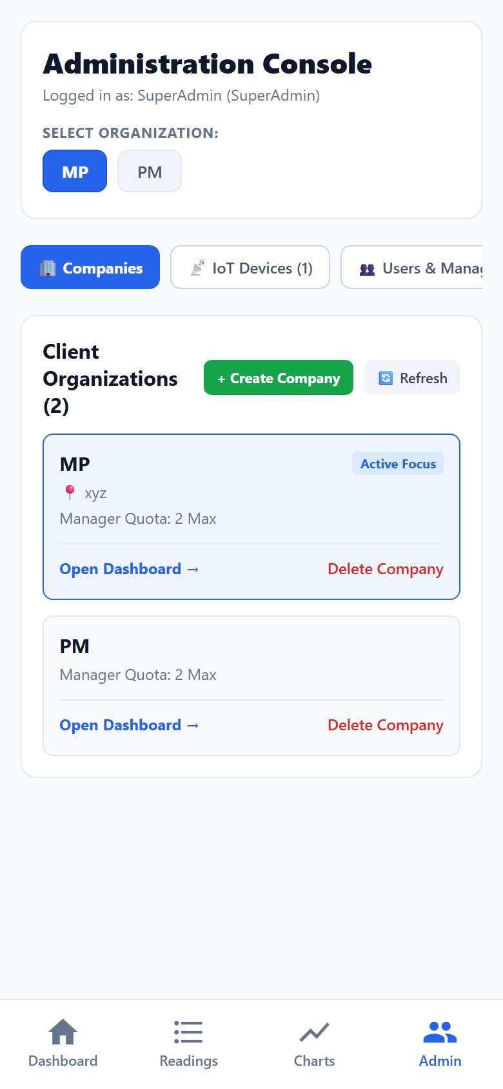
Mobile UI View: Mobile Admin Console — Client Organizations Tab with Manager Quota Badges

3.2 Mobile Create Company Screen & Manager Limit Setup
Creating a new client organization on mobile is streamlined into a dedicated full-screen flow accessible via the '+ Create Company' button. The interface includes a native-feeling top navigation bar with a back button (`← Create Company`), grouped form sections, and the unified 'Manager Limit' control.
- Company Details: Captures organization identity and physical installation facility.
- Manager Limit (Max Managers Allowed): Directly governs how many manager accounts the new company is allowed to register. Defaults to 2, and can be customized to any integer specified by the SuperAdmin.
- Company Owner Credentials: Configures the initial Organization Admin account, including full name, business email, and strong password.
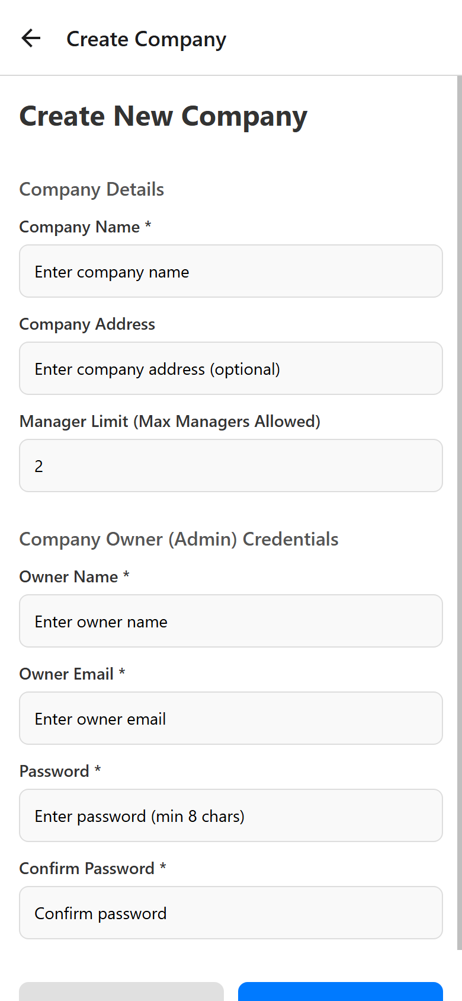
Mobile UI View: Mobile Create Company Screen showing Unified Manager Limit Configuration

4. Mobile IoT Device Management & Sensor Provisioning
Physical sensor stations deployed in the field require clear visibility and hassle-free registration. The Mobile Admin 'IoT Devices' tab provides field engineers with instant insight into hardware connection health and cloud broker configurations.

4.1 Mobile IoT Devices Inventory
The mobile device inventory lists all provisioned monitoring hardware stations. Each card displays the Hardware Station ID, connected ThingSpeak Channel ID, installation location (e.g., 'Floor 1'), assigned manager, and real-time connectivity status.
- Connection Status Pill: Color-coded pill indicating whether the hardware has transmitted telemetry within the configured heartbeat window (`Online` in green, `Warning` in amber, `Offline` in red).
- Sensors Monitored: Summarizes active sensor channels (pH, Turbidity, TDS) and confirms operational access.
- Quick Actions: Provides direct shortcuts to view live sensor telemetry on the dashboard or decommission retired equipment.
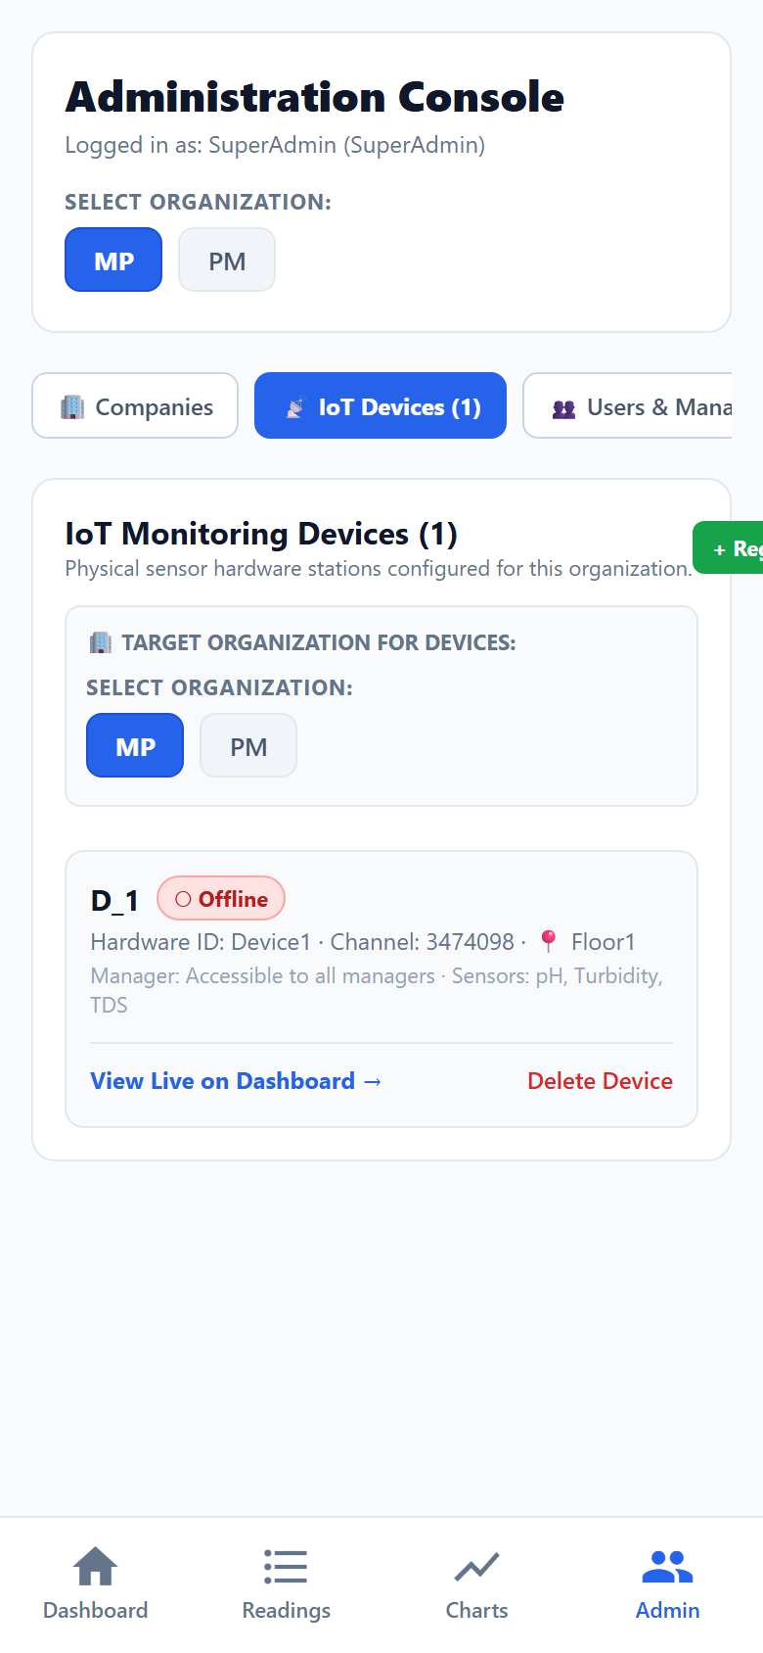
Mobile UI View: Mobile Admin Console — IoT Devices Inventory Tab

4.2 Mobile IoT Device Registration Form
Tapping '+ Register Device' reveals the mobile registration form. This interface allows field technicians to associate new hardware nodes with a client organization, enter the ThingSpeak Channel ID, and securely store the Read API Key.
📌 Architectural Security: Server-Side API Key Storage
When an IoT device is registered via the mobile app, the ThingSpeak Read API Key is transmitted over encrypted TLS to the Node.js backend and stored in MongoDB. The Read API Key is NEVER returned to client browsers or mobile devices in public responses. All telemetry queries are brokered server-side, eliminating API key leakage vulnerabilities.

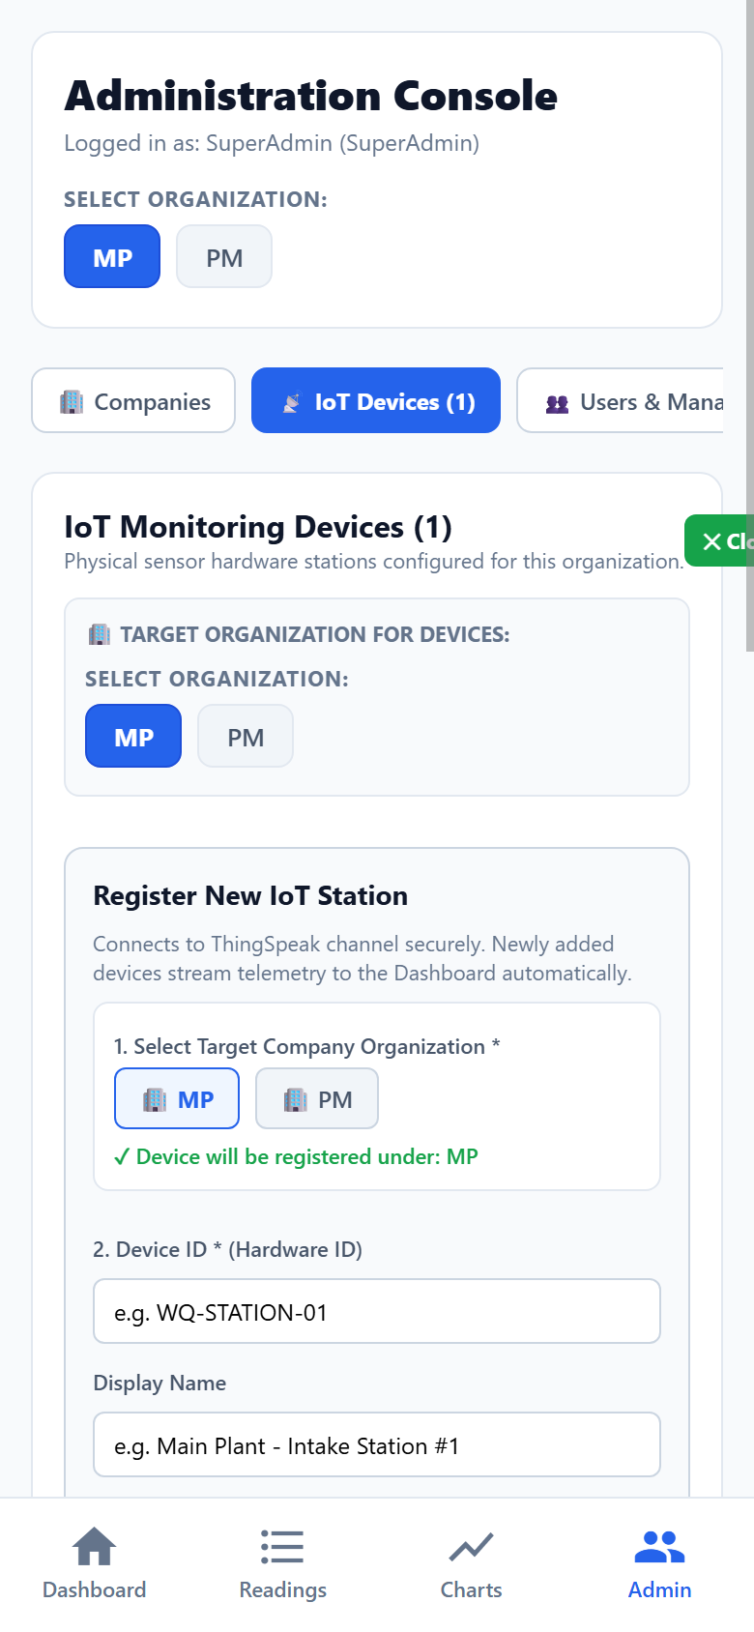
Mobile UI View: Mobile Admin Console — Register IoT Device Configuration Form

5. Mobile User Governance & Manager Quota Enforcement
Role-Based Access Control (RBAC) ensures strict separation of privileges between administrators, managers, and field operators. A central innovation requested by organization executives is the strict quota governing how many manager accounts each organization may register.

5.1 The Manager Allocation Quota Banner
Upon opening the 'Users & Managers' tab on mobile, administrators are immediately greeted by the prominent 'Manager Allocation Quota' banner. This card displays an exact accounting of manager seat utilization in real time:
- Total Allowed: The strict ceiling established by the SuperAdmin when the organization was registered (e.g., '2 Max').
- Active Managers: The count of active manager accounts currently provisioned for this organization.
- Available Slots: The remaining headcount available before registration is locked (e.g., '2 Available').
- Quota Status Badge: High-contrast status indicator displaying overall capacity utilization (e.g., '0 / 2 Used').
If an administrator attempts to create an additional manager account when the quota is reached (`2 / 2 Used`), the system proactively disables the submission button and presents a clear error: 'Manager limit reached for this organization (2/2). Contact SuperAdmin to increase your quota.'
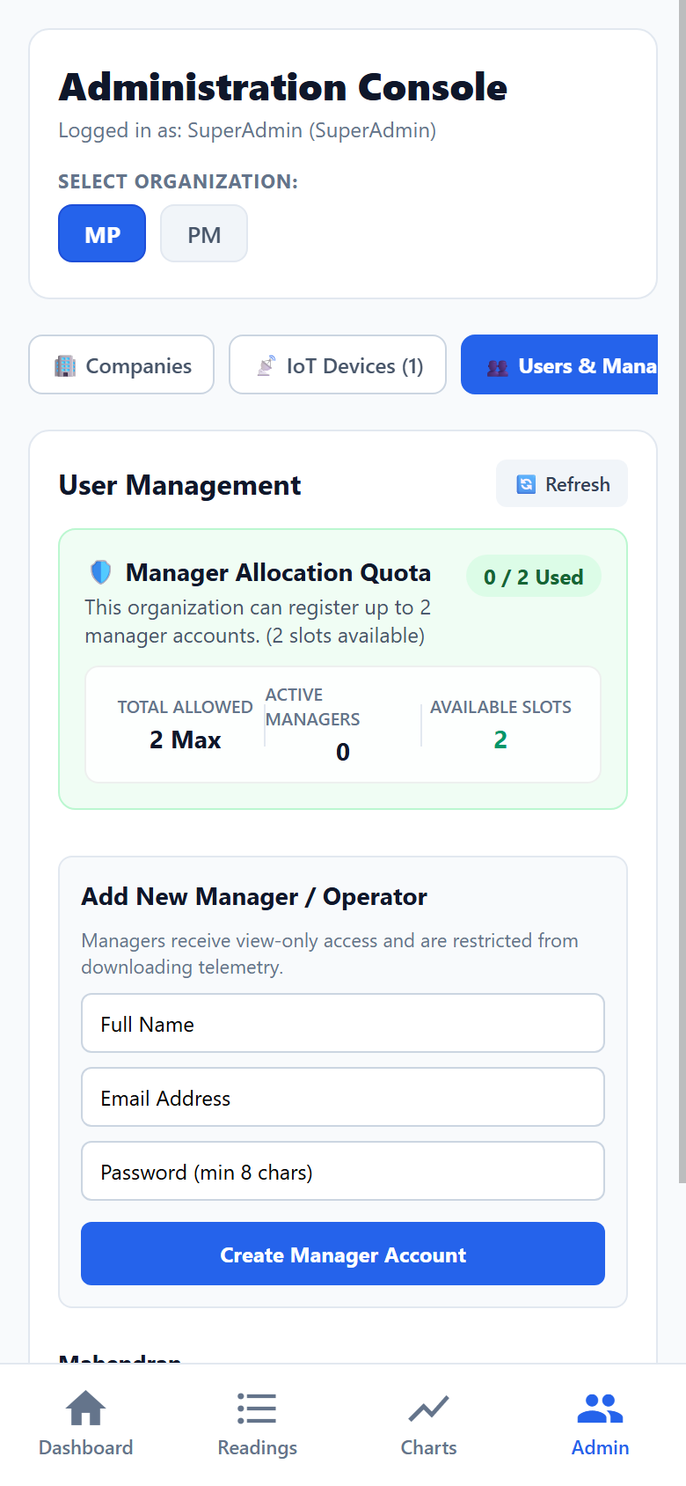
Mobile UI View: Mobile Admin Console — Users & Managers Tab with Manager Quota Banner

5.2 Role Hierarchy & Operational Permissions Matrix
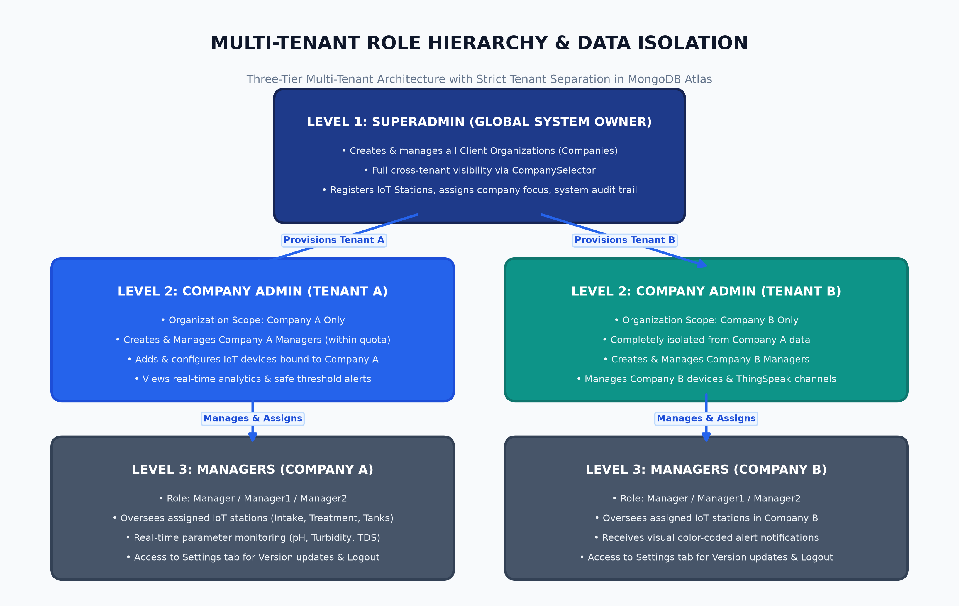
Architecture Diagram: AquaFlow RBAC Hierarchy & Manager Quota Validation Workflow

6. Mobile Audit Logging & Streamlined Settings
Enterprise field operations demand comprehensive compliance auditing alongside a clean, focused user settings experience. All extraneous configuration clutter has been removed, ensuring that administrators can focus solely on version verification, software updates, and secure session termination.

6.1 Mobile Security Audit Trail
The 'Audit Trail' tab on mobile delivers an immutable chronological log of critical system events. Each log entry displays the timestamp, event action type (e.g., 'User Login', 'Device Registered', 'Company Created'), actor user email, and client IP address.
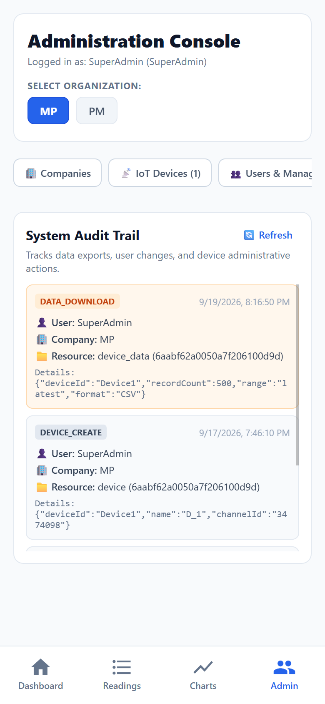
Mobile UI View: Mobile Admin Console — Security Audit Trail Tab

6.2 Streamlined Mobile Settings & Updates Tab
In response to executive requirements, the Settings tab has been completely redesigned to eliminate confusing metadata, cloud service diagnostics, and scattered log-out buttons. The mobile Settings screen now focuses exclusively on three essential pillars:
- Software Version Verification: Displays current app version (`v1.0.0 Production Release`) and release channel.
- Software Update Checker: Enables mobile users to verify if new firmware or client software updates are available.
- Dedicated Account & Session Log Out: A prominent, dedicated 'Log Out' button located exclusively in Settings, cleanly clearing cached session tokens and redirecting to the login screen.
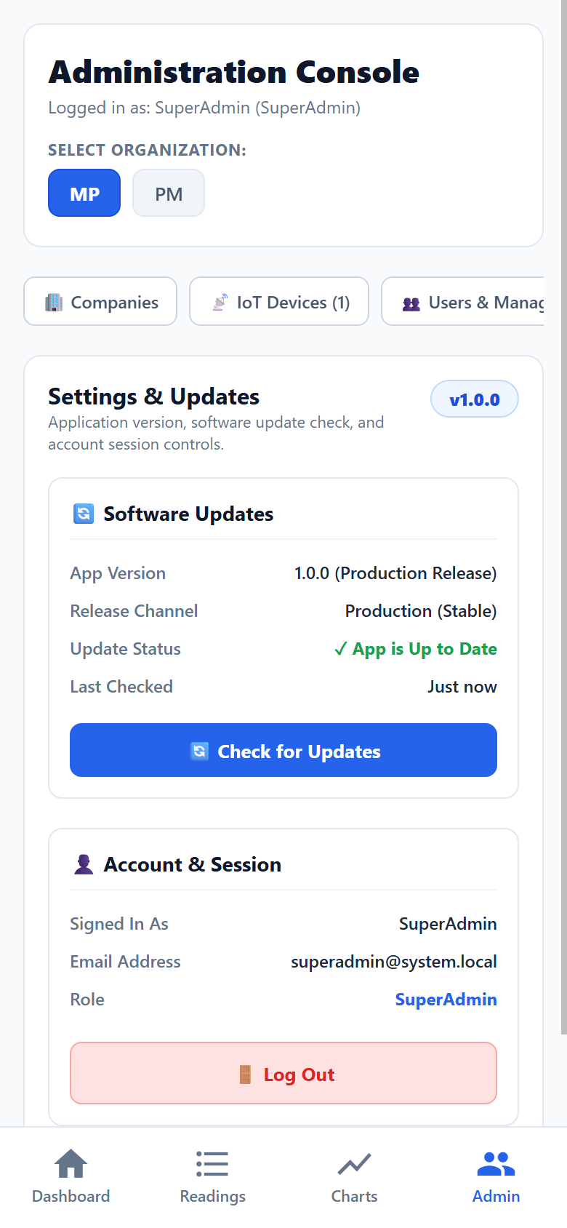
Mobile UI View: Streamlined Mobile Settings Tab with Version v1.0.0 and Dedicated Log Out

7. Mobile Operational Live Dashboard
The Live Dashboard serves as the primary nerve center for mobile users. It aggregates fleet status metrics at a glance and presents color-coded sensor alert boxes for every physical monitoring station.

7.1 Mobile Fleet KPI Cards
At the top of the mobile dashboard, four responsive KPI summary cards provide instant situational awareness across all assigned hardware:
- Total Devices: Total count of hardware monitoring nodes provisioned.
- Online (Green): Count of devices actively communicating with recent telemetry.
- Warning (Amber): Count of stations reporting sensor parameters outside safe thresholds.
- Offline (Red): Count of stations with heartbeat silence exceeding 30 minutes.

7.2 Connected Device Cards with Real-Time Parameter Alert Boxes
Each connected device is rendered as an interactive mobile card. Distracting emoji icons have been replaced with professional, high-contrast parameter cards for the three core physical metrics:
- pH Parameter Box: Evaluated against safe limits of 6.5 - 8.5. If the reading drops below 6.5 (e.g., 3.12 pH as captured in field data), the card dynamically transitions to a high-visibility pink/red warning background with bold red typography.
- Turbidity Parameter Box: Evaluated against safe limits of 0 - 5.0 NTU. If water cloudiness exceeds 5.0 NTU (e.g., 62.38 NTU), the card immediately flags an alarming red alert status indicating high suspended particulate matter.
- TDS Parameter Box: Evaluated against safe drinking water standards (0 - 500 ppm). Readings within safe limits (e.g., 95.18 ppm) render with a clean neutral background.
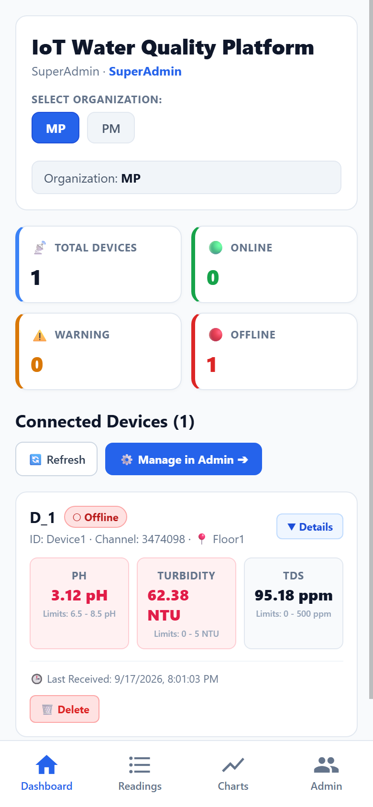
Mobile UI View: Mobile Live Dashboard showing Fleet KPIs & Parameter Alert Boxes (pH 3.12, Turbidity 62.38 NTU)

8. Mobile Historical Readings & Telemetry Analytics
Mobile operators frequently need to investigate historical water quality trends and inspect telemetry over specific operational timeframes. The Readings and Charts tabs provide fluid touch navigation and interactive data exploration on mobile viewports.

8.1 Historical Readings Mobile View & Filter Toolbar
The Historical Readings screen is tailored for field readability. The top toolbar provides a compact timeframe selector (`One Day`, `One Week`, `One Month`, `Custom`), quick organization and device tabs, and an interactive view toggle (`📱 Mobile Cards` vs `📄 Table`).
- Mobile Cards Mode: Displays each reading as an individual card with clear timestamp, parameter pills, and threshold color coding, ideal for scrolling on small screens.
- Table Mode: Renders a compact horizontal data grid for quick comparative scanning across multiple parameters.
- Role-Based Export Access: Per security policies, the 'Export CSV' button is shown only to authorized administrators and hidden from standard view-only managers.
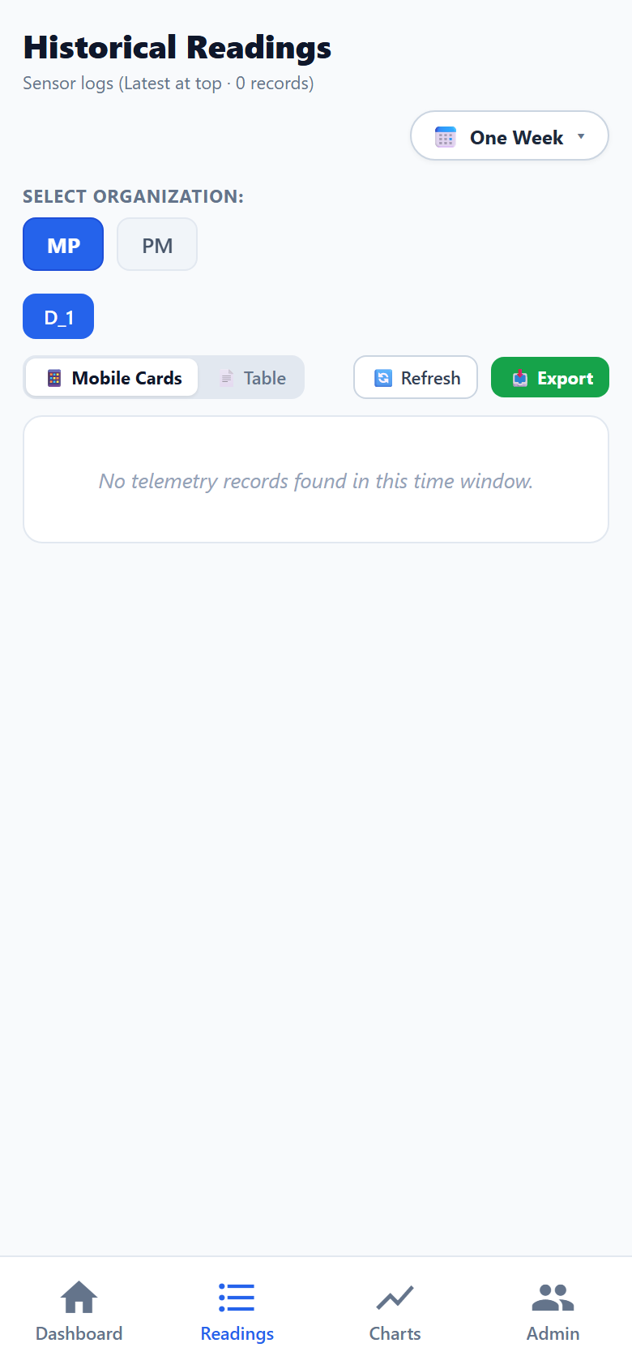
Mobile UI View: Mobile Historical Readings Screen with Timeframe & View Mode Selectors

8.2 Mobile Telemetry Analytics Charts
The Analytics Charts screen presents real-time telemetry curves plotted over time. Rather than cluttering the mobile display with multiple overlapping lines, the app employs single-parameter metric chips (`pH`, `Turbidity`, `TDS`).
- Single-Parameter Metric Selection: Tapping any metric pill instantly renders the high-contrast curve for that specific parameter.
- Safe Threshold Reference Lines: Dashed horizontal guide lines indicate the minimum and maximum safe thresholds (e.g., 6.5 and 8.5 for pH), allowing instant visual verification of water safety.
- Touch Point Inspection: Field engineers can drag their finger along the chart curve to inspect exact point-by-point values and timestamps in real time.
- Download Graph Action: Generates an instant high-resolution snapshot of the telemetry chart for incident reports or regulatory filings.
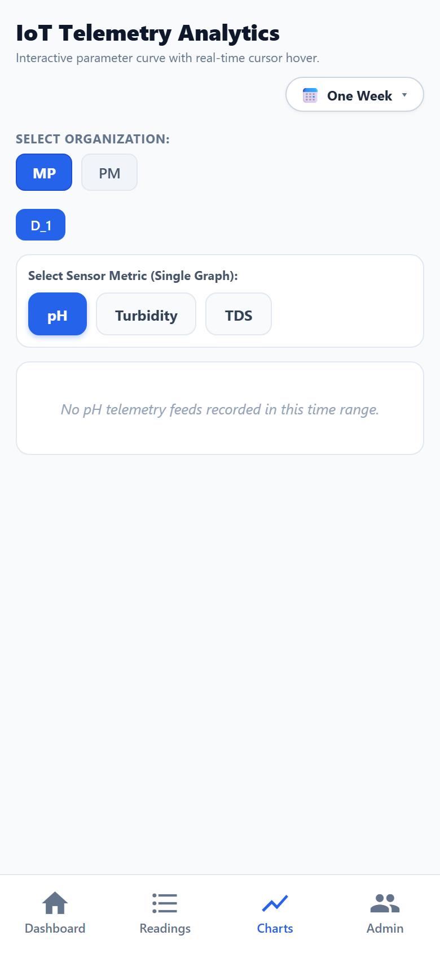
Mobile UI View: Mobile Telemetry Analytics Chart Screen showing Single-Parameter Chips & Thresholds

9. System Technology Stack & Specifications
The AquaFlow IoT platform is engineered using modern, production-grade open-source technologies designed for high throughput, sub-second latency, and zero vendor lock-in.
Layer | Technology / Framework | Key Architectural Purpose
Mobile Client | React Native & Expo Router v54 | Universal cross-platform application (iOS, Android, PWA) with responsive styling and smooth animations.
State Management | Zustand with LocalStorage Sync | Lightweight in-memory state store with persistent session storage across web reloads and native app launches.
Backend Server | Node.js & Express REST API | Modular MVC microservices handling authentication, tenant isolation, quota validation, and audit logging.
Database Engine | MongoDB Atlas (Multi-Tenant) | NoSQL document database storing companies, users, devices, thresholds, and immutable audit trails.
IoT Broker | ThingSpeak Cloud REST Feeds | Secure IoT ingestion broker receiving sensor data packets from field ESP32/ESP8266 nodes.
Security / Crypto | JWT & Argon2 Password Hashing | Role-based token authentication with 15-minute access expiry, 30-day refresh tokens, and strict permission middleware.

9.1 Authentication & Session Token Lifecycle
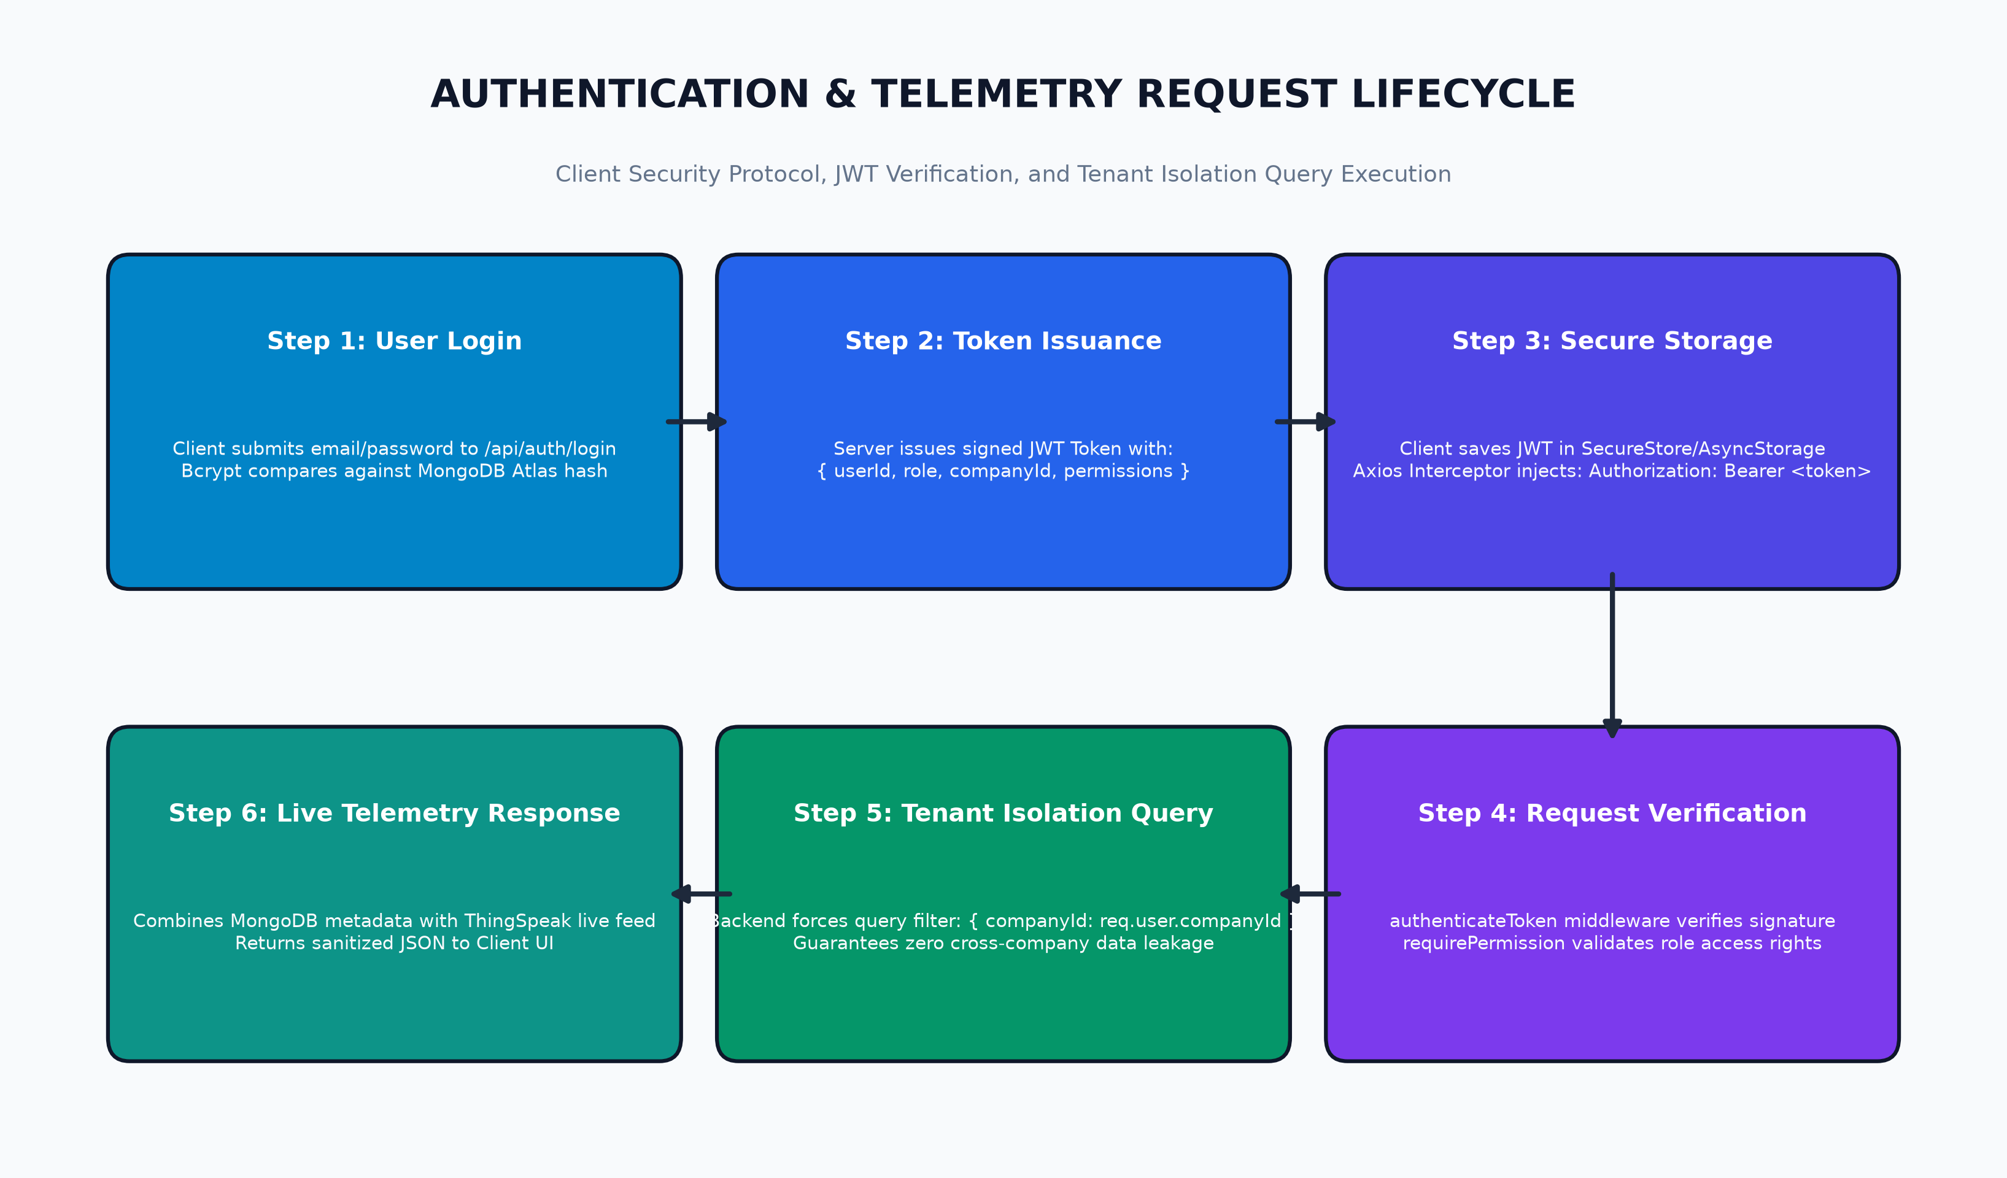
Architecture Diagram: JWT Token Issuance, Session Renewal & Auto-Refresh Sequence

10. Mobile Field Operator & Manager Quick Reference
This quick reference guide provides actionable procedures for field engineers and plant managers using the mobile application during routine operations and alarm response scenarios.

10.1 Daily Morning Inspection Routine
- Step 1: Launch the AquaFlow mobile app and sign in using your manager credentials.
- Step 2: Verify the top Fleet KPI cards. Ensure 'Offline Devices' is 0. If any station is marked Offline, verify physical power and Wi-Fi signal at the field transmitter.
- Step 3: Scan the Connected Devices cards. Confirm all three parameter boxes (pH, Turbidity, TDS) display normal white backgrounds.
- Step 4: If any parameter displays a pink/red warning card (e.g., pH < 6.5 or Turbidity > 5.0 NTU), tap 'View Live on Dashboard' to inspect immediate sensor trendlines.

10.2 Responding to a Water Quality Threshold Alarm
- Alarm Assessment: Note the exact parameter in breach, the current reading, and the timestamp.
- Trend Verification: Navigate to the 'Charts' tab, select the breaching parameter chip (e.g., 'Turbidity'), and review the trend over the last '1 Day' or '1 Week'.
- Root Cause Analysis: Determine whether the spike was a gradual rise (indicating filter saturation) or an abrupt step-change (indicating sensor fouling or sudden inlet contamination).
- Corrective Action: Take physical water samples for benchtop verification and notify plant maintenance according to standard operating procedures.

10.3 Safe Session Log Out Procedure
- Step 1: At the conclusion of your shift, tap the 'Admin' icon on the bottom navigation bar.
- Step 2: Select the 'Settings' tab.
- Step 3: Tap the red 'Log Out' button. This purges cached tokens from the mobile device and returns to the secure login prompt.
— END OF MOBILE OPERATIONS MANUAL —
AquaFlow IoT Water Quality Platform · Production Release v1.0.0

