<!doctype html>

<html class="no-js" lang="en" dir="ltr">

<head>

<meta charset="utf-8">

<meta http-equiv="x-ua-compatible" content="ie=edge">

<meta name="viewport" content="width=device-width, initial-scale=1.0">

<title>1602-15-737-089</title>

<link rel="stylesheet" href="css/foundation.css">

<link rel="stylesheet" href="css/app.css">

<style>

* {

box-sizing: border-box;

}

body {

font-family: Arial, Helvetica, sans-serif;

}

/* Style the header */

.header {

background-color: #f1f1f1;

padding: 25px;

text-align: center;

font-size: 35px;

}

/* Create three unequal columns that floats next to each other */

.column {

float: left;

padding: 10px;

height: 300px; /* Should be removed. Only for demonstration */

}

/* Left and right column */

.column.side {

width: 40%;

}

/* Middle column */

.column.middle {

width: 60%;

}

/* Clear floats after the columns */

.row:after {

content: "";

display: table;

clear: both;

}

/* Style the footer */

.footer {

background-color: #f1f1f1;

padding: 20px;

text-align: center;

}

/* Responsive layout - makes the three columns stack on top of each other instead of next to each other */

@media (max-width: 600px) {

.column.side, .column.middle {

width: 100%;

}

}

</style>

</head>

<body>

<div class="header">

<img src="https://www.dsc-clinic.sg/Patient%20Care%20Image%20Carousal%20Library/_NSC1475medit.jpg">

<div class="expanded button-group">

<a class="secondary button">Home</a>

<a class="secondary button">About project</a>

<a class="secondary button">Gallery</a>

<a class="secondary button">register</a>

<a class="secondary button">Login</a>

<a class="secondary button">contact</a>

<a class="secondary button"></a></div>

</div>

<div class="row">

<div class="column middle" >

<h1>welcome</h1>

<p>We strongly encouraged you to book an appointment to shorten your waiting time in the clinic. There will be a walk-in fee of $5 charged in addition to a longer waiting time.

If the clinic is particularly busy or your case is not urgent, you may be asked to make an appointment to attend another day. We recommend all patients to book an appointment at least 3 working days in advance.

To make an appointment, please fill in the Online Appointment Form or alternatively, you may wish to call 62939648 or drop us an email at apptdsc@nsc.com.sg to book an appointment. The appointment call center is opened every Monday to Friday from 8am - 12pm and 1pm to 5pm.</p>

<ul>

<li>Full Name as Per NRIC / Work Permit / Passport (For Tourist Only)</li>

</ul></div>

<div class="column side" style="background-color:#ccc;">

<h5>Latest clinic News</h5>

<ul>

<li>0:00:00</li></ul>

<p>Doctor appointmnet</p>

<ul>

<li>0:00:00</li></ul>

<p>appointment booking the patient can visit the doctor at that booked time</p>

<ul>

<li>0:00:00</li></ul>

<p></p>

<p>Doctor Schedule due to some reason the doctor might not seee you</p>

</div>

</div>

<div class="footer">

<div class="title-bar" data-sticky data-options="marginTop:0;" style="width:100%" data-top-anchor="1" data-btm-anchor="content:bottom">

<div class="title-bar-left"><!-- Content --></div>

<div class="title-bar-right">

<nav aria-label="You are here:" role="navigation">

<ul class="breadcrumbs">

<li class="disabled">Home</li>

<li class="disabled">About project</li>

<li class="disabled">Gallery</li>

<li class="disabled">Register</li>

<li class="disabled">Login</li>

<li class="disabled">Contact</li>

</ul>

</nav></div>

</div>

</div>

</div>

<script src="js/vendor/jquery.js"></script>

<script src="js/vendor/what-input.js"></script>

<script src="js/vendor/foundation.js"></script>

<script src="js/app.js"></script>

</body>

</html>

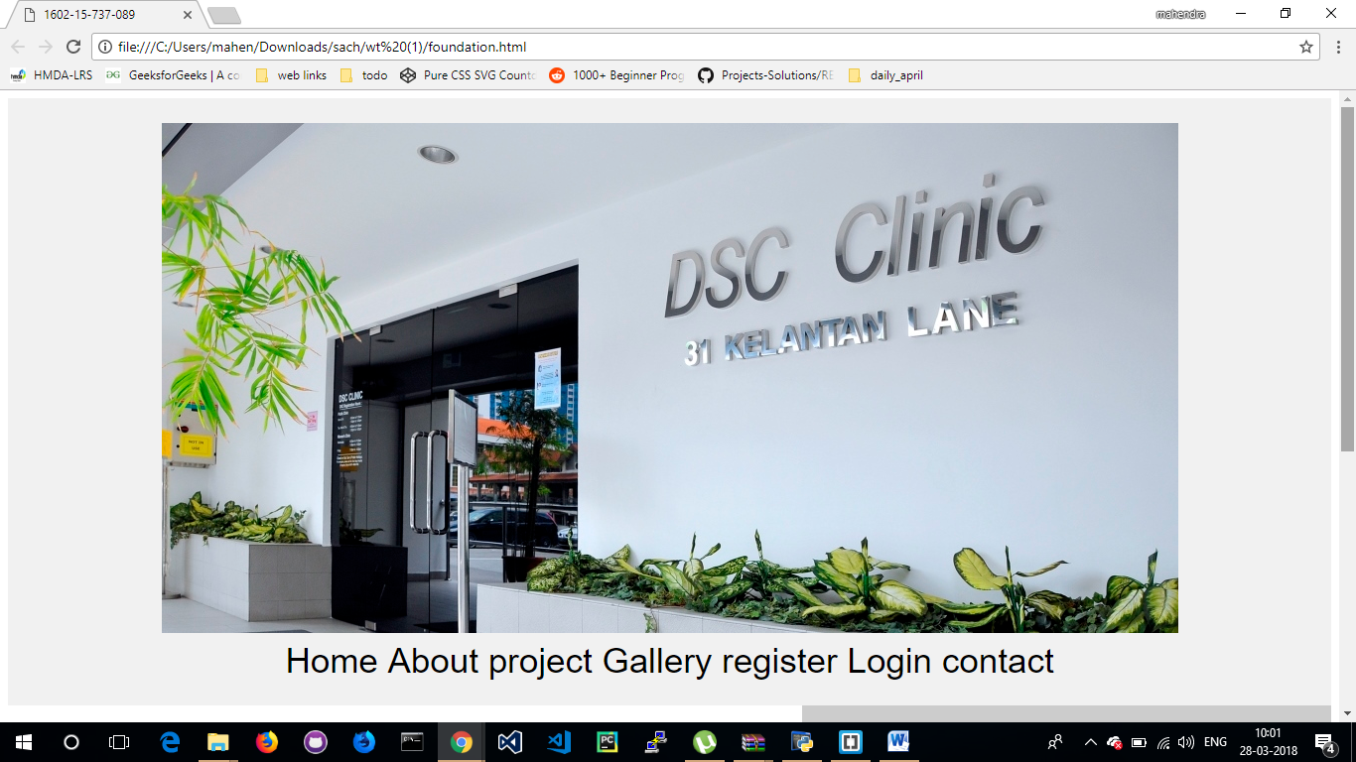

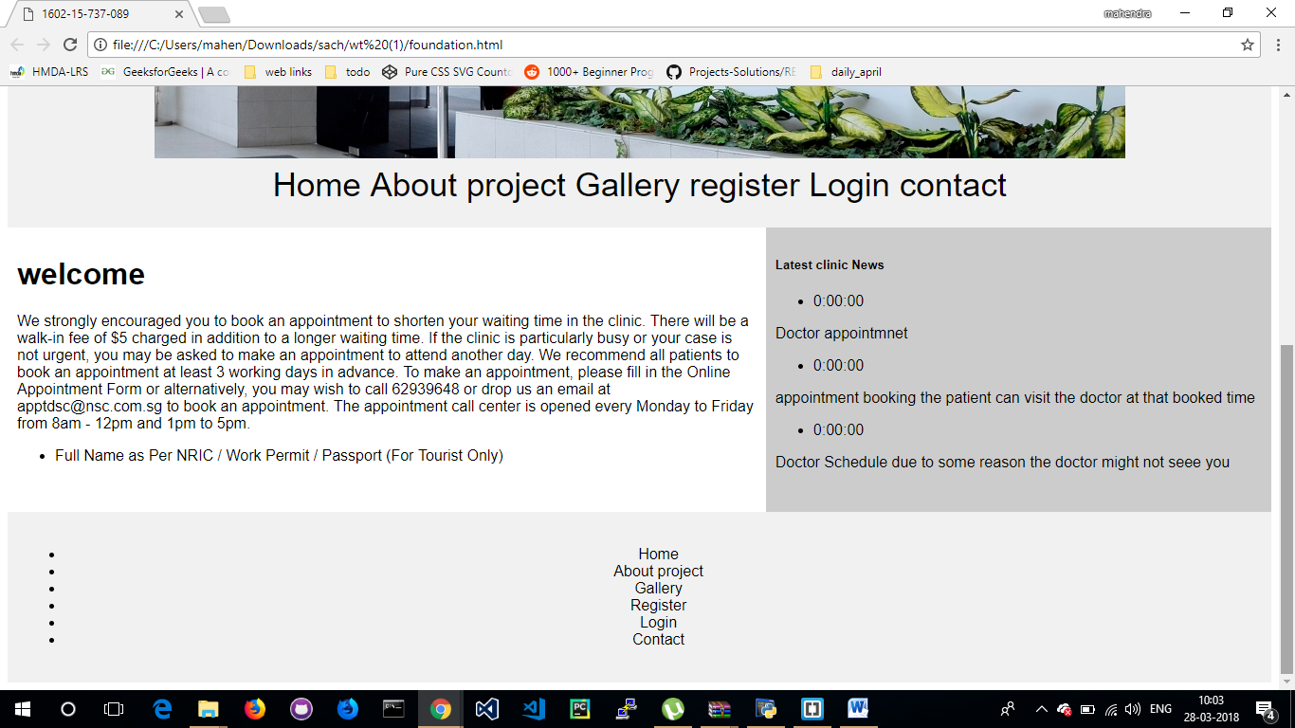

Python Program output:

