**Data Model:**

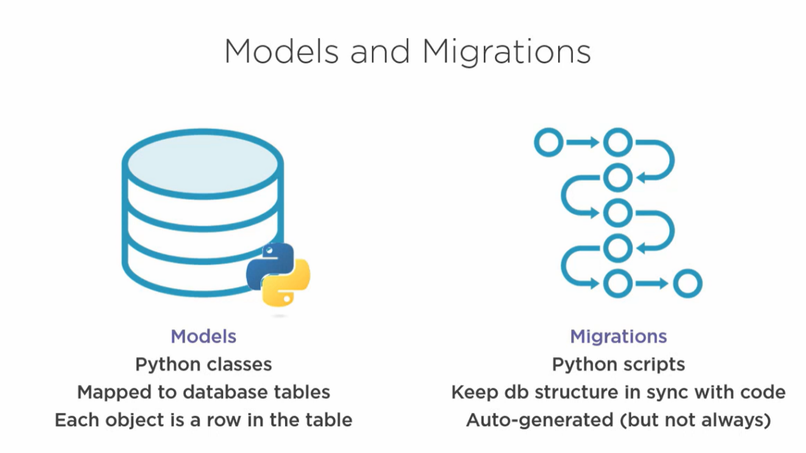

**Create a MODEL:**

Lets create a new app called **meetings**:

python manage.py startapp meetings

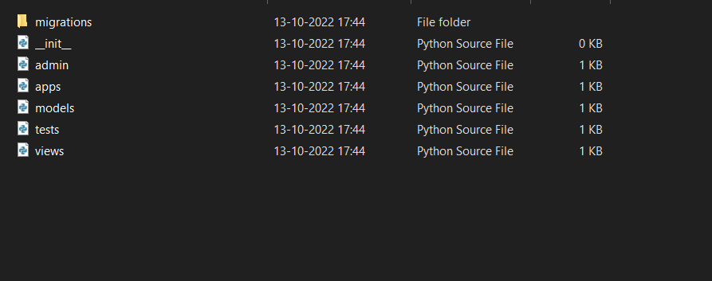

Folder will created.

Add the application in **Meeting_planner-->settings.py**

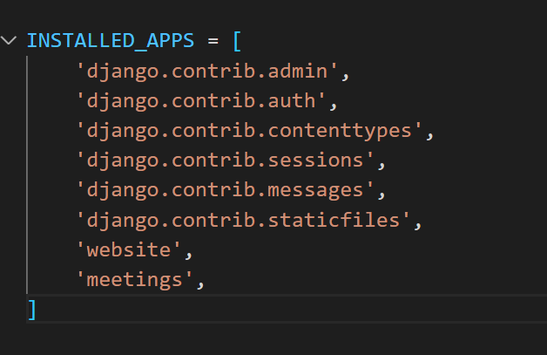

In **models.py** file written the model class:

class Meeting(models.Model): # models.Model was an base class which we inherited

Title = models.CharField(max_length = 200)

Date = models.DateField()

Once it done make the migration:

By using command python manage.py makemigrations

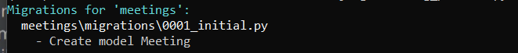

Now you can new file is created in meeting-->migrations folder

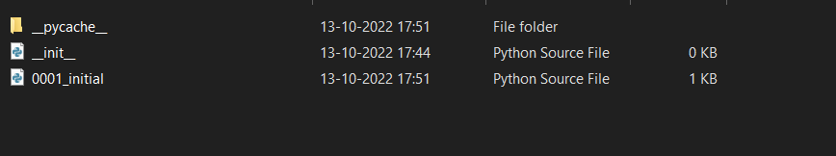

File content

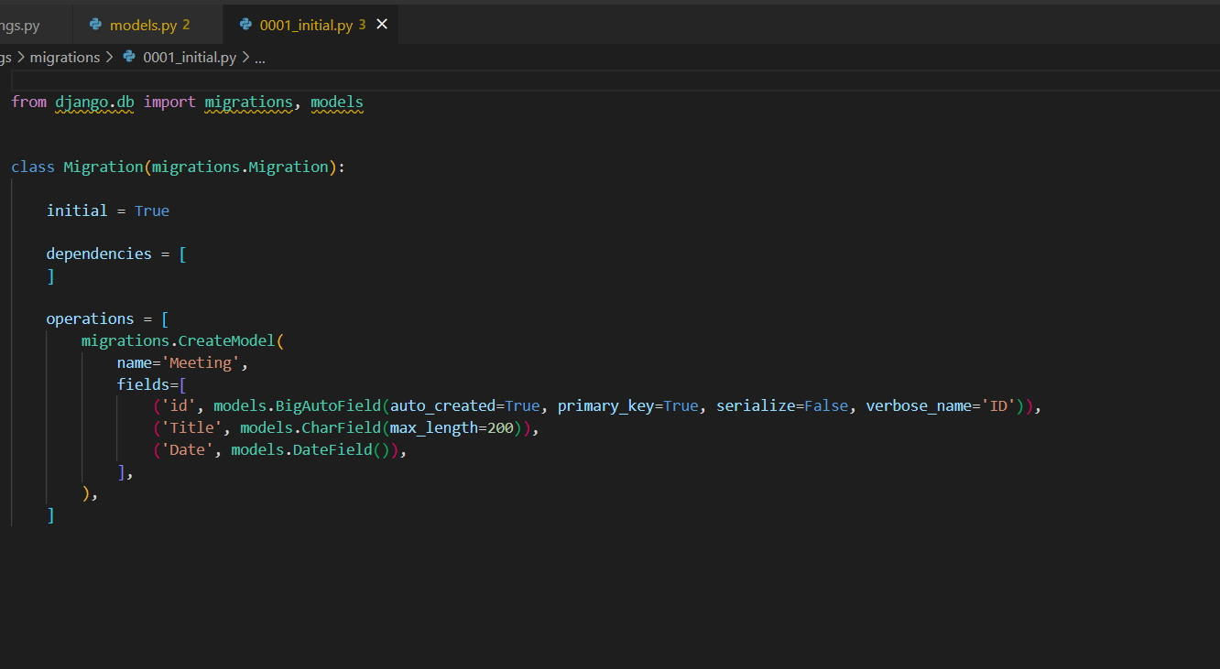

Now we need to migrate this to our project:

Now run the command:

python manage.py sqlmigrate meetings 0001 # either you can gave entire name or number is enough.

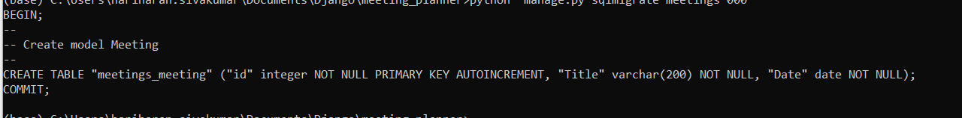

The model is created now we need to migrate this

python manage.py migrate

now you can see the changes will done

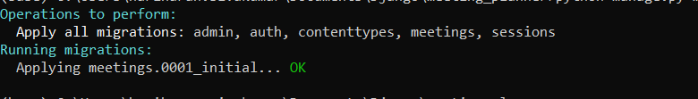

ADMIN:

Lets add some admin controls:

Lets dive to **meetings--> admin.py**

Add our model into **admin.py** file

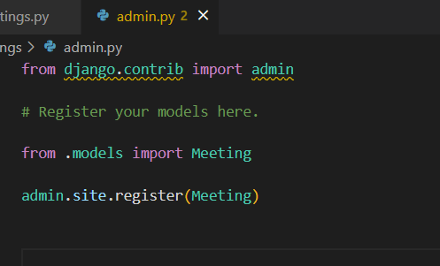

After this run the server and you can admin page to access that we need login username and password.

Lets create login username and password

python manage.py createsuperuser

Enter the username, mailid, password

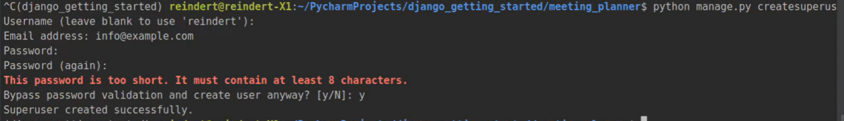

Now run the server and enter the password and username

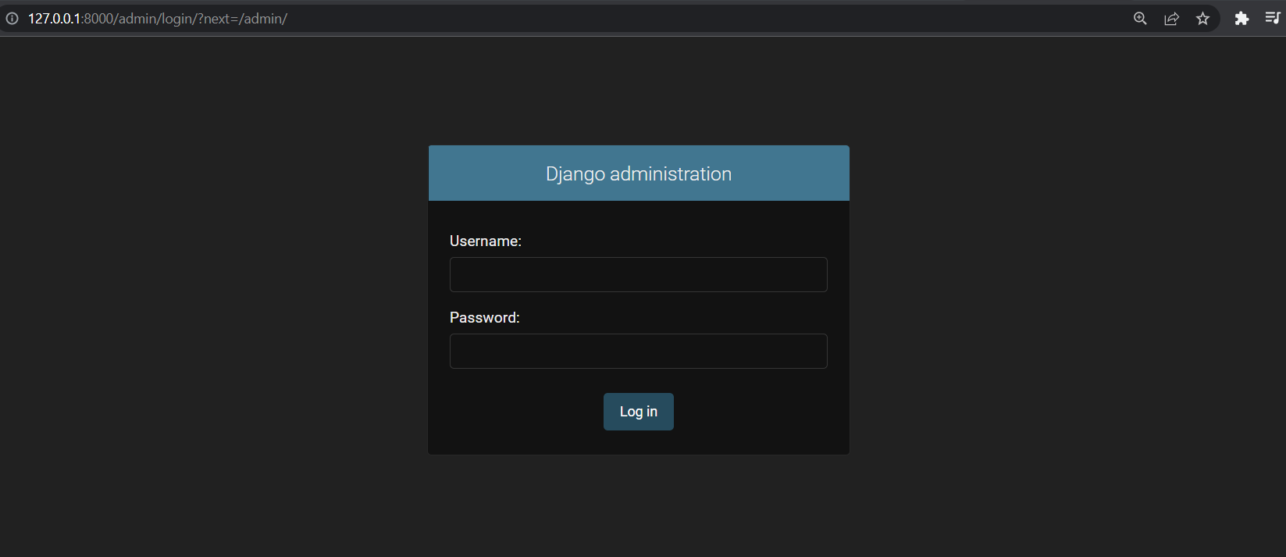

Once you logged in you access the database tables(python classes)

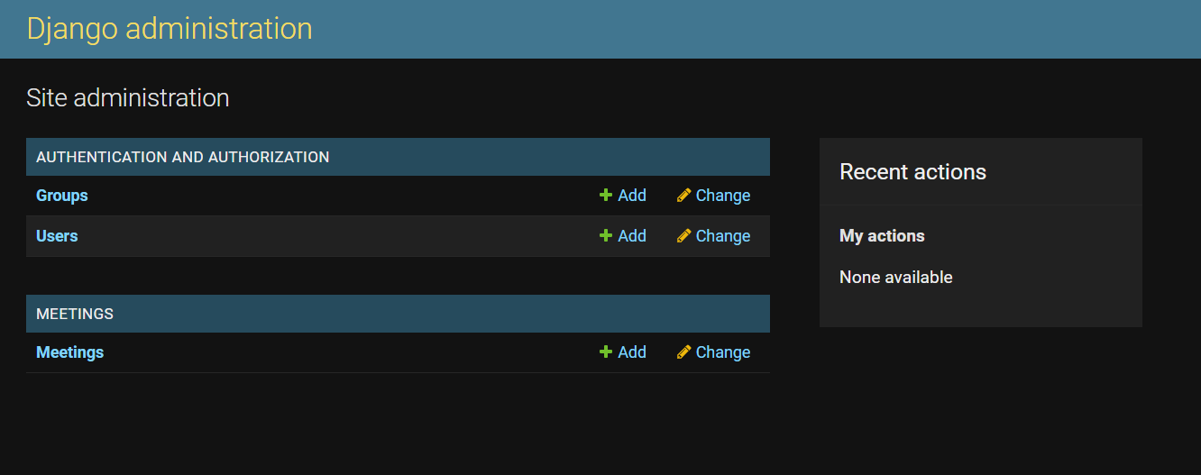

Click Add on meeting to enter the values.

The Django having built in features to build basic web HTML pages. It will helps work.

Eg:

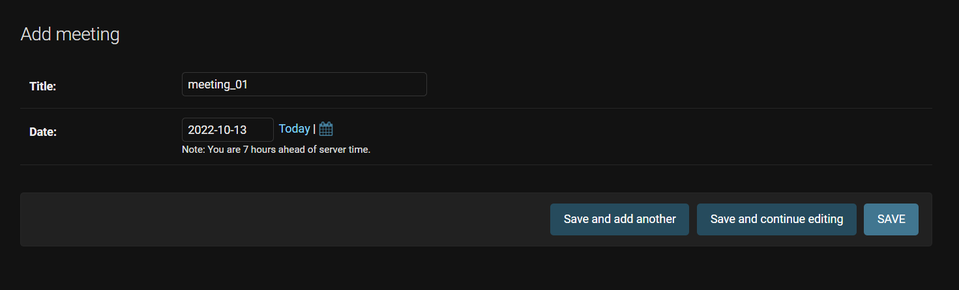

Enter the necessary details and choose any of save options. Once you done you can see result like

This.

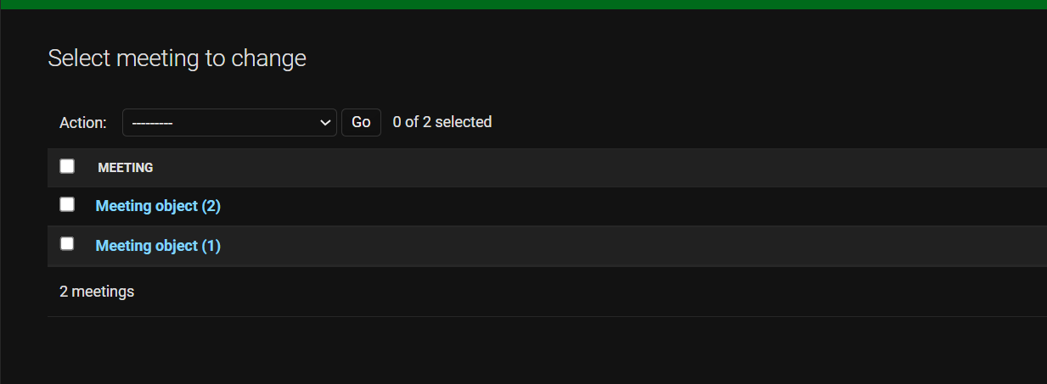

1. , (2) are unique Id’s.

(note: this is not for user purpose)

REVIEW:

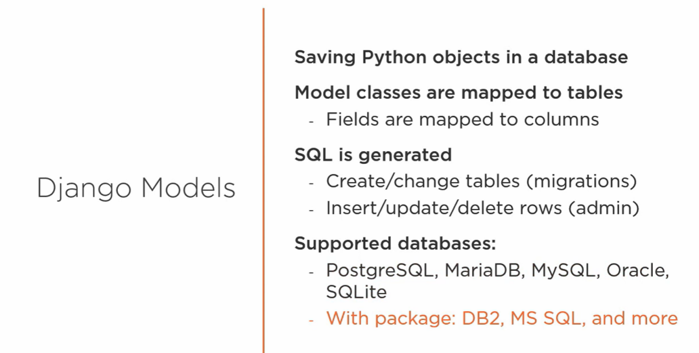

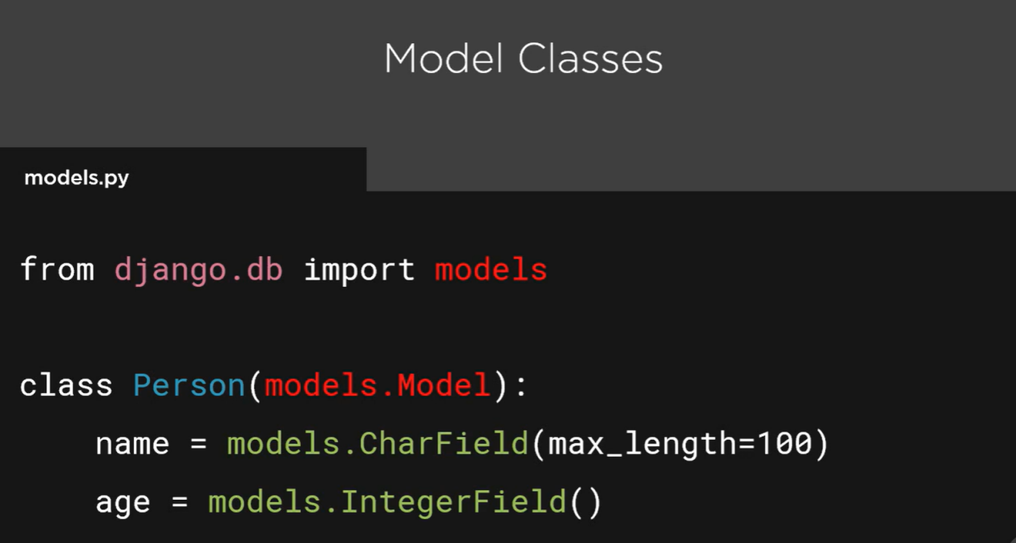

[More django model : visit <https://docs.djangoproject.com/en/4.1/ref/models/fields/>

