1. 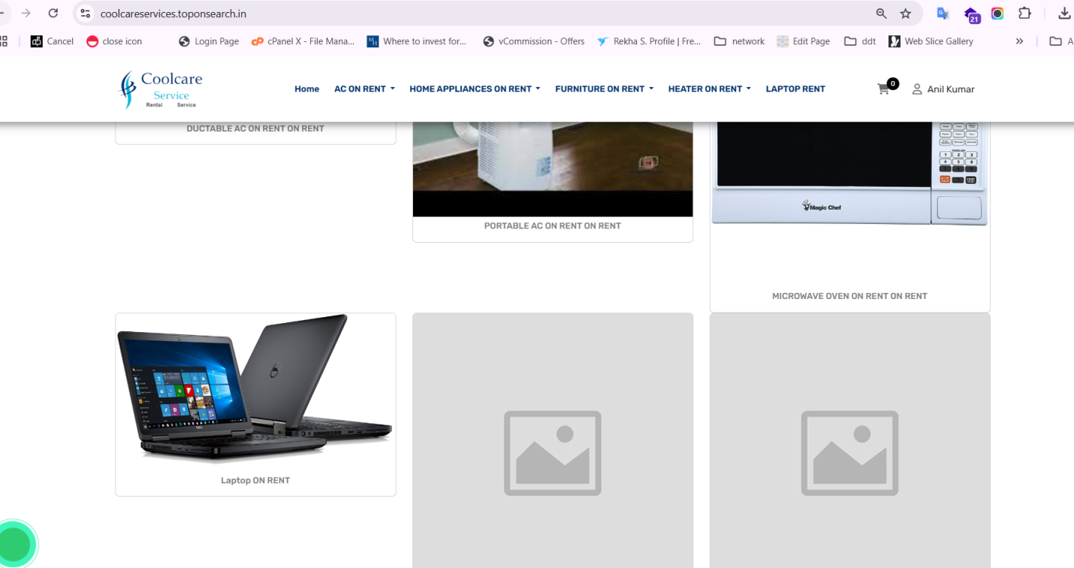  
   please setup images and please specify the images size in admin panel as well.(Done upload image 500x500px)
2. 2nd image is not showing so either delete it or get rectify(Done)  
   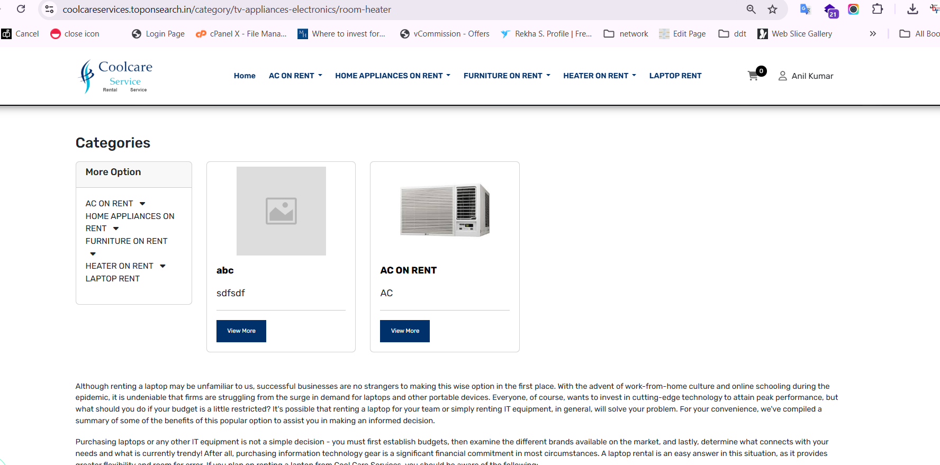
3. As per below screenshot size is not showing in attributes of AC so please check(Done)  
   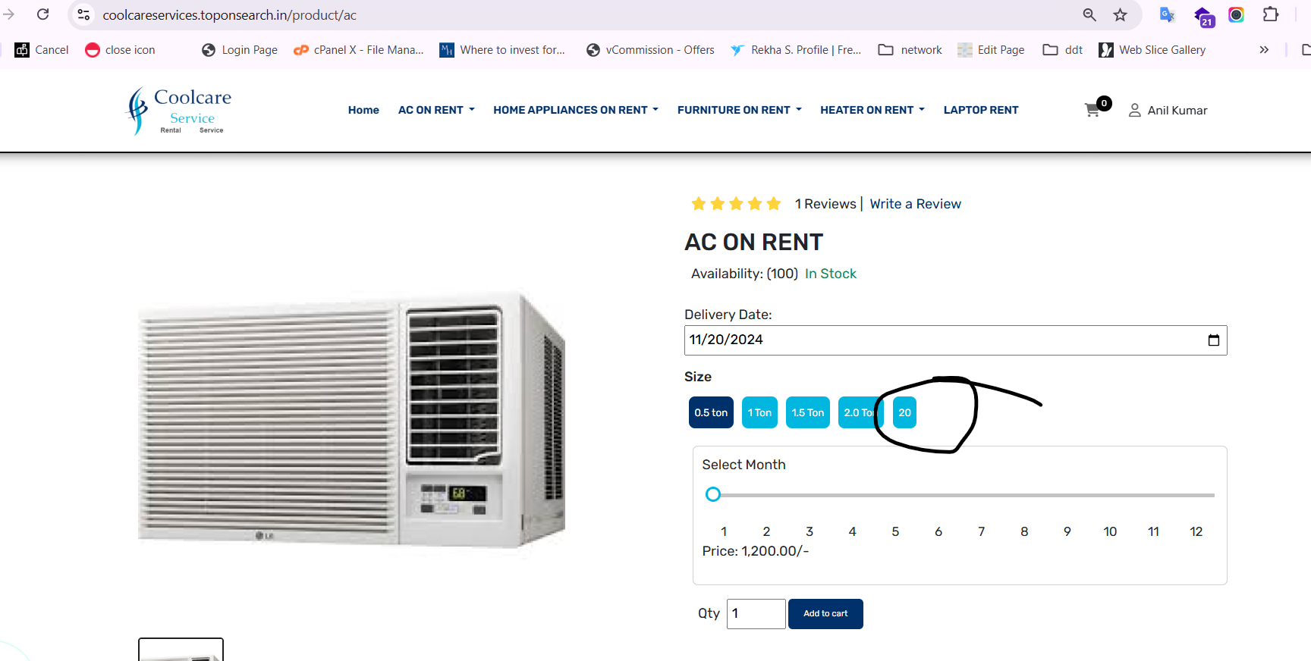
4. As per below screenshot the option will not be valid for cutomer this will options from admin panel and customer will see only shipping charges  
   Shipping will be options as free 2nd is 300 rs and 3rd options can be add any amount.(Done)  
     
   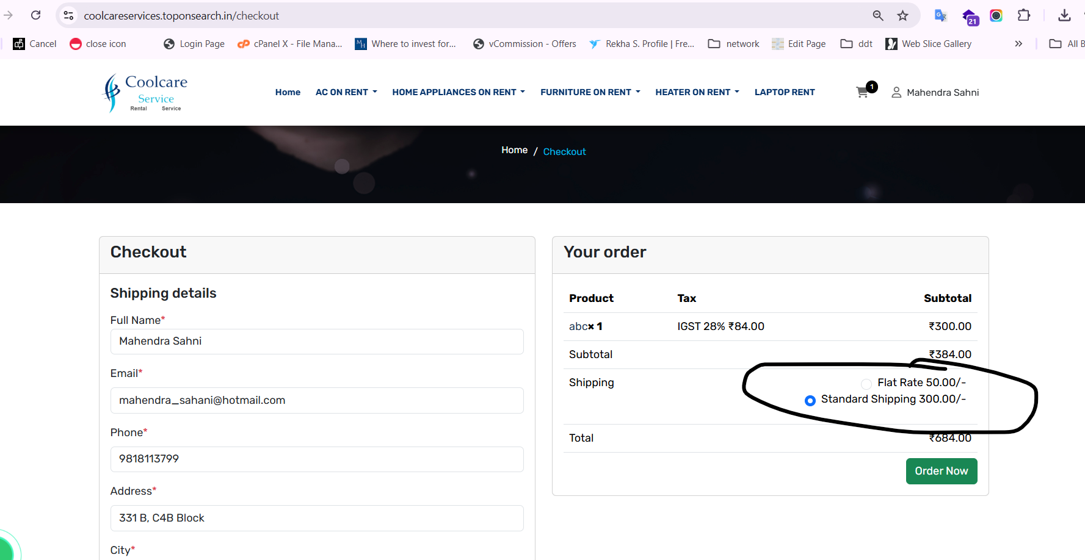
5. As per below screenshot resend OTP link is not working(Done)  
   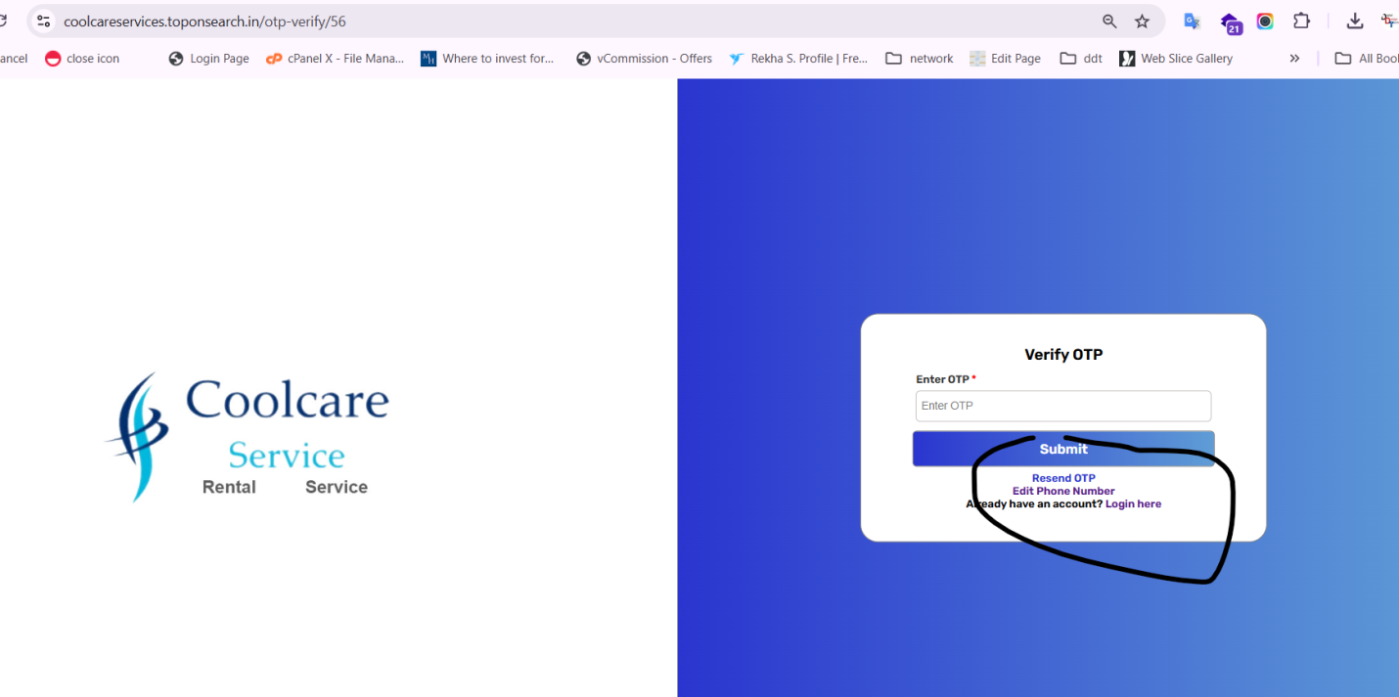
6. As per below screenshot Please mentioned mobile no(Done)  
   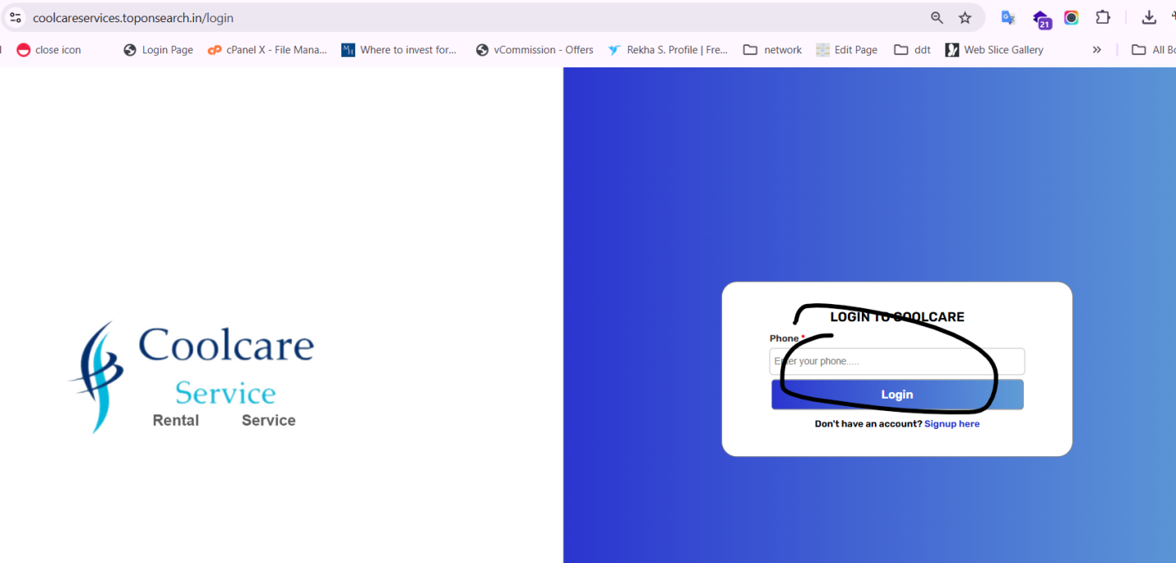
7. As per below screen please remove both customer   
   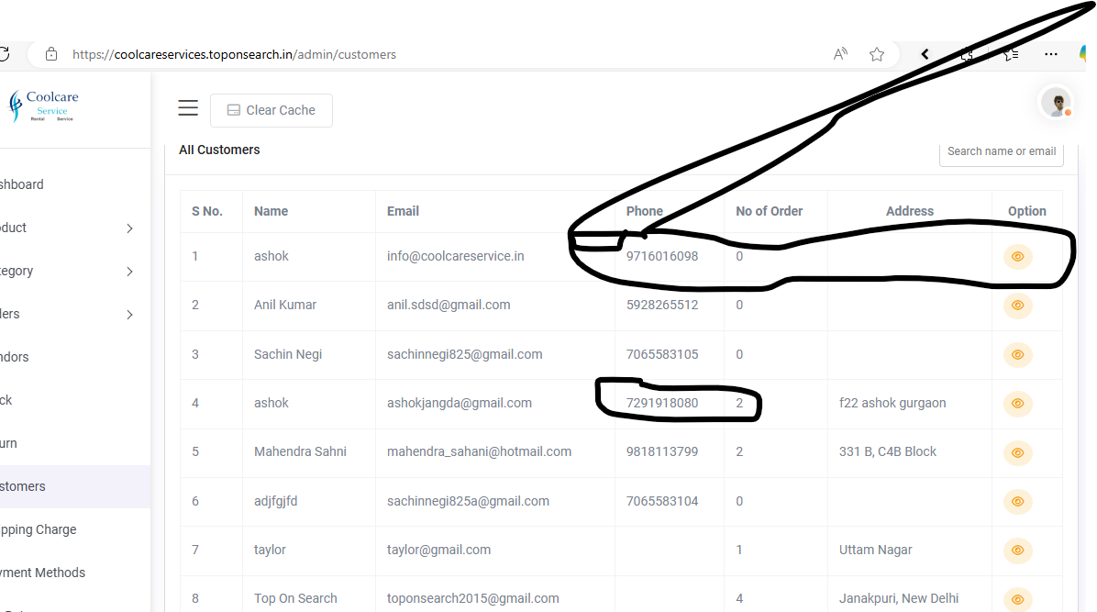
8. As per below screen product gst is not showing (Done)

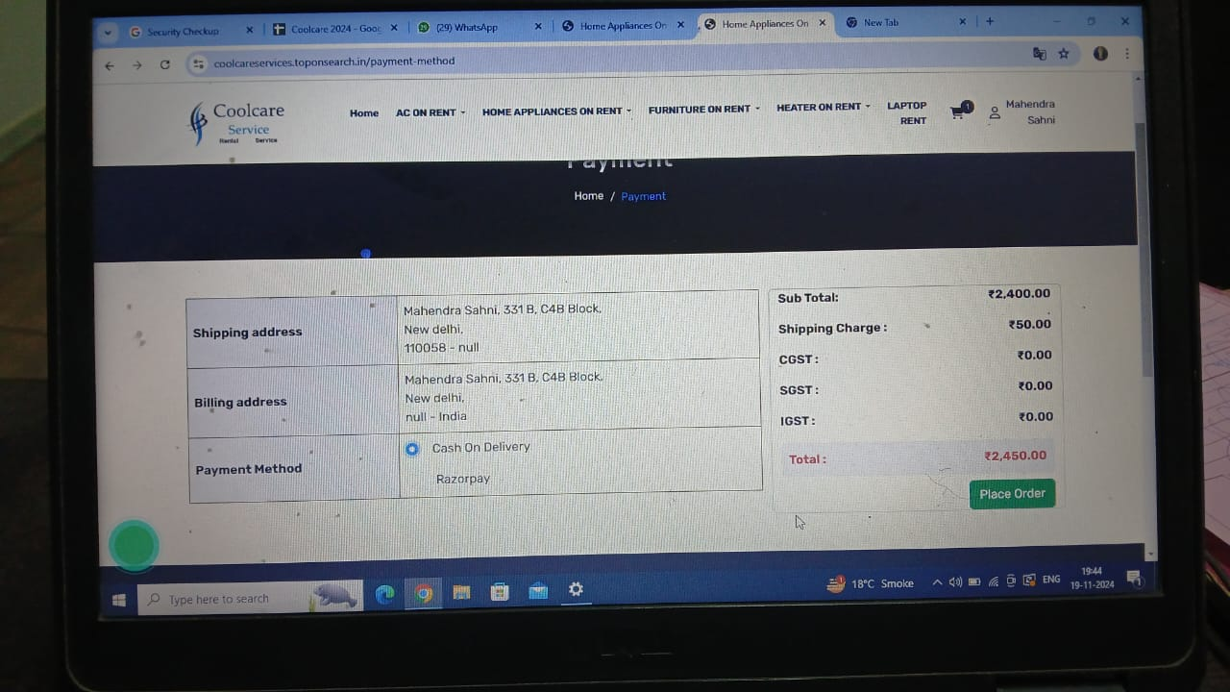

1. As per below screenshot order date is showing always Mon Jun 24(Done)  
   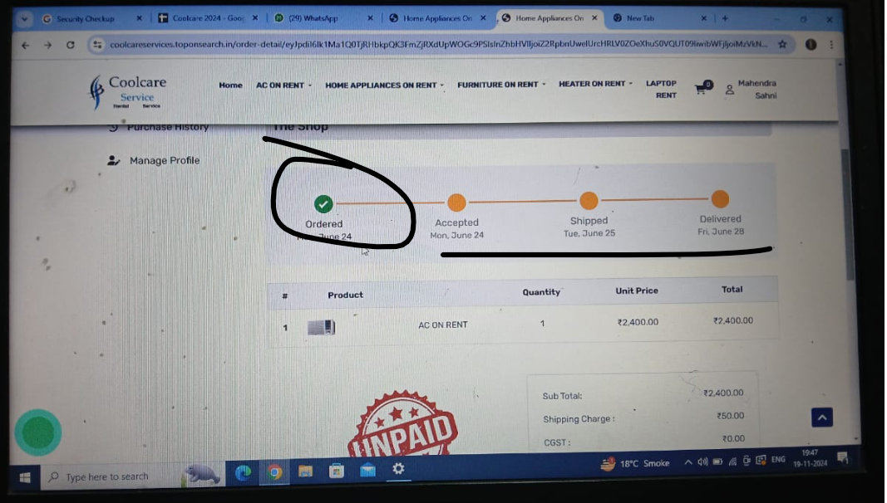
2. As per below screenshot if coupon discount is zero or not selected then it should not be shwned in order pages   
   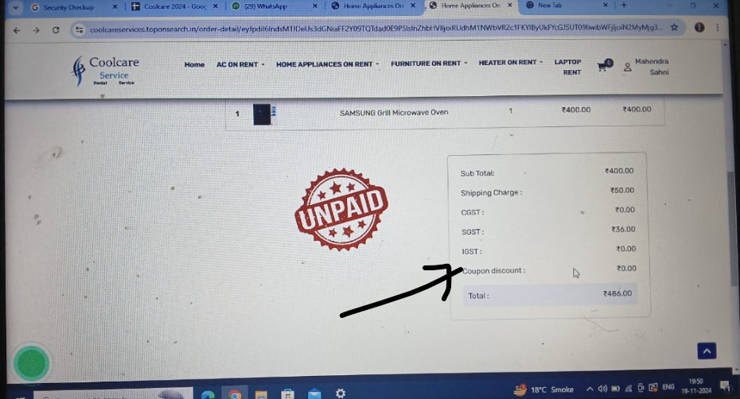
3. GST Value should be shown in admin panel after customer orders   
   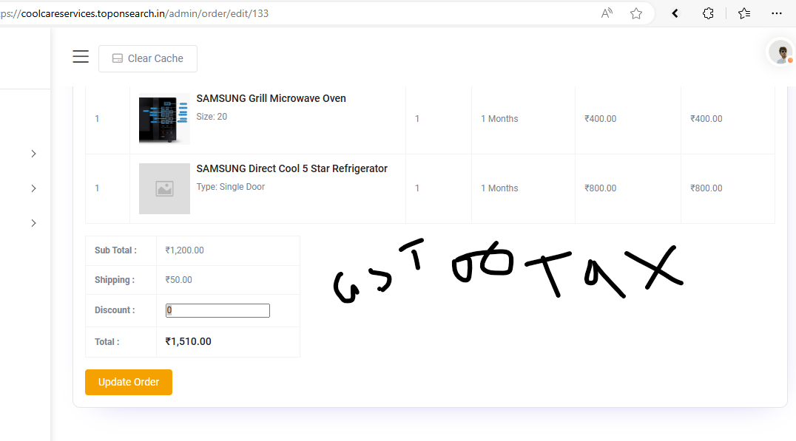
4. As per below screenshot in admin panel there wil be button to share invoice to the customer   
   