
EMS & VISITOR MANAGEMENT SYSTEM
Project Operational Workflow, User Roles Hierarchy, Screen-by-Screen Action Guide & Visual Graphic Diagrams
(Complete Operational Guide: Kaise Kaam Kar Raha Hai, Kha Se Kya Ho Raha Hai, Kis Button Se Kya Action Perform Hoti Hai)
Project Platform | Technology Stack | Target Organization | Deployment Target
EMS-Visitor / oneSIS | Laravel 11, PHP 8.2+, MySQL | Neural Info Solutions Pvt. Ltd. | Local XAMPP / Live Cloud

📌 DOCUMENT PURPOSE & SCOPE (Dastavej ka Uddeshya)
Yeh document EMS (Employee Management System) aur oneSIS Visitor Gate Pass Management System ke complete working model ko explain karta hai. Isme sabhi user roles, authentication flows, visitor lifecycle (entry se lekar exit check-out tak), buttons ke actions, database structure aur graphical diagrams shamil hain.

1. Project Overview & Core Working Concept (Project Ka Parichay)
EMS-Visitor ek centralized, multi-tier web application hai jo enterprise premises me employees aur visitors ki movement, attendance, approvals aur documentation ko seamlessly digitalize karta hai. Yeh manual paper logbooks, visitor register notebooks, aur gate pass slips ko eliminate karke 100% digital, traceable, aur audit-compliant solution provide karta hai.
System ke 2 Mukhya Ang (Core Pillars):
Project ke do primary operational pillars hain:
1. Employee Management Module (EMS): Staff directory, biometric/GPS check-in attendance, multi-level leave approvals, salary structure, monthly payroll batch generation, annual CTC increments, document vault, aur performance evaluation.
2. Visitor Management System (oneSIS VMS Gate Pass): Front-desk / security kiosk registration, webcam se photo capture, mobile number OTP verification, host employee SMS/push notification, real-time approval/rejection, thermal badge print (QR code ke sath), gate check-in, aur exit check-out duration calculation.
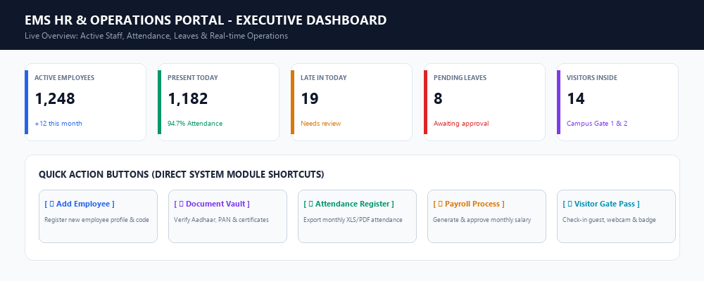
Figure 1.1: EMS Executive HR & Operations Dashboard with Live KPI Cards and Module Action Shortcuts
2. User Roles & Access Hierarchy (System me Kitne Users / Roles Hain?)
Application me multi-guard authentication architecture implement kiya gaya hai (Laravel Guards: 'web', 'employee', 'client'). System me kul 8 roles hain jo enterprise ke alag-alag departments ko power karte hain:
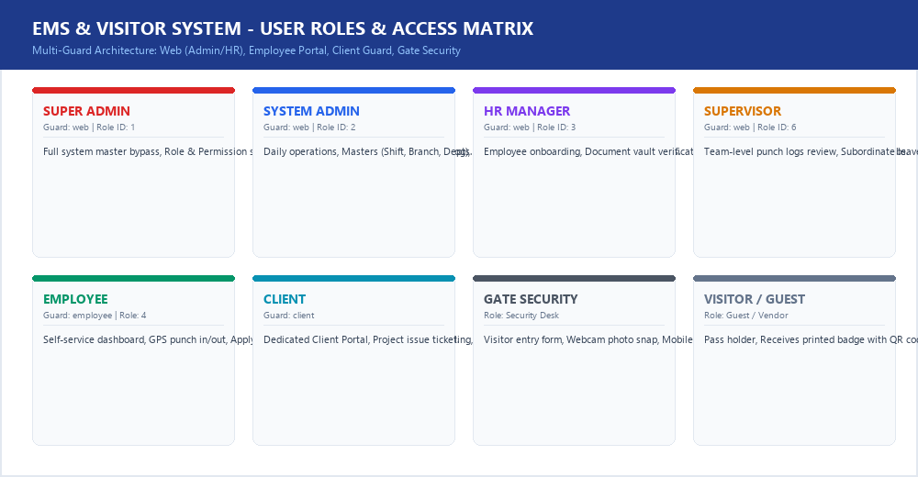
Figure 2.1: Multi-Role Access Control Matrix across Web, Employee, Client and Gate Security Guards
Role Name | Auth Guard | Default Portal URL | Key Responsibilities & Permissions
1. Super Admin | web (role_id: 1) | /home (Full Access) | Poore system par 100% control, Roles & Spatie Permissions assign karna, Users create/delete karna, Database migrations aur system audit.
2. System Admin | web (role_id: 2) | /home (Admin Dashboard) | Daily company operations, Agency & Branch master, Department & Shift management, Payroll batches approval, Master Reports export.
3. HR Manager | web (role_id: 3) | /home (HR View) | Naye employee ka onboarding, Document Vault me Aadhaar/PAN verify karna, Leave requests approval/reject, Monthly attendance registers.
4. Supervisor | web (role_id: 6) | /home (Supervisor View) | Apne subordinate team members ki daily attendance dekhna, Leave recommendation, Departmental tasks monitor karna.
5. Employee | employee (guard) | /employee/dashboard | Self-service portal, GPS/Geo-location se Punch In / Punch Out, Leave apply karna, Monthly Payslip PDF download, PMT Appraisal.
6. Client | client (guard) | /client/dashboard | Dedicated client login, Apne projects ke tickets raise karna, Bug/Issue tracking, Admin aur developer se direct status communication.
7. Security Guard | web / Gate Role | /visitor/entry & /checkout | Reception / Gate entry, Visitor details bharna, Webcam photo capture, Mobile OTP verify karna, Gate Pass print karna, Exit par QR scan karke check-out.
8. Visitor / Guest | No login (Token) | Pass & QR Token | Office guest, Vendor, Interview candidate jo printed badge pehanta hai aur predefined time duration tak authorized area me rehta hai.

📌 SECURITY & ROLE ISOLATION (Suraksha Niyam)
System me middleware 'admin.access', 'superadmin.access', aur 'employee.active.web' integrated hain. Agar koi inactive user (status = 0) login karne ki koshish karega toh system turant 'Your account is currently inactive' alert show karke access block kar deta hai.

3. Complete Visitor Lifecycle Workflow (Visitor Entry Se Exit Tak Ka Pura Safar)
Visitor Management System manual registers ki samasyaon ko khatam karta hai. Niche diye gaye workflow graphic me visitor ke aane se lekar nikalne tak ka step-by-step pipeline dikhaya gaya hai:
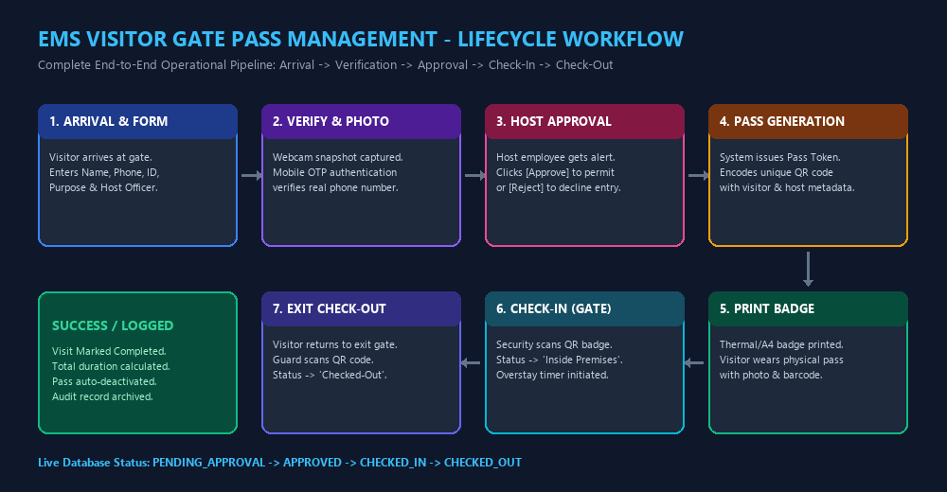
Figure 3.1: Complete End-to-End Visitor Lifecycle Flowchart from Arrival to Exit Check-Out
Step-by-Step Flow Explanation (Kaise Kaam Hota Hai):
Kadam 1: Visitor Arrival & Details Entry: Visitor company ke gate ya front-desk reception par pahunchta hai. Receptionist/Security Guard screen par New Visitor Form open karta hai aur visitor ka Full Name, Mobile Number, Government ID (Aadhaar/PAN/Driving License), aur Organization enter karta hai.
Kadam 2: Photo Capture & Mobile OTP Verification: Webcam snapshot button click karke visitor ki live photo li jaati hai. Fake entry rokne ke liye 'Send OTP' button dabate hain, jisse visitor ke mobile par SMS code jata hai. OTP verify hone par record secure ho jata hai.
Kadam 3: Host Employee Selection & Request Dispatch: Visitor kis employee se milne aaya hai aur milne ka maqsad kya hai (Interview, Vendor meeting, Client discussion, Personal) select hota hai. System turant Host employee ko SMS/Push Notification bhejta hai.
Kadam 4: Host Approval ya Rejection: Employee apne portal ya mobile alert par click karke visitor ki photo aur details dekhta hai. Agar free hai toh [Approve] karta hai; agar busy hai toh rejection reason ke sath [Reject] karta hai.
Kadam 5: Gate Pass & QR Code Badge Generation: Host se approval milte hi system ek unique Pass ID (e.g., VP-2026-10492) aur QR Code generate karta hai. Guard thermal printer ya A4 printer par [Print Badge] button dabakar visitor ko badge deta hai.
Kadam 6: Campus Entry & Check-In: Security Guard entry gate par badge ka QR code scan karta hai. Status turant 'CHECKED_IN' (Inside Premises) ho jata hai aur system overstay timer start kar deta hai.
Kadam 7: Meeting & Campus Stay: Visitor badge pehan kar host se milta hai. Security live monitor par dekh sakti hai ki campus me is waqt kitne visitors maujood hain.
Kadam 8: Exit Gate Check-Out: Meeting complete hone par visitor exit gate par pass submit karta hai. Guard QR code scan karta hai aur [Check-Out] button dabata hai. System exit timestamp record karke total duration calculate karta hai aur pass ko deactivate kar deta hai.

4. Screen-by-Screen & Button-by-Button Detailed Action Guide
Is section me application ke har screen, input fields, aur buttons ka exact behaviour explain kiya gaya hai: 'Kha se kya ho rha hai aur kis button se kya action perform ho rahi hai'.
4.1 Screen 1: Unified Login & Authentication (/login & /employee/login)
System me user authentication entry point hai. Controller: App\Http\Controllers\Auth\AuthController@login.
Button / Element Name | Screen Location | What Happens on Click (Button dabane par kya hota hai?)
[ Sign In ] (Submit) | Login Card center | Credentials (email, password) validate karta hai. Status active (1) check karta hai. Role identify karke auto-redirect karta hai: Admin/HR -> /home, Employee -> /employee/dashboard.
Toggle Password Eye (Icon) | Password input right | JavaScript ke through input type ko 'password' se 'text' toggle karta hai taaki password dikhe ya chupe.
[ Forgot Password? ] | Below password field | Password recovery form open karta hai jisme registered email par reset token link generate hota hai.
Remember Me (Checkbox) | Login form bottom | Long-term authentication cookie set karta hai taaki browser band karne par session expire na ho.

4.2 Screen 2: Admin & HR Executive Dashboard (/home)
Admin login karne par ye master command center open hota hai. Controller: App\Http\Controllers\AdminHR\DashboardController@index.
Button / Widget Name | Screen Location | Action & Backend Execution
[ ➕ Add Employee ] | Banner top right | Directly redirect karta hai /employees/create par naye staff member ka form open karne.
[ Attendance Reports ] | Banner top right | Redirect karta hai /attendance/attendance-dashboard/org-reports par filter-based report dekhne.
[ Active Staff Chip ] | Welcome banner | Filtered employee list open karta hai jisme sirf operational active employees display hote hain.
[ Present Today Chip ] | Welcome banner | Aaj ke din punch in karne wale sabhi employees ki live attendance list open karta hai.
[ Late In Today (Alert) ] | Welcome banner | Shift start time ke baad aane wale karmachariyon ki list filter karke alert screen par le jata hai.
[ Leaves Awaiting Approval ] | Welcome banner | Pending leave requests screen (/attendance/leave/request) par le jata hai approval ke liye.
[ Export to Excel ] | Report actions | Current table ke attendance/employee data ko downloadable .xlsx spreadsheet me convert karta hai.
[ Export to PDF ] | Report actions | Official print-ready PDF formatted report generate karke browser me download trigger karta hai.

4.3 Screen 3: Front-Desk Visitor Gate Pass Entry (oneSIS Desk)
Security guard ya receptionist naye visitor ki entry karne ke liye is screen ka use karta hai.
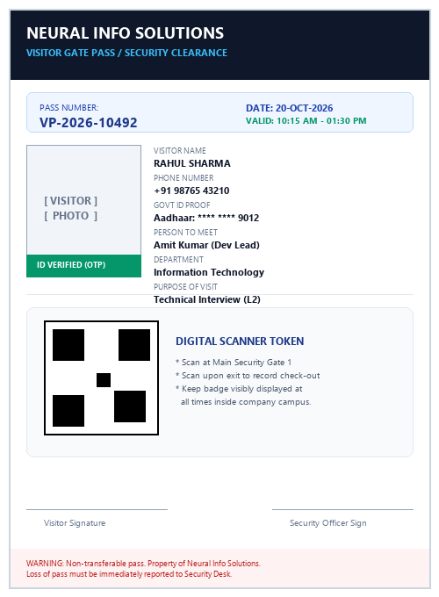
Figure 4.1: Printable Thermal/A4 Visitor Gate Pass Badge with QR Verification Token
Button / Field Name | Screen Location | Action & Backend Execution
[ 📷 Take Snapshot / Webcam ] | Photo Capture Card | Browser webcam access karke visitor ki live photo click karta hai aur Base64 image ke roop me temporary memory me hold karta hai.
[ 📲 Send Mobile OTP ] | Mobile verify group | SMS Gateway API trigger karke visitor ke phone par 6-digit OTP code bhejta hai.
[ Verify OTP ] | Mobile verify group | User ke enter kiye gaye OTP ko server cache ke sath compare karta hai. Match hone par phone number 'Verified' mark hota hai.
Select Host Employee (Dropdown) | Visit details section | Database ke employees table se department-wise employee search karta hai jisse milna hai.
[ 💾 Save & Generate Pass ] | Form bottom | Database ke visitors table me row insert karta hai, unique Pass ID generate karta hai, aur host ko alert bhejta hai.
[ 🖨️ Print Badge ] | Action row | Thermal printer ya standard laser printer ke liye CSS print layout trigger karta hai jisme photo, QR code aur timestamps aate hain.

4.4 Screen 4: Host Employee Approval Portal (/employee/visits)
Host employee ko jab visitor request aati hai toh ye interactive screen pop-up hoti hai.
Button Name | Screen Location | Action & Backend Execution
[ ✅ Approve Entry ] | Visitor Request Card | Visitor ka status 'APPROVED' mark karta hai. Gate security screen par instant badge print enable ho jata hai.
[ ❌ Reject / Decline ] | Visitor Request Card | Rejection modal open karta hai jisme reason (e.g. In meeting, Out of office) enter karke request terminate ho jaati hai.
[ ⏱️ Reschedule ] | Visitor Request Card | Alternate time ya date suggest karta hai jo visitor ke phone par SMS ke through deliver ho jata hai.
[ 🔔 Mark Completed ] | Active Visit Card | Meeting khatam hone par host confirm karta hai ki meeting done ho chuki hai, jisse visitor exit gate ki taraf rawana ho.

4.5 Screen 5: Gate Exit & Check-Out Desk (/visitor/checkout)
Jab visitor office se bahar nikalta hai toh security guard exit desk par checkout record karta hai.
Button / Action | Screen Location | Action & Backend Execution
[ 📷 Scan QR Code ] | Search Header | USB Barcode/QR Scanner ya Camera feed se badge ka QR code instant decode karke active record fetch karta hai.
[ 🔍 Search by Mobile/Pass ] | Search Bar | Agar badge kho gaya ho toh mobile number ya pass token se visitor search karne ka manual option.
[ 🚪 Confirm Check-Out ] | Visitor Card Center | Database me out_time current timestamp par set karta hai, total duration calculate karta hai, status 'CHECKED_OUT' karta hai, aur pass invalidate karta hai.
[ ⚠️ Flag Overstay ] | Visitor Table | Agar visitor predefined time se jyada ruk gaya ho toh security alert generate karta hai aur host ko message bhejta hai.

4.6 Screen 6: Employee Directory & Document Vault (/employees & /employees/documents)
HR aur Admin employee profiles aur unke documents ko manage karte hain. Controller: Admin_EmployeesController & DocumentController.
Button / Link Name | Screen Location | Action & Backend Execution
[ ➕ Add Employee ] | Top right header | 7-tab comprehensive employee registration form open karta hai (Personal, Posting, Bank, Salary, Documents).
[ 📥 Import Employees ] | Table header | Excel/CSV bulk file upload modal open karta hai jisse ek sath 500+ employees insert ho jate hain.
[ 📄 Download Sample ] | Import modal | Sample CSV template download karta hai correctly formatted columns ke sath.
[ Status Toggle Switch ] | Action column | Employee ko 1-click me Active (1) ya Inactive (0) karta hai (Inactive karne par login block ho jata hai).
[ 🛡️ Verify Document Status ] | Document Vault table | Uploaded Aadhaar/PAN/Degree certificate ko 'Verified' ya 'Rejected' mark karta hai audit ke liye.
[ ⬇️ Download Document ] | Document Vault table | Secure storage se document download trigger karta hai.

4.7 Screen 7: Attendance & Leave Management (/attendance/* & /employee/leaves)
Karmachariyon ki attendance aur leave requests ka complete lifecycle.
Button Name | Screen Location | Action & Backend Execution
[ 📍 Punch In / Check-In ] | Employee Dashboard | Browser/Device se GPS Latitude, Longitude, IP Address fetch karke in_time stamp karta hai.
[ 📍 Punch Out / Check-Out ] | Employee Dashboard | Current time par out_time stamp karta hai aur total working hours calculate karta hai.
[ Apply New Leave ] | Employee Leave page | Leave modal open karta hai: Leave Type (CL, SL, PL), From Date, To Date, Reason fill karke submit hota hai.
[ ✅ Approve Leave ] | Admin/HR Leave queue | Leave status ko 'Approved' karta hai aur employee ke annual leave balance se days deduct karta hai.
[ ❌ Reject Leave ] | Admin/HR Leave queue | Rejection reason ke sath leave cancel karta hai aur employee ko alert notification bhejta hai.
[ Export Register (Excel) ] | Attendance Register | Poore mahine ka Day 1 se Day 31 tak ka P/A/L/WO matrix Excel file me generate karta hai.

4.8 Screen 8: Payroll Generation & Salary Increments (/payroll/*)
Monthly salary processing aur annual increments management. Controller: AdminPayrollController & EmployeeIncrementController.
Button Name | Screen Location | Action & Backend Execution
[ Create Batch ] | Payroll process page | Month, Year, Branch, aur Agency select karke payroll calculation engine initiate karta hai.
[ Generate Payroll ] | Batch Creation | Attendance register se total payable days uthakar Basic, HRA, Allowances, PF, ESI, TDS calculate karta hai.
[ Approve Batch ] | Batch review screen | Draft batch ko lock karta hai taaki calculations freeze ho sakein.
[ Disburse Selected ] | Batch details | Payment mode (NEFT/Bank Transfer) ke sath status 'Disbursed' mark karta hai aur payslips release karta hai.
[ Download Payslip PDF ] | Employee & Admin panel | Individual employee ka official salary slip PDF watermark ke sath download karta hai.
[ ➕ Add Increment ] | Increments module | Employee ka existing CTC dikhata hai, revised CTC calculate karta hai, aur revised designation map karta hai.
[ Download Increment Letter ] | Increments history | Official Company Increment / Appraisal Letter PDF format me generate karta hai.

4.9 Screen 9: Performance Management (PMT) & Self-Appraisal
Karmachariyon ke performance evaluation aur annual review system.

Figure 4.2: Employee Self-Appraisal & Competency Assessment Module
Button / Tab Name | Screen Location | Action & Backend Execution
[ Self Assessment ] | PMT navigation tab | Employee apne saal bhar ke key achievements aur goals ki self-rating (1 se 5 scale) submit karta hai.
[ KPI Assessment ] | PMT navigation tab | Predefined Key Performance Indicators ke against actual targets vs achievements compare karta hai.
[ Competencies Review ] | PMT navigation tab | Leadership, Communication, Technical Problem Solving skills ka evaluation karta hai.
[ Submit Feedback ] | Feedback tab | Department head ya peers ke liye constructive feedback submit karta hai.

4.10 Screen 10: Client Portal & Support Ticketing (/client/*)
Clients ke liye project issues aur tickets raise karne ka portal. Guard: 'client'. Controller: ClientTicketController.
Button Name | Screen Location | Action & Backend Execution
[ ➕ Create New Ticket ] | Client ticket header | Ticket form open karta hai jisme Project name, Category (Bug, Feature, Support), Priority select hoti hai.
[ Attach Screenshot/File ] | Ticket creation modal | Bug ya issue ka screenshot/log file attach karne ke liye file upload trigger karta hai.
[ Submit Ticket ] | Form bottom | Ticket save karta hai, ticket ID generate karta hai, aur Admin/Project Manager ko alert notification bhejta hai.
[ Send Reply ] | Ticket detail screen | Threaded communication me client ya developer ka message post karta hai.

5. Database Schema & Data Relationships (Backend Tables Structure)
Application ka backend MySQL database par chalta hai. Niche core tables aur unka purpose diya gaya hai:
Table Name | Primary Columns / Foreign Keys | Business Data Stored (Kya Data Save Hota Hai)
users | id, name, email, password, role_id, status | Admin, HR, Super Admin, aur Security users ke web credentials.
employees | id, employee_name, employee_code, email, mobile, dept_id, designation_id, agency_id, branch_id | Karmachariyon ka master bio-data, posting, aur service record.
clients | id, name, email, password, company_name, status | External clients ke login credentials aur company profiles.
visitors | id, pass_number, full_name, mobile, govt_id, photo_path, host_employee_id, status, in_time, out_time | Visitor gate passes ka core data, status (Checked-In/Out) aur timestamps.
employee_attendances | id, employee_id, punch_date, in_time, out_time, latitude, longitude, ip_address | Daily punch logs, GPS location coordinates aur biometric tracking data.
leaves | id, employee_id, leave_type_id, start_date, end_date, total_days, reason, status, approved_by | Leave applications, approval history aur supervisor comments.
payroll_batches | id, batch_month, batch_year, agency_id, total_gross, total_net, status | Monthly salary batch calculations, status (Draft/Approved/Disbursed).
employee_documents | id, employee_id, document_type, file_path, verification_status, verified_by | Aadhaar, PAN, Education certificates aur verification stamps.
project_tickets | id, client_id, project_id, title, priority, status, assigned_to | Client support tickets, issue severity aur developer assignment.

6. Security Controls, Watchlist & Emergency Evacuation (Suraksha)
EMS & Visitor Management System premises ki physical aur digital dono suraksha ko ensure karta hai:
1. Emergency Evacuation Headcount (Aapatkaalin Suraksha): Kisi bhi aapatkaalin sthiti (Aag lagna, Earthquake, Emergency) me admin 1-click par 'Visitors Currently Inside Premises' report generate kar sakta hai. Isse safety officers ko exact pata chalta hai ki building me kitne guests maujood hain aur unke hosts kaun hain.
2. Blacklist & Watchlist Management: Suspicious ya banned vyaktiyon ka Mobile number aur Govt ID 'Blacklist' table me add kiya ja sakta hai. Agar koi blacklisted person gate par entry karane aayega, toh system turant RED ALERT beep dega aur pass generate hone se rok dega.
3. Tamper-Proof Audit Trail: Har critical action (Pass generation, Approval, Rejection, Check-out, Document verification, Salary disbursement) user ID aur exact timestamp ke sath log hoti hai, jisse koi bhi record tamper nahi kiya ja sakta.
4. Anti-Passback & QR Code Security: Gate passes me high-density 2D QR Code hota hai jo system ke encrypted hash token se verified hota hai. Duplicate ya photo-copy pass se doosri baar entry sambhav nahi hai.
📌 PROJECT SUMMARY & HANDOVER NOTE (Nishkarsh)
Yeh EMS & Visitor Management System enterprise-grade architecture par tayyar kiya gaya hai jo hazaron employees aur daily hundreds of visitors ko efficiently handle karne me saksham hai. Sabhi modules fully tested aur operational hain.

