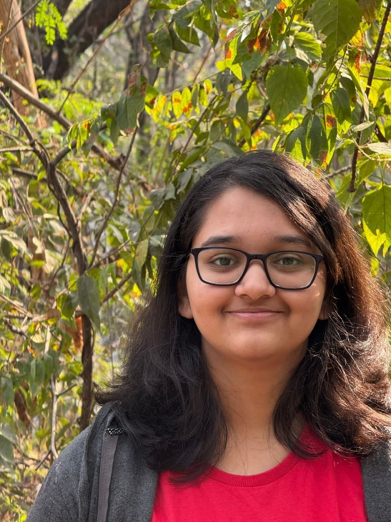


PROFILE
ANUSHA DIXIT
I am currently enrolled at ILS Law College Pune, as a first-year student of BA LLB. I am immensely interested and intrigued by the field of law. Legal research and writing are something that I am very passionate about, and intend to explore further. I am eager to deepen my legal knowledge, broaden my horizons, and develop experiences through debates, internships and moots. I am highly motivated to learn and develop skills necessary for succeeding in this field and aim to use my analytical and critical skills developed through my studies.


EDUCATION

+91 7208562181
Anushadixit1406@gmail.com
Mumbai, Maharashtra
www.linkedin.com/in/anusha-dixit-0764a624b


2024 – 2025

ILS Law College, Pune
I BALLB (Hons)
Grade- 8.5 GPA (Semester I)
99.61 percentile in MH CET-Law 2024 (Maharashtra Rank 22)



2022 – 2024

Thakur College of Science and Commerce
Secured 89.83% in 12th Board Examination (HSC)

LANGUAGES

2009 – 2022

Thakur Public School
Secured 97.8% in 10th Board Examination (ICSC)

- English
- Hindi
- Marathi
- Japanese: N5 Level


EXPERIENCE

ACADEMIC ACHIEVEMENTS

- Secured AIR 379 in CLAT 2025 and AIR 394 in AILET 2025
- Secured AIR 107 in AILET 2024
- Secured 98.35 percentile in SLAT 2024 and accepted to Symbiosis Law School Pune
- Cleared the Japanese Language Proficiency Examination Level N5 in 2023
- 12th Board Examination (HSC):
o Secured 99 marks in Book Keeping & Accountancy
o Topped Organization of Commerce and Management with 97 marks
o Secured 95 marks in Economics
- 10th Board Examination (ICSE):
o Topped in Mathematics with a score of 100

SKILLS
HOBBIES & INTERESTS

- Legal Research
- Writing
- Critical Reasoning
- Microsoft & Google Docs

- Reading
- Hiking & Trekking
- Sketching & Painting
EXTRA CURRICULAR ACTIVITIES

- BLOGS, ARTICLES & PUBLICATIONS
- Presented a research paper at the ‘19th Remembering SP Sathe Conference’, on the topic of “Comparative Analysis on Predictive Policing: Assessing Risks and the Need for Regulation” organized by ILS Law College in March 2025 (results not yet declared)

©AZURIUS – Modeles-de-cv.com
©AZURIUS - My-resume-templates.com

- Published a blog in the XXVII No. I edition of the ILS Centre for International Law Newsletter, writing on the topic “When Miscarriage Means Prison: The Brutal Abortion Laws of El Salvador” in March 2025
- Participated in the Blog Writing Competition held by ILS Environmental and Animal Cell, writing on a sub-topic under “Protecting Endangered Species: Critical Analysis of Wildlife Conservation Laws” in January 2025


- Finished as finalist in the Extempore Moot Competition organized by the ILS Centre for Commercial Law in March 2025
- Researched on Insolvency and Bankruptcy Code 2016
- Researched on Industrial Disputes Act 1947

- Participated in the ILS Novice Moot Court Competition held in February 2025
- Learnt extensively about the Copyright Act 1957 and related laws by participating as the counsel for the respondent in a civil case regarding copyright violation

MISCELLANEOUS ACTIVITIES
- Volunteered at the 14th Intra-College Trial Advocacy Court Competition 2025 at ILS Law College
- Participated in the Intra-College MUN organized by ILS Law College in the UNHRC Committee in January 2025
- Participated in the AIPPM Committee in SYNCHRONISMUN conducted by Symbiosis College of Arts and Commerce in January 2025
- MOOT COURT ACTIVITIES

