PRIYANKA SAHOO 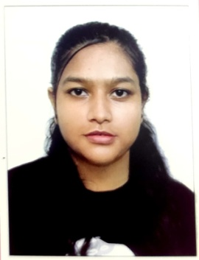
Pursuing 4 year Bachelor Arts with Honours in Political Science from LADY BRABOURNE COLLEGE under the University of Kolkata . Team player with excellent communication skill and highly self - motivated.
PERSIONAL DETAIL
ADDRESS :- 11C BAISHNAB GHATA LANE , GARIA , KOLKATA
PIN - 700047
EMAIL :- priyankasahoo001234@gmail.com
CONTRACT NUMBER :- 8011302839
DATE OF BIRTH :- 30/07/2005
FATHER'S NAME :- Susanta Sahoo
NATIONALITY :- Indian
MARITAL STATUS :- Unmarried
WORK EXPERIENCE :- N.A.

EDUCATIONAL QUALIFICATION
2023 - 2027
Pursuing 4 YEAR BACHELOR of ARTS with Political Science Major , History and Sociology as Minor .
2023 - 2025
Pursuing Diploma in Computer Applications .
2023
Passed Higher Secondary Examination with 78.6 % from CENTRAL BOARD OF SECONDARY EDUCATION , from Kendriya Vidyalaya No -1 Tezpur Assam .
2021
- Passed Class X Examination with 74.2 % from CENTRAL BOARD OF SECONDARY EDUCATION , from Kendriya Vidyalaya No - 1 Tezpur Assam .
- NCC A Certificate, from Kendriya Vidyalaya No - 1 Tezpur .

SKILL
Proficiency in MS Office , Teamwork , Adaptability

HOBBIES AND INTERESTS
Drawing , Traveling , Cooking , Dancing , listening music

LANGUAGES KNOWN
English, Hindi , Bengali

