SHARODIA KAR 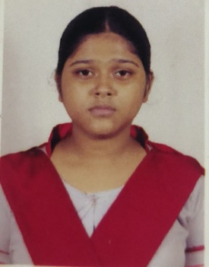

Pursuing 4 year Bachelor Arts with Honours in Political Science from LADY BRABOURNE COLLEGE under the University of Kolkata . Team player with excellent communication skill and highly self - motivated.
PERSIONAL DETAIL
ADDRESS :- NETAJI PARA , JALPAIGURI
PIN :- 735101
EMAIL :- karsharodia2005@gmail.com
CONTRACT NUMBER :- 9907131385
DATE OF BIRTH :- 20/10/2005
FATHER'S NAME :- Subhrajit Kar
NATIONALITY :- Indian
MARITAL STATUS :- Unmarried
WORK EXPERIENCE :- N.A.

EDUCATIONAL QUALIFICATION
2023 - 2027
Pursuing 4 YEAR BACHELOR of ARTS with Political Science Major , Philosophy and Sociology as Minor .
2023 - 2025
Pursuing Diploma in Computer Applications .
2023
Passed Higher Secondary Examination with 76.6 % from West Bengal Council of Higher Secondary Education
2022
Diploma in Computer Applicable , from INDIAN COUNCIL OF COMPUTER TECHNOLOGY
2021
Passed Class X Examination with 72.2 % from West Bengal Board of Secondary Education

SKILL
Proficiency in MS Office , Teamwork

HOBBIES AND INTERESTS
Reading Book , Cooking , Dancing , listening music

LANGUAGES KNOWN
English , Bengali

