CURRICULAM VITAE

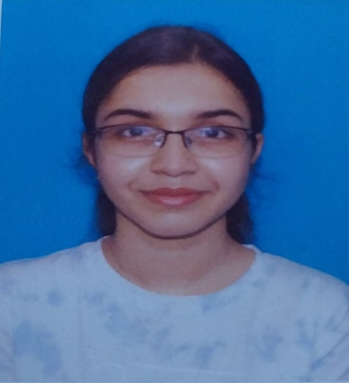
ARUSHI BISWAS

20/2A, MADHUPUR ROAD
P.0+ P.S: BERHAMPORE
DIST. MURSHIDABAD, PIN - 742101
WEST BENGAL
Contact: 9474579616
e-mail: arushi.biswas5002@gmail.com

CAREER OBJECTIVE:
I would like to involve myself in challenging environment, offering scope for growth and
development and an opportunity to apply my learning to effectively contribute towards society and the achievement of the organizational goal.

ACADEMIC QUALIFICATION:

Name of examination | Board/University | Year | Marks
10th | ICSE | 2021 | 92.50%
12th | CBSE | 2023 | 93.40%

PRESENT EDUCATION:
I am under graduate student of semester 3 and pursuing 4 years’ Honors course in Sociology from Lady Brabourne College Kolkata.

PERSONAL INFORMATION:

Father’s Name | : Soumya Subhro Biswas
Mother's Name | : Sanchita Biswas (Bose)
Date of Birth | : 28th August 2005
Marital Status | : Single
Nationality | : Indian
Language | : English, Bengali, Hindi
Hobbies | : Recitation, Dance and Listening Music
Strength | : I am task oriented & hard working

DECLARATION:

I hereby declare that all the information given above are true to the best of my knowledge.

Date : 19th March.2025
Place : Kolkata

(Arushi Biswas)

