Ayushmita Dhar
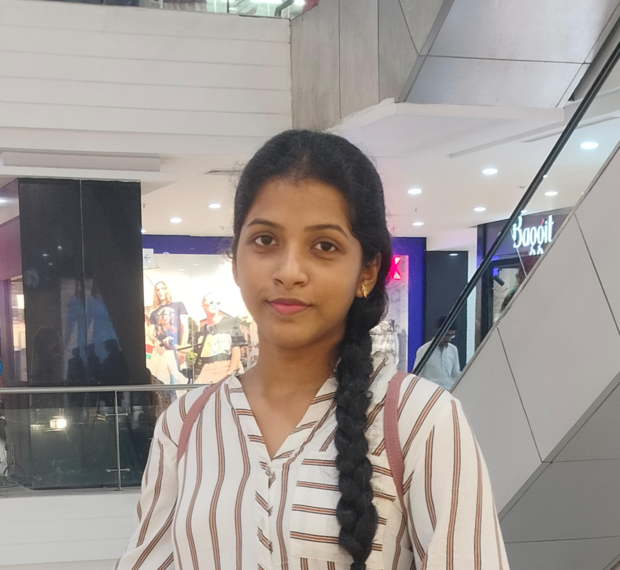
4/5 , Bijoygarh , Kolkata - 700032
Email id : ayushmita67@gmail.com
Contact No. : 6291042538
_________________________
Personal Profile
Father’s Name : Ashis Dhar
DOB: 28/09/2004
Category: General
Nationality: Indian
Religion: Hindu
Marital Status: Unmarried
Languages Known: English, Hindi, Bengali
Skills
- Dance , Sports & Fitness , Literature and Creative Writing

Experience
Taught Basic History and Geography in a Coaching Center for 6 Months
Educational Qualification
W.B.C.H.S.E Passed From Andrew’s High School , with 91%
Bachelor of Arts (Hons.) in Political Science (2023 – Present)
Lady Brabourne College , University of Calcutta
Declaration
I hereby declare that the above mentioned information is correct up to my knowledge and I bear the responsibility of the suitability of the above mentioned particulars.
DATE:
PLACE:

